Global EV Market Analysis
Tableau Story Design
Team ID: [Enter Team ID] | Prepared by: Nilamber Singh Hada | Date: 6 November 2026
Dataset note: ev_market_test.csv provided by Skill Wallet, 100,000 rows x 37 columns. The data is synthetic, so totals are relative measures, not real-world figures.

Story purpose
A Tableau Story combines worksheets, dashboards and captions into a sequence that guides an audience through the analysis. The EV story moves from the size of the market, to who sells the most, to what drives price, to battery technology, to regions, and ends with recommendations.

Story sequence (6 scenes)
Scene | Caption | Suggested visual | Message | Evidence
1 | Market snapshot: 100,000 EV models | Dataset overview and key counts | Size and scope of the market. | 100,000 rows, 200 manufacturers, 15 categories, 2018 to 2026.
2 | Who sells the most | Sales by Category and Top Manufacturers | Scooters, sedans and compact SUVs lead; trucks, pickups and buses sell far fewer units. | Scooters 85.0M, sedans 78.3M, compact SUVs 76.1M; trucks, pickups, buses 5 to 7M.
3 | Price vs Range | Price vs Range scatter | Battery capacity drives price much more than range does. | Correlation 0.84 with capacity, 0.28 with range.
4 | Battery technology | Battery Durability bars | Solid-State and LFP last longest with the lowest degradation. | Solid-State 2,999 cycles / 7.36%; LFP 2,498 / 10.11%; others about 14%.
5 | Regions and countries | Country Map and Average Price by Region | Regional totals are balanced; no single region dominates. | Average price $64.6k to $65.3k in all seven regions.
6 | Recommendations | CO2 Saved chart and summary text | Focus on high-volume categories and durable battery chemistries. | Heavy vehicles save the most CO2; durable chemistries lower degradation.

Story in the web app
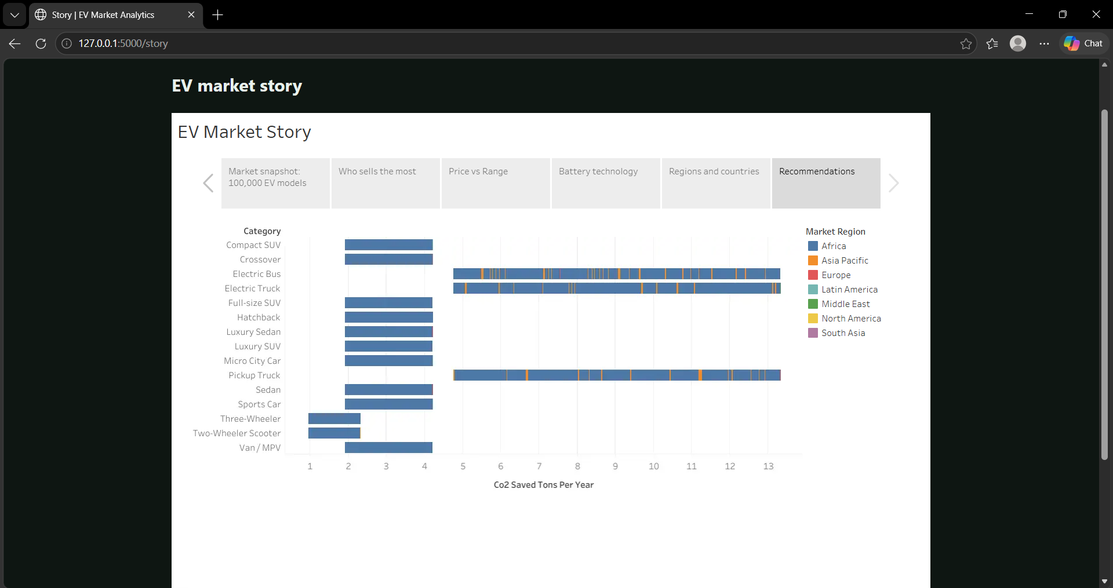
Figure 1. Story page of the Flask app showing the six-scene Tableau story (scene 6 selected).
Captions and messages come from the published story. The suggested visual for scenes 1 to 5 is a proposed match to the worksheets; confirm it against your workbook.

Observations
- Observation 1: Two-wheeler scooters sell about 85.0M units, the most of any category, while electric buses sell about 5.3M.
- Observation 2: The top five manufacturers sell between 4.6M and 4.9M units each, so sales are spread across many manufacturers.
- Observation 3: Price correlates 0.84 with battery capacity and 0.28 with range.
- Observation 4: Solid-State batteries average 2,999 cycles against 1,598 for NCA, and 7.36% degradation against about 14%.
- Observation 5: These are descriptive patterns in synthetic data; summed sales (about 773 million units) are relative measures, not real-world totals.

Activity 2: Publish story on Tableau Public
Published story: https://public.tableau.com/views/EVMarketAnalysis_17926786113420/Story1
Published dashboard: https://public.tableau.com/views/EVMarketAnalysis_17926786113420/MarketOverview

Submission checklist
Item | Status
Story points created in Tableau from the real worksheets and dashboard | Done (6 scenes)
Each scene has a concise caption | Done
Numbers verified against the SQL query outputs | Done
Story published to Tableau Public | Done
Story embedded in the Flask web app | Done (Story page)
Synthetic-data limitation stated | Done

