

Technical Safety Concept Lane Assistance

**Document Version: [Version]**

**Template Version 1.0, Released on 2017-06-21**



# Document history

|  |  |  |  |
| --- | --- | --- | --- |
| Date | Version | Editor | Description |
| 19/08/2018 | 1.0 | Jumana MP | First Attempt |
|  |  |  |  |
|  |  |  |  |
|  |  |  |  |
|  |  |  |  |

# 

# Table of Contents

Document history

Table of Contents

Purpose of the Technical Safety Concept

Inputs to the Technical Safety Concept

Functional Safety Requirements

Refined System Architecture from Functional Safety Concept

Functional overview of architecture elements

Technical Safety Concept

Technical Safety Requirements

Refinement of the System Architecture

Allocation of Technical Safety Requirements to Architecture Elements

Warning and Degradation Concept

# Purpose of the Technical Safety Concept

# The purpose of the technical safety concept is to refine the functional safety requirements

established in the functional safety concept into technical safety requirements. This step is taken before any software and hardware development to ensure that all components when designed meets their respective safety requirements. As a part of product development, technical safety concept involves:

* Turning functional safety requirements into technical safety requirements.
* Allocating technical safety requirements to the system architecture.

As a subsequent step, technical safety requirements will be considered within the software and hardware implementation.

# Inputs to the Technical Safety Concept

## Functional Safety Requirements

**[Instructions: Provide the functional safety requirements derived in the functional safety concept ]**

|  |  |  |  |  |
| --- | --- | --- | --- | --- |
| **ID** | **Functional Safety Requirement** | **ASIL** | **Fault Tolerant Time Interval** | **Safe State** |
| Functional  Safety  Requirement  01-01 | The electronic power steering ECU shall ensure that the lane departure warning oscillating torque amplitude is below Max_Torque_Amplitude | C | 50ms | Deactivate the function |
| Functional  Safety  Requirement  01-02 | The electronic power steering ECU shall ensure that the lane departure warning oscillating torque frequency is below Max_Torque_Frequency | C | 50ms | Deactivate the function |
| Functional  Safety  Requirement  02-01 | The lane keeping item shall ensure that the it stops applying the steering torque to direct car towards the center of the lane after a certain amount of time. | B | 500ms | Deactivate the function |
| Functional  Safety  Requirement  02-02 | The lane assistance item shall ensure that it stops working in weather conditions where camera sensor fails. | A | 10ms | Deactivate the function |
| Functional  Safety  Requirement  02-03 | The lane assistance item shall ensure that it takes wind force into account while computing required torque for car steering. | C | 10ms | Alert the driver with alarm and verify driver is in control. |

## Refined System Architecture from Functional Safety Concept

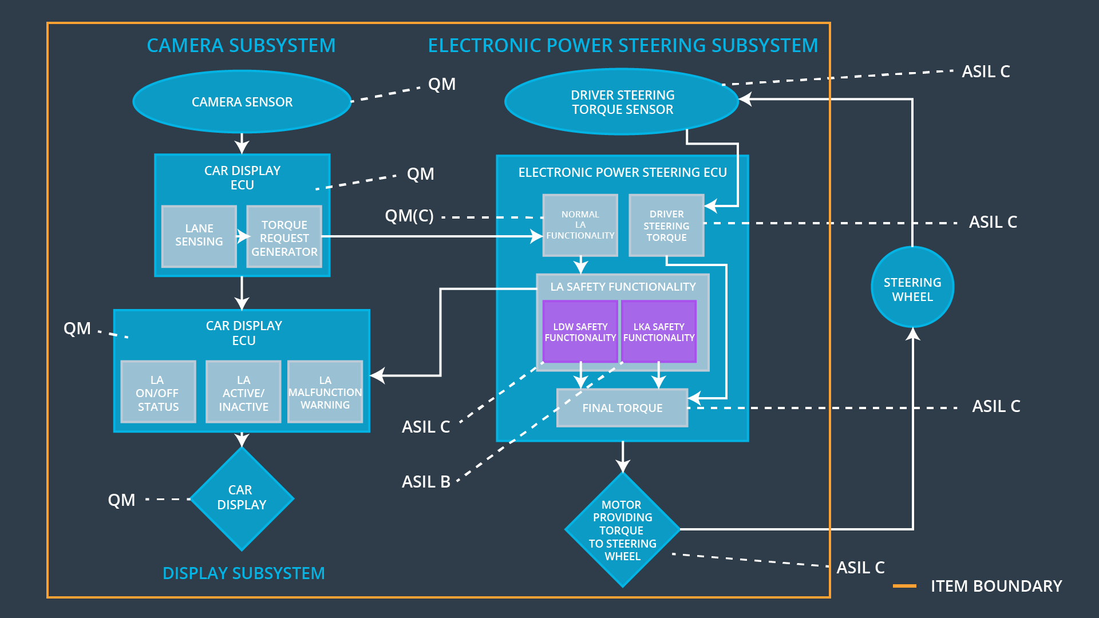

### 

### Functional overview of architecture elements

**[Instructions: Provide a description for each functional safety element; what is each element's purpose in the lane assistance item? ]**

|  |  |
| --- | --- |
| **Element** | **Description** |
| Camera Sensor | Captures lame images and sends to the Camera Sensor ECU |
| Camera Sensor ECU - Lane Sensing | Detects lane line positions from the camera images. |
| Camera Sensor ECU - Torque request generator | Generates torque requests to the EPS ECU after evaluating the lane position data from the camera sensor ECU. |
| Car Display | Displays warning and status messages from the item to the driver. |
| Car Display ECU - Lane Assistance On/Off Status | Indicate if the LA functionality is powered on. |
| Car Display ECU - Lane Assistant Active/Inactive | Indicate if the LA functionality is active at the moment. |
| Car Display ECU - Lane Assistance malfunction warning | Informs if there is a malfunction detected in the LA functionality. |
| Driver Steering Torque Sensor | Senses the intensity of the torque being provided by the driver to the steering wheel. |
| Electronic Power Steering (EPS) ECU - Driver Steering Torque | Processes the input torque being provided by the driver to the steering wheel. |
| EPS ECU - Normal Lane Assistance Functionality | Processes the input torque request from the car sensor ECU torque request generator and pass the data to the LDW Safe software block. |
| EPS ECU - Lane Departure Warning Safety Functionality | Checks for malfunctions in the LDW functionality. |
| EPS ECU - Lane Keeping Assistant Safety Functionality | Checks for malfunctions in the LKA functionality. |
| EPS ECU - Final Torque | Generates final torque from the input from both the Lane Assistance Safety functionality and the Electronic Power Steering (EPS) ECU - Driver Steering Torque |
| Motor | Applies the final torque obtained from the EPS ECU - Final Torque component to the steering wheel. |

# 

# Technical Safety Concept

## Technical Safety Requirements

**Lane Departure Warning (LDW) Requirements:**

Functional Safety Requirement 01-01 with its associated system elements

|  |  |  |  |  |
| --- | --- | --- | --- | --- |
| **ID** | **Functional Safety Requirement** | **Electronic Power Steering ECU** | **Camera ECU** | **Car Display ECU** |
| Functional  Safety  Requirement  01-01 | The lane keeping item shall ensure that the lane departure oscillating torque amplitude is below Max_Torque_Amplitude | X |  |  |

Technical Safety Requirements related to Functional Safety Requirement 01-01 are:

|  |  |  |  |  |  |
| --- | --- | --- | --- | --- | --- |
| **ID** | **Technical Safety Requirement** | **ASIL** | **Fault Tolerant Time Interval** | **Architecture Allocation** | **Safe State** |
| Technical  Safety  Requirement  01 | The LDW safety component shall ensure that the amplitude of the 'LDW_Torque_Request' sent to the 'Final electronic power steering Torque' component is below 'Max_Torque_Amplitude. | C | 50ms | LDW Safety Software block | LDW torque output is set to zero |
| Technical  Safety  Requirement  02 | As soon as the LDW function deactivates the LDW feature, the 'LDW Safety' software block shall send a signal to the car display ECU to turn on a warning light. | C | 50ms | LDW Safety Software block | LDW torque output is set to zero |
| Technical  Safety  Requirement  03 | As soon as a failure is detected by the LDW function, it shall deactivate the LDW feature and the 'LDW_Torque_Request' shall be set to zero. | C | 50ms | LDW Safety Software block | LDW torque output is set to zero |
| Technical  Safety  Requirement  04 | The validity and integrity of the data transmission for 'LDW_Torque_Request' signal shall be ensured. | C | 50ms | Data Transmission Integrity Check | N/A |
| Technical  Safety  Requirement  05 | Memory test shall be conducted at start up of the EPS ECU to check for any faults in memory. | A | Ignition cycle | Memory Test | LDW torque output is set to zero |

Functional Safety Requirement 01-2 with its associated system elements

(derived in the functional safety concept)

|  |  |  |  |  |
| --- | --- | --- | --- | --- |
| **ID** | **Functional Safety Requirement** | **Electronic Power Steering ECU** | **Camera ECU** | **Car Display ECU** |
| Functional  Safety  Requirement  01-02 | The lane keeping item shall ensure that the lane departure oscillating torque frequency is below Max_Torque_Frequency | X |  |  |

Technical Safety Requirements related to Functional Safety Requirement 01-02 are:

|  |  |  |  |  |  |
| --- | --- | --- | --- | --- | --- |
| **ID** | **Technical Safety Requirement** | **ASIL** | **Fault Tolerant Time Interval** | **Architecture Allocation** | **Safe State** |
| Technical  Safety  Requirement  01 | The LDW safety component shall ensure that the frequency of the 'LDW_Torque_Request' sent to the 'Final electronic power steering Torque' component is below 'Max_Torque_Frequency. | C | 50ms | LDW Safety Software block | LDW torque output is set to zero |
| Technical  Safety  Requirement  02 | As soon as the LDW function deactivates the LDW feature, the 'LDW Safety' software block shall send a signal to the car display ECU to turn on a warning light. | C | 50ms | LDW Safety Software block | LDW torque output is set to zero |
| Technical  Safety  Requirement  03 | As soon as a failure is detected by the LDW function, it shall deactivate the LDW feature and the 'LDW_Torque_Request' shall be set to zero. | C | 50ms | LDW Safety Software block | LDW torque output is set to zero |
| Technical  Safety  Requirement  04 | The validity and integrity of the data transmission for 'LDW_Torque_Request' signal shall be ensured. | C | 50ms | Data Transmission Integrity Check | N/A |
| Technical  Safety  Requirement  05 | Memory test shall be conducted at start up of the EPS ECU to check for any faults in memory. | A | Ignition cycle | Memory Test | LDW torque output is set to zero |

**Lane Keeping Assistance (LKA) Requirements:**

Functional Safety Requirement 02-1 with its associated system elements

(derived in the functional safety concept)

|  |  |  |  |  |
| --- | --- | --- | --- | --- |
| **ID** | **Functional Safety Requirement** | **Electronic Power Steering ECU** | **Camera ECU** | **Car Display ECU** |
| Functional  Safety  Requirement  02-01 | The lane keeping item shall ensure that the lane keeping assistance torque is applied for only Max_Duration | X |  |  |

Technical Safety Requirements related to Functional Safety Requirement 02-01 are:

|  |  |  |  |  |  |
| --- | --- | --- | --- | --- | --- |
| **ID** | **Technical Safety Requirement** | **ASIL** | **Fault Tolerant Time Interval** | **Allocation to Architecture** | **Safe State** |
| Technical  Safety  Requirement  01 | The LKA safety component shall ensure that the frequency of the 'LDW_Torque_Request' sent to the 'Final electronic power steering Torque' component is only for 'Max_Duration. | B | 500ms | LKA Safety Software block | LKA Activation status is zero |
| Technical  Safety  Requirement  02 | As soon as a failure is detected by the LKA function, it shall deactivate the LKA feature and the 'LKA_Torque_Request' shall be set to zero. | B | 500ms | LKA Safety Software block | LKA Activation status is zero |
| Technical  Safety  Requirement  03 | As soon as the LKA function deactivates the LKA feature, the 'LKA Safety' software block shall send a signal to the car display ECU to turn on a warning light | B | 500ms | LKA Safety Software block | LKA Activation status is zero |
| Technical  Safety  Requirement  04 | The validity and integrity of the data transmission for 'LKA_Torque_Request' signal shall be ensured. | B | 500ms | LKA Safety Software block | N/A |
| Technical  Safety  Requirement  05 | Memory test shall be conducted at start up of the EPS ECU to check for any faults in memory. | B | 500ms | LKA Safety Software block | LKA Activation status is zero |

## Refinement of the System Architecture

**A screenshot of a video game

Description generated with high confidence**

## Allocation of Technical Safety Requirements to Architecture Elements

For this particular item, all technical safety requirements are allocated to the Electronic Power Steering ECU. Refer tables above for more details.

## Warning and Degradation Concept

|  |  |  |  |  |
| --- | --- | --- | --- | --- |
| **ID** | **Degradation Mode** | **Trigger for Degradation Mode** | **Safe State invoked?** | **Driver Warning** |
| WDC-01 | Turn off the LDW function | Malfunction_01 | Yes | Warning on Car display dashboard |
| WDC-02 | Turn off the LKA function | Malfunction_02 | Yes | Warning on Car display dashboard |
| WDC-03 | Turn off the LDW function | Malfunction_03 | Yes | Warning on Car display dashboard |
| WDC-04 | Turn off the LDW function | Malfunction_04 | Yes | Warning on Car display dashboard |
| WDC-05 | Alarm the driver to be in control. | Malfunction_05 | Yes | Warning on Car display dashboard |