Programming 109
Project 3
Due: Friday, January 18th (1:00pm)
10 Points

Description

- Create an html document that contains one table in that document. It should look like the table example below. Leave the table borders on and add text for “Cell 1”.
Cell 1

- Create an html document that contains one table in that document. It should look like the table example below.Leave the table borders on and add text for “Cell 1” and “Cell 2”.
Cell 1 | Cell 2

3. Create an html document that contains one table in that document. It should look like the table example below.. Leave the table borders on and add text for “Cell 1”, “Cell2”, and “Cell3”.
Cell 1 | Cell 2
Cell 3

- For the last html document develop a table that resembles an American Flag. Refer to the image attached to this project description. The table does not need to include stars or the exact number of stripes as on the real flag. It should be entirely hand-coded and use only table code (no images or CSS) to build the flag image.

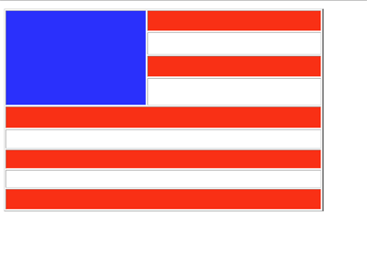
Project Details:
- Create 4 html pages and each one will need a separate table as described above.
- Name each file: table1, table2, table3, and table4.
- The last page will need the most complex table that looks like the flag.
- The last table will need to make use of colspan and rowspan attributes.
- Use background colors for the table cells. At this time do not use images or CSS.
- Hand code the xhtml.

Submission
Submit the project by Friday, January 18th

