1 Scope
The dimensions of a tire, including static spring rate and static loaded radius, are functions of tire construction, compound, and design. These properties may be found at various application conditions and influence tire/vehicle clearances, bumper heights and vehicle ride. The quantification of these properties is very important to both vehicle design and tire selection since these properties will indicate a tire's response to certain inputs on the road surface and are therefore required in meeting the demands of tire development process, vehicle simulation and integration of chassis systems.
Note: Nothing in the specification supersedes applicable laws and regulations unless specific exemption has been obtained.
Note: In the event of conflict between the English and domestic language, the English language shall take precedence.

1.1 Purpose. This document describes the test equipment requirements and test methodology for measuring static dimensions of a given tire to support the corporate vehicle simulation models and the tire validation process.

1.2 Forward. Dimension parameters covered by this procedure include section width (SW), outer diameter (OD), loaded section width (LSW), static loaded radius (SLR) and static spring rate (SSR).

1.3 Applicability. Passenger car, compact spare, and light truck tires.

2 References
Note: Only the latest approved standards are applicable unless otherwise specified.

2.1 External Standards/Specifications.
SAE J670E
Tire and Rim Association Yearbook

2.2 GM Standards/Specifications.
GM Engineering Report # 55825
GM Engineering Report #PG067698

2.3 Additional References.
None

Tire and Rim Association Yearbook The Tire and Rim Association Inc., 3200 W. Market Street, Akron, Ohio 44313, current year. Vehicle Dynamic Terminology, SAE J670e, Society of Automotive Engineers, Warrendale, Pennsylvania. GM enigineering report 55825, Evaluation of Michelin Tire Radial Load deflection Model, Jay Prestage & Nancy Ebert. GM engineering report PG067698, Mathematical Modeling of Radial Load deflection Behavior in Tires, David M. Cummings, August 1997.

3 Resources

3.1 Facilities.

3.2 Equipment.

3.2.1 The following equipment is required for the Outer Diameter, Section Width, Loaded Section Width and Static Spring Rate and Static Load Radius tests.

3.2.1.1 A π tape for measuring the Outer Diameter from a circumferential measurement, 0.1 mm incremental scale, or other suitable device.

3.2.1.2 Tire inflation gauge or regulated pressure system, accuracy of ± 2 kPa (±0.5 psi).

3.2.1.3 Vernier calipers, digital calipers, dial calipers or inside/outside joint caliper, non-contacting optical measurement device, or other suitable device.

3.2.1.4 A measuring rule to determine the caliper opening if using inside outside joint calipers, smallest scale division shall be no greater than 0.5 mm incremental scale. Accuracy of the scale should be within 0.25 mm. These requirements also apply to vernier, digital and dial calipers.

3.2.2 Additional equipment is required for the Loaded Section Width, Static Spring Rate and Static Loaded Radius.
3.2.2.1 Load frame with displacement rate control accurate to ±1 mm/minute. Displacement rate of machine used for testing should be documented.
3.2.2.2 Data acquisition system or X-Y recorder for recording force and displacement.

3.3 Test Vehicle/Test Piece.

3.3.1 Tires of specified nominal size, meeting dimensional requirements of T&RA or ETRTO.
3.3.2 The wheel must meet T&RA or ETRTO dimensional requirements for the specified tire.

3.4 Test Time.
Calendar time: | 2 days
Test hours: | 26 hours
Coordination hours: | <1 hour

Note: “Calendar time” is the overall time from start to finish assuming the parts are available. “Test hours” is the actual time for test setup, test execution, and test breakdown. “Coordination time is the time for coordinating the test request, part procurement, part modification, analysis, and part disposition.

3.5 Test Required Information. Not Applicable

3.6 Personnel/Skills. Not Applicable

4 Procedure

4.1 Preparation. Use the following preparation for all three tests; 4.3.3 Section Width and Outer Diameter for an Unloaded Tire, 4.3.4 Loaded Section Width, and 4.3.5 Static Loaded Radius and Static Spring Rate.

4.1.1 Sample Preparation. The test tire must be free of all tags, tape, stones and other foreign objects.

4.1.1 Wheel: The wheel must meet T&RA or ETRTO dimensional requirements for the specified tire. The wheel width must also conform to that which is stated in the work request.

4.1.2 The tire bead must be lubricated prior to mounting.

4.1.3 Mount the tire on the wheel using RMA recommended practice. Never inflate a tire over 275 kPa (40 psi) to seat the beads.
4.1.4 Inflate to the first test inflation pressure. See Table A1 in Appendix A for test pressures. Note: the order in which pressures are tested is unimportant, however, it is more efficient to test at the highest pressure first due to the required pre-loading specified in 4.3.1.

4.1.5 Mark reference position on the tire sidewall.

4.1.5.1 For tires with DOT marking, select and mark the O in the DOT as the reference point.

4.1.5.2 If the tire does not have a DOT marking select a location that can easily be found as the reference point.

4.1.6 Mark additional measurement locations at equally spaced intervals around the tire circumference. A minimum of four (4) measurement locations are required.

4.1.7 Allow inflated tire to stand at least 24 hours at ambient test temperature.

4.2 Conditions.
4.2.1 Environmental Conditions. Ambient temperature: 24° ± 3° C
4.2.2 Tires standardized by an organization other than T&RA and ETRTO are to be tested at the same inflation pressure as the equivalent T&RA and ETRTO size.
4.2.3 Deviations from the requirements of the procedure shall have been agreed upon. Such requirements shall be specified on component drawings, test certificates, reports, etc.

4.2.4 Test Inflation Pressures.

4.2.4.1 Table A1 in Appendix A outlines the inflation pressures for testing based on tire type, load range and sidewall pressure.

4.2.1 Load Deflection Inflation: Load deflection cycles must be run at these pressures

4.2.1 TPC Inflation: Measure OD, SW, LSW at these pressures. The measurements along with the calculated SLR and SSR will be put into the TPC file.

4.2.4.2 Capped Inflation Pressure. All tests under load should use an inflation pressure set while the tire is loaded to 80% of the Tire Load Limit as defined in the glossary section.

4.2.4.2.1 The primary method to set the capped inflation pressure is to load the tire to 80% of T&RA or ETRTO rated load for the test condition, and inflate the tire to test inflation pressure.

4.2.4.2.2 Alternatively, to avoid the need to load the tire to 80% load, the measured pressure channel can be used to determine the exact pressure at 80% load during the test.

4.2.4.2.2.1 An electronic pressure transducer is required to measure the actual tire pressure during the test. If the 80% capped pressure is determined to be more than ± 5 kPa from the required test pressure the data is invalid.

4.2.4.2.2.2 Some experience may be necessary to determine the expected unloaded pressure to achieve an acceptable 80% capped pressure.

4.2.4.2.2.3 This alternative method requires that the actual measured 80% capped pressure be measured dynamically and used in the Michelin-Haas analysis.
4.2.5 Test Loads.
4.2.5.1 Table A2 in Appendix A outlines the test loading conditions.
4.3 Instructions.
4.3.1 Preloading. For LSW, SLR, and SSR measurements, the tire must be preloaded prior to taking measurements.
Align the reference location against the loading platform.
Load tire from zero to the test load for the highest test inflation pressure and unload as a preconditioning step.
Repeat at least one more time.
4.3.2 The remaining instructions are broken up into 3 segments that can be performed individually or in conjunction with each other.

4.3.3 Section Width (SW) and Outer Diameter (OD) of an Unloaded Tire.

4.3.3.1 If measuring OD as first segment in test, readjust inflation to first test inflation pressure set in 4.1.4, and cap the pressure as stated in 4.2.4.2.

4.3.3.2 Measure and record the Outer Diameter of tire by measuring the maximum circumference and converting to Outer Diameter or other equivalent means.

4.3.3.3 Measure and record the section width of tire at locations specified in step 4.1.6 starting at the reference location. Avoid raised letters, protective side ribs, bars, or decorations.

4.3.3.3.1 When a caliper device is used, adjust for a slight drag when drawn over the widest section

4.3.3.3.2 If using other than digital or vernier calipers, measure the caliper width with a measuring rule.
4.3.3.4 Repeat the OD, and SW measurements for each test inflation pressure.

4.3.4 Loaded Section Width (LSW).

4.3.4.1 If measuring LSW as first segment in test, readjust inflation to first test inflation pressure set in 4.1.4, and cap the pressure as stated in 4.2.4.2.

4.3.4.2 Mount tire/wheel assembly in the load frame with reference location against the loading surface.

4.3.4.3 Measure and record the loaded section width of tire, complying with 4.3.3.3.

4.3.4.4 Dismount the tire, rotate, and remount tire/wheel assembly with the next reference location against the loading surface to measure the remaining locations specified in section 4.1.6.
4.3.4.5 Repeat the LSW measurement for each test inflation pressure and for each pressure.

4.3.5 Static Loaded Radius (SLR) and Static Spring Rate (SSR).

4.3.5.1 Required displacement rate is 30 mm/minute ± 1 mm/minute.

4.3.5.2 Mount tire/wheel assembly in the load frame.

4.3.5.3 If measuring SLR and SSR as first segment in test, readjust inflation to first test inflation pressure set in 4.1.4, and cap the pressure as stated in 4.2.4.2.

4.3.5.4 If OD is required for determining SLR, measure and record OD at test inflation pressure.

4.3.5.5 Use approved method to zero the load and deflection of the tire. Zero deflection should coincide with zero load. This can be done at the time of test or in the data processing.

4.3.5.5.1 If a visual method is used to determine when the tire begins to touch the loading surface, the load on the tire at zero deflection should not exceed 10N.

4.3.5.5.2 Another method requires starting the tire a short distance above the contact surface (10 to 200 mm) and determining the contact point mathematically as described in section 5.1.4.2.

4.3.4.6.2 If using TWS LDP program to run analysis the tire must be elevated from test surface minimum 5 millimeters and any digital measuring device must be zeroed at this position.

4.3.5.6 Without changing tire orientation used during preloading, follow either of the following steps depending on the type of test that is requested. Do not conduct Standard Load-Deflection Tests and Deflection-to-Rim Tests on ETRTO tires unless specifically requested by the requesting Tire Engineer.

Should these also be in 4.3 instructions section?

4.3.5.6.1 Standard Load-Deflection Test. Load tire to at least 140% of the T&RA or ETRTO load, without exceeding 200% T&RA Load, for the test inflation pressure at the rate specified in 4.3.5.1 while recording load and deflection. , Include data collection rate.

4.3.5.6.2 Deflect-to-Rim Test (GM internal test option). Load the tire according to 4.3.5.6.1 except continue to load the tire until wheel flange is approximately 2 cm from test surface, this will vary change depending on tire type, tread thickness etc., or until enough number of points have been collected at specified deflection rate while recording load and deflection, making sure that tire/wheel is not damaged. If acquired data is plotted real-time, the slope of the plot will change significantly and can serve as a notification when rim contact occurs.
Note: If additional testing is to be conducted on test tire after deflect-to-rim testing, it should be inspected after deflect-to-rim testing as localized irreparable damage and/or material separation can occur.

4.3.5.7 Unload tire.

4.3.5.8 Reset inflation pressure to the next sequential test inflation pressure, cap the pressure as stated in 4.2.4.2 and repeat steps 4.3.5.4 through 4.3.5.7 for all additional test inflation pressures.

5 Data

5.1 Calculations.
5.1.1 The following calculations are provided as one solution to obtaining the reported values in 5.3. However, to increase certainty of correlation to GM, it is recommended the calculations are made as specified in this document.

5.1.2 OD and SW of an Unloaded Tire and LSW of a Loaded Tire.

5.1.2.1 Calculate the mean of the SW and LSW measurements that were taken at each reference location at each pressure (obtained in steps 4.3.3.3 and 4.3.4.3 respectively.) The calculated means are to be the reported data values for each pressure.

5.1.3 Michelin-Haas Tire Model.

5.1.3.1 The Michelin-Haas equation is used in modeling tire load-deflection behavior over the range of operating loads and pressures. The Michelin-Haas Equation is fitted to 56 equally spaced data points to obtain the A, B, and C coefficients to properly define load deflection behavior of the tire. Michelin-Haas equation is given as follows:
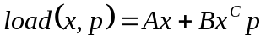
where A, B, C are coefficients. The slope of Michelin-Haas gives the rate of change of load per unit distance, Static Spring Rate (SSR)
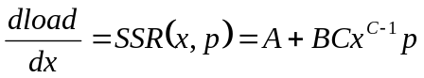
where,
load = Vertical Load (N)
x = Deflection (mm)
p = Inflation Pressure (kPa), capped at 80%
T&RA or ETRTO load
SSR = Static Spring Rate (N/mm)
The Static Loaded Radius (SLR) is given by
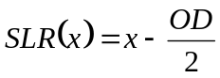

5.1.4 Data Conditioning (Optional). Data Conditioning is only done if necessary to provide results that correlate to GM. If data is already smooth and if the zero point of the load-deflection cycle is already known, these steps are not required. The methodology used for processing GMNA data and is provided as reference.

5.1.4.1 Smoothing. To produce adequate accuracy of calculations, recorded data may need smoothing. The method described here uses a 10-point moving average as shown in Figure B1 in Appendix B. Every calculation from this point on will be done using the smoothed data.

5.1.4.2 Determining the True Origin. True origin (0,0) is defined as the point, on load-deflection graph, at which the tire has just contacted the surface after which loading begins. This point must be determined by an approved method that results in accuracy of 0.5 mm. The origin is determined by the following steps.

5.1.4.2.1 Mean load and standard deviation (σ) must be calculated from load values that have matching deflection values between 0 and 4 mm. Figure B2, label 1.

5.1.4.2.2 Add (N × σ) to the mean load, N is initially set to 3, and pick first 20 points with load values above (N × σ) and deflection values above 4 mm deflection. Figure B2, label 2.

5.1.4.2.3 Fit a second order curve to the selected 20 points using a standard regression technique. Figure B2, label 3.

5.1.4.2.4 Calculate the R² value of the fit from step 5.1.4.2.3. If R² value is less than 0.95 (95%) increase N by 0.5 and repeat steps 5.1.4.2.2. through 5.1.4.2.4.

5.1.4.2.5 When the selected 20 points satisfy R² > 95%, find the intersection of the fitted curve and the average load. This point will be considered as true origin. Figure B2, label 4.

5.1.4.3 Translate original data to (0,0). Subtract the load and deflection values of the intersection found in step 5.1.4.2.5 from each data point greater than the average load and corresponding deflection value greater than the intersection point, This process is called translating and the data points are referred to as translated data, Figure B2, label 5.

5.1.5 Standard Load-Deflection Analysis (required).

5.1.5.1 Determine Michelin-Haas Coefficients. Coefficients of the Michelin-Haas Equation are determined using an appropriate regression technique with load and deflection data from all inflation pressures tested. Load and deflection values corresponding to individual test pressures must be regressed together at the same time. If the tire was tested at three different pressures, 3 different sets of load-deflection values should be used in the regression.

5.1.5.1.1 Unless otherwise specified by the test request, translated data points between 30% and 140% of T&RA or ETRTO tire load limit corresponding to each test inflation pressure should be used for the regression analysis for a standard load-deflection test.

5.1.5.1.2 LDP uses following steps to calculate A, B, C Coefficients. Variations from this methodology need to be approved by GM.

5.1.5.1.2 Select 56 evenly spaced points in the load range determined in step 5.1.5.1.1 for each of the tested pressures, this value will be called m.
5.1.5.1.2.1 The number of data points is arbitrary, 56 is used by GMNA.

5.1.5.1.3 Assign arbitrary values to A, B, C and calculate load through the Michelin-Haas equation using the deflection values of the 56 points.

5.1.5.1.4 Calculate the % error for each point
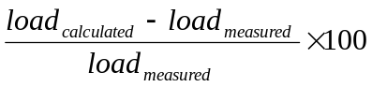
5.1.5.1.5 Sum the absolute values of the % error calculated for all points and pressures, this value will be called error_{overall}.

5.1.5.1.6 Use the Solver Add-In in Microsoft Excel (or other suitable optimization routine) to minimize overall calculated error by changing A, B, C values. Solver is activated and run programmatically in LDP,

5.1.5.1.6.1 The Solver Add-In utilizes a routine called Generalized Reduced Gradient.
5.1.5.1.6.2 The following is a description of the Solver parameters:
- ‘Set Target Cell’: This points to overall calculated error from 5.1.5.1.5
- ‘Equal to’: set to ‘Min’
- ‘By Changing Cells’: This points to the three cells that contain A, B, C coefficient values.
Once Solver arrives at a solution, the resulting A, B, and C values are the Michelin-Haas coefficients that will be used to calculate SLR and SSR values.

5.1.5.1.7 Calculate mean fit error as follows

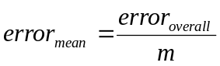

by dividing the overall calculated error by the total number of points, where Total Number Of Points = Number Of Pressures Tested x 56.

5.1.5.1.8 Report A, B, C, and error_{mean}.

5.1.5.2 SLR and SSR of a Loaded Tire. Calculate SLR and SSR at inflation pressures per Appendix A, by using the Michelin-Haas equations with coefficients calculated in step 5.1.5.1.6.2.

5.1.5.2.1 In order to calculate SSR and SLR for a given load and pressure, the deflection at the desired the load and pressure must be known. Since load is given as function of deflection and pressure, deflection must be iterated until the desired load is achieved with an accuracy of 0.001 N. Use the Newton-Raphson method to calculate deflection at a given load and pressure which given as:
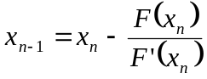
Note: With an initial estimate (x_{o}) equal to 20.

5.1.5.2.1.1 Use SSR equation from 5.1.3.1 with calculated A, B, and C coefficients and the deflection value (x) calculated in step 5.1.5.2.1 to calculate SSR’s at each test pressure and loads as specified in Appendix A.

5.1.5.2.1.2 Calculate SLR by using the SLR equation from 5.1.3.1 and deflection value (x) calculated in step 5.1.5.2.1. from Outer Diameter / 2 for the pressure of interest

5.1.5.2.1.3 The reporting loads for SLR are 70% and 100% T&RA or ETRTO. The reporting loads for SSR are 50% and 80% T&RA or ETRTO.

5.1.6 Deflect-to-Rim Analysis, (required if Deflect-to-Rim test was conducted).

5.1.6.1 Finding the Critical Point. For each test inflation pressure, fit a second order curve of the form

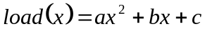

where a, b, and c are constants and x is deflection (mm) starting from the last point recorded through N^{th} point from the last. N is initially set to 100. The value of N may need to be adjusted depending on the data acquisition rate of the load frame. The value of N should be large enough to cover all the data points to encompass the bend on the load deflection curve that occurs when the rim contacts the load surface. Calculate R² value of the fit of the curve.

5.1.6.1.1 If R² calculated in step 5.1.6.1 is less than 99.95%, consider the fit unacceptable and subtract 10 from N and repeat fit. Keep repeating until R² is less than 99.95%.

5.1.6.2 Fit a second order curve of the form

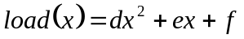

where d, e, and f are constants and x is deflection (mm) starting from 140% load point through Mth point from 140% load point. M is initially set to 1000. The value of M may need to be adjusted depending on the data acquisition rate of the load frame. The value of M should be large enough to cover all the data points to encompass the bend on the load deflection curve that occurs when the rim contacts the load surface.

5.1.6.2.1 Calculate R² value of the fit of the curve fit.

5.1.6.2.2 If R² calculated in step 5.1.6.2.1 is less than 99.99%, consider the fit unacceptable and subtract 10 from M and repeat fit. Keep repeating until R² is less than 99.99%.

5.1.6.3 Find the intersection of the two acceptable 2nd order curves fitted in steps 5.1.6.1 and 5.1.6.2 The intersection of the two 2nd order curves will be used to determine the Critical Point, let the coordinates of the intersection point be (x_{intersection}, y_{intersection})

5.1.6.4 Find the roots of the equation in the form of
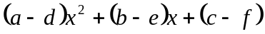

5.1.6.5 Pick the root that is between 140% T&RA or ETRTO Load and the last load value in the data file. The chosen root is the load value of the intersection point.

5.1.6.6 Find the deflection corresponding to the load value of the intersection point by using load in either one of the equations found in step 5.1.6.1 or 5.1.6.2.
5.1.6.7 Figure B3 in Appendix B shows this process graphically.

5.1.6.8 Starting from 140% load until the last data point in the data, calculate the distance of the data point from the intersection point by using
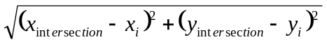
Where the coordinate (x_{i}, y_{i}) is the current data point and (x_{intersection}, y_{intersection}) is the intersection point.

5.1.6.9 Chose the data point with the smallest distance value as the critical point. Data point with the smallest distance implies that it is the closest to the intersection point. Record the load and deflection at this point, for each pressure.

5.1.6.10 Select 56 points between 30% and Critical Point load values with equal increments; record load and deflection values.

5.1.6.11 Follow steps 5.1.5.1.3 through 5.1.5.2.1.2 ignoring specific directions for Standard Load Deflection Test.

5.1.6.7 Using the same increment calculated in Step 5.2.3.5., gather points starting from Critical Point until the end of the data. This data will be used to fit a linear trend line for points above the critical point.
5.1.6.12 Fit a linear trend line using the points selected in 5.1.6.5 from the critical point to the end of the data (the rim-contact portion of the curve) for each pressure. Record the trend line equation for each pressure.

5.1.6.8 Fit linear trend line only on the data recorded in step 5.2.3.7. for individual test pressures.

5.1.6.8 Repeat 5.2.3.7. for all pressures tested as specified in Test Conditions Section.

5.1.6.9 Report the trend line equation, load and deflection values that correspond to the Critical Point in compliance with Section 10 for each pressure tested.

5.2 Interpretation of Results. Not Applicable

5.3 Test Documentation.
5.3.1 Appendix C contains example output plots for a standard load deflection test (Appendix C1) and a deflect-to-rim test (Appendix C2). These plots are not required from suppliers.
5.3.2 For each tested tire and all reported pressures listed in Table A1 in Appendix A, the following values should be reported
- Pressure Tested
- 100% T&RA or ETRTO load*
- Outer Diameter
- Section Width
- Loaded Section Width
- Static Loaded Radius at 70% T&RA or ETRTO load (use Michelin-Haas equation to determine this value)
- Static Loaded Radius at 100% T&RA or ETRTO load (use Michelin-Haas equation to determine this value)
- Static Spring Rate at 50% T&RA or ETRTO load (use Michelin-Haas equation to determine this value)
- Static Spring Rate at 80% T&RA or ETRTO load (use Michelin-Haas equation to determine this value)
*use T&RA or ETRTO specs as required for each test tire.
Record any additional test parameters according to local region specifications. Several additional pertinent parameters and general tire information parameters are specified in Appendix D as reference. For GMNA testing, contact the Tire and Wheel Systems Department for data format specifications.

5.3.1 Create TPC data file according to the required file format outlined in section 8.4. Leave blank lines for data that is not to be provided.

5.3.2 Create DAT file using the conditioned load-deflection-pressure data points.

5.3.2.1 Sample smoothed raw data at the same interval used to select 56 data points between 30 and 140% load.

5.3.2.1 If pressure is NOT measured dynamically during the test, each pressure field should contain the inflation pressure capped at 80% T&RA or ETRTO load.

5.3.3 Create Analysis Report GM Internal Analysis ONLY

5.3.3.1 Fields to be presented on the analysis report, all fields must comply with TPC file formats.

5.3.3.2 Test Specific Data

Tire Size. Tire size must be presented with service description, for example LT225/75R16 110/107R
Construction Number
Tire Type
Load Rating
Supplier
Rim Width

5.3.3.3 Tire Specific Data
Tire ID
Test Date
Work Request Number
DOT Number
Purpose
Requester
Location
Tester, Group testing the tire not the operator, example TWS

5.3.3.3 Tire Specific Analysis Results
Pressure Tested
Tire ID
Test Date
100% T&RA Load
Outer Diameter
Section Width
Loaded Section Width
Static Loaded Radius at 70% T&RA or ETRTO Load
Static Loaded Radius at 100% T&RA or ETRTO Load
Static Spring Rate at 50% T&RA or ETRTO Load
Static Spring Rate at 80% T&RA or ETRTO Load

5.3.3.4 Tire Specific Michelin-Haas Equation Coefficients
Tire ID
Test Date
A, B, C Coefficients
Percent Error

5.3.3.5 Plot of Load Deflection Curve Range of Michelin-Haas Fit (Example: “Curve fit between 30% and 140% T&RA Load”) Linear fit equations for individual pressures tested for deflect to rim tests. Critical points at each tested pressure

5.3.3.5.1 Appendix C shows example reports for a single tire on a standard load deflection test and another tire on a deflect-to-rim test.

5.3.3.5.2 Appendix A2 shows an example report for a single tire on a deflect to rim test.

5.3.3.5.3 Appendix A3 shows an example report for a multi-tire composite analysis. Additional parameter to report for composite reports, more than one tire tested for a work request, are:
Average Values
Composite Michelin-Haas Equation Coefficients
Composite Fit Error

6 Safety
This procedure may involve hazardous materials, operations, and equipment. This method does not propose to address all the safety problems associated with its use. It is the responsibility of the user of the method to establish appropriate safety and health practices and determine the applicability of regulatory limitations prior to use.

7 Notes

7.1 Glossary.
Capped Inflation Pressure: The process of inflating the tire to a specified test pressure at a given load and ambient temperature and allowing the inflation to change as test conditions vary.
Commercial Truck Tire: A tire developed primarily for use on commercial trucks.
Critical Point: The point on a load-deflection graph, from a deflect to rim test, where the tire deflection goes beyond pneumatic properties and the wheel flange starts compressing beads, tread and/or sidewalls of the tire.
Light Truck Tire: A tire developed primarily for use on light trucks. Light truck tires classified by T&RA are commonly referred to as LT-Metric tires.
LDP: The GM Analysis program used to calculate and report tire dimensions from load-deflection test data. (moved to section 7.2)
Load Range: For P-Metric tires this is either LL, SL, or EL. For Hard-Metric tires this is either S or E. For LT tires this is C, D or E.
Loaded Section Width (LSW): The section width of a loaded tire including normal sidewalls, excluding protective side ribs, bars or decorations.
Maximum Sidewall Pressure: This is the maximum allowable cold pressure value molded into the sidewall of the tire.
Maximum Tire Load: This is the maximum load the tire can carry at the maximum sidewall pressure. This is the value molded into the side of the tire.
Outer Diameter (OD): The diameter of an unloaded tire, determined by measuring the maximum circumference and dividing by π, or other equivalent method.
Passenger Car Tire: A tire developed primarily for use on passenger cars. Passenger car tires classified by T&RA are commonly referred to as P-Metric tires, passenger car tire classified by ETRTO are commonly referred to as Hard Metric tires.
Section Width (SW): The width of an unloaded tire, including normal sidewalls, excluding protective side ribs, bars, or decorations.
Static Loaded Radius (SLR): The perpendicular distance from the wheel rotational axis centerline to the tire/road interface of a loaded, non-rotating tire.
Static Spring Rate (SSR): The rate of change of static loaded radius with change in vertical load.
Tire Load Limit (TLL): Refers to the load tables by the Tire and Rim Association Year Book or European Tyre and Rim Technical Organization for a specific respective tire size, type, load range and test condition pressure. At pressures below the maximum sidewall pressure this load can be less than the Maximum Tire Load. For example, the TLL for a P225/60R16 with a load range of ‘SL’ is 625kg at a test pressure of 180 kPa instead of max load of 730 kg (which occurs at 240 kPa).

7.2 Acronyms, Abbreviations, and Symbols.
CTS Component Technical Specifications
T&RA Tire and Rim Association
DOT Department of Transportation
EL Extra Load
ETRTO European Tyre and Rim Technical Organisation
OD Tire Outer Diameter
LDP Load-Deflection Program. The GM analysis program used to calculate and report tire dimensions from load-deflection test data.
LL Light Load
LSW Loaded Section Width
M (common algebra terminology
Nth (common algebra terminology
π Ratio of circumference to diameter
SAE Society of Automotive Engineers
SL Standard Load
SLR Tire Static Loaded Radius
SSR Tire Static Spring Rate
SW Tire Section Width
T&RA Tire and Rim Association
VTS Vehicle Technical Specifications

8 Coding System
This technical specification shall be referenced in other documents, drawings, VTS, CTS, etc. as follows:
Test to GMW14997

9 Release and Revisions

9.1 Release. This standard supercedes GM procedures T97DIM1, T97DIM3 and T97DIM4 for measuring tire dimensions.

This standard originated in Februay 2006. It was first approved by Global Chassis Center in February 2006. It was first published in February 2006.

9.2 Revisions. Not Applicable
Rev | Approval Date | Description (Organization)

TWS Tire and Wheel Systems Department
Appendix A: Test Conditions

Table A1: Test Pressure Conditions
Tire Type | Load Range | Sidewall Pressure (kPa) | Test Inflation Pressures (kPa) | Reported Inflation Pressures (kPa)
Passenger Car (P-Metric) | Light Load (LL) or Standard Load (SL) | 240 | 180, 240 | 180, 240
Passenger Car (P-Metric) | Light Load (LL) or Standard Load (SL) | 300 | 180, 240, 300 | 180, 240
Passenger Car (P-Metric) | Light Load (LL) or Standard Load (SL) | 350 | 180, 240, 350 | 180, 240, 350
Passenger Car (P-Metric) | Extra Load (XL) or REINFORCED | 280 | 220, 280 | 220, 280
Passenger Car (P-Metric) | Extra Load (XL) or REINFORCED | 340 | 220, 280, 340 | 220, 280, 340
Passenger Car (Hard Metric - ETRTO) | Standard Load | 290 | 180, 240, 290 | 180, 240
Passenger Car (Hard Metric - ETRTO) | Extra Load or REINFORCED | 340 | 220, 280, 340 | 220, 280, 340
Compact Spare | All | N/A | 420 | 420
Light Truck or Commercial | C | N/A | 250, 350 | 250, 350
Light Truck or Commercial | D | N/A | 250, 350, 450 | 250, 350, 450
Light Truck or Commercial | E | N/A | 250,350,450,550 | 250,350,450,550
Note:
- Order in which pressures are tested is not important
- Test Inflation Pressures are used in data analysis but only Reported Inflation Pressures are reported.

Table A2: Test Load Conditions
 |  | Load
Test Type | Standard Load Deflection Test | Continuous loading from 0% to at least 140% T&RA or ETRTO Load (Not to exceed 200% T&RA or ETRTO Load)
Test Type | Deflect-to-Rim Test | Continuous loading from 0% to slightly beyond rim contact load*
Measured Dimension | Loaded Section Width (LSW) | 100% T&RA or ETRTO Load corresponding to test inflation pressure
*Note: In order to have enough data for linear regression of the rim-contact load-deflection region of the data (see Figure C2 in Appendix C), loading must continue beyond rim contact, but before yielding of the test wheel. Some experience may be required to determine this point, as the actual load is dependant on the tire and wheel characteristics. GM suggests plotting load-deflection data dynamically so the operator can visually see the slope of the load deflection line change, indicating rim contact.

Appendix B: Data Analysis Figures

0
1
2
3
4
5
6
7
8
9
10
11
-100
-50
0
50
100
150
200
250
300
Load (N)
Deflection (mm)
Smoothed Data
Original Data
Figure B1: 10-point average smoothing of original data

0
1
2
3
4
5
6
7
0
50
100
150
200
250
300
350
Load (N)
Deflection (mm)
5) Translated Data
0) Normalized Data
1) Average Load between 0 and 4 mm
2) 20 Data points above Average + (N × σ)
3) Trend Line for 20 Points
4) Intersection
Figure B2: Determining True Origin

y = -5E-08x + 0.0031x + 25.489
R² = 0.9997
y = -3.4E-08x + 4.4E-03x – 2.6643
R² = 0.999912102
0
10
20
30
40
50
60
70
80
90
0
5000
10000
15000
20000
25000
30000
Original Data
Selected Points for Second-Order Trendlines
Second Order Trendlines
Intersection

Figure B3: Determining Critical Point
Appendix C: Example Data Reports
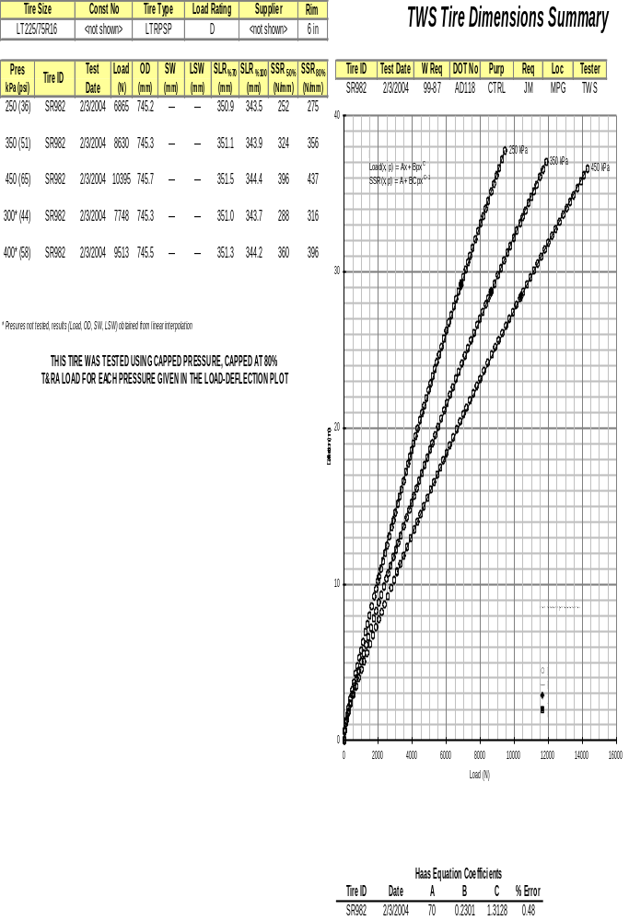
Figure C1. Standard Load Deflection Test Report

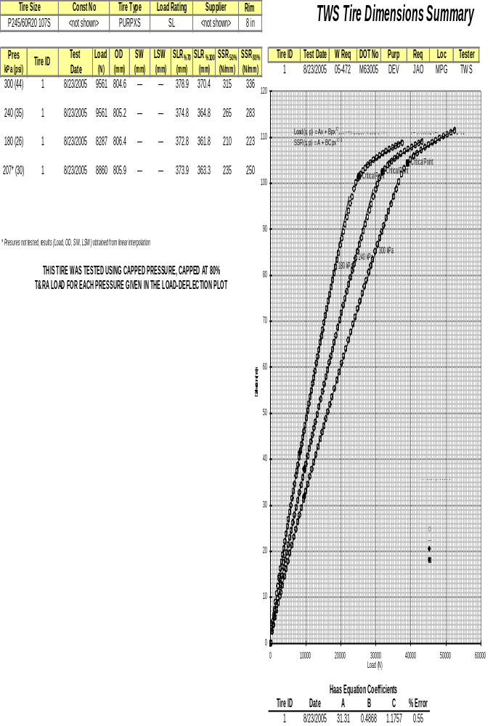
Figure C2: Deflect-to-Rim Test Report
Appendix D
Additional Values to Report
- Test Tire Information
  - Test Date
  - Tester
  - Test Location
  - Size
  - Load Rating
  - Supplier
  - Construction Number / Part Number
  - Tire ID
  - DOT Serial (located on tire sidewall, first 2 + last 4 characters, i.e., XX0361)
  - Rim Width (in.)
- Tire Specific Michelin-Haas Equation Results
  - A, B, C coefficients
  - Percent Error
- Deflect-to-Rim Results for Each Tested Pressure
  - Rim contact region fit equation
  - Load and deflection at critical point
- Data Sets for Each Tested Pressure
  - Load (N), deflection (mm), pressure (kPa) data for each of the 56 chosen data points
  - For a capped pressure test, if pressure is not measured dynamically during test, each pressure field should contain the inflation pressure capped at 80% T&RA or ETRTO load.
- Comments

