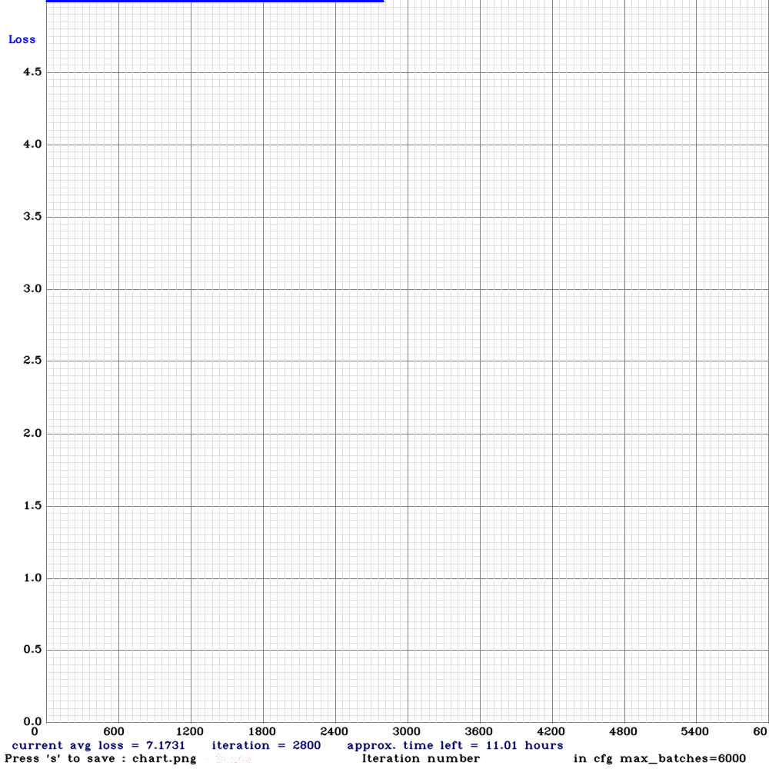

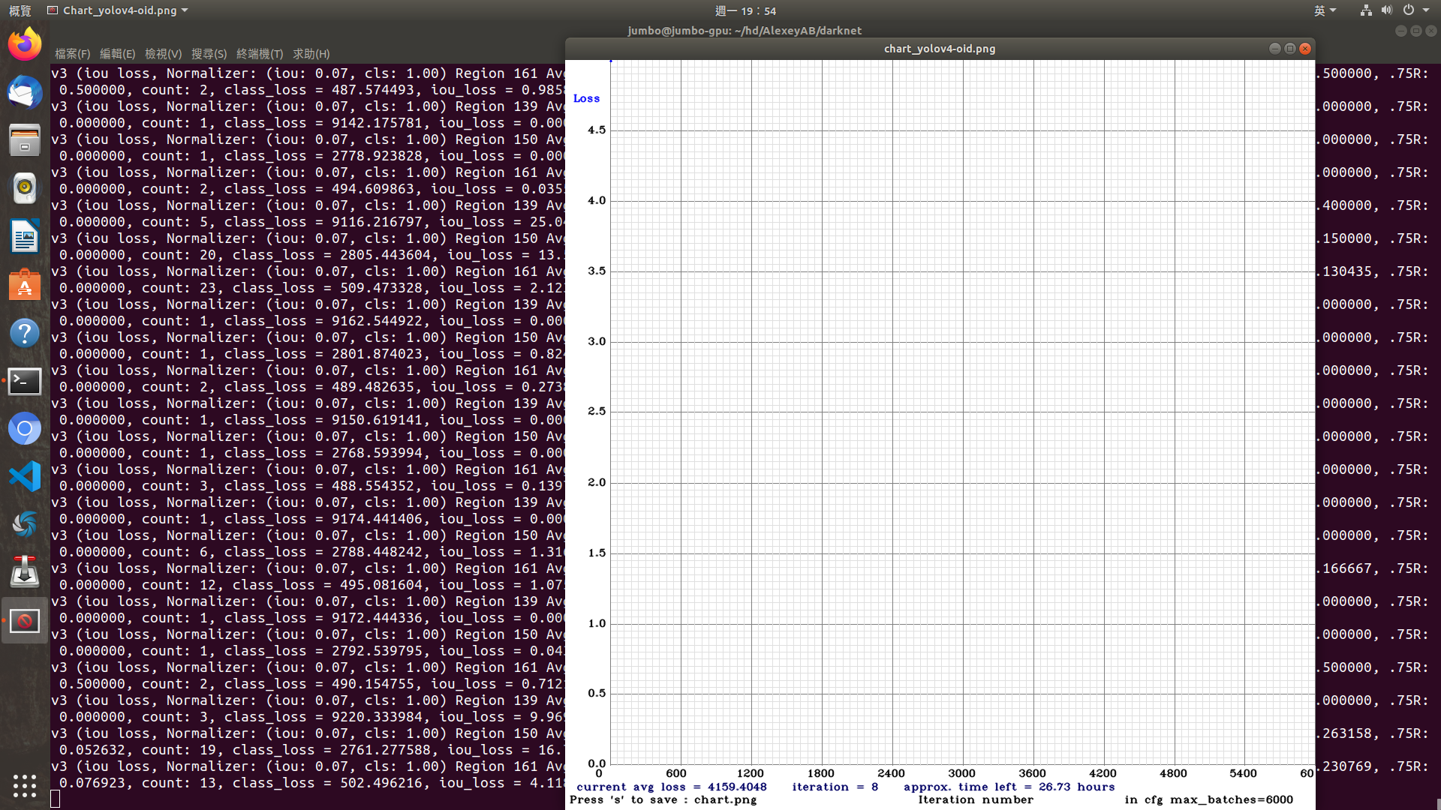

Enter Image Path: data/img/child5.jpg
data/img/child5.jpg: Predicted in 48.223000 milli-seconds.
Boy: 61%
Woman: 60%
Man: 54%
Woman: 44%
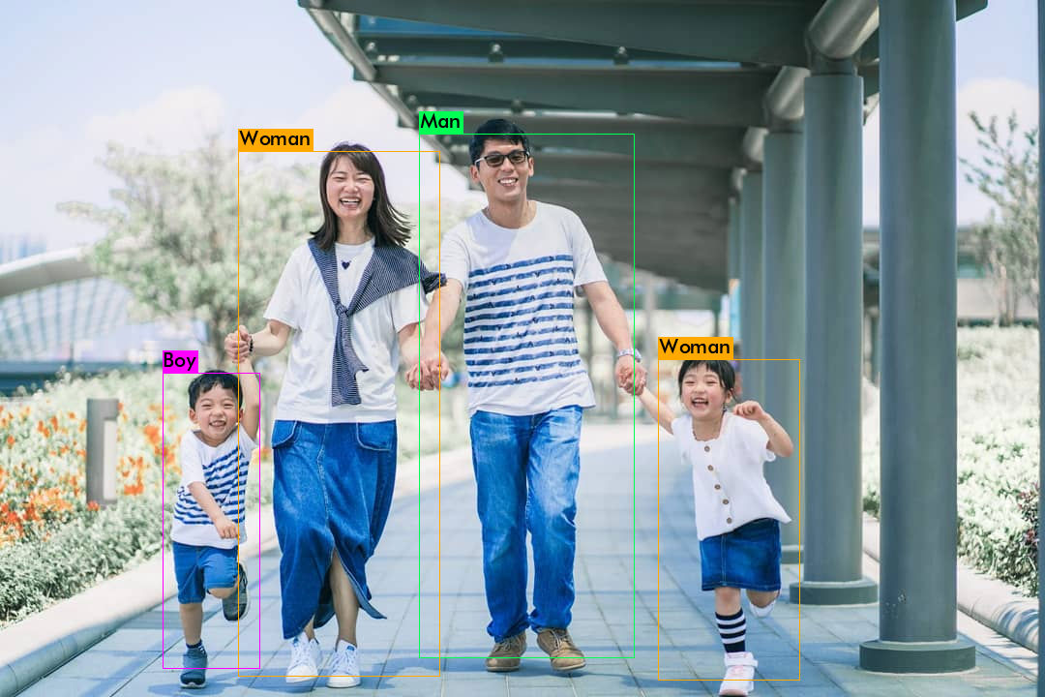
Enter Image Path: data/img/child1.jpg
data/img/child1.jpg: Predicted in 46.371000 milli-seconds.
Woman: 40%
Man: 29%
Boy: 51%
Woman: 55%
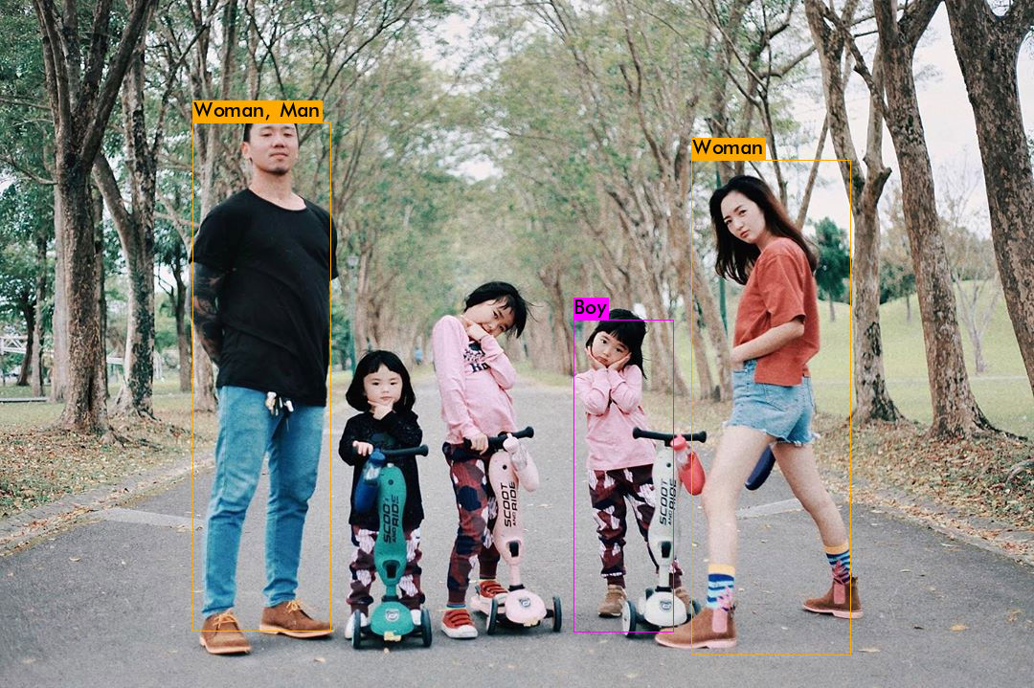
data/img/child2.jpg
Enter Image Path: data/img/child2.jpg: Predicted in 47.566000 milli-seconds.
Boy: 65%

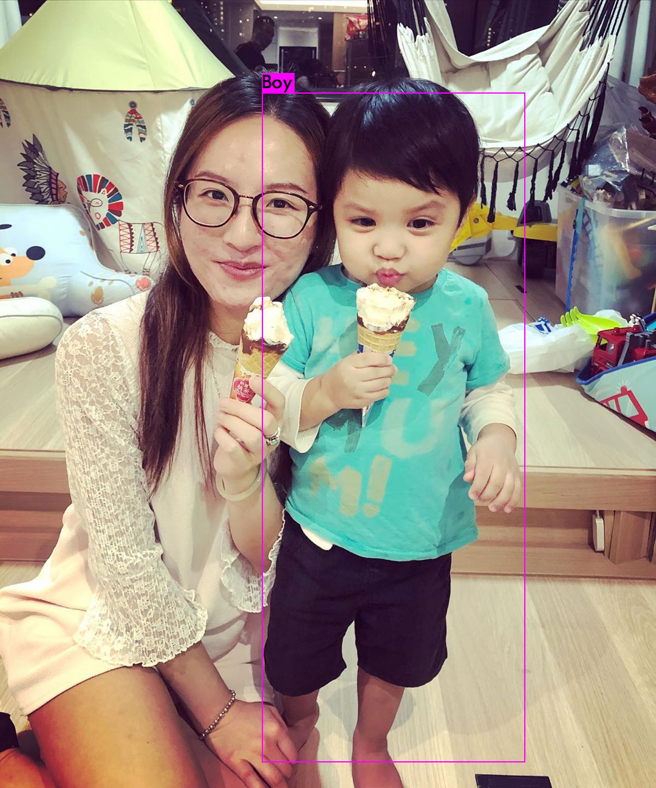
Enter Image Path: data/img/child3.jpg
data/img/child3.jpg: Predicted in 37.746000 milli-seconds.
Boy: 93%
Boy: 45%
Boy: 97%
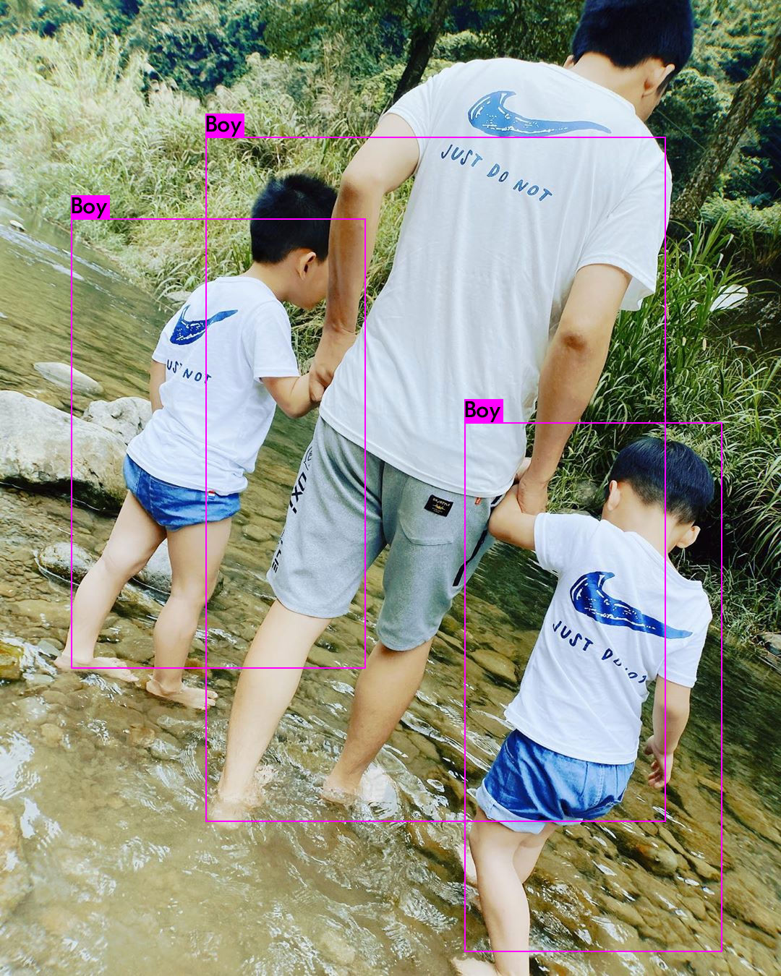
Enter Image Path: data/img/child4.jpg
data/img/child4.jpg: Predicted in 53.704000 milli-seconds.
Woman: 27%
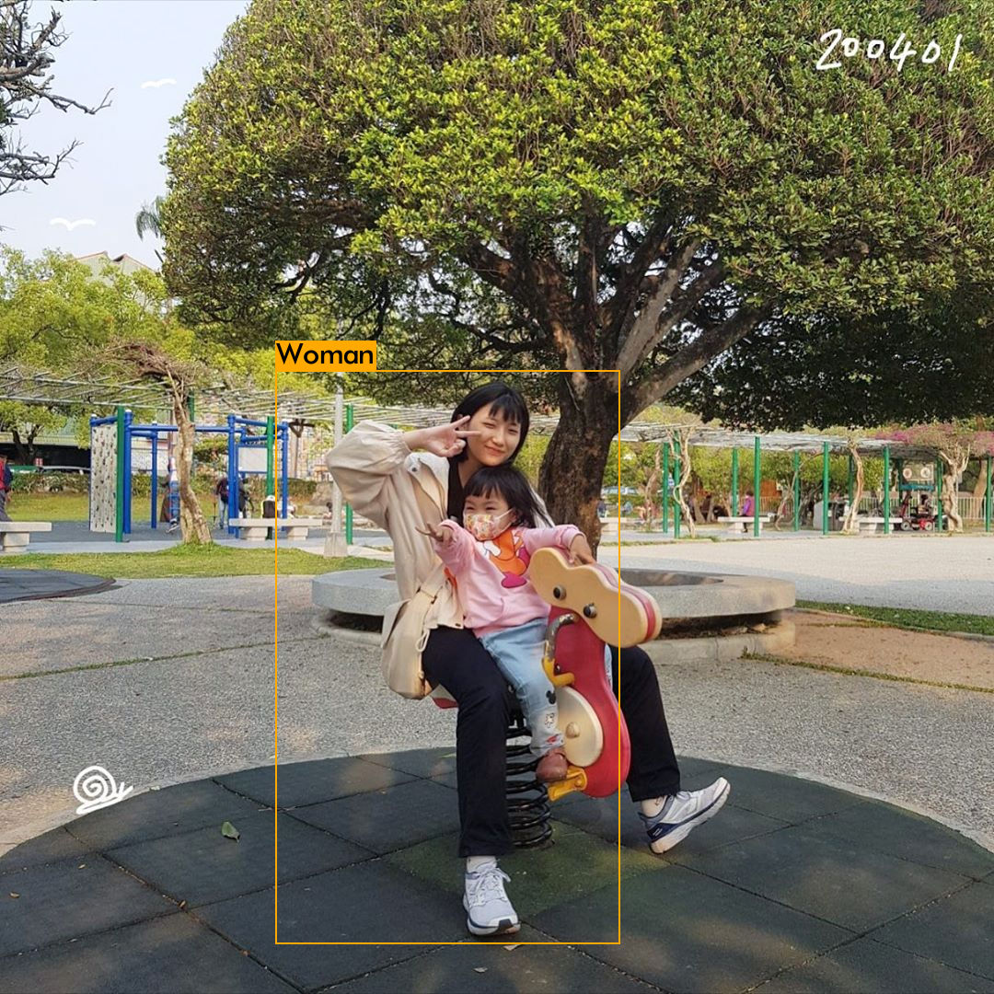
Enter Image Path: data/img/golf1.jpg
data/img/golf1.jpg: Predicted in 52.359000 milli-seconds.
Woman: 41%
Man: 58%
Man: 77%
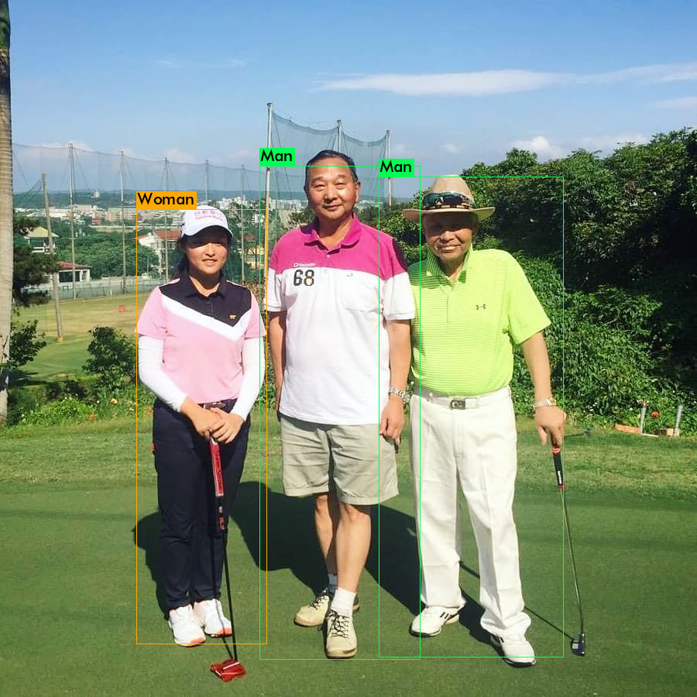
Enter Image Path: data/img/golf2.jpg
data/img/golf2.jpg: Predicted in 39.587000 milli-seconds.
Man: 43%
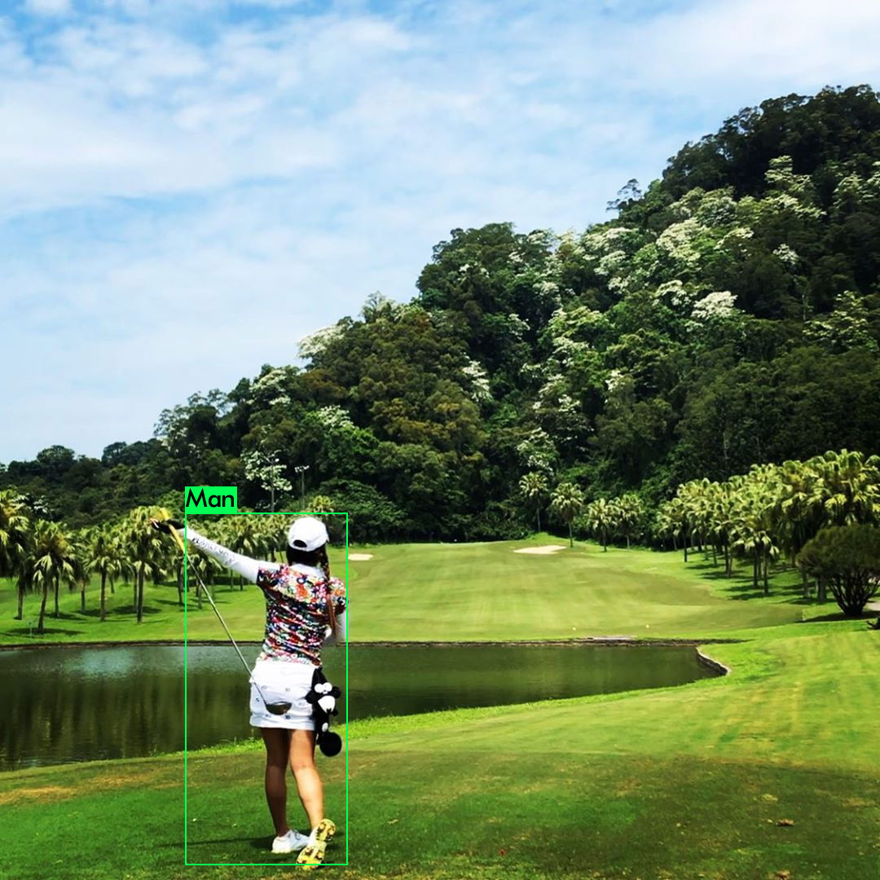
Enter Image Path: data/img/golf3.jpg
data/img/golf3.jpg: Predicted in 44.582000 milli-seconds.
Man: 63%
Man: 81%
Man: 86%
Man: 92%
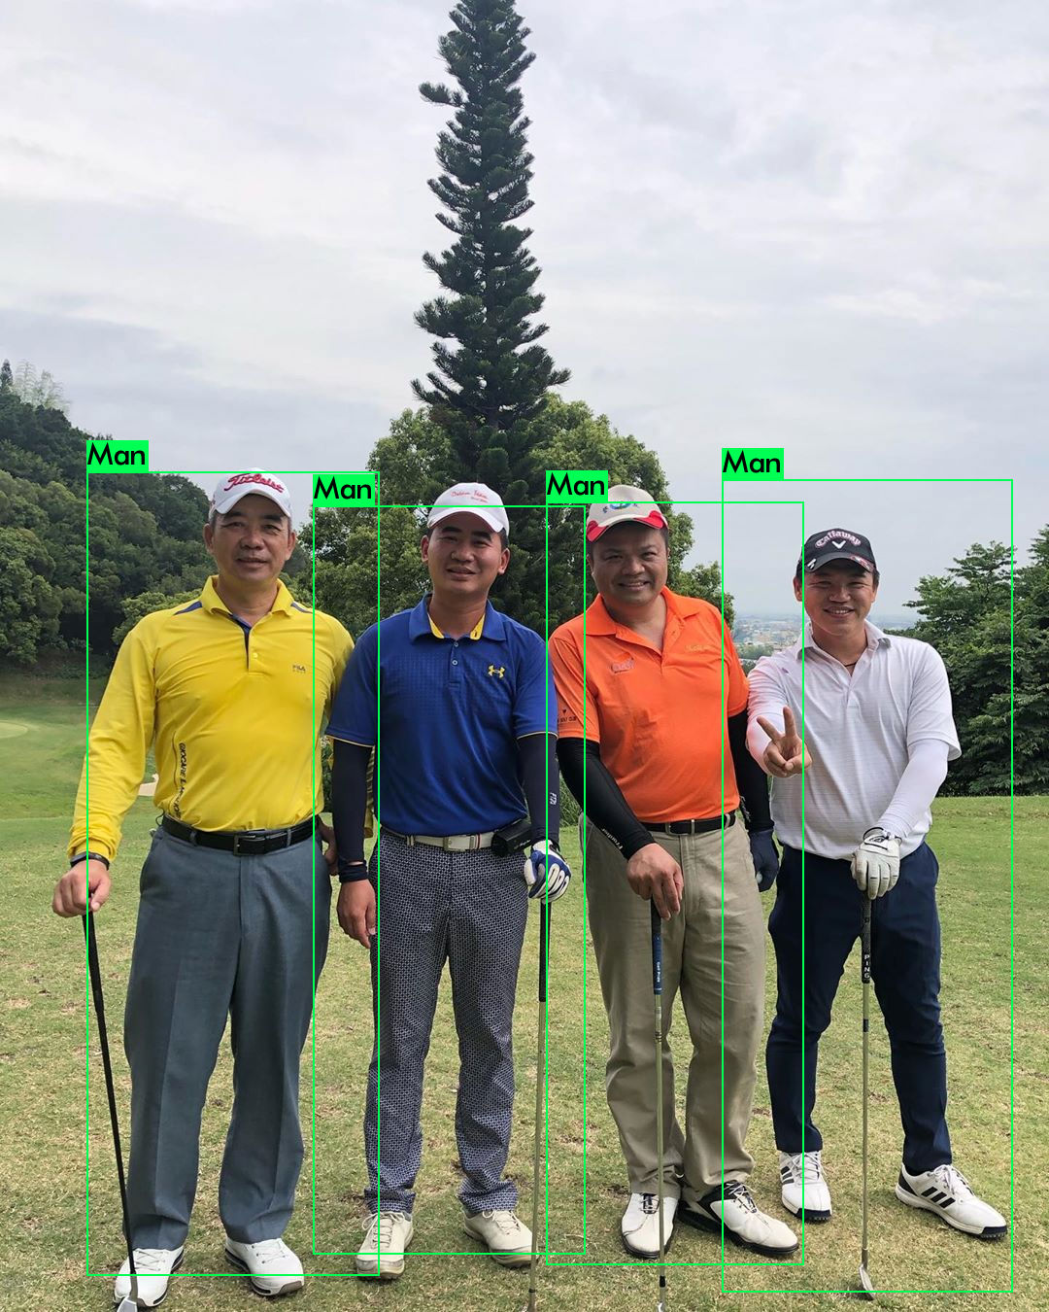
Enter Image Path: data/img/golf4.jpg
data/img/golf4.jpg: Predicted in 42.144000 milli-seconds.
Man: 90%
Man: 92%
Man: 91%
Man: 85%
