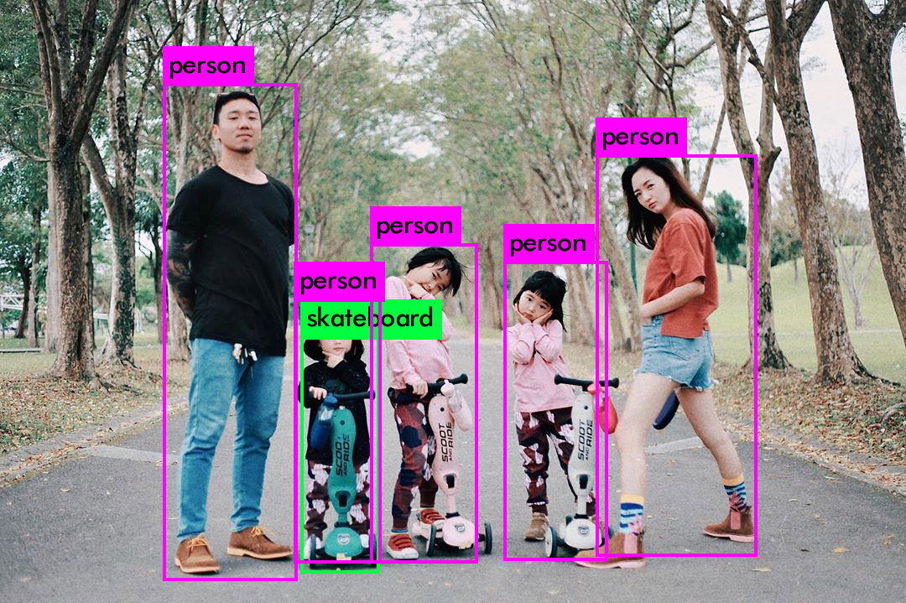
Loading weights from /home/jumbo/yolo/w/yolov3.weights...Done!
img/child1.jpg: Predicted in 14.118275 seconds.
skateboard: 63%
person: 100%
person: 100%
person: 99%
person: 96%
person: 92%

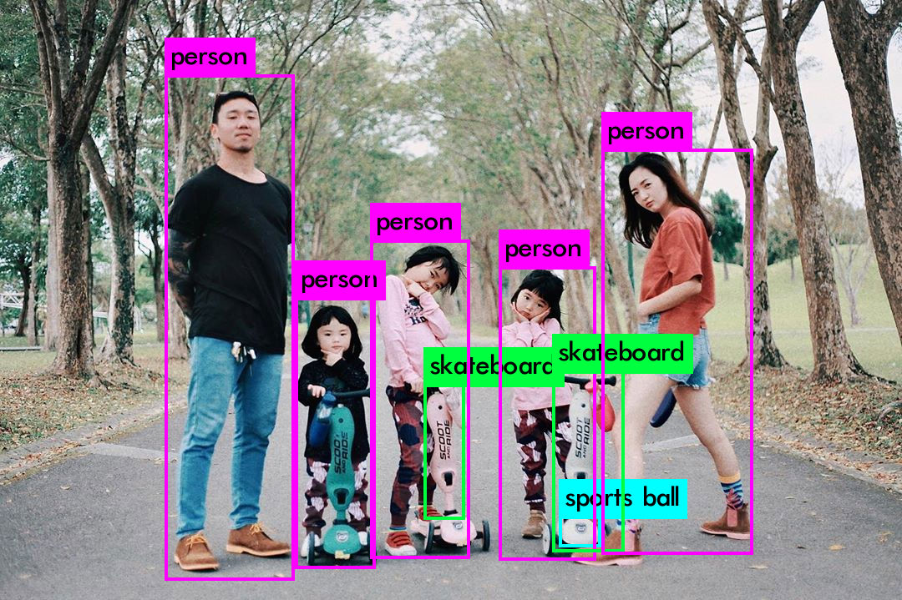

Loading weights from /home/jumbo/yolo/w/yolov4.weights...
seen 64, trained: 32032 K-images (500 Kilo-batches_64)
Done! Loaded 162 layers from weights-file
img/child1.jpg: Predicted in 39.661000 milli-seconds.
person: 100%
person: 97%
person: 98%
skateboard: 76%
person: 87%
skateboard: 91%
sports ball: 28%
person: 98%

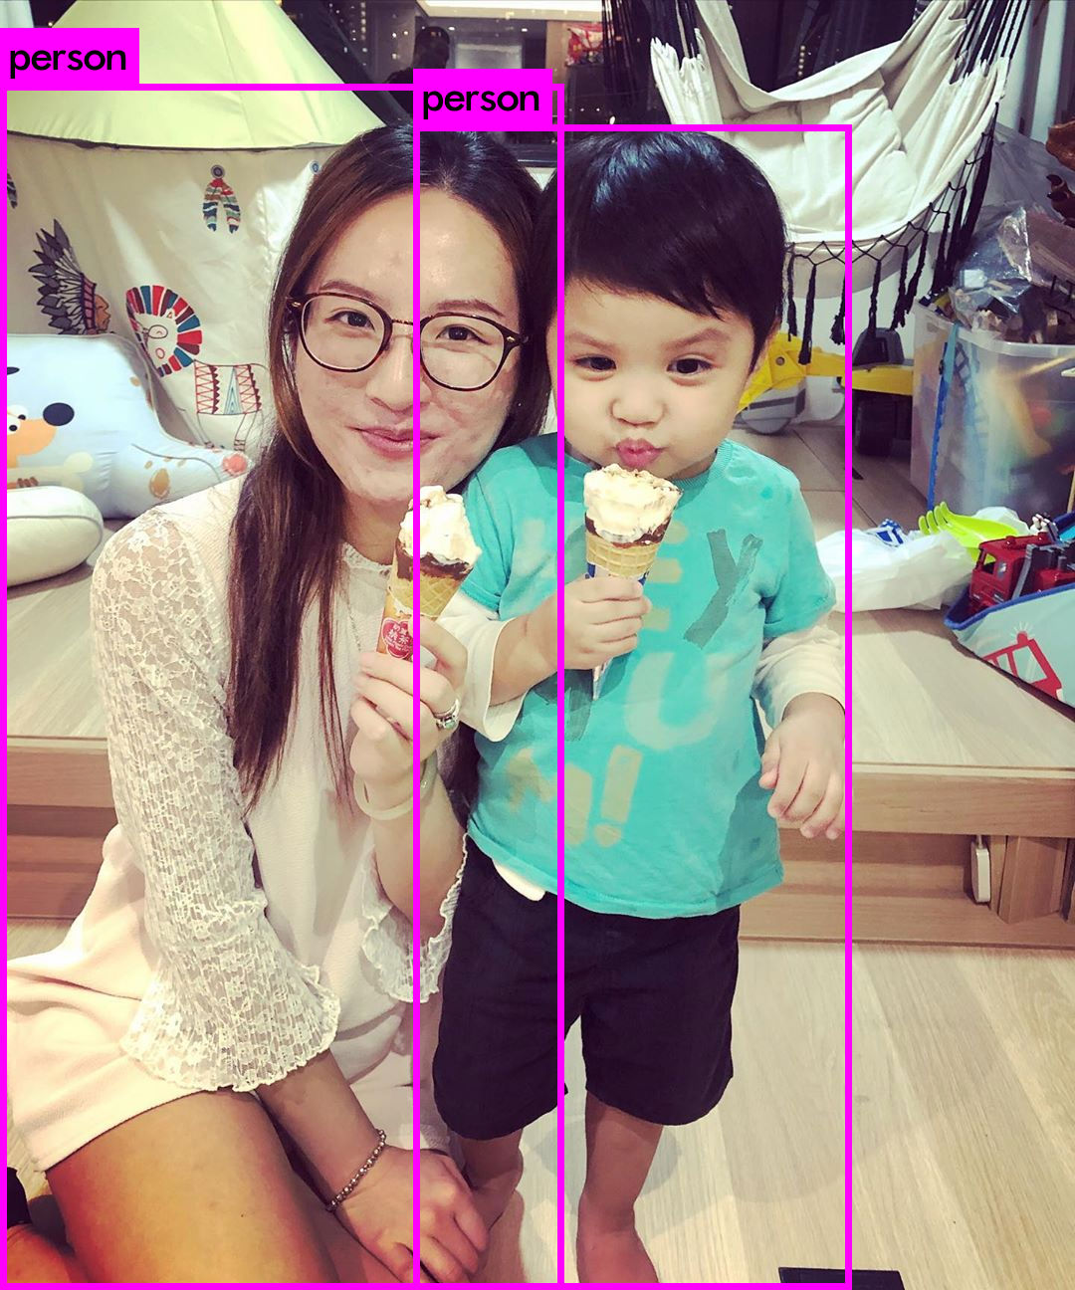

Loading weights from /home/jumbo/yolo/w/yolov3.weights...
seen 64, trained: 32013 K-images (500 Kilo-batches_64)
Done! Loaded 107 layers from weights-file
img/child2.jpg: Predicted in 20.162000 milli-seconds.
person: 100%
person: 100%

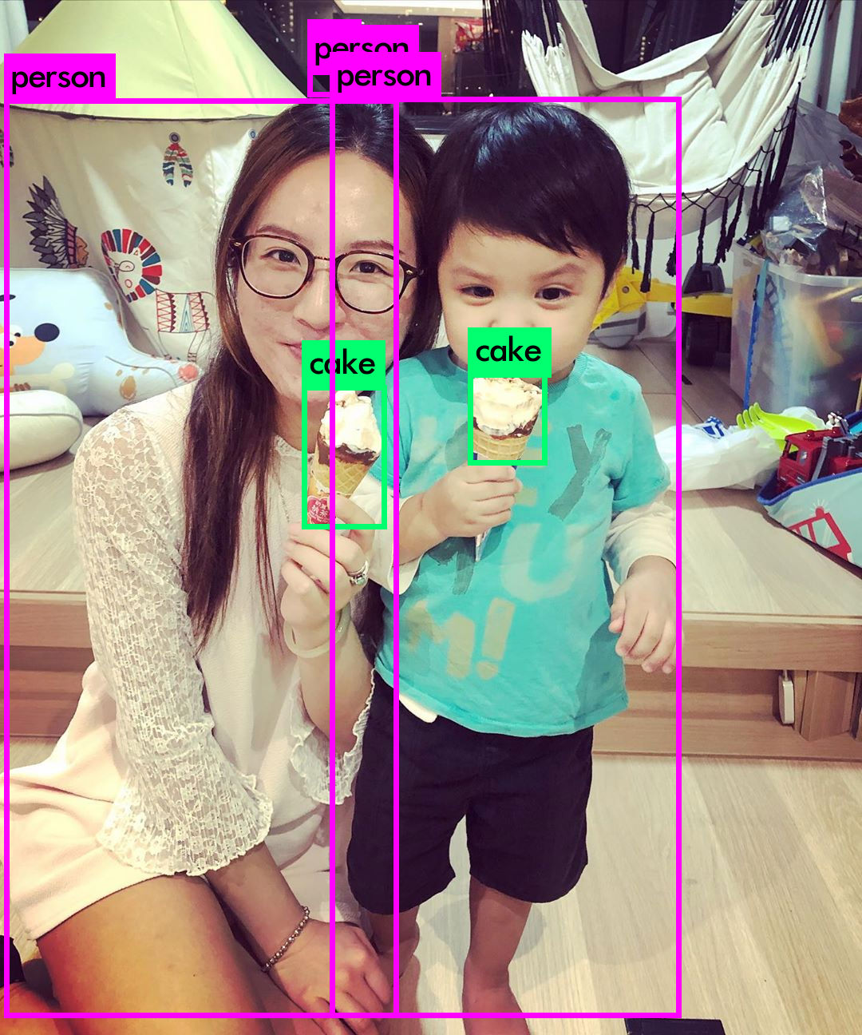
Loading weights from /home/jumbo/yolo/w/yolov4.weights...
seen 64, trained: 32032 K-images (500 Kilo-batches_64)
Done! Loaded 162 layers from weights-file
img/child2.jpg: Predicted in 39.870000 milli-seconds.
person: 96%
cake: 74%
person: 27%
person: 98%
cake: 67%

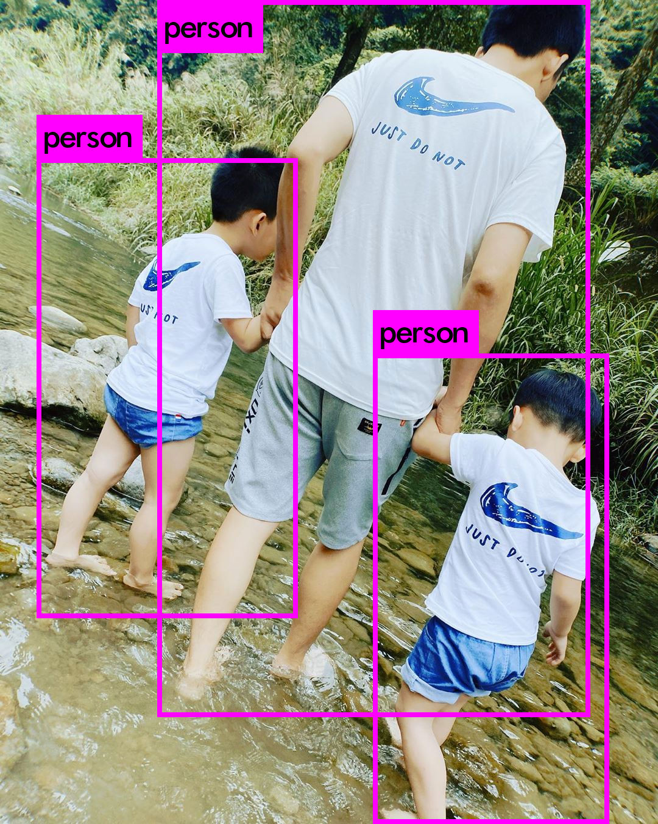
Loading weights from /home/jumbo/yolo/w/yolov3.weights...
seen 64, trained: 32013 K-images (500 Kilo-batches_64)
Done! Loaded 107 layers from weights-file
img/child3.jpg: Predicted in 20.319000 milli-seconds.
person: 100%
person: 100%
person: 100%
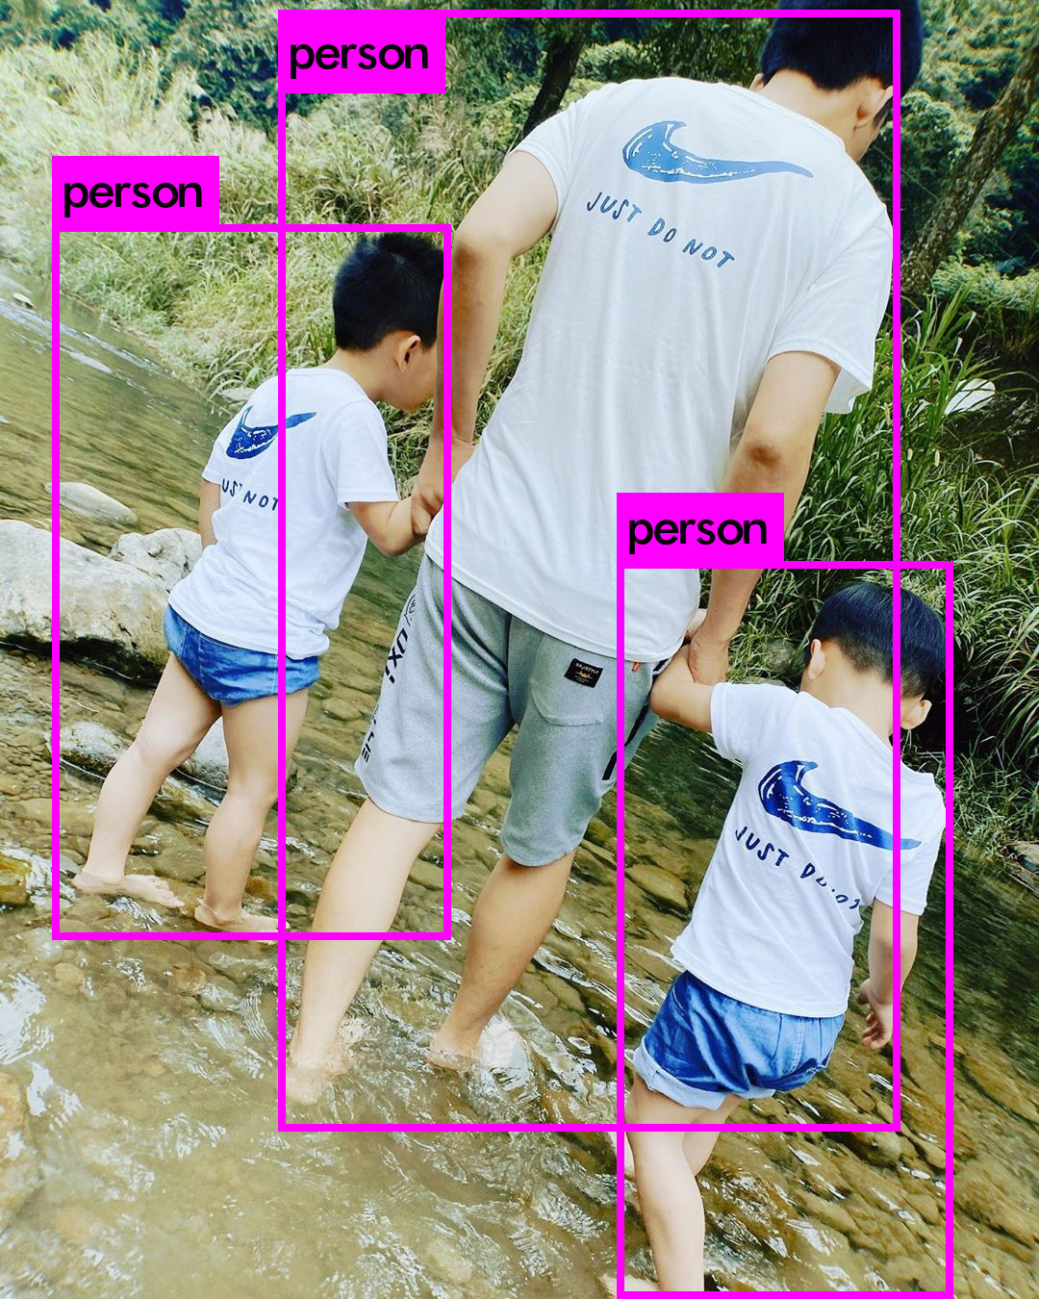
Loading weights from /home/jumbo/yolo/w/yolov4.weights...
seen 64, trained: 32032 K-images (500 Kilo-batches_64)
Done! Loaded 162 layers from weights-file
img/child3.jpg: Predicted in 39.802000 milli-seconds.
person: 99%
person: 98%
person: 92%
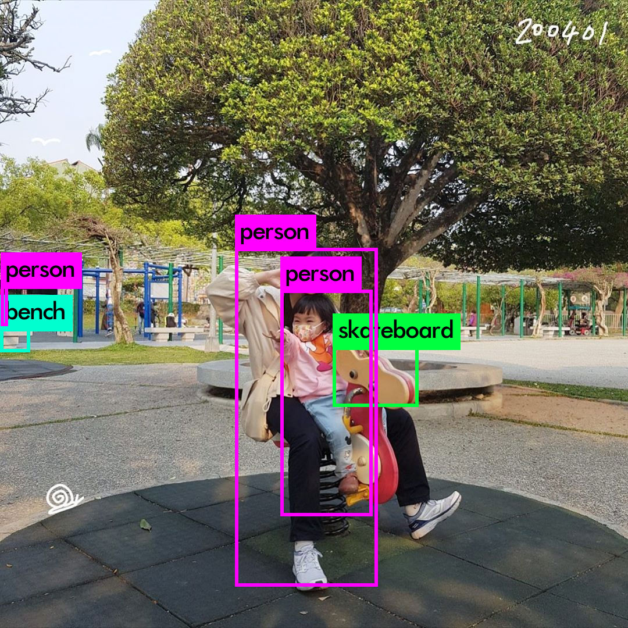
Loading weights from /home/jumbo/yolo/w/yolov3.weights...
seen 64, trained: 32013 K-images (500 Kilo-batches_64)
Done! Loaded 107 layers from weights-file
img/child4.jpg: Predicted in 20.184000 milli-seconds.
bench: 30%
person: 54%
person: 100%
person: 28%
skateboard: 28%
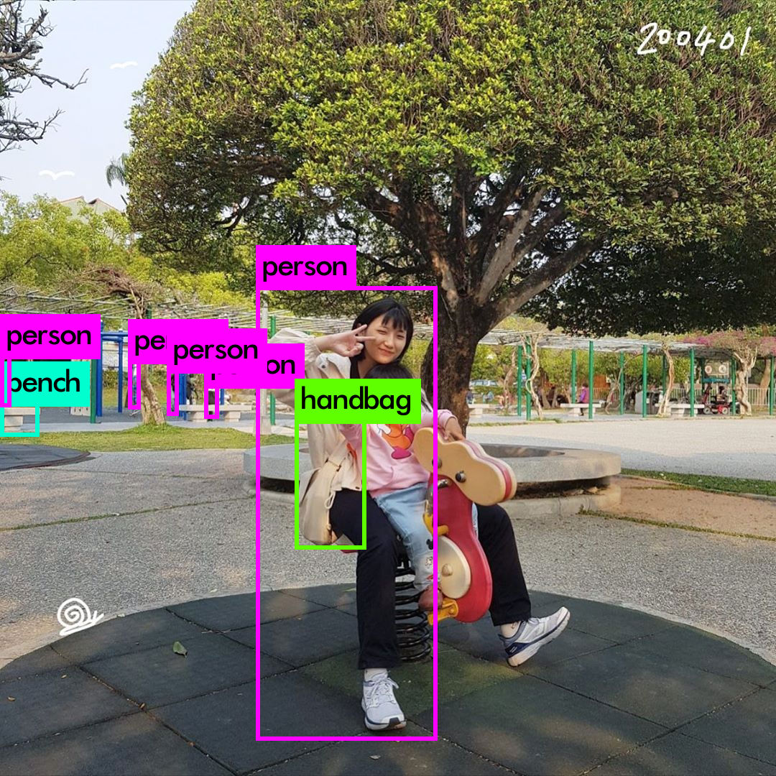
Loading weights from /home/jumbo/yolo/w/yolov4.weights...
seen 64, trained: 32032 K-images (500 Kilo-batches_64)
Done! Loaded 162 layers from weights-file
img/child4.jpg: Predicted in 40.612000 milli-seconds.
person: 66%
bench: 43%
person: 30%
person: 66%
person: 28%
person: 58%
handbag: 39%
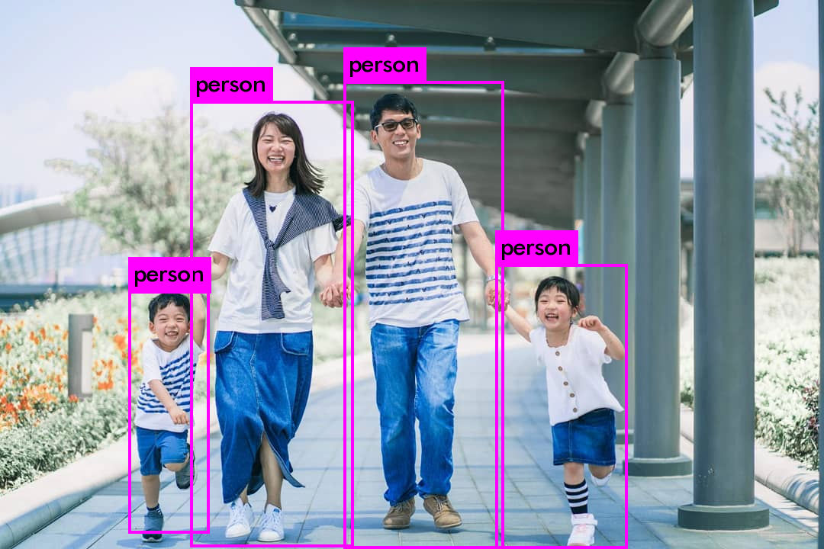
Loading weights from /home/jumbo/yolo/w/yolov3.weights...
seen 64, trained: 32013 K-images (500 Kilo-batches_64)
Done! Loaded 107 layers from weights-file
img/child5.jpg: Predicted in 20.385000 milli-seconds.
person: 100%
person: 100%
person: 100%
person: 100%
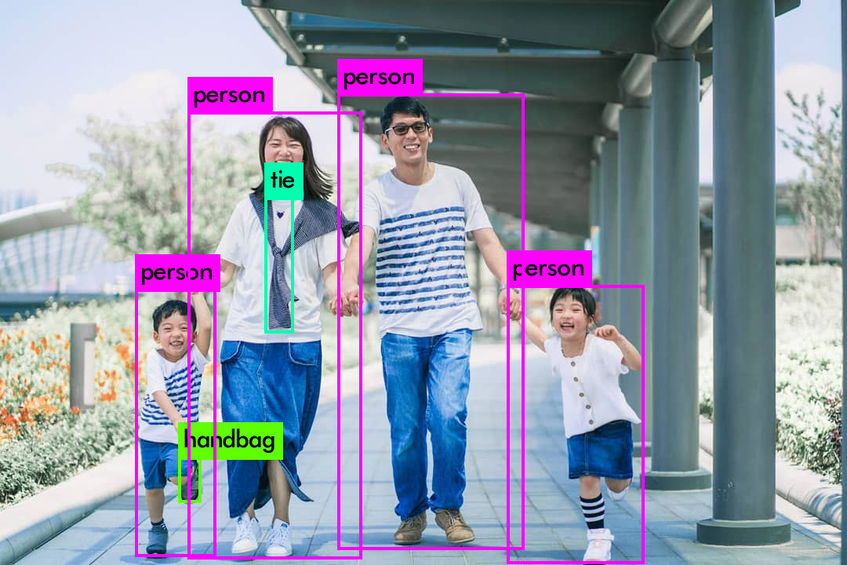
Loading weights from /home/jumbo/yolo/w/yolov4.weights...
seen 64, trained: 32032 K-images (500 Kilo-batches_64)
Done! Loaded 162 layers from weights-file
img/child5.jpg: Predicted in 40.383000 milli-seconds.
person: 95%
handbag: 34%
person: 99%
tie: 29%
person: 99%
person: 99%
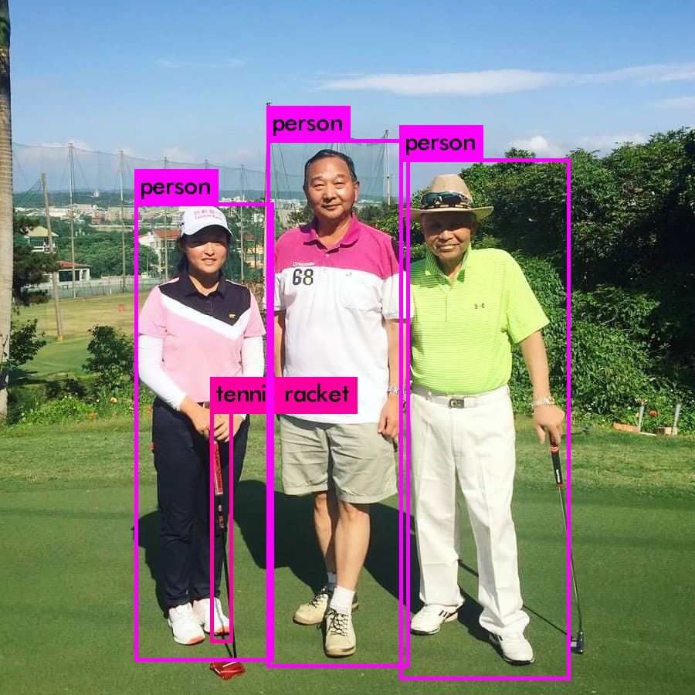
Loading weights from /home/jumbo/yolo/w/yolov3.weights...
seen 64, trained: 32013 K-images (500 Kilo-batches_64)
Done! Loaded 107 layers from weights-file
img/golf1.jpg: Predicted in 20.080000 milli-seconds.
person: 100%
tennis racket: 27%
person: 100%
person: 100%
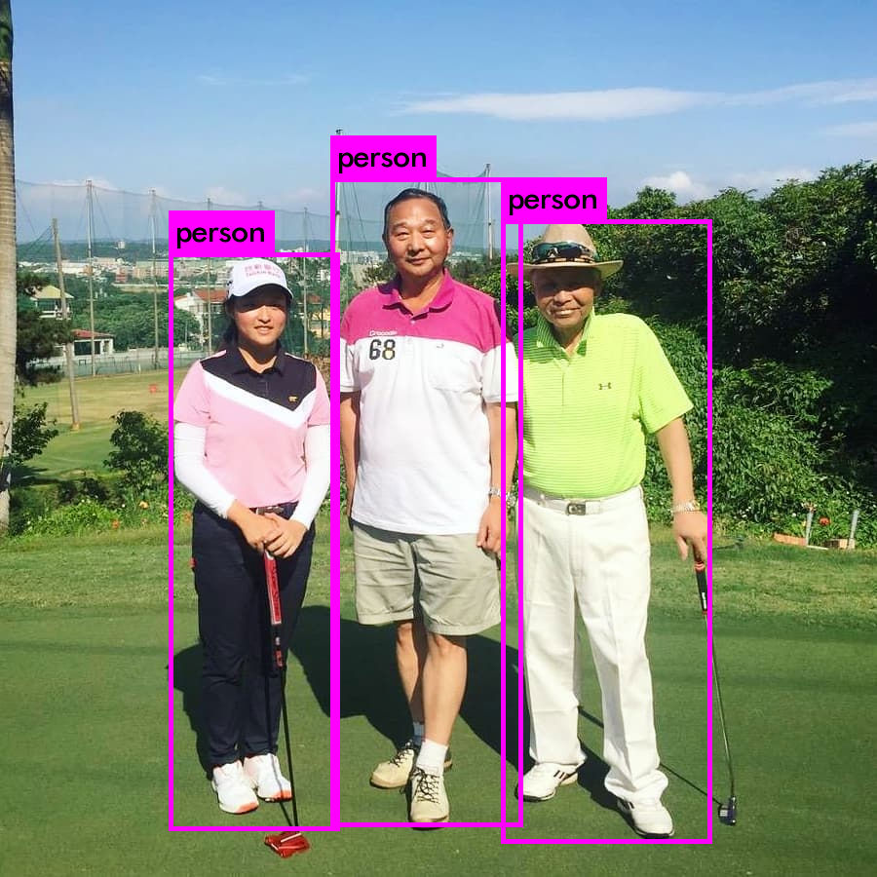
Loading weights from /home/jumbo/yolo/w/yolov4.weights...
seen 64, trained: 32032 K-images (500 Kilo-batches_64)
Done! Loaded 162 layers from weights-file
img/golf1.jpg: Predicted in 39.598000 milli-seconds.
person: 100%
person: 99%
person: 99%
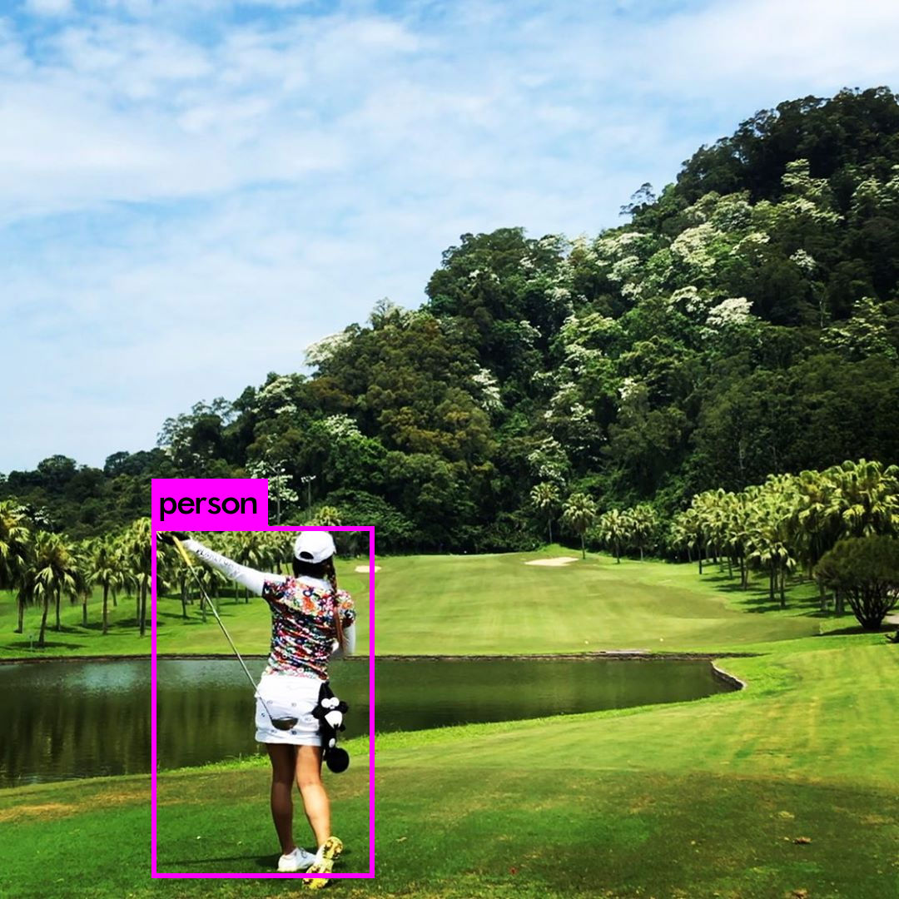
Loading weights from /home/jumbo/yolo/w/yolov3.weights...
seen 64, trained: 32013 K-images (500 Kilo-batches_64)
Done! Loaded 107 layers from weights-file
img/golf2.jpg: Predicted in 19.924000 milli-seconds.
person: 100%
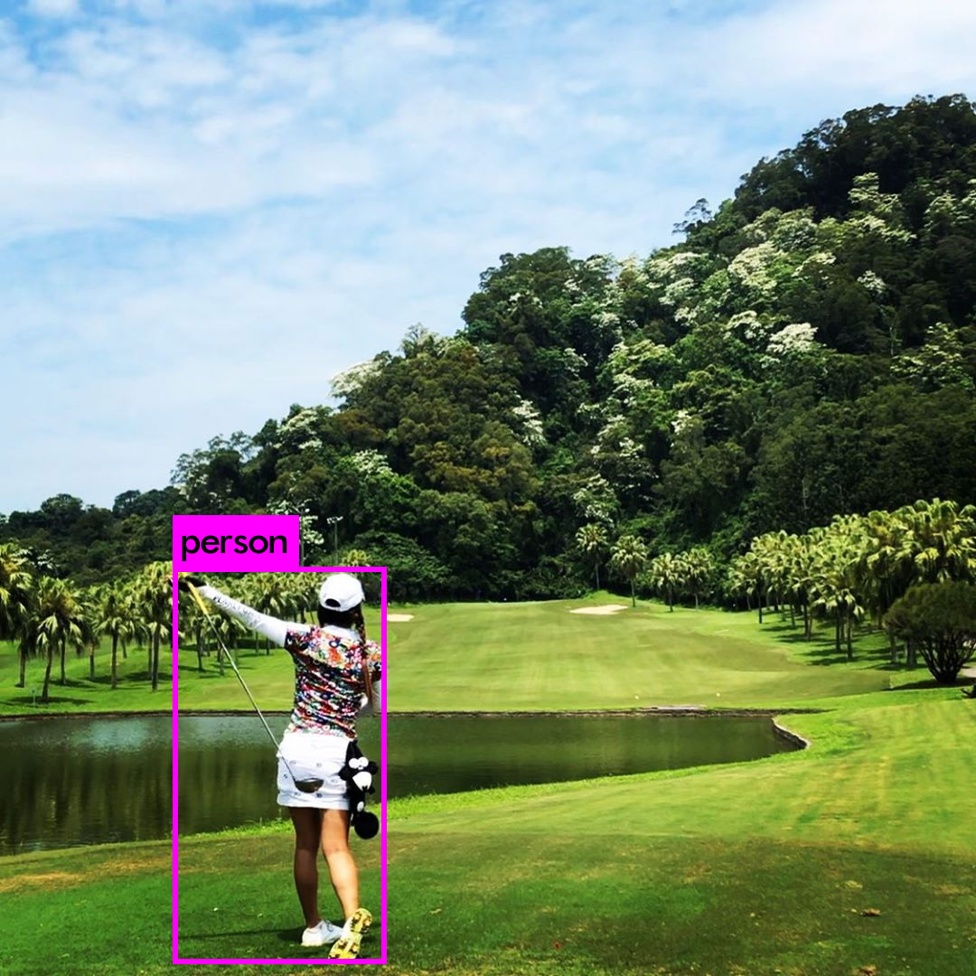
Loading weights from /home/jumbo/yolo/w/yolov4.weights...
seen 64, trained: 32032 K-images (500 Kilo-batches_64)
Done! Loaded 162 layers from weights-file
img/golf2.jpg: Predicted in 39.567000 milli-seconds.
person: 100%
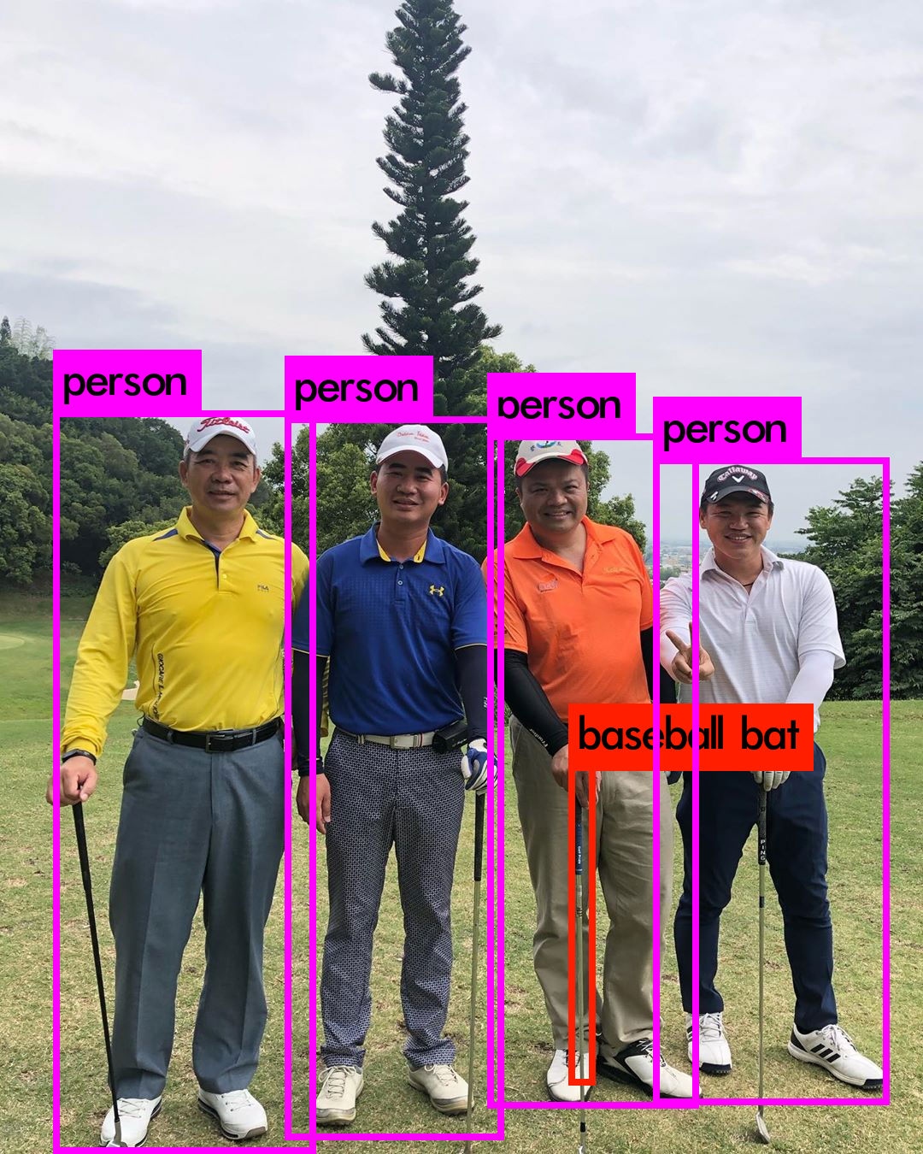
Loading weights from /home/jumbo/yolo/w/yolov3.weights...
seen 64, trained: 32013 K-images (500 Kilo-batches_64)
Done! Loaded 107 layers from weights-file
img/golf3.jpg: Predicted in 20.006000 milli-seconds.
person: 100%
person: 100%
person: 100%
baseball bat: 25%
person: 100%
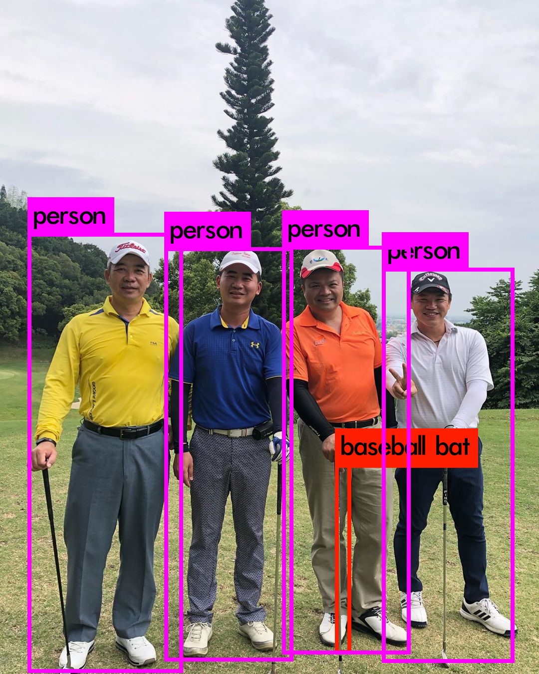
Loading weights from /home/jumbo/yolo/w/yolov4.weights...
seen 64, trained: 32032 K-images (500 Kilo-batches_64)
Done! Loaded 162 layers from weights-file
img/golf3.jpg: Predicted in 39.521000 milli-seconds.
person: 99%
person: 99%
person: 99%
baseball bat: 44%
person: 98%
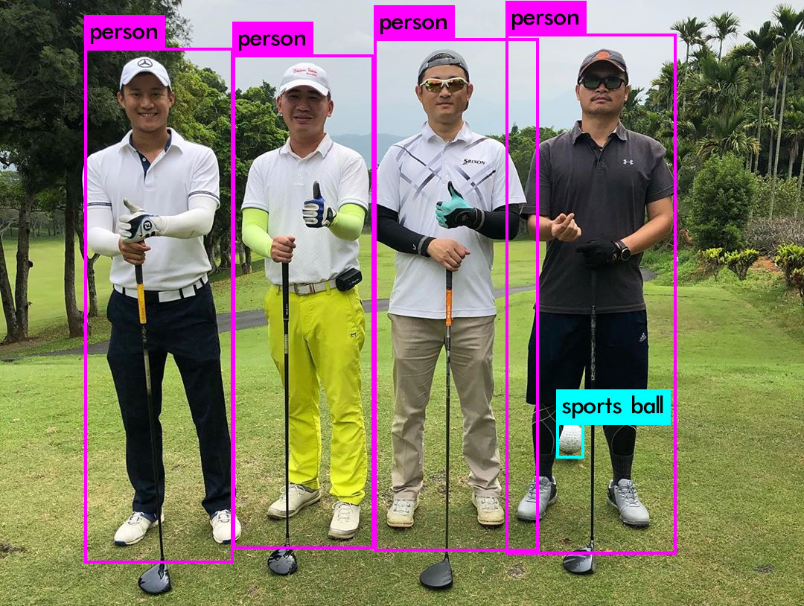
Loading weights from /home/jumbo/yolo/w/yolov3.weights...
seen 64, trained: 32013 K-images (500 Kilo-batches_64)
Done! Loaded 107 layers from weights-file
img/golf4.jpg: Predicted in 19.947000 milli-seconds.
person: 100%
person: 100%
person: 100%
person: 100%
sports ball: 99%
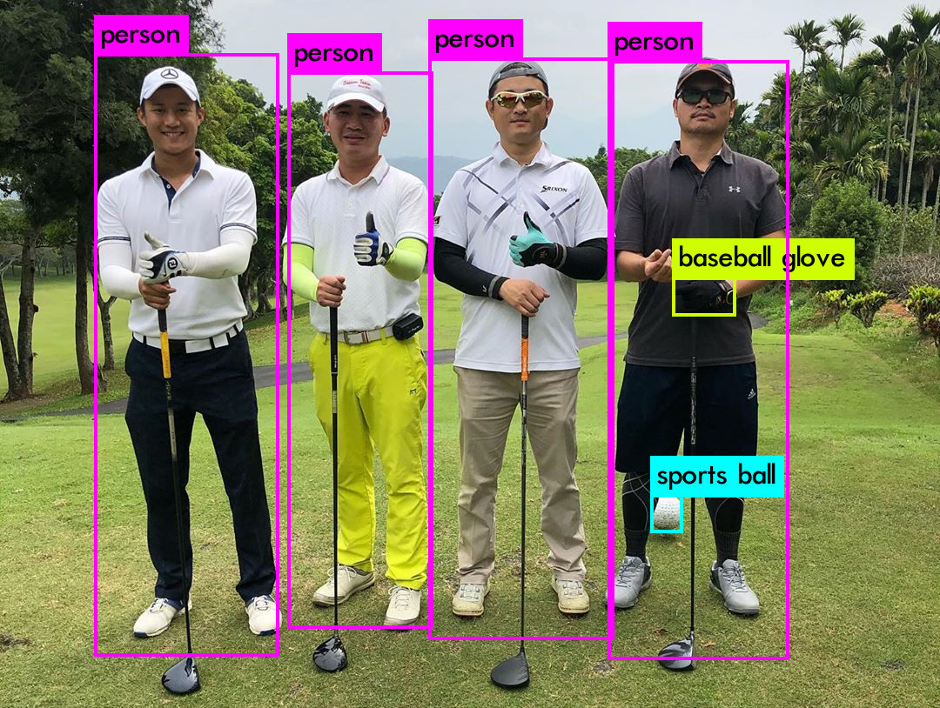
Loading weights from /home/jumbo/yolo/w/yolov4.weights...
seen 64, trained: 32032 K-images (500 Kilo-batches_64)
Done! Loaded 162 layers from weights-file
img/golf4.jpg: Predicted in 39.881000 milli-seconds.
person: 99%
person: 100%
person: 99%
person: 100%
sports ball: 99%
baseball glove: 27%
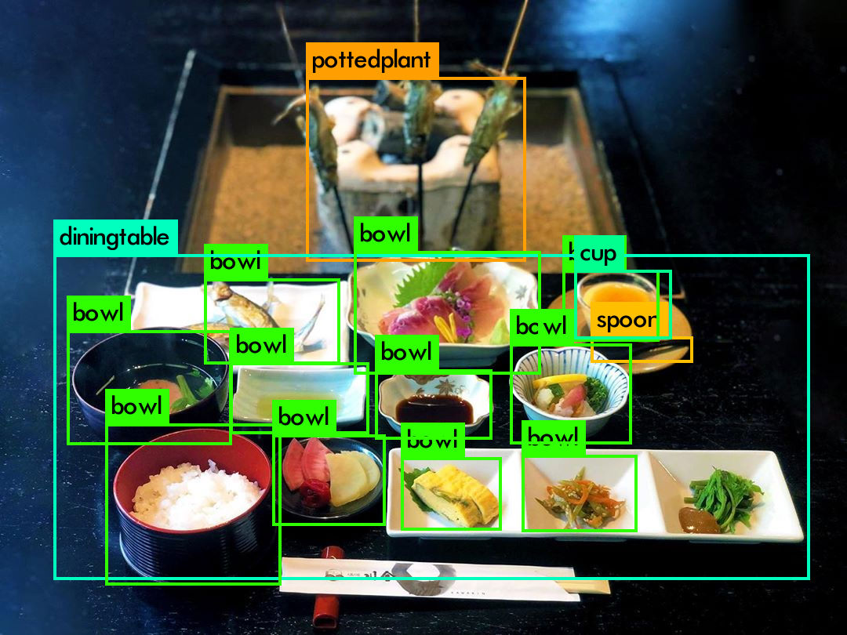
Loading weights from /home/jumbo/yolo/w/yolov3.weights...
seen 64, trained: 32013 K-images (500 Kilo-batches_64)
Done! Loaded 107 layers from weights-file
img/jf1.jpg: Predicted in 20.044000 milli-seconds.
diningtable: 67%
bowl: 90%
bowl: 97%
bowl: 25%
bowl: 71%
bowl: 93%
pottedplant: 37%
bowl: 100%
bowl: 99%
bowl: 44%
bowl: 97%
bowl: 29%
bowl: 63%
cup: 71%
spoon: 25%
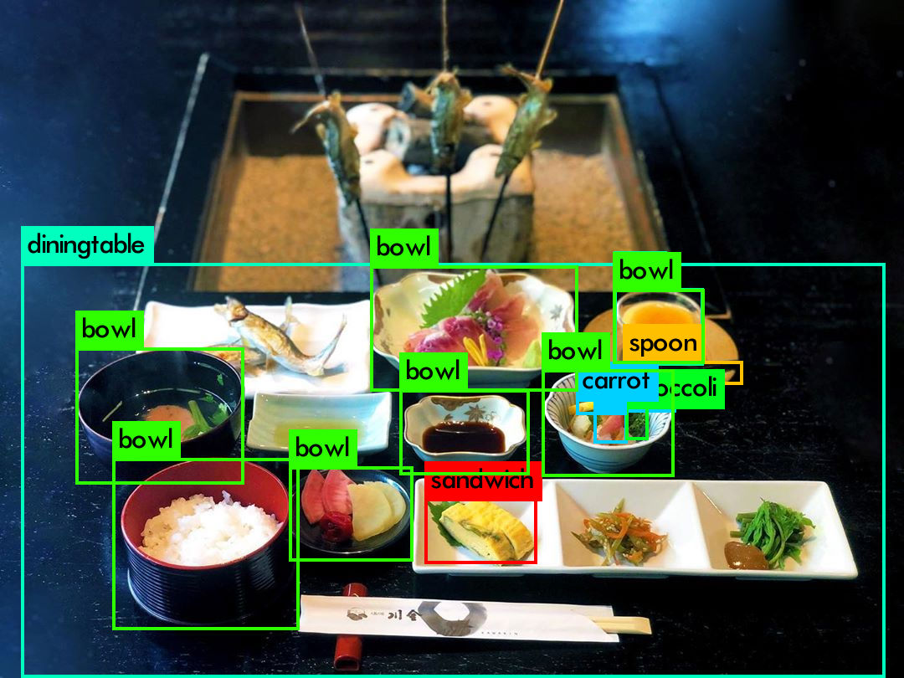
Loading weights from /home/jumbo/yolo/w/yolov4.weights...
seen 64, trained: 32032 K-images (500 Kilo-batches_64)
Done! Loaded 162 layers from weights-file
img/jf1.jpg: Predicted in 39.665000 milli-seconds.
diningtable: 77%
bowl: 99%
bowl: 97%
bowl: 97%
bowl: 94%
bowl: 96%
sandwich: 32%
bowl: 100%
carrot: 38%
carrot: 33%
bowl: 98%
cup: 26%
spoon: 32%
broccoli: 37%
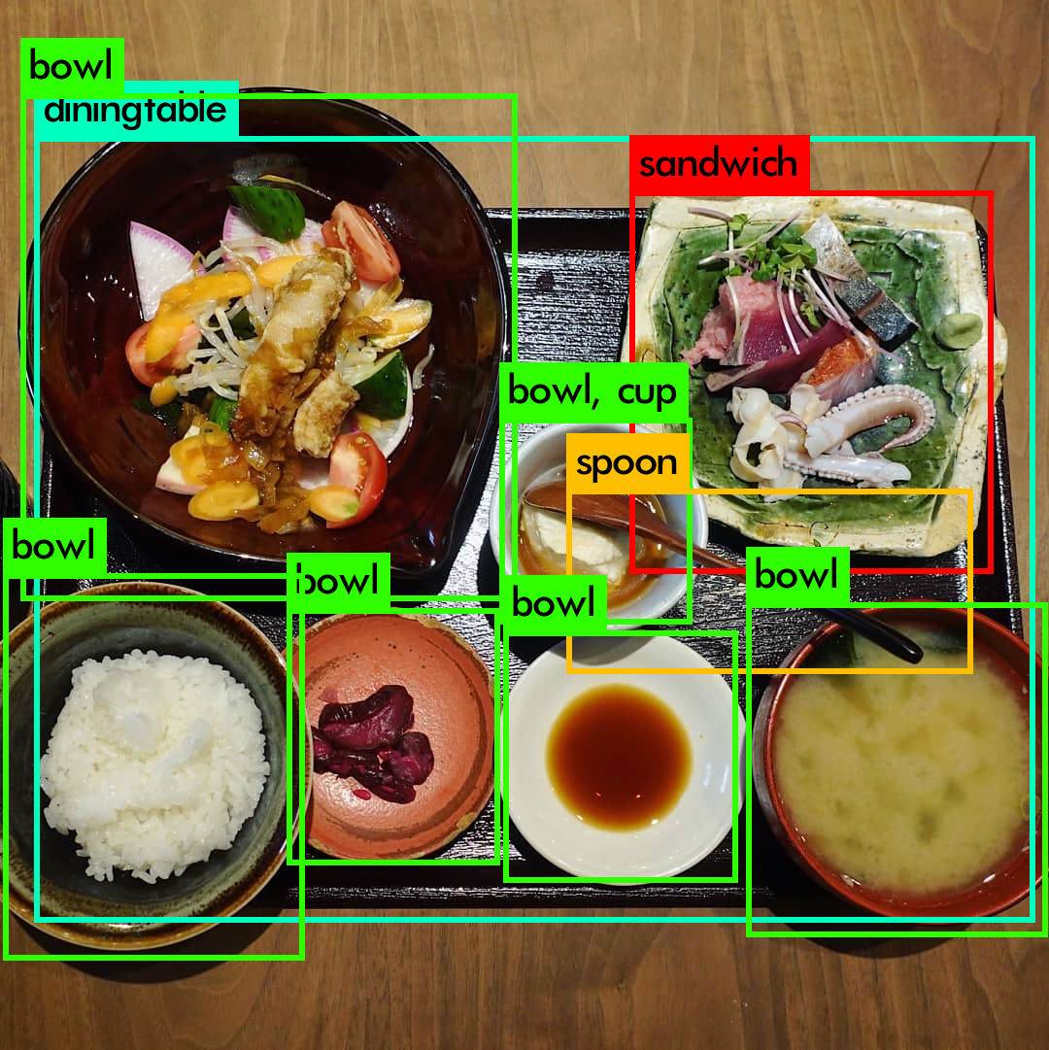
Loading weights from /home/jumbo/yolo/w/yolov3.weights...
seen 64, trained: 32013 K-images (500 Kilo-batches_64)
Done! Loaded 107 layers from weights-file
img/jf2.jpg: Predicted in 19.922000 milli-seconds.
bowl: 97%
bowl: 53%
diningtable: 31%
bowl: 78%
bowl: 91%
cup: 28%
bowl: 99%
spoon: 96%
sandwich: 46%
bowl: 98%
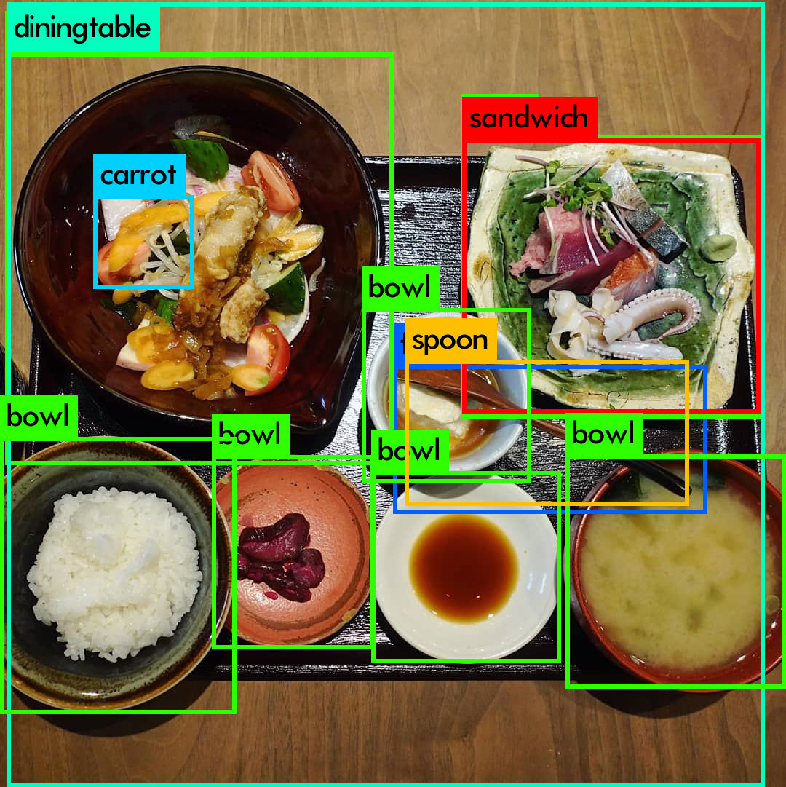
Loading weights from /home/jumbo/yolo/w/yolov4.weights...
seen 64, trained: 32032 K-images (500 Kilo-batches_64)
Done! Loaded 162 layers from weights-file
img/jf2.jpg: Predicted in 40.722000 milli-seconds.
bowl: 98%
bowl: 65%
diningtable: 80%
carrot: 29%
bowl: 88%
bowl: 98%
bowl: 97%
fork: 29%
spoon: 98%
bowl: 31%
sandwich: 76%
bowl: 97%
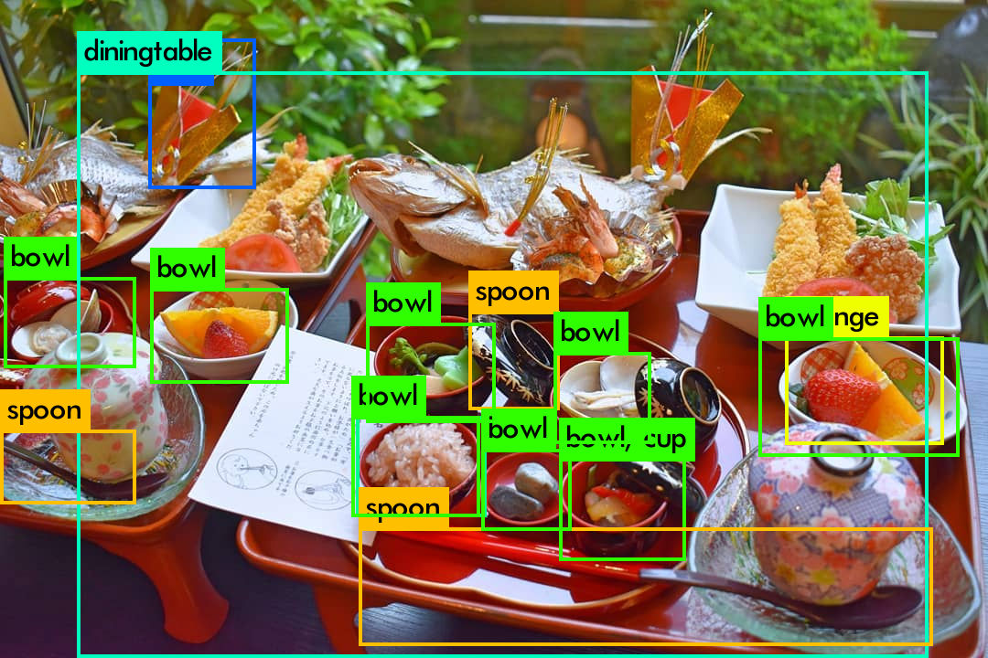
Loading weights from /home/jumbo/yolo/w/yolov3.weights...
seen 64, trained: 32013 K-images (500 Kilo-batches_64)
Done! Loaded 107 layers from weights-file
img/jf3.jpg: Predicted in 20.224000 milli-seconds.
spoon: 57%
bowl: 47%
diningtable: 57%
fork: 49%
bowl: 95%
bowl: 84%
cup: 30%
spoon: 73%
bowl: 96%
spoon: 30%
bowl: 75%
bowl: 60%
bowl: 58%
cup: 42%
bowl: 77%
orange: 27%
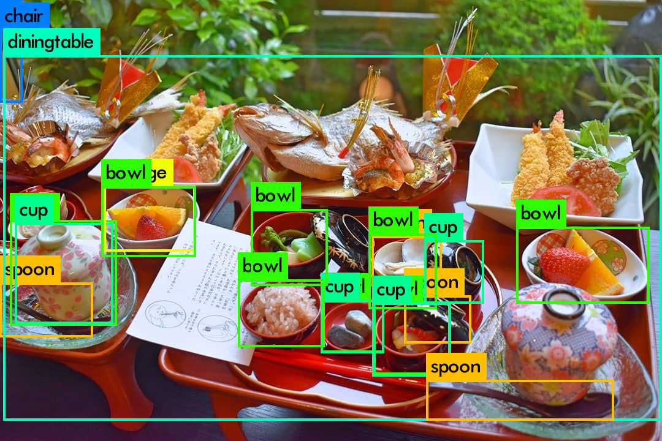
Loading weights from /home/jumbo/yolo/w/yolov4.weights...
seen 64, trained: 32032 K-images (500 Kilo-batches_64)
Done! Loaded 162 layers from weights-file
img/jf3.jpg: Predicted in 39.523000 milli-seconds.
spoon: 28%
chair: 25%
diningtable: 52%
bowl: 35%
cup: 52%
bowl: 95%
orange: 57%
bowl: 94%
bowl: 97%
bowl: 30%
cup: 37%
bowl: 56%
spoon: 26%
cup: 81%
bowl: 44%
spoon: 26%
cup: 42%
spoon: 81%
bowl: 94%
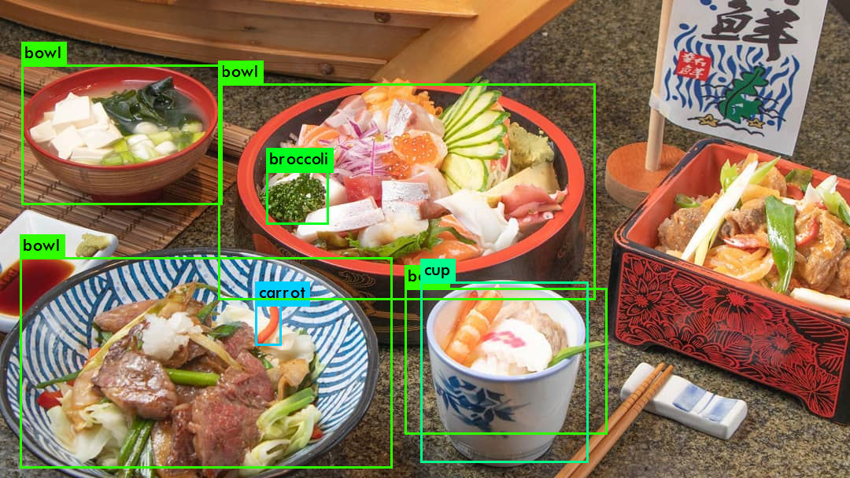
Loading weights from /home/jumbo/yolo/w/yolov3.weights...
seen 64, trained: 32013 K-images (500 Kilo-batches_64)
Done! Loaded 107 layers from weights-file
img/jf4.jpg: Predicted in 21.015000 milli-seconds.
bowl: 50%
bowl: 98%
bowl: 90%
carrot: 45%
broccoli: 62%
bowl: 55%
cup: 97%
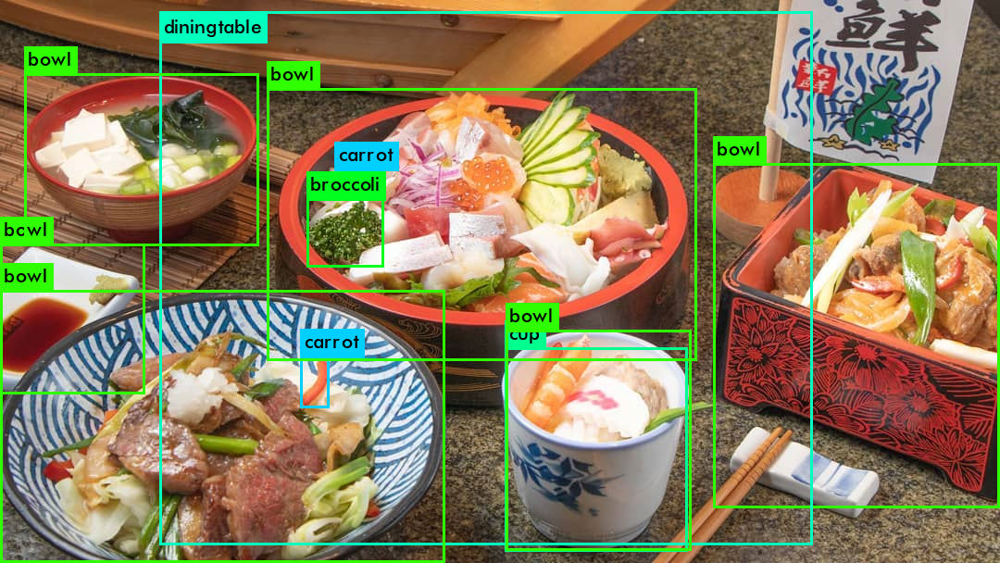
Loading weights from /home/jumbo/yolo/w/yolov4.weights...
seen 64, trained: 32032 K-images (500 Kilo-batches_64)
Done! Loaded 162 layers from weights-file
img/jf4.jpg: Predicted in 39.737000 milli-seconds.
bowl: 55%
bowl: 96%
bowl: 96%
diningtable: 34%
bowl: 84%
carrot: 32%
broccoli: 85%
carrot: 50%
cup: 71%
bowl: 76%
bowl: 34%
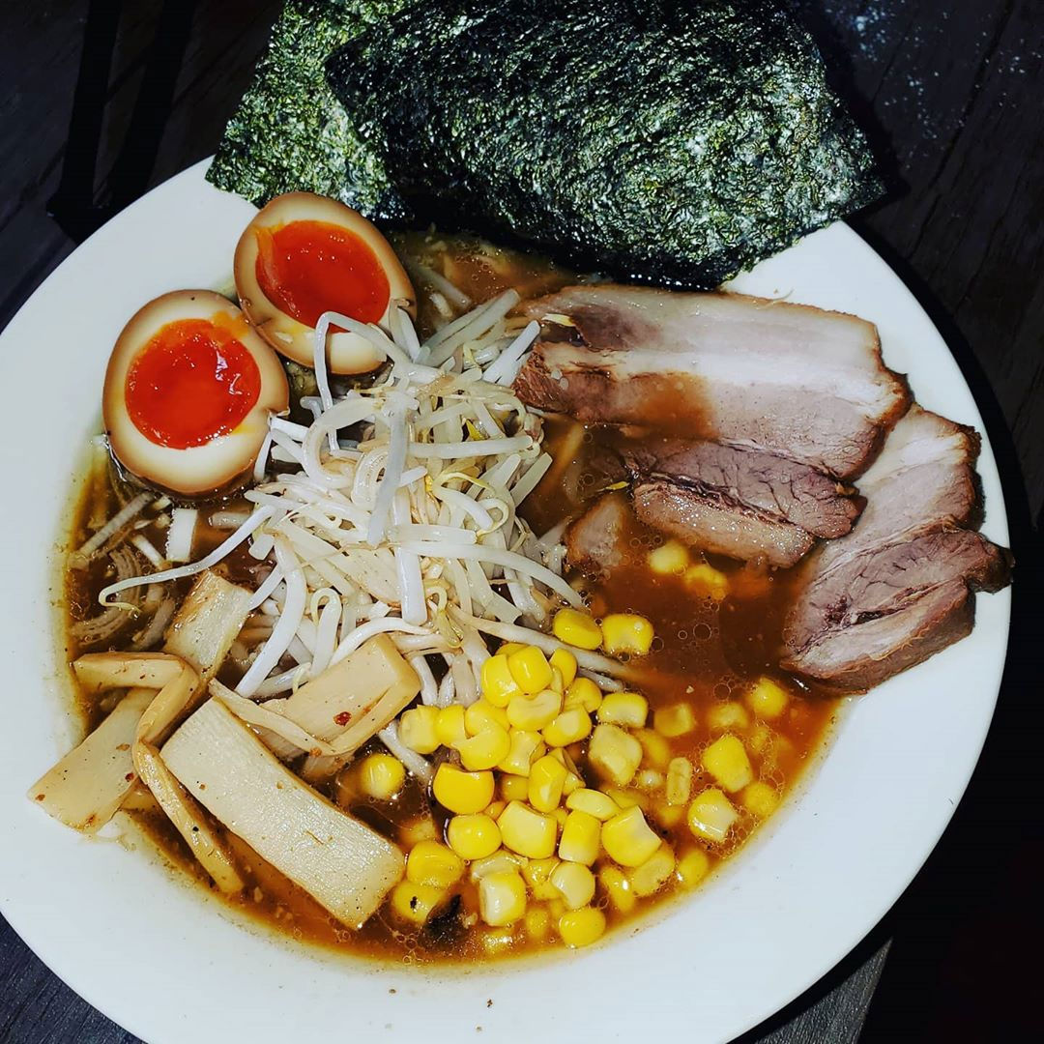
Loading weights from /home/jumbo/yolo/w/yolov3.weights...
seen 64, trained: 32013 K-images (500 Kilo-batches_64)
Done! Loaded 107 layers from weights-file
img/jf5.jpg: Predicted in 20.059000 milli-seconds.
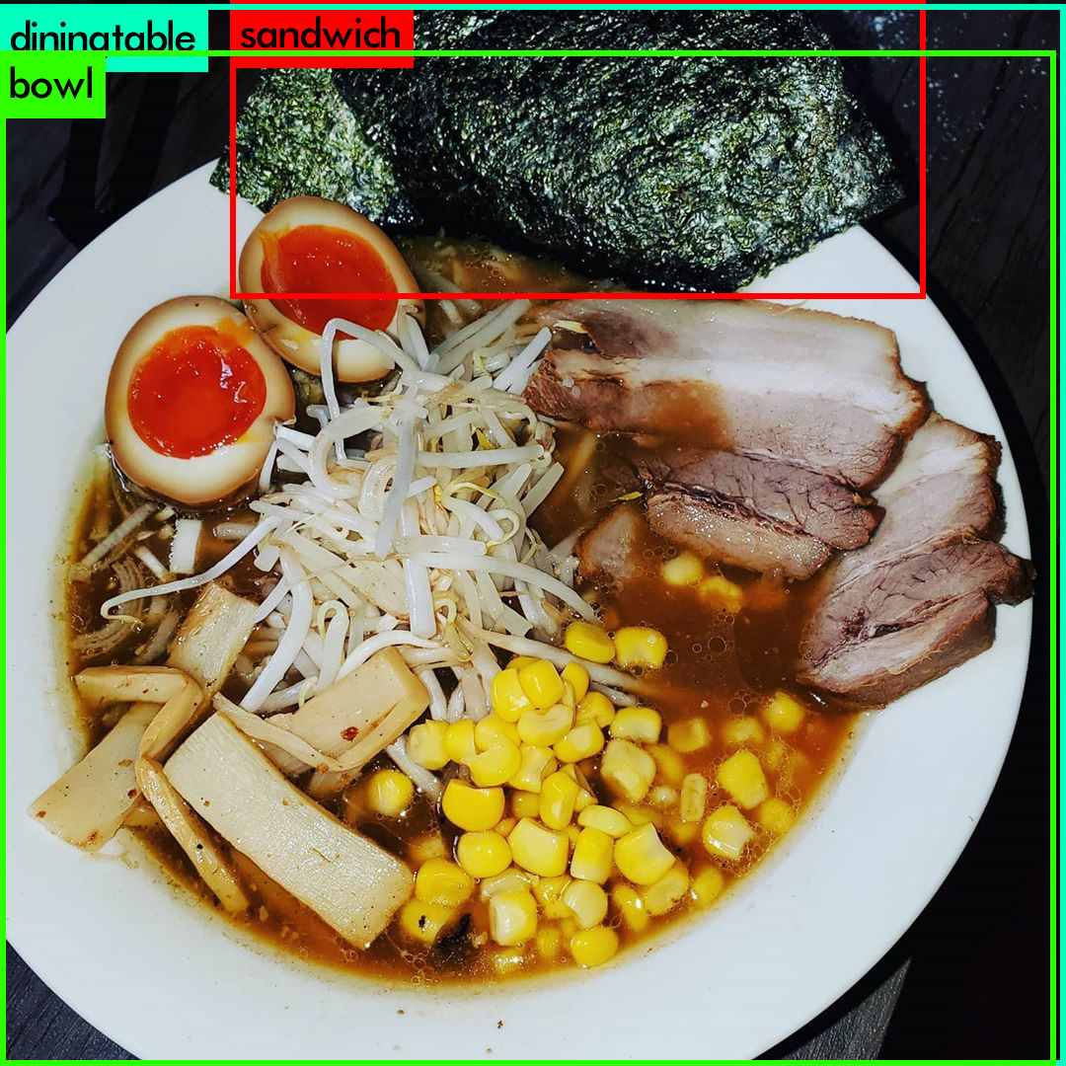
Loading weights from /home/jumbo/yolo/w/yolov4.weights...
seen 64, trained: 32032 K-images (500 Kilo-batches_64)
Done! Loaded 162 layers from weights-file
img/jf5.jpg: Predicted in 39.535000 milli-seconds.
diningtable: 40%
bowl: 52%
sandwich: 26%
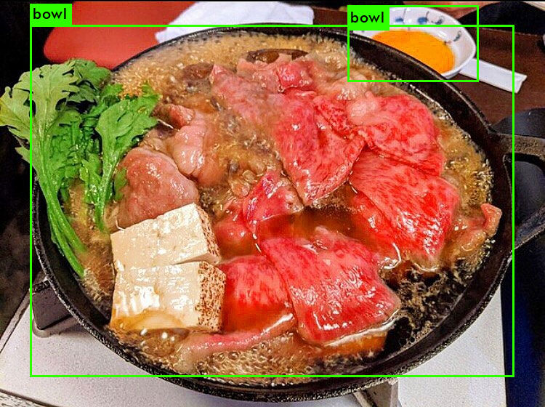
Loading weights from /home/jumbo/yolo/w/yolov3.weights...
seen 64, trained: 32013 K-images (500 Kilo-batches_64)
Done! Loaded 107 layers from weights-file
img/jf6.jpg: Predicted in 20.322000 milli-seconds.
bowl: 68%
bowl: 94%
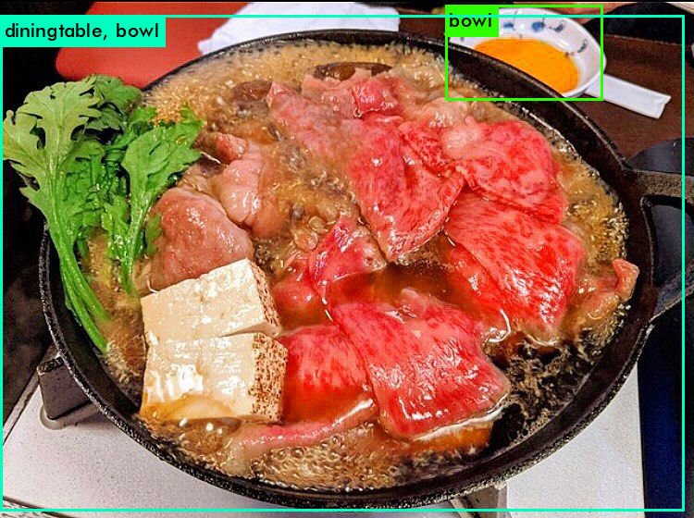
Loading weights from /home/jumbo/yolo/w/yolov4.weights...
seen 64, trained: 32032 K-images (500 Kilo-batches_64)
Done! Loaded 162 layers from weights-file
img/jf6.jpg: Predicted in 39.588000 milli-seconds.
diningtable: 70%
bowl: 55%
bowl: 67%
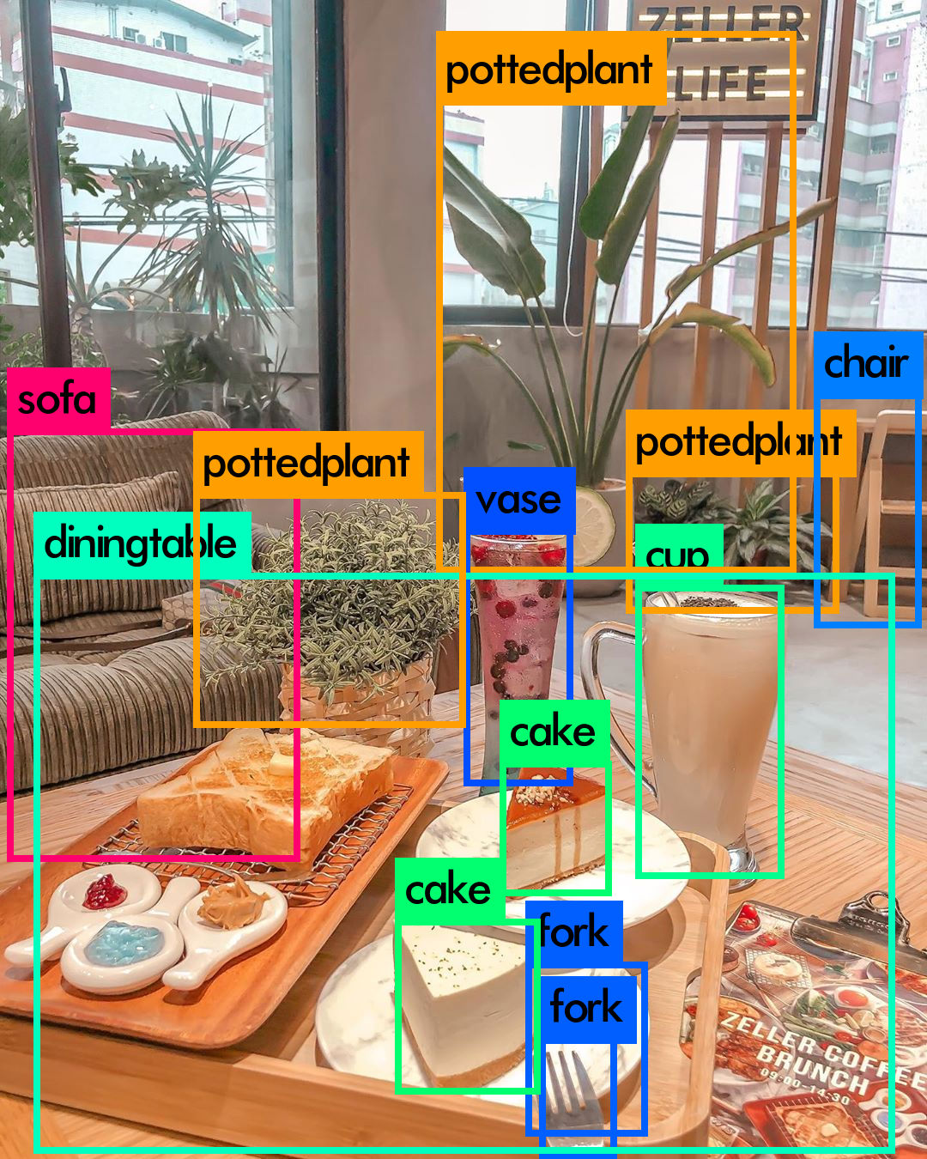
Loading weights from /home/jumbo/yolo/w/yolov3.weights...
seen 64, trained: 32013 K-images (500 Kilo-batches_64)
Done! Loaded 107 layers from weights-file
img/tea1.jpg: Predicted in 20.130000 milli-seconds.
sofa: 84%
diningtable: 94%
pottedplant: 97%
cake: 81%
pottedplant: 91%
vase: 92%
cake: 98%
fork: 45%
fork: 73%
pottedplant: 68%
cup: 80%
chair: 76%
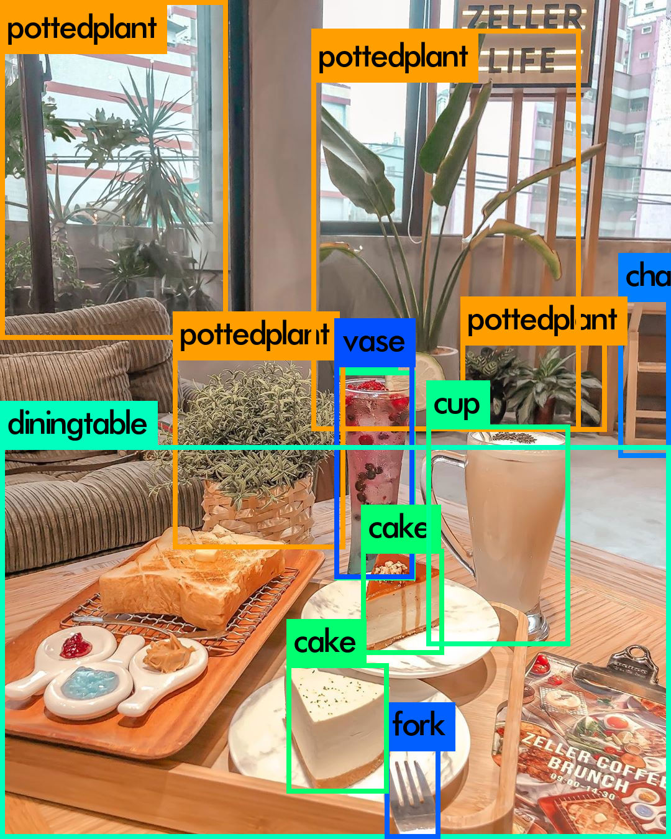
Loading weights from /home/jumbo/yolo/w/yolov4.weights...
seen 64, trained: 32032 K-images (500 Kilo-batches_64)
Done! Loaded 162 layers from weights-file
img/tea1.jpg: Predicted in 39.641000 milli-seconds.
diningtable: 73%
pottedplant: 42%
pottedplant: 60%
cake: 93%
pottedplant: 70%
vase: 72%
cup: 57%
cake: 97%
fork: 77%
cup: 99%
pottedplant: 55%
chair: 46%
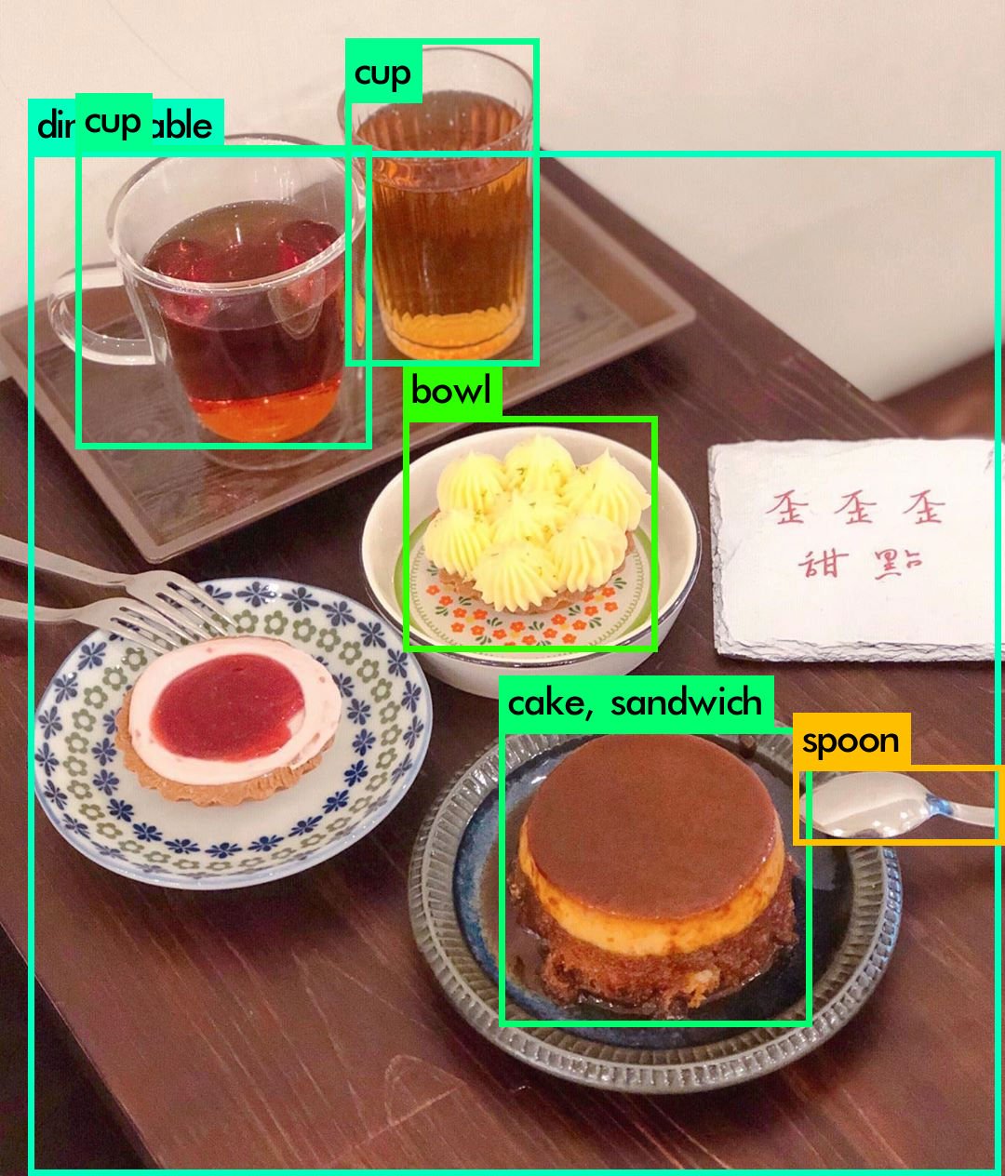
Loading weights from /home/jumbo/yolo/w/yolov3.weights...
seen 64, trained: 32013 K-images (500 Kilo-batches_64)
Done! Loaded 107 layers from weights-file
img/tea2.jpg: Predicted in 20.000000 milli-seconds.
diningtable: 50%
cup: 99%
cup: 99%
bowl: 78%
cake: 59%
sandwich: 38%
spoon: 76%
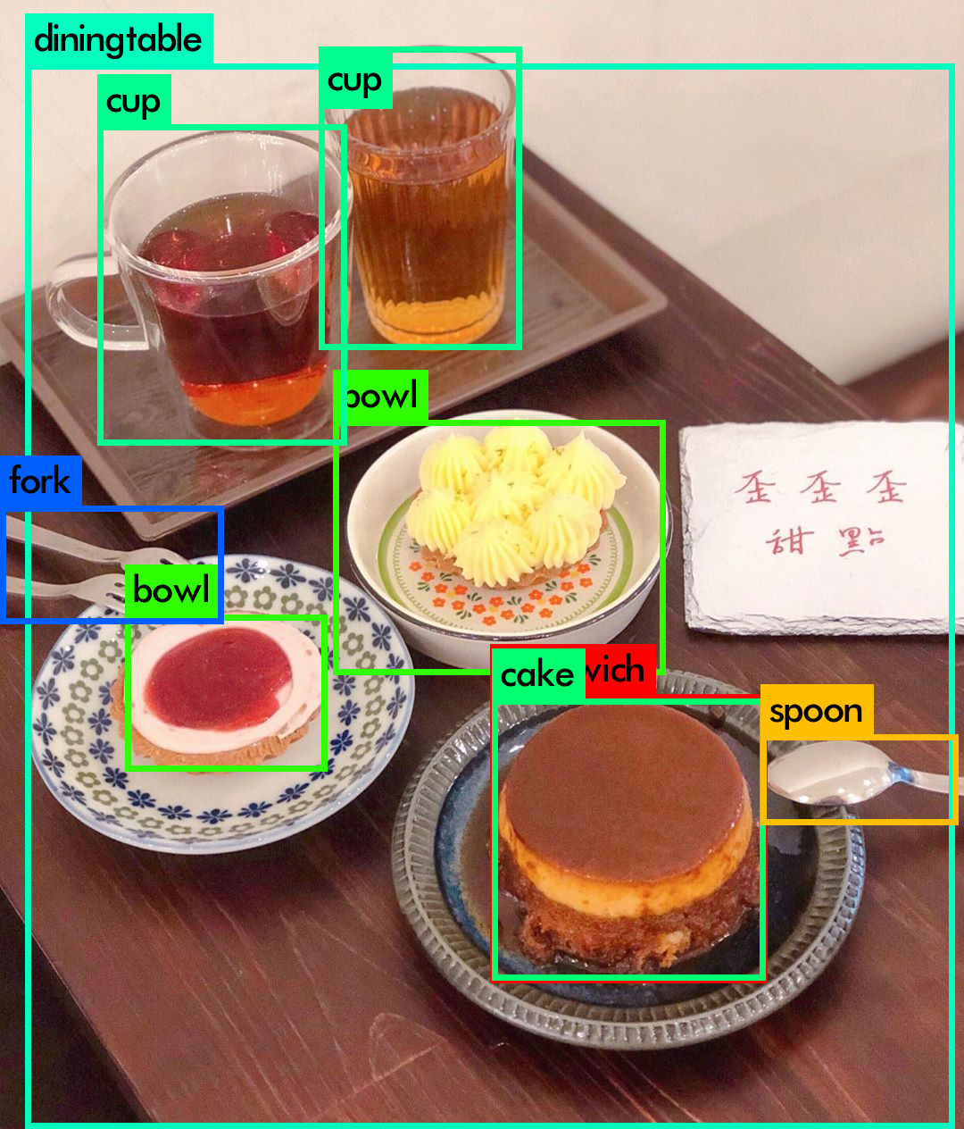
Loading weights from /home/jumbo/yolo/w/yolov4.weights...
seen 64, trained: 32032 K-images (500 Kilo-batches_64)
Done! Loaded 162 layers from weights-file
img/tea2.jpg: Predicted in 39.704000 milli-seconds.
fork: 82%
diningtable: 77%
cup: 99%
bowl: 49%
cup: 100%
bowl: 27%
sandwich: 60%
cake: 72%
spoon: 90%
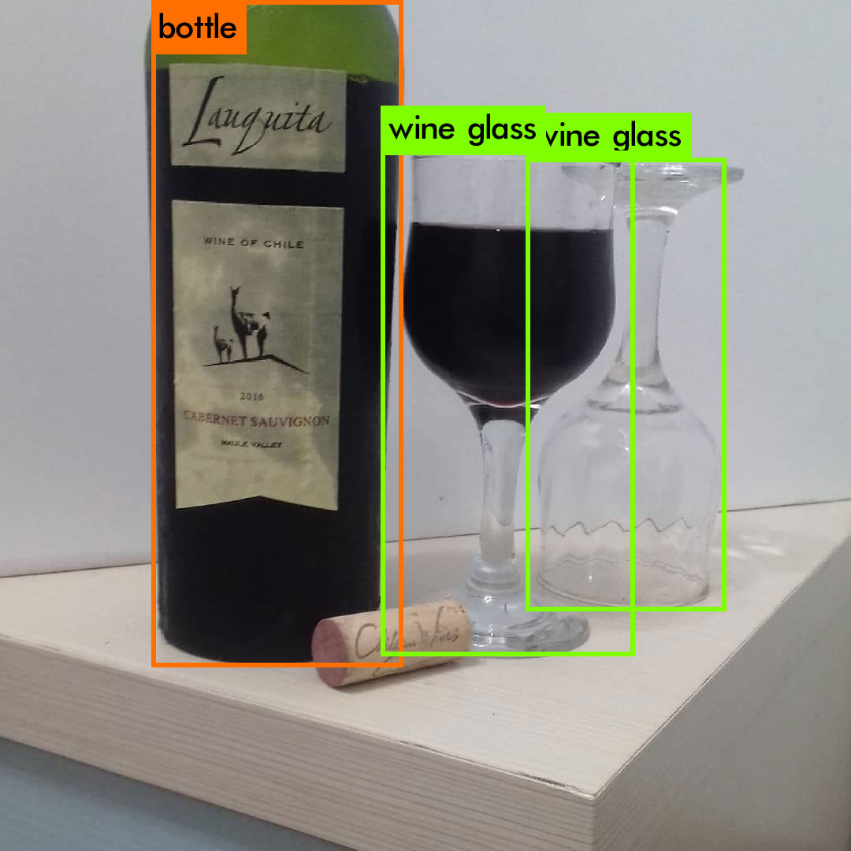
Loading weights from /home/jumbo/yolo/w/yolov3.weights...
seen 64, trained: 32013 K-images (500 Kilo-batches_64)
Done! Loaded 107 layers from weights-file
img/wine1.jpg: Predicted in 20.182000 milli-seconds.
bottle: 95%
wine glass: 99%
wine glass: 84%
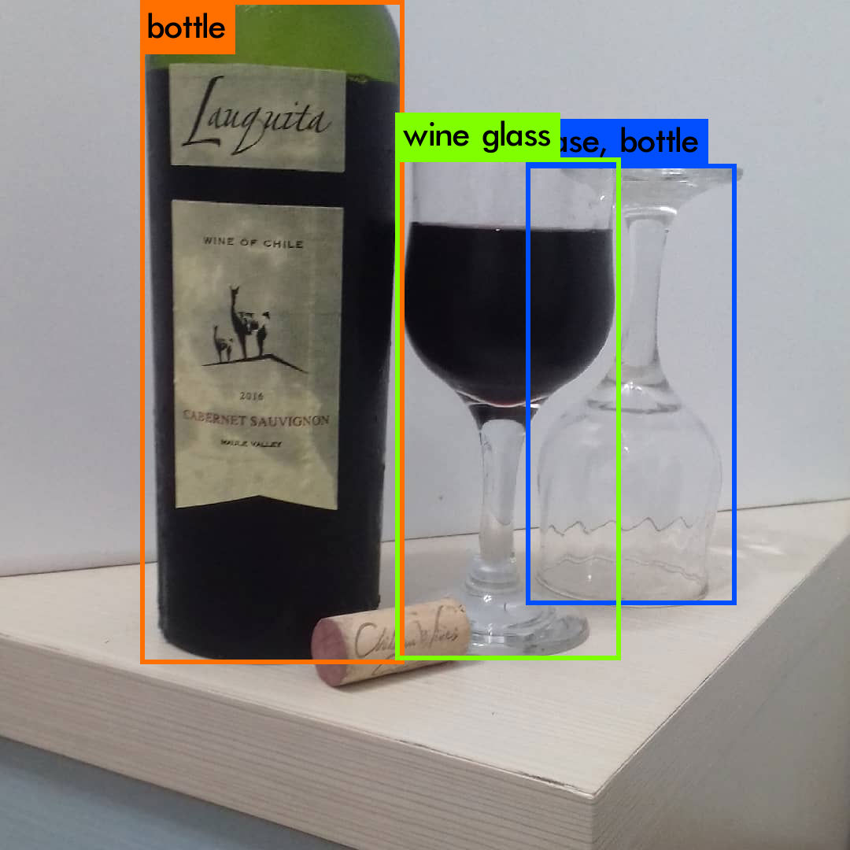
Loading weights from /home/jumbo/yolo/w/yolov4.weights...
seen 64, trained: 32032 K-images (500 Kilo-batches_64)
Done! Loaded 162 layers from weights-file
img/wine1.jpg: Predicted in 39.994000 milli-seconds.
bottle: 99%
wine glass: 99%
vase: 79%
bottle: 30%
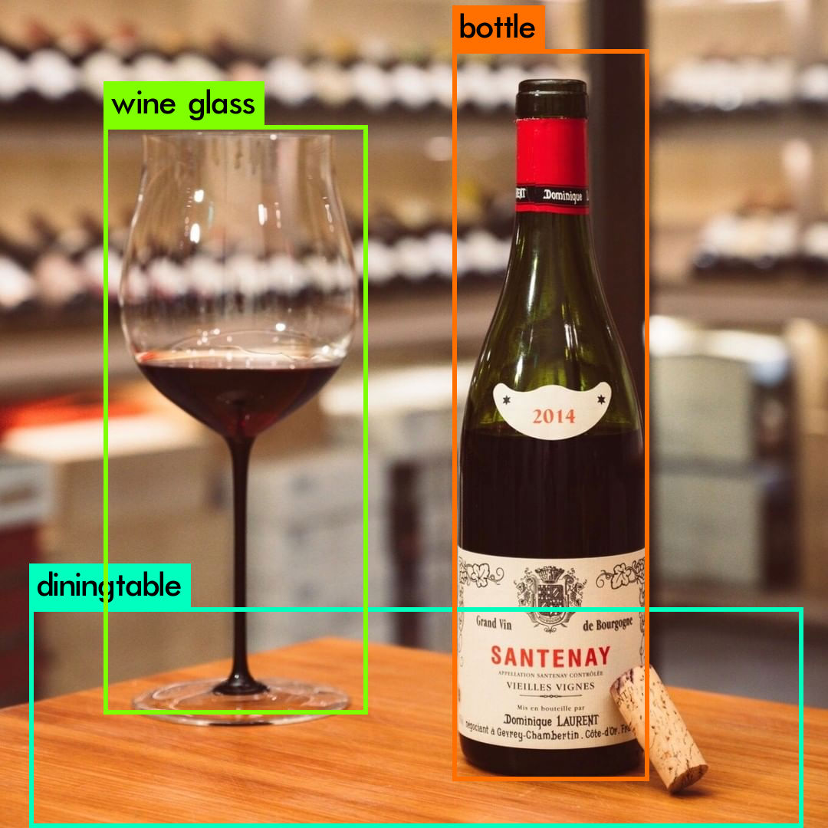
Loading weights from /home/jumbo/yolo/w/yolov3.weights...
seen 64, trained: 32013 K-images (500 Kilo-batches_64)
Done! Loaded 107 layers from weights-file
img/wine2.jpg: Predicted in 20.221000 milli-seconds.
diningtable: 36%
wine glass: 98%
bottle: 100%
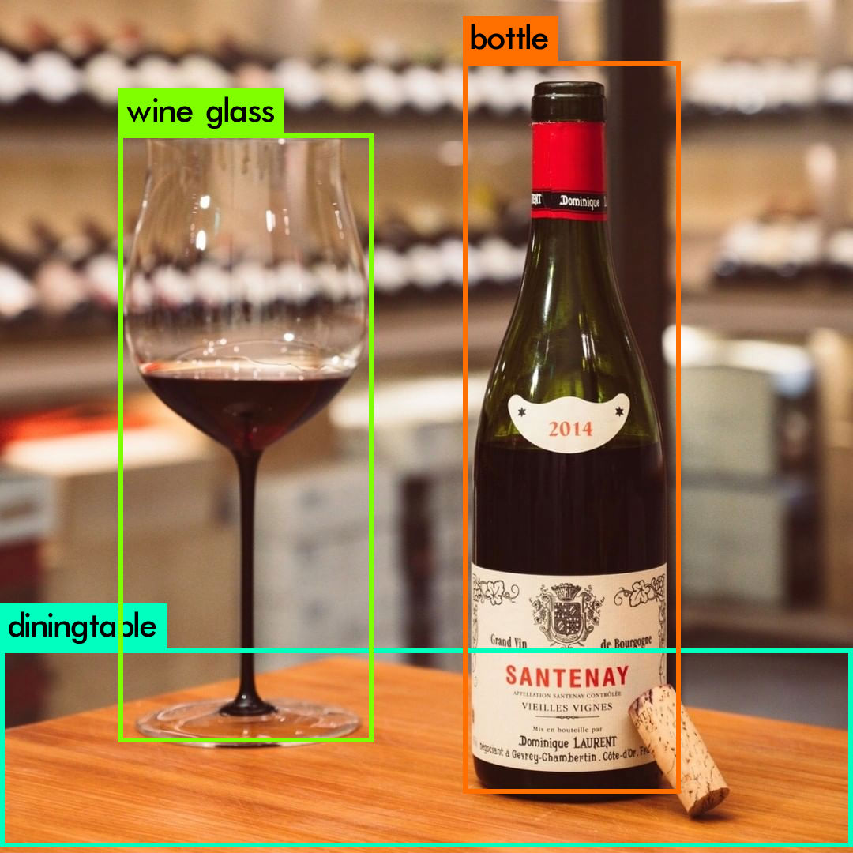
Loading weights from /home/jumbo/yolo/w/yolov4.weights...
seen 64, trained: 32032 K-images (500 Kilo-batches_64)
Done! Loaded 162 layers from weights-file
img/wine2.jpg: Predicted in 40.562000 milli-seconds.
diningtable: 79%
wine glass: 100%
bottle: 99%
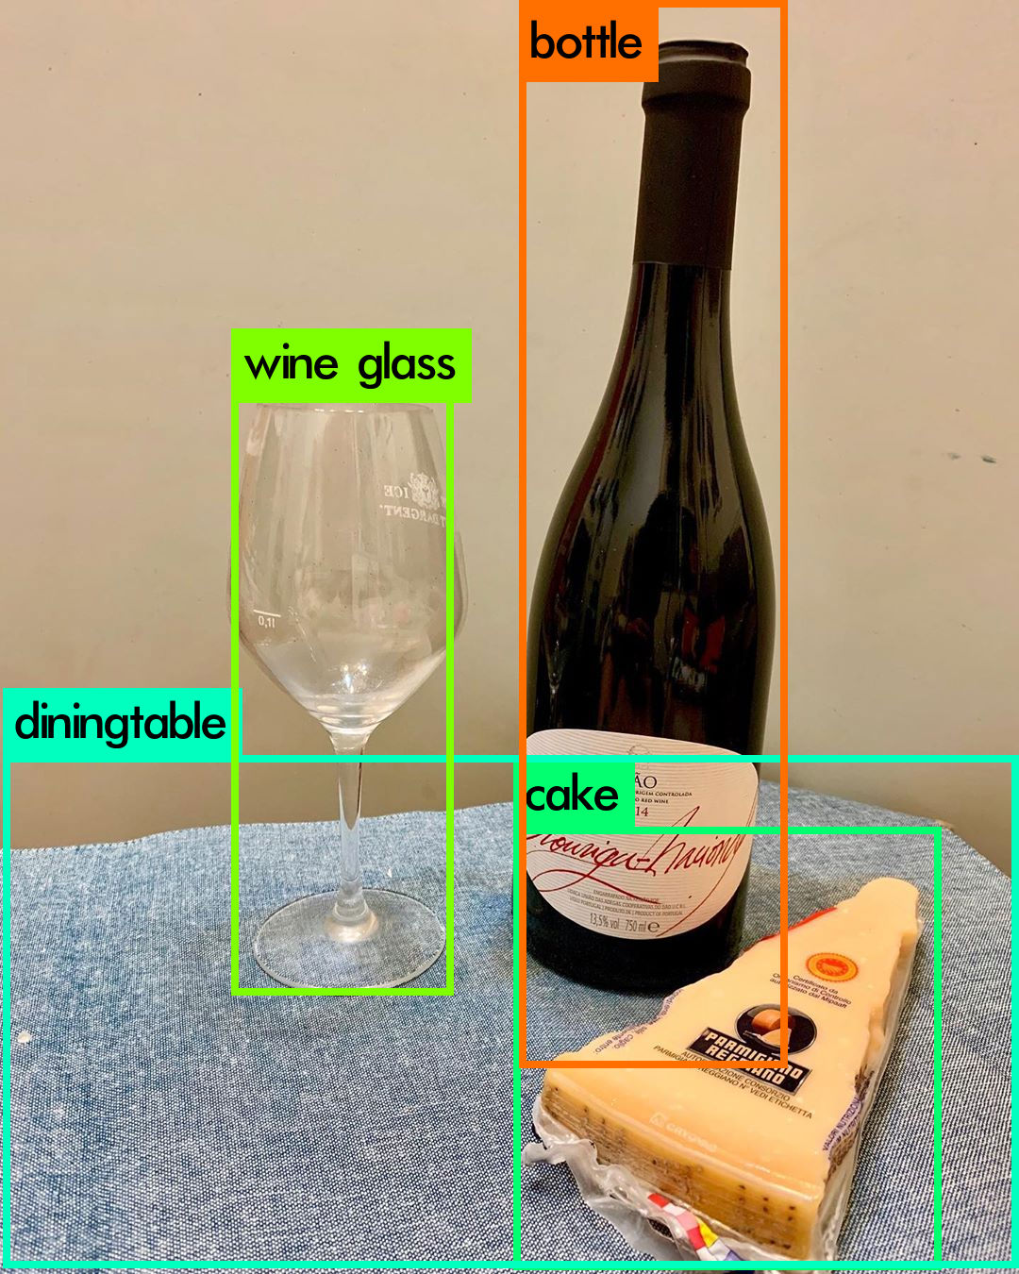
Loading weights from /home/jumbo/yolo/w/yolov3.weights...
seen 64, trained: 32013 K-images (500 Kilo-batches_64)
Done! Loaded 107 layers from weights-file
img/wine3.jpg: Predicted in 20.199000 milli-seconds.
diningtable: 84%
wine glass: 100%
cake: 26%
bottle: 99%
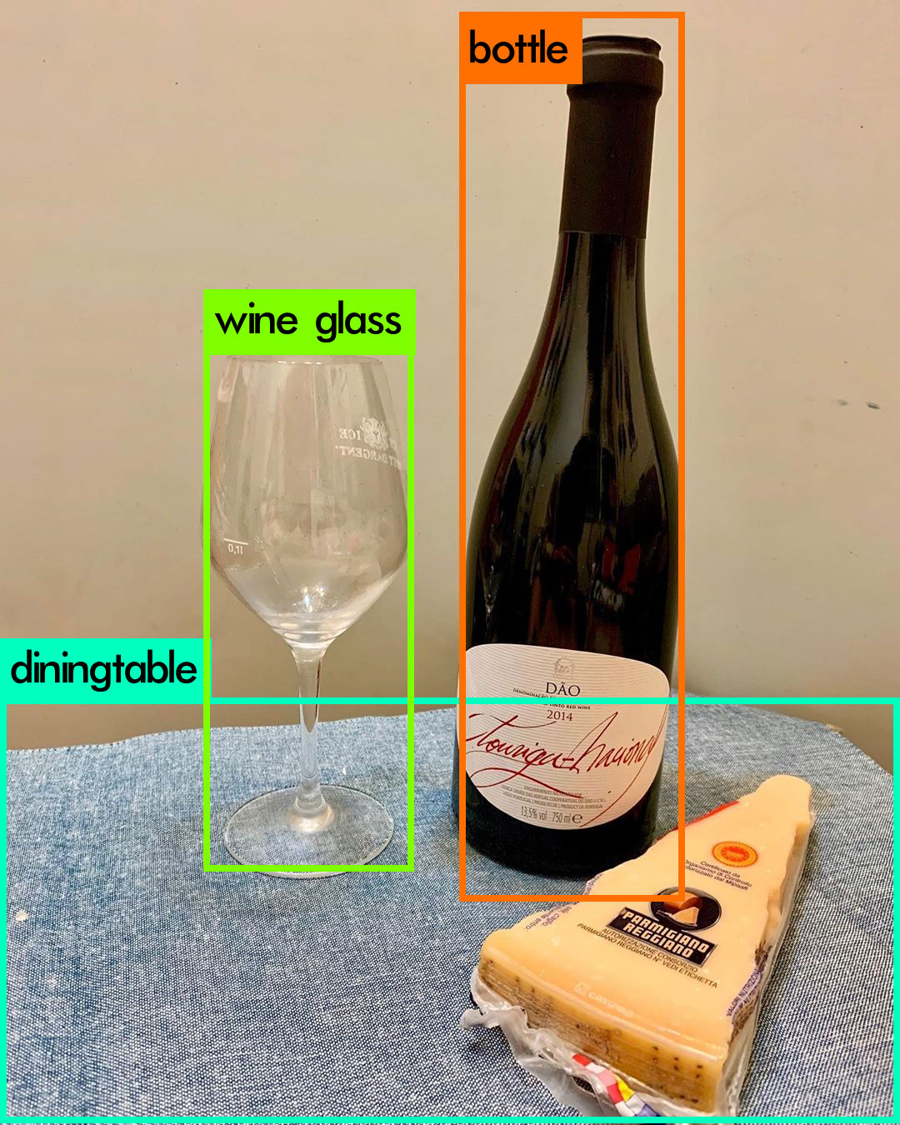
Loading weights from /home/jumbo/yolo/w/yolov4.weights...
seen 64, trained: 32032 K-images (500 Kilo-batches_64)
Done! Loaded 162 layers from weights-file
img/wine3.jpg: Predicted in 39.614000 milli-seconds.
diningtable: 72%
wine glass: 100%
bottle: 98%
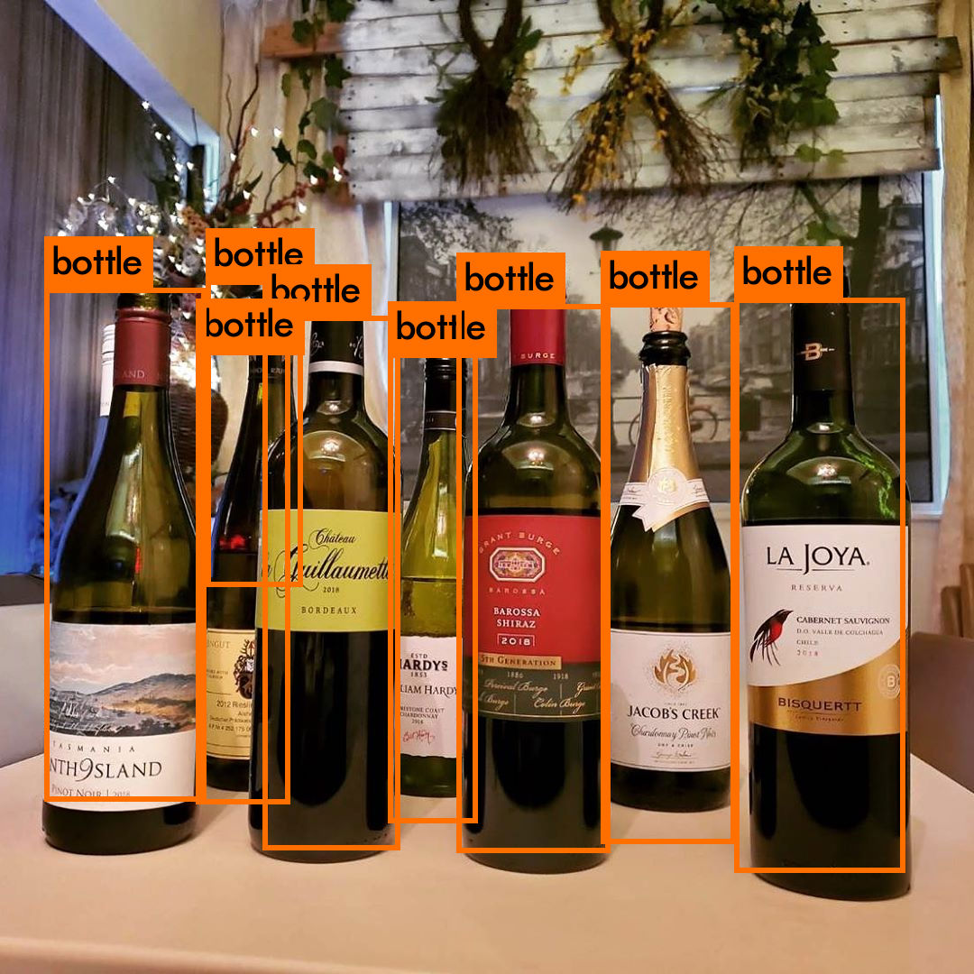
Loading weights from /home/jumbo/yolo/w/yolov3.weights...
seen 64, trained: 32013 K-images (500 Kilo-batches_64)
Done! Loaded 107 layers from weights-file
img/wine4.jpg: Predicted in 20.213000 milli-seconds.
bottle: 99%
bottle: 98%
bottle: 43%
bottle: 97%
bottle: 100%
bottle: 100%
bottle: 100%
bottle: 93%

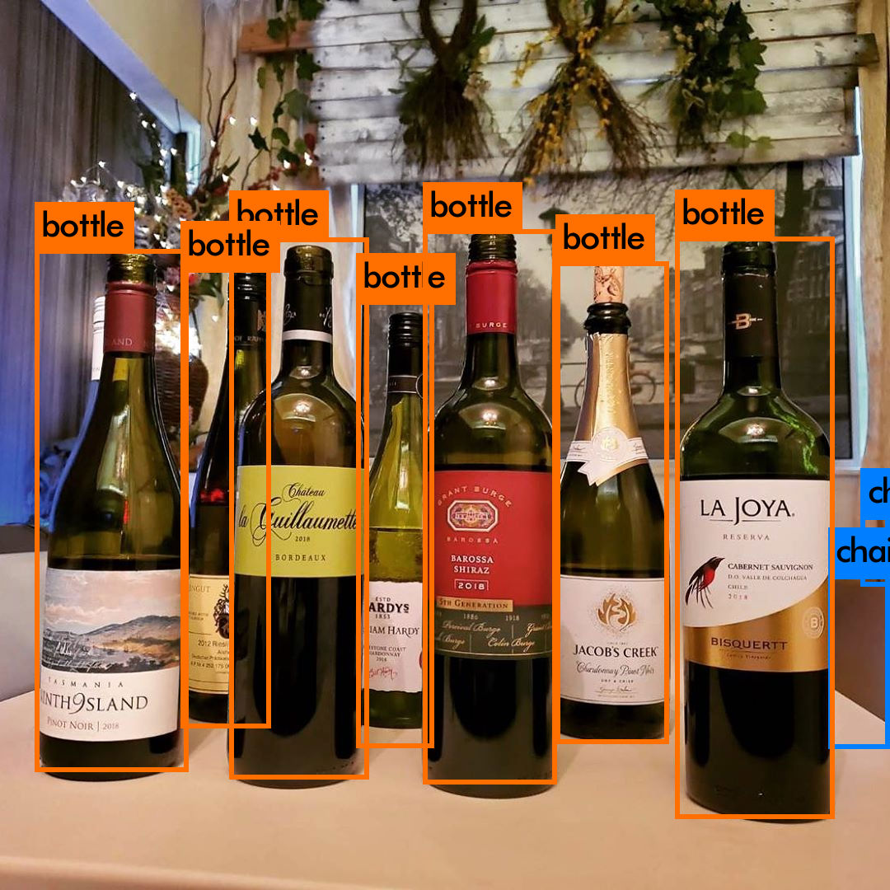
Loading weights from /home/jumbo/yolo/w/yolov4.weights...
seen 64, trained: 32032 K-images (500 Kilo-batches_64)
Done! Loaded 162 layers from weights-file
img/wine4.jpg: Predicted in 39.605000 milli-seconds.
bottle: 99%
bottle: 99%
bottle: 98%
bottle: 98%
bottle: 99%
bottle: 100%
bottle: 100%
chair: 65%
chair: 33%
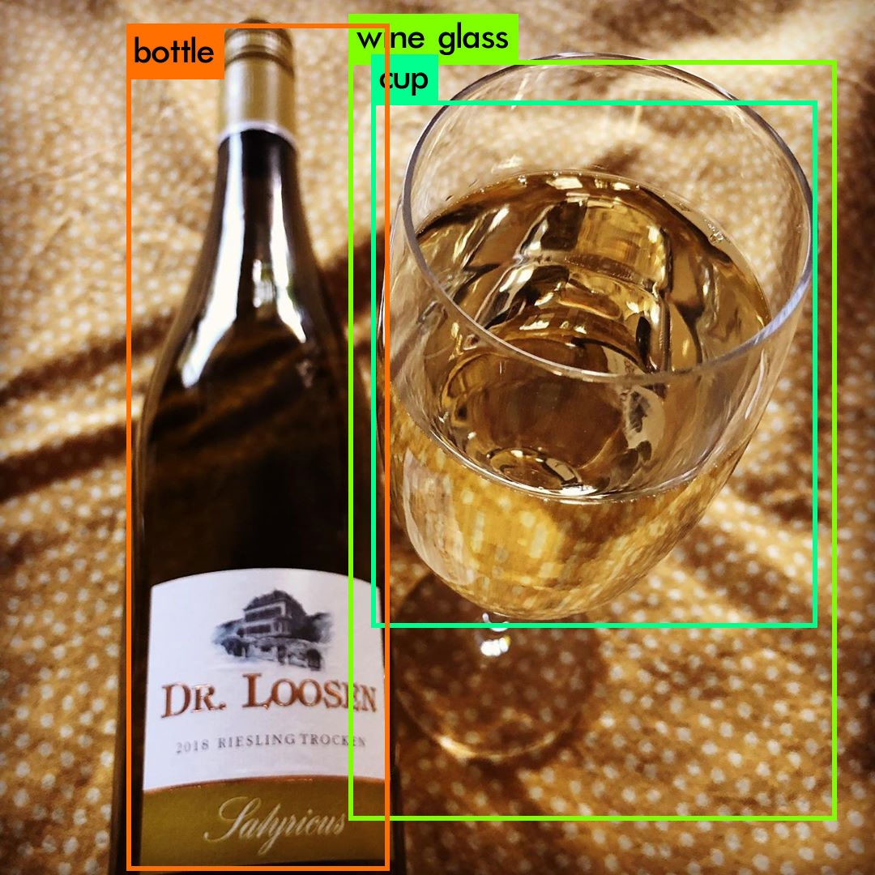
Loading weights from /home/jumbo/yolo/w/yolov3.weights...
seen 64, trained: 32013 K-images (500 Kilo-batches_64)
Done! Loaded 107 layers from weights-file
img/wine5.jpg: Predicted in 20.200000 milli-seconds.
bottle: 100%
wine glass: 46%
cup: 93%
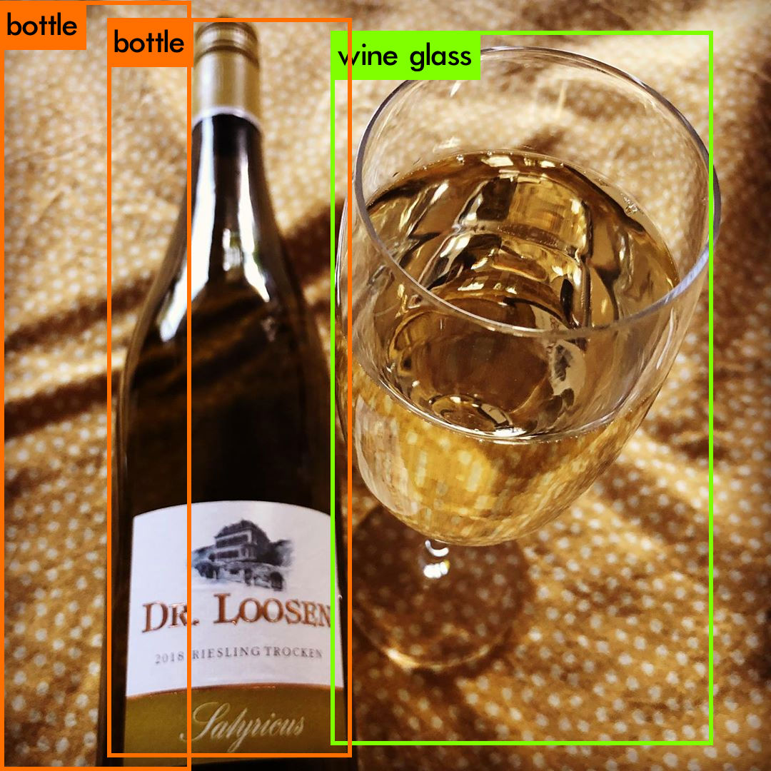
Loading weights from /home/jumbo/yolo/w/yolov4.weights...
seen 64, trained: 32032 K-images (500 Kilo-batches_64)
Done! Loaded 162 layers from weights-file
img/wine5.jpg: Predicted in 40.324000 milli-seconds.
bottle: 42%
bottle: 99%
wine glass: 32%
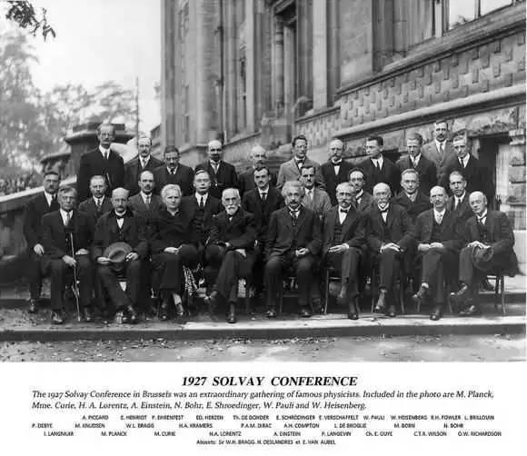
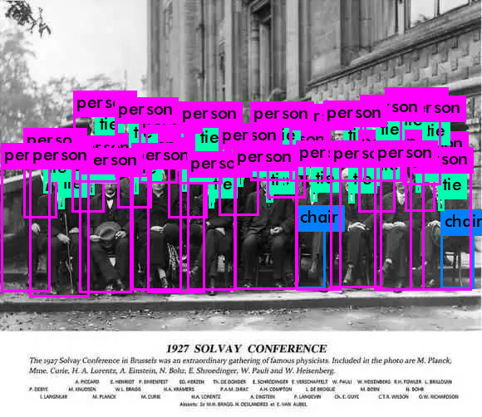
Loading weights from /home/jumbo/yolo/w/yolov3.weights...
seen 64, trained: 32013 K-images (500 Kilo-batches_64)
Done! Loaded 107 layers from weights-file
phicys.jpg: Predicted in 20.526000 milli-seconds.
person: 56%
person: 30%
person: 99%
tie: 54%
tie: 29%
person: 74%
person: 88%
person: 99%
tie: 79%
tie: 65%
person: 92%
person: 70%
tie: 78%
person: 99%
tie: 42%
person: 91%
person: 51%
tie: 50%
person: 50%
person: 96%
tie: 74%
person: 99%
tie: 68%
tie: 30%
tie: 27%
person: 77%
person: 100%
tie: 38%
person: 92%
tie: 28%
person: 57%
tie: 74%
tie: 54%
person: 88%
chair: 37%
person: 96%
tie: 31%
person: 93%
person: 99%
tie: 54%
tie: 31%
person: 78%
person: 90%
person: 99%
tie: 40%
tie: 79%
person: 61%
tie: 65%
person: 77%
person: 37%
person: 99%
tie: 55%
tie: 62%
tie: 59%
chair: 43%
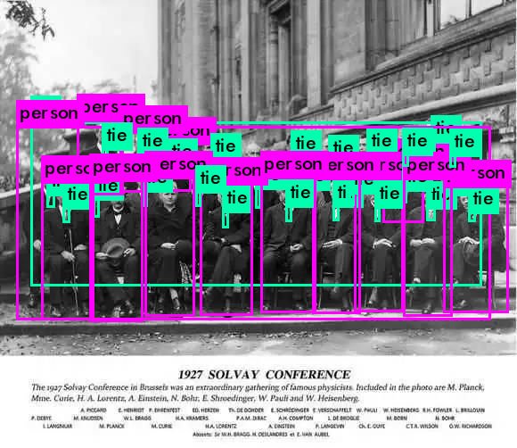
Loading weights from /home/jumbo/yolo/w/yolov4.weights...
seen 64, trained: 32032 K-images (500 Kilo-batches_64)
Done! Loaded 162 layers from weights-file
phicys.jpg: Predicted in 39.734000 milli-seconds.
person: 42%
tie: 29%
person: 63%
tie: 46%
tie: 57%
person: 42%
person: 72%
tie: 30%
tie: 62%
person: 43%
tie: 54%
tie: 48%
person: 63%
person: 38%
tie: 44%
tie: 62%
tie: 71%
person: 62%
tie: 40%
tie: 29%
tie: 40%
person: 79%
tie: 65%
tie: 38%
tie: 27%
person: 64%
tie: 31%
tie: 31%
tie: 47%
person: 38%
tie: 37%
tie: 49%
person: 27%
tie: 45%
tie: 77%
person: 52%
tie: 34%
tie: 41%
person: 49%
tie: 40%
tie: 60%
tie: 44%

