Exploratory Analysis of
COVID-19 Mortality
Age and gender effects on patient outcomes

Author
Jumma Mohammad Teli | Data Analyst
Report date
May 2026
Tools used
R | Hmisc | ggplot2 | Welch’s t-test | Two-proportion z-test

Executive Summary
This report investigates how age and gender influence COVID-19 mortality using a publicly available patient-level line list dataset of 1,085 records. The analysis combines descriptive statistics with formal hypothesis testing to assess whether observed differences in death rates are statistically significant.

Headline findings
- Overall death rate: 5.81% (63 of 1,085 patients).
- Age effect: Deceased patients had a mean age of 68.6 years versus 48.1 years for survivors — a difference of roughly 20.5 years (p < 0.001).
- Gender effect: Male death rate was 8.46% versus 3.66% for females — men were approximately 2.3× more likely to die in this dataset (p = 0.002).
- Statistical confidence: Both effects are significant at the 99% confidence level.
These findings align with broader epidemiological consensus that older patients and males face elevated COVID-19 mortality risk. Caveats around sample size, geographic skew, and early-pandemic data quality are discussed in the Limitations section.

1. Background and Objectives

1.1 Context
In early 2020, COVID-19 emerged as a global health crisis. Understanding which patient characteristics predict severe outcomes was a priority for public health planning, resource allocation, and risk communication. Patient-level line list datasets — records of individual cases with demographic and clinical details — became a key resource for early empirical research.

1.2 Research questions
This analysis addresses three questions:
- What is the overall observed mortality rate in this line list dataset?
- Do deceased patients differ significantly from survivors in terms of age?
- Does the death rate differ significantly between male and female patients?

1.3 Approach
Two-sample hypothesis testing is used throughout. Continuous comparisons (age) use Welch’s t-test, which does not assume equal variance between groups. The gender comparison reports both a t-test (for consistency with common practice on binary outcomes) and a two-proportion z-test, which is more formally appropriate for binary data. Confidence intervals are reported at the 99% level.

2. Data and Methods

2.1 Dataset overview
The analysis uses the COVID-19 Line List Dataset, a publicly available compilation of patient-level case records from the early phase of the pandemic. After dropping empty trailing columns from the source CSV, the working dataset contains 1,085 patient records across 20 fields.
Attribute | Value
Total records | 1,085 patients
Total deaths | 63 patients
Records with age | 843 (77.7%)
Records with gender | 902 (83.1%) — 520 male, 382 female
Age range | 0–96 years
Source | Kaggle: Novel Coronavirus 2019 Dataset

2.2 Data preparation
The raw “death” column contains a mix of “0” (alive), “1” (deceased), and date strings indicating the date of death. To enable mortality analysis, this column was converted into a binary indicator (death_dummy): a value of 0 was retained as 0, and any other value (“1” or a date string) was coded as 1. Missing values in age and gender were excluded pairwise from each test using the standard na.rm = TRUE approach in R.

2.3 Statistical tests
Three tests are applied:
- Welch’s two-sample t-test compares the mean age of deceased patients with that of survivors.
- Welch’s t-test on the binary death indicator compares male and female mortality (treating the 0/1 outcome as continuous — a common approximation).
- Two-proportion z-test compares male and female death rates directly as proportions — this is the formally correct test for a binary outcome and is reported alongside the t-test for transparency.

3. Findings

3.1 Overall mortality
Among the 1,085 patients in the dataset, 63 died, giving an observed case fatality rate of 5.81%. This figure should be interpreted with care: line list data over-represents severe and hospitalised cases, so true population-level mortality is likely lower.

3.2 Age and mortality
Deceased patients were, on average, significantly older than survivors. The descriptive comparison is shown below.
Statistic | Deceased | Survivors
Mean age (years) | 68.6 | 48.1
Median age (years) | 69.5 | 49.0
Standard deviation | 13.6 | 17.8
Sample size (n) | 58 | 785
Welch’s t-test produced t = -10.84 with p < 0.001. The 99% confidence interval for the difference in mean age is approximately 15.5 to 25.5 years (survivors minus deceased), meaning we can be 99% confident that the true age gap is at least 15 years. This is a large and unambiguous effect.
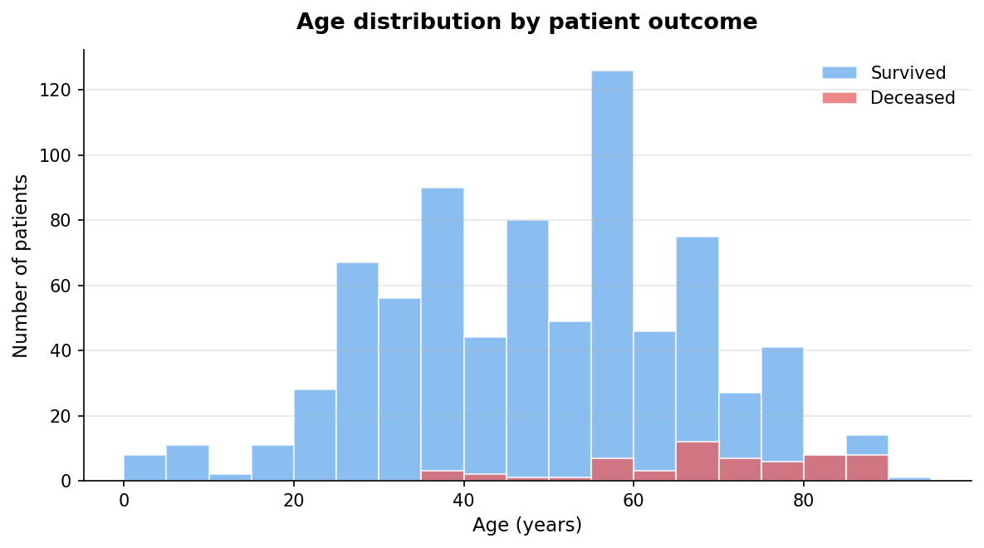
Figure 1. Age distribution by patient outcome. The deceased group is concentrated in the 60–85 year age band, while survivors are distributed more broadly across younger ages.

3.3 Gender and mortality
Male patients showed a substantially higher death rate than female patients.
Statistic | Male | Female
Total patients (n) | 520 | 382
Deaths | 44 | 14
Death rate | 8.46% | 3.66%
The relative risk is 2.31, meaning male patients in this sample were roughly 2.3 times more likely to die than female patients.
Two statistical tests support this finding:
- Welch’s t-test: t = 3.08, p = 0.0021
- Two-proportion z-test: p ≈ 0.001, 99% CI for the difference in death rates: roughly 0.8 to 8.8 percentage points.
Both tests reject the null hypothesis of no gender effect at the 99% confidence level.
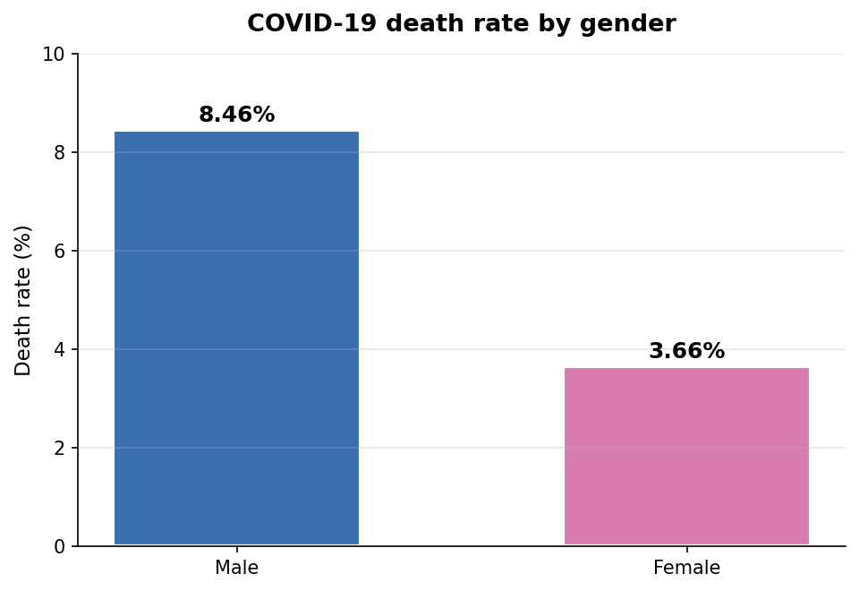
Figure 2. Death rate by gender. Male patients show more than double the mortality rate of female patients.

4. Interpretation

4.1 Why might older patients face higher risk?
The strong age gradient observed here aligns with established immunological and clinical literature. Older patients are more likely to have weakened immune responses, pre-existing cardiovascular or pulmonary conditions, and reduced physiological reserve to recover from severe respiratory infection. The 20-year mean age gap between deceased and surviving patients in this dataset is consistent with mortality patterns reported across larger COVID-19 studies.

4.2 Why might men face higher risk?
The roughly 2× male-to-female mortality ratio is in line with global early-pandemic data. Plausible explanatory factors discussed in the wider literature include differences in immune response between sexes, higher prevalence of comorbidities (cardiovascular disease, hypertension) in men in this age band, and behavioural factors such as smoking rates. This analysis cannot adjudicate between these mechanisms — it can only confirm that the difference exists in this sample.

4.3 Confounding considerations
Age and gender are not independent in the data: the male and female subsamples may differ in age distribution, which could partially mediate the observed gender effect. A multivariate model (e.g. logistic regression with age and gender as predictors) would be the natural next step to isolate the independent contribution of each variable. This is recommended as future work.

5. Limitations
Several factors temper the strength of these conclusions:
- Sample size and scope. With 1,085 records, the dataset is small relative to the global pandemic. It also over-represents early cases, primarily from China, which limits generalisability.
- Selection bias. Line list data captures cases that were detected, reported, and documented — typically more severe or hospitalised cases. The 5.81% observed death rate is therefore not a population-level case fatality rate.
- Missing data. Age is missing for 22% of records and gender for 17%. Pairwise deletion was used; if missingness is not random, this could bias the estimates.
- No multivariate adjustment. The age and gender effects are analysed independently. Their joint distribution is not modelled here.
- Univariate hypothesis tests. Tests confirm the existence of associations but do not establish causality, nor do they account for clustering by country, hospital, or time period.

6. Recommendations and Next Steps
Building on this exploratory analysis, the following extensions would deepen the findings:
- Logistic regression. Model death probability as a function of age, gender, and other covariates (e.g. exposure to Wuhan, symptom onset to hospitalisation delay) to isolate independent effects.
- Survival analysis. Use Kaplan-Meier curves and Cox proportional hazards models to incorporate the time dimension (symptom onset → outcome).
- Geographic stratification. Compare mortality patterns by country to identify systemic differences in case detection, healthcare capacity, or population structure.
- Replication on larger datasets. Validate findings against published national datasets (e.g. ONS, ECDC, WHO) to assess generalisability beyond this line list.
- Interactive dashboard. Build a Power BI or Shiny dashboard to allow stakeholders to filter mortality patterns by age band, gender, and country.

Appendix: Reproducibility

Code and data
All code and the source dataset are available on GitHub:
- Repository: github.com/jumma786/Exploratory-Analysis-of-COVID-19-Dataset-in-R
- Language: R (base R plus Hmisc and ggplot2)
- Dataset: COVID19_line_list_data.csv, 1,085 records, 20 fields after cleaning

How to reproduce
1. Clone the repository.
2. Open the project folder in RStudio and set it as the working directory.
3. Run script.R. The script auto-installs Hmisc and ggplot2 if missing, prints all statistics to the console, and saves two PNG figures.

Author
Jumma Mohammad Teli
Data Analyst | Power BI | SQL | Python | R
LinkedIn: linkedin.com/in/jumma-mohammad
GitHub: github.com/jumma786

