Hospital Quality Intelligence
Project Case Study — End-to-End Data Analytics & Machine Learning
An end-to-end system built on public CMS data for 5,800+ US hospitals: SQL analysis → two explainable ML models → a five-year trend analysis → a deployed, tested, CI-backed dashboard. Designed around a real decision: which hospitals should limited oversight resources target, and why.
Role | Solo project — data engineering, ML modeling, and deployment
Data | CMS Care Compare (public) · 3 datasets · 24 quarterly releases, 2021–2026
Core stack | SQL Server (T-SQL), Python, pandas, scikit-learn, SHAP, XGBoost, Streamlit, pytest, GitHub Actions
Live demo | https://hospital-quality-intelligence-puoehkx7u7po2laff5rv6y.streamlit.app/
Source code | https://github.com/jumma786/hospital-quality-intelligence

Results at a glance
- 75 SQL queries across 5 analytical perspectives on 5,830 hospitals
- Underperformer-triage classifier: ROC-AUC 0.90, 84% recall
- Patient-satisfaction regressor: R^2 0.44 (leakage-free, cross-validated)
- 24 quarterly releases stitched into a longitudinal panel; 817 hospitals flagged on a declining trajectory
- 13 automated tests, CI on Python 3.10 & 3.11, and a publicly deployed app
Skills demonstrated
Data Engineering | Multi-source ETL; schema-drift handling across 5 years; encoding normalization; long→wide reshaping; 100k+ row panel
SQL | Joins, CTEs, window functions (RANK/NTILE/LAG), views, composite scoring
Machine Learning | Classification + regression; 5-fold cross-validation; baseline-anchored model selection; data-leakage prevention
Explainable AI | SHAP feature attribution for stakeholder-facing 'why'
Software / MLOps | pytest test suite; GitHub Actions CI; config-driven design; Streamlit Cloud deployment
Communication | Interactive dashboard, professional documentation, and business-framed problem definition

What I built
Phase 1 — SQL Analytics: 75 queries turning three messy CMS tables into rankings, per-state leaders, and a national hospital scorecard.
Phase 2 — Machine Learning: two Random Forest models (satisfaction prediction + underperformer triage), selected via cross-validated benchmarking and explained with SHAP. Deployed as a 3-tab Streamlit dashboard: ranked audit list, hospital drill-down, and model card.
Phase 3 — Longitudinal Pipeline: 24 real CMS quarterly releases (2021–2026) assembled into a panel that flags hospitals on a sustained downward trajectory — an early-warning tool, not just a snapshot.
Why it stands out
- Judgment over vanity metrics — identified and prevented data leakage, choosing an honest 0.90 model over a fake 'perfect' one, enforced by a test.
- Real-world resilience — handled genuine messy government data: multi-year schema changes and mixed file encodings, not a clean Kaggle CSV.
- Production mindset — tested, CI-verified, documented, and deployed live, not a one-off notebook.
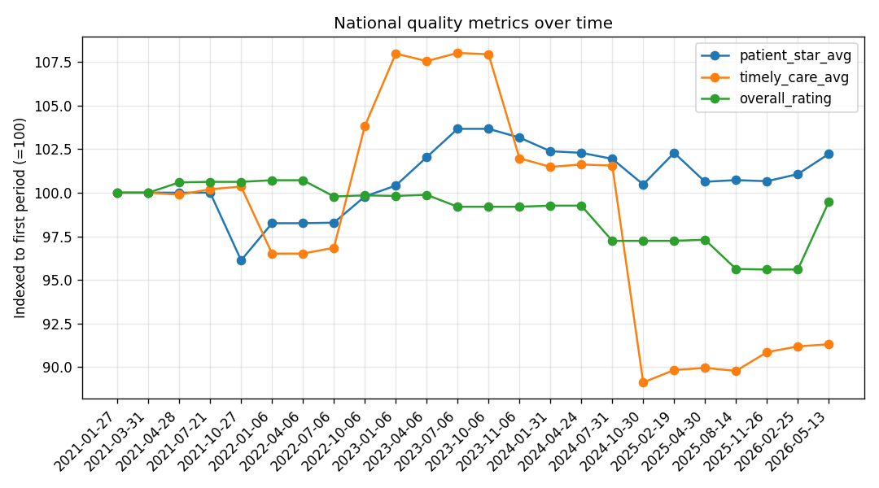
Real national quality trends, 2021–2026 — one output of the longitudinal pipeline.
Explore the work
Live demo: https://hospital-quality-intelligence-puoehkx7u7po2laff5rv6y.streamlit.app/
Code & documentation: https://github.com/jumma786/hospital-quality-intelligence

