What 5 Years of Hospital Data Taught Me About Building Honest ML
How I turned messy government data on 5,800+ US hospitals into an explainable, deployed decision-support tool — and why I chose a worse-looking model on purpose.

Every data science portfolio has the same project: a clean CSV, a model, an accuracy score, a victory lap. I wanted to build something closer to real analytics work — where the data is messy, the 'obvious' model is a trap, and the goal is a decision someone can actually act on. So I picked a domain where quality genuinely matters: US hospitals.
The result is Hospital Quality Intelligence — an end-to-end project built on public CMS Care Compare data that goes from SQL exploration, to two explainable machine-learning models, to a live interactive dashboard, to a five-year trend analysis. Here's the story, including the parts that broke.
The question
Imagine you work for a state health department. You oversee a couple hundred hospitals, but you can only send auditors to a handful each quarter. Which ones do you inspect first? And when a hospital is struggling, what should it actually fix? Those two questions — triage and root cause — framed the entire project. They're not academic; they decide where real resources go.
Phase 1: Learning the data with SQL
Before any modeling, I wrote 75 SQL queries across five perspectives — geography, ownership, clinical safety, timeliness, and patient experience. This wasn't busywork. Real CMS data is full of landmines: ratings stored as text, literal 'Not Available' strings, and three tables that only join cleanly on a facility ID. Window functions (RANK, ROW_NUMBER, NTILE, LAG), CTEs, and views turned 4,800+ hospitals into rankings, per-state leaders, and a composite risk score. The final query stitched all three datasets into a single national scorecard.
Phase 2: The model — and the trap I almost fell into
I built two Random Forest models: one to predict a hospital's patient-satisfaction star rating, and one to flag likely 'underperformers' for audit triage. The classifier hit a ROC-AUC of 0.90. The regressor landed at R^2 = 0.44. But the interesting part isn't the numbers — it's a decision I made that lowered them on purpose.
CMS's overall star rating is mechanically derived from a set of mortality, safety, and readmission measure counts. If I fed those counts into a model predicting the rating, I'd get a near-perfect score — and prove absolutely nothing. That's data leakage: the model would just be reverse-engineering a formula, not learning anything about hospital quality.
"A model that scores 0.99 by cheating is worth less than one that scores 0.90 honestly. Knowing the difference is the job."
So I excluded those columns entirely and trained only on structural and experiential features — hospital type, ownership, location, emergency services, survey engagement, and process-of-care scores. The models got weaker but honest. To make sure that discipline survived future edits, I put the forbidden columns in one place and wrote an automated test that fails if any of them ever reach the feature matrix.
Explaining 'why', not just 'what'
A risk score no one understands is a risk score no one trusts. I used SHAP to open the black box and show which factors push a hospital's predicted satisfaction up or down. Survey response rate and timely-care performance carried far more weight than ownership type — a genuinely actionable finding for an administrator deciding where to invest.
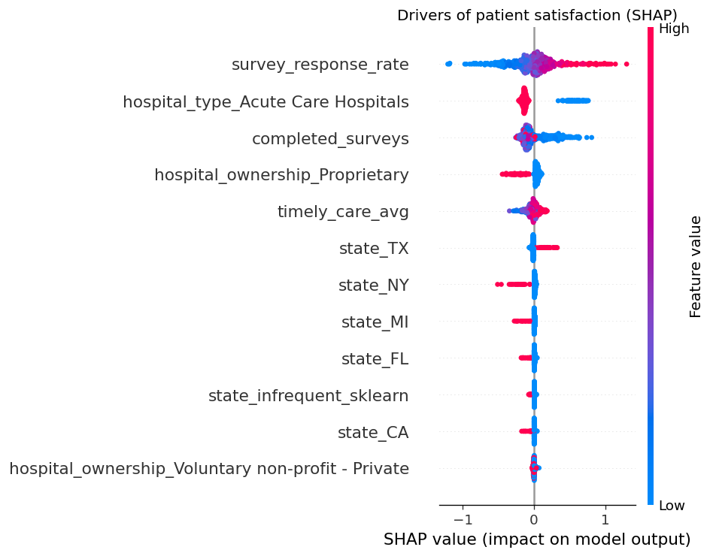
SHAP: what drives a hospital's predicted patient satisfaction.
Phase 3: Five years of real trends (and a data-engineering war story)
A single snapshot can't tell you where a hospital is heading. So I pulled the real CMS archives — 24 quarterly releases from January 2021 to May 2026 — and stacked them into a longitudinal panel of 5,830 hospitals. That let me compute each hospital's trajectory and flag 817 of them as being on a sustained decline: an early-warning list, before they even show up as low-rated.
Getting there was the messiest part of the whole project, and the most realistic. The 2021-2022 archives used an older CMS schema with renamed columns and categorical quality fields instead of numeric counts. Some files were UTF-8; others were Windows-1252 and crashed the parser on an en-dash. The pipeline now resolves column aliases, treats missing risk counts as genuinely unknown (NaN, not a misleading zero), and auto-detects encoding — so 24 heterogeneous releases assemble into one clean panel.
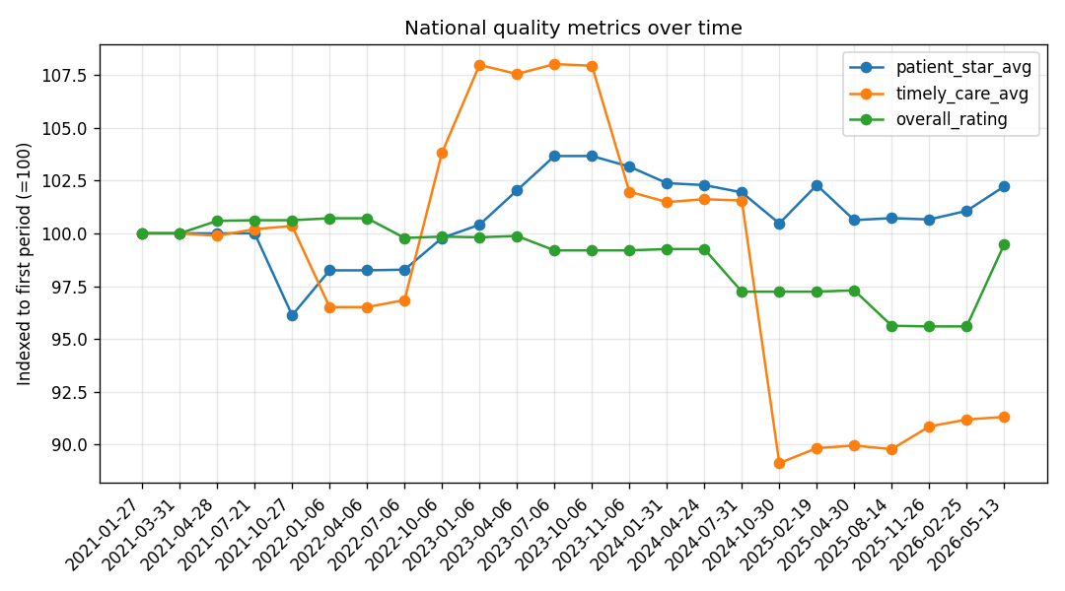
National quality metrics, 2021-2026, indexed to the first period.
The trends themselves are real and a little surprising: timely-care scores climbed through 2023, then dropped sharply in late 2024 (a CMS measure-set change, not a sudden collapse in care); patient satisfaction held steady around 3.2 stars; and survey response rates quietly eroded from 25% to 23% — a small signal of nationwide survey fatigue.
Making it real: tests, CI, and a live app
What separates a notebook from a product is the boring infrastructure. The project has a 13-test suite covering the cleaning logic, the leakage guard, and the trend math, all running automatically on every push via GitHub Actions across two Python versions. And the whole thing is deployed as an interactive Streamlit dashboard: pick a state, get a ranked risk list; pick a hospital, see its drivers.
What I'd tell my past self
- The hard part of analytics isn't the model — it's messy data and honest framing.
- Chase the right number, not the biggest one. Guarding against leakage matters more than a leaderboard score.
- Explainability isn't optional for decision-support. 'Why' is the product.
- Real-world data is heterogeneous over time. Schema drift and encoding chaos are the norm, not the exception.
Try it yourself
The full project — code, tests, and write-up — is open source, and the dashboard is live:
Live demo: https://hospital-quality-intelligence-puoehkx7u7po2laff5rv6y.streamlit.app/
Code: https://github.com/jumma786/hospital-quality-intelligence

If you're building your own portfolio project, my one piece of advice: pick a problem where being honest is harder than being impressive. That's where the real learning — and the real signal to employers — lives.

