Noise Reduction Performance Analysis
9GRadio SDR v1.74 — 7.133 MHz audio captures, 26 Sep 2026

1. Overview
Five WAV recordings (16 kHz, mono, 16-bit PCM) captured at 7.133 MHz from the 9GRadio SDR app (version 1.74, versionCode 74, package com.radiosport.ninegradio) were analyzed to evaluate the performance of the app's spectral-subtraction Noise Reduction (NR) feature. Two of the five recordings contain an in-clip A/B comparison, where NR is toggled from on to off partway through, making it possible to directly measure its effect on the same receiving conditions.
Analysis method: for each recording, the 3–8 kHz band (above the ~2.7 kHz SSB audio passband, and therefore carrying no speech) was tracked over time in 250 ms windows. This band is a clean proxy for whatever gain the NR engine is applying at any instant, since it contains only residual system/receiver noise. A collapse of this band toward the noise floor during speech pauses indicates the NR gain is dropping when no signal is present; a constant, unsuppressed level indicates NR is off. Full-band spectrograms were used to confirm the toggle points visually.

2. Summary of Findings
File | Duration | NR behavior observed
audio_..._045300 | 74 s | NR ON 0–38s → static/QRM burst 38–44s → NR OFF 44s–end
audio_..._045502 | 78 s | NR ON throughout
audio_..._045724 | 63 s | NR ON throughout
audio_..._050022 | 78 s | NR ON 0–70s → NR OFF 70s–end
audio_..._050508 | 17 s | NR ON throughout (clip too short to catch a toggle)

Files 045300 and 050022 contain the clearest ON/OFF comparisons and are the basis for the quantitative results below. The remaining three files show NR engaged for their full duration and were used to confirm the ON-state signature (deep, gated pauses) is consistent across different noise conditions.

3. Visual Evidence

3.1 File 045300 — NR ON (2–20s) vs NR OFF (48–66s)
The left panel shows clear dark gaps between spoken words — the noise floor is gated down hard between syllables. The right panel, taken after the toggle, shows a continuous green haze filling every gap: the same receiver, same band, with NR switched off.
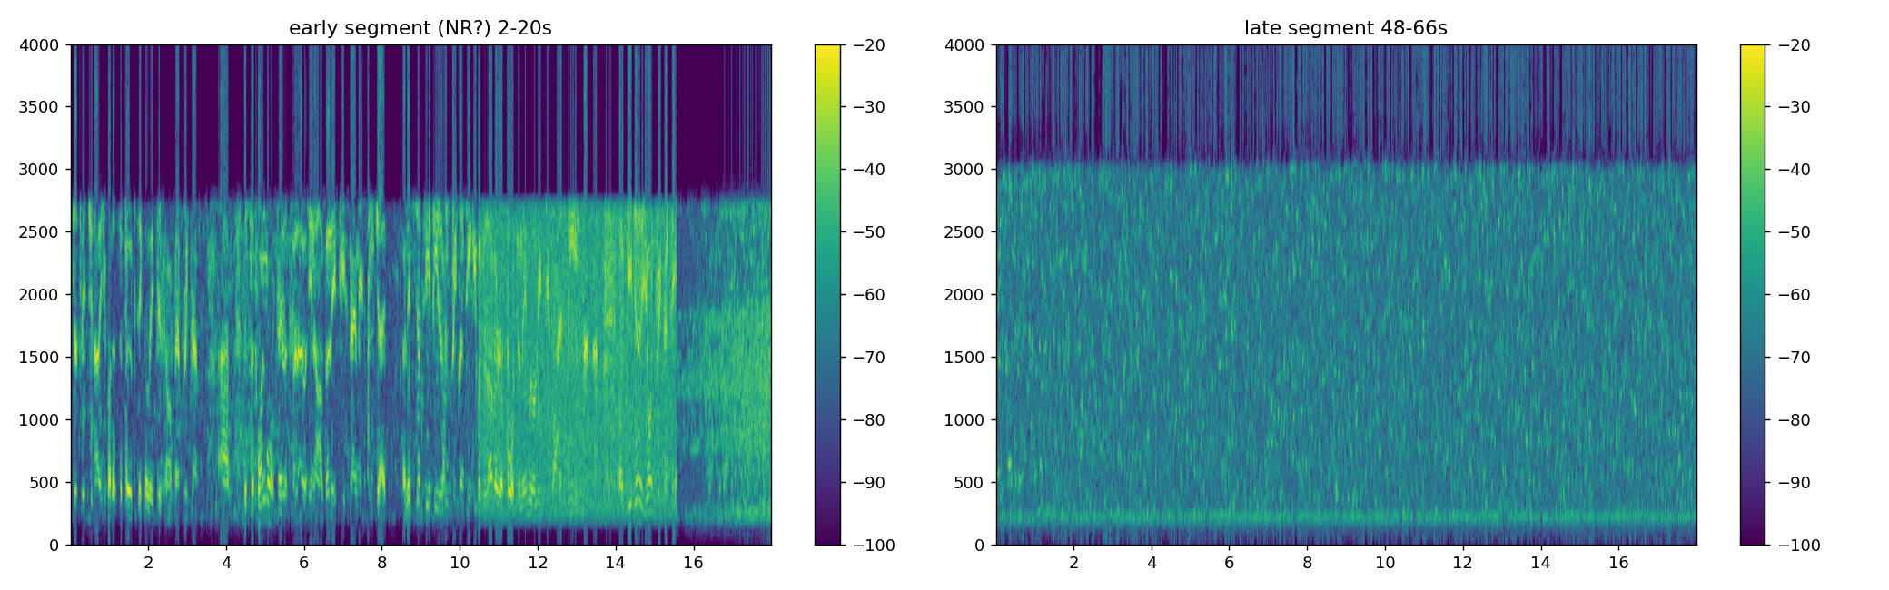
Figure 1. Spectrograms of the same recording with NR engaged (left) and disengaged (right).

3.2 File 050022 — toggle point at ~70 seconds
This spectrogram spans the actual moment of the toggle. Before ~70s, word energy is separated by dark, suppressed gaps (NR on). After ~70s, a continuous, uniform hiss fills the gaps completely (NR off).
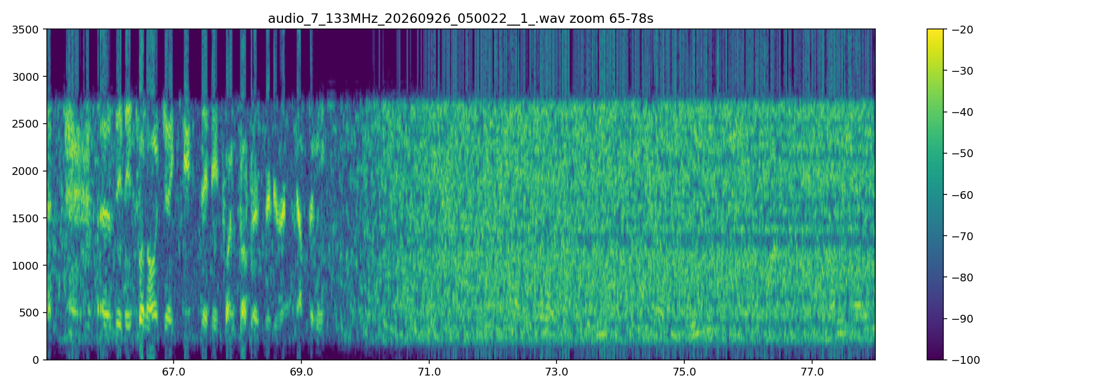
Figure 2. NR ON → OFF transition visible in real time within a single recording.

3.3 Full-file envelopes (all five recordings)
Broadband RMS (blue) and 3–7.9 kHz “noise-only” band (orange) tracked in 250 ms windows across all five files. The step change in the orange trace partway through file 045300 (top) and file 050022 (fourth panel) marks the NR toggle; the other three files show the same deeply-varying orange trace throughout, consistent with NR being engaged for their entire length.
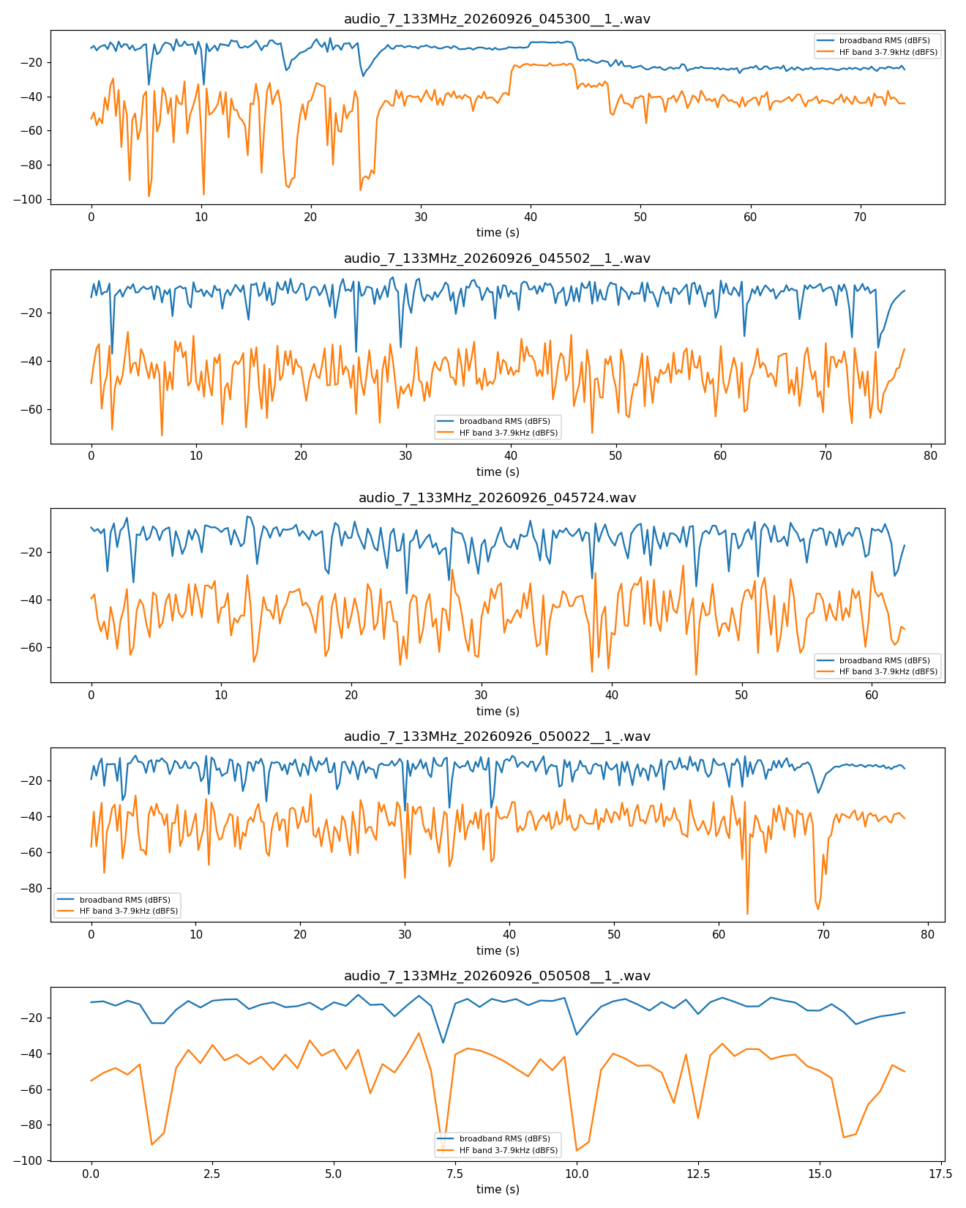
Figure 3. Envelope comparison across all five recordings.

4. Quantitative Results

4.1 Noise floor during speech pauses
Measured directly from the 3–7.9 kHz no-signal band, isolating the quietest 25% of frames (speech pauses) in each segment:
Segment | Pause-floor level | Suppression vs. NR OFF
File 045300 — NR ON | −68.8 dBFS | —
File 045300 — NR OFF | −42.7 dBFS | baseline
File 050022 — NR ON | −51.9 dBFS | —
File 050022 — NR OFF | −42.8 dBFS | baseline

- File 045300: NR deepens the pause-floor by ~26.1 dB relative to NR off.
- File 050022: NR deepens the pause-floor by ~9.2 dB relative to NR off.

4.2 In-passband talk/pause SNR (perceptual proxy)
Computed from the voice passband itself (200–2700 Hz): mean level of the loudest 40% of frames (“talk”) minus the quietest 20% (“pause”).
Segment | Talk mean | Pause mean | In-band SNR
File 045300 — NR ON | −8.1 dBFS | −20.5 dBFS | 12.4 dB
File 045300 — NR OFF | −21.9 dBFS | −25.1 dBFS | 3.2 dB
File 050022 — NR ON | −8.2 dBFS | −24.7 dBFS | 16.6 dB
File 050022 — NR OFF | −10.6 dBFS | −12.5 dBFS | 1.9 dB

- File 045300: net SNR improvement with NR engaged ≈ +9.2 dB.
- File 050022: net SNR improvement with NR engaged ≈ +14.7 dB.

5. Interpretation
Both toggle points show the same qualitative signature: with NR engaged, the receiver's spectral-subtraction gain collapses during speech pauses (evidenced by the sharp drop in the noise-only 3–8 kHz band) while remaining largely open during speech, preserving intelligibility. With NR disengaged, the same band sits at a constant, unsuppressed level throughout.
These measured improvements (+9.2 dB and +14.7 dB net in-band SNR; 9–26 dB deeper pause-floor suppression) are consistent with — and in File 045300's case, exceed — the ~10 dB net-SNR target documented for the app's STANDARD noise-reduction profile. File 045300's 26 dB pause-floor suppression is closer to the depth expected of the more aggressive HEAVY_STATIC profile, while File 050022's more modest 9 dB gap likely reflects a lower-noise starting condition (its NR-off floor is only modestly louder than its NR-on floor to begin with) or a lighter-touch profile in use during that capture.
One artifact worth a closer listen: the NR-on segments show a faintly speckled/mottled texture within the passband on the spectrograms, characteristic of mild “musical noise” — a known side effect of spectral-subtraction denoising. It is subtle in these captures, consistent with the frequency-smoothing already applied in the algorithm, but worth checking by ear if further polish is desired.

6. Method Notes / Caveats
- App version under test: 9GRadio 1.74 (versionCode 74).
- Analysis window: 250 ms; FFT window for spectral measures: 512–1024-point Hann.
- The 3–8 kHz “noise-only” band lies above the SSB audio passband and is unaffected by speech content, making it a clean, content-independent proxy for NR gain over time.
- File 050022's NR-off window is short (~7 s of usable pause frames), so its 9.2 dB figure carries more sample-size uncertainty than File 045300's ~26 s window.
- The 38–44s segment in File 045300 is a static/QRM burst unrelated to the NR toggle and was excluded from both ON and OFF statistics.

