Justin Morrow
10/04/2025
CSD 340 – Assignment: bioSite: Ideas, Sketches, and Inspiration

Note: I couldn’t find anyone willing to allow their pictures online or willing to go through this entire assignment for the next 5 weeks. Since I’m writing this about myself, I assume I still write it in a 3rd persons perspective? (Ex: He instead of me, His instead of mine?)

Front-end Style Guide
Note: You will need to create your own style guide from the examples provided under the “Resources” section.

Adobe Color Wheel: https://color.adobe.com/create/color-wheel
Sea Hawks | Complimentary | Balanced/Modern | Black and White
#69BE28 | #45362B | #2B4C69 | #FFFFFF
#002244 | #2B4145 | #C8A978 | #000000
#ASACAF | #908A85 | #8FA9BG
#F4F4F4 | #82969A | #F5F4F2
#1A1A1A | #C4A286 | #333333
 | #7BDEEF
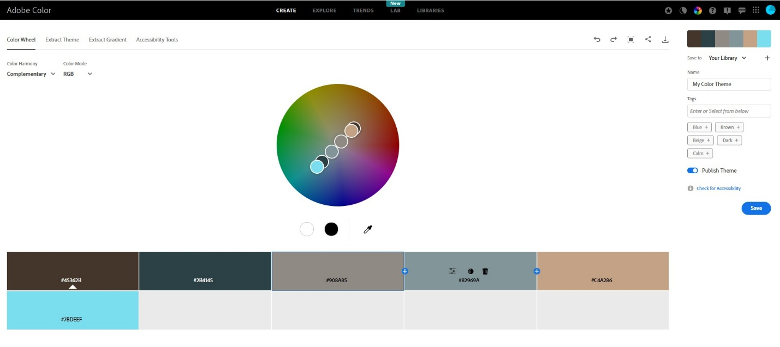
I’m still not 100% locked on my color scheme as I chose my color scheme first based upon Seahawks colors but after playing around with it don’t think it looks good unless you’re the Seattle Seahawks. Then I played around with the colors based upon my main headshot which is mostly earth tones. I like it, but the example site I want to model is primarily black and white, and it looks like we need multiple colors per the color pallet site as seen in the image above with 6 colors.
Wireframes, sketches, or prototypes

Note: The deliverables here are wireframes, sketches, and/or prototypes of the proposed design. Outcomes from this task will be compared against the final submission and they must match.
I found 3 personal bio sites that I liked based on the style. They are big, clean and straight to the point.
https://www.jakesinclair.ca/ (I like the big image of himself but in black and white keeping the clean look of the site. I think the videos below or to much since full size maybe, but I want to model my landing page like this one. I also like the mouse cursor. Also his menu expands as his contact me page which also includes his resume)
https://kylecraven.design/ (I like that it’s simple, clean and the font selection stands out. You scroll down to see each section and 1 image wipes over with another image if moused over, or some sort of fade depending on the space on the page and my skill level to make it do that. I also really like his last page which is more of a contact me)
https://colin-moy.webflow.io/ (I like that the About, Portfolio and Contact match them with a filled in black circle for the O to match the top part of the site. I might make my Menu Selections at the bottom of the banner of the landing page or top right area)

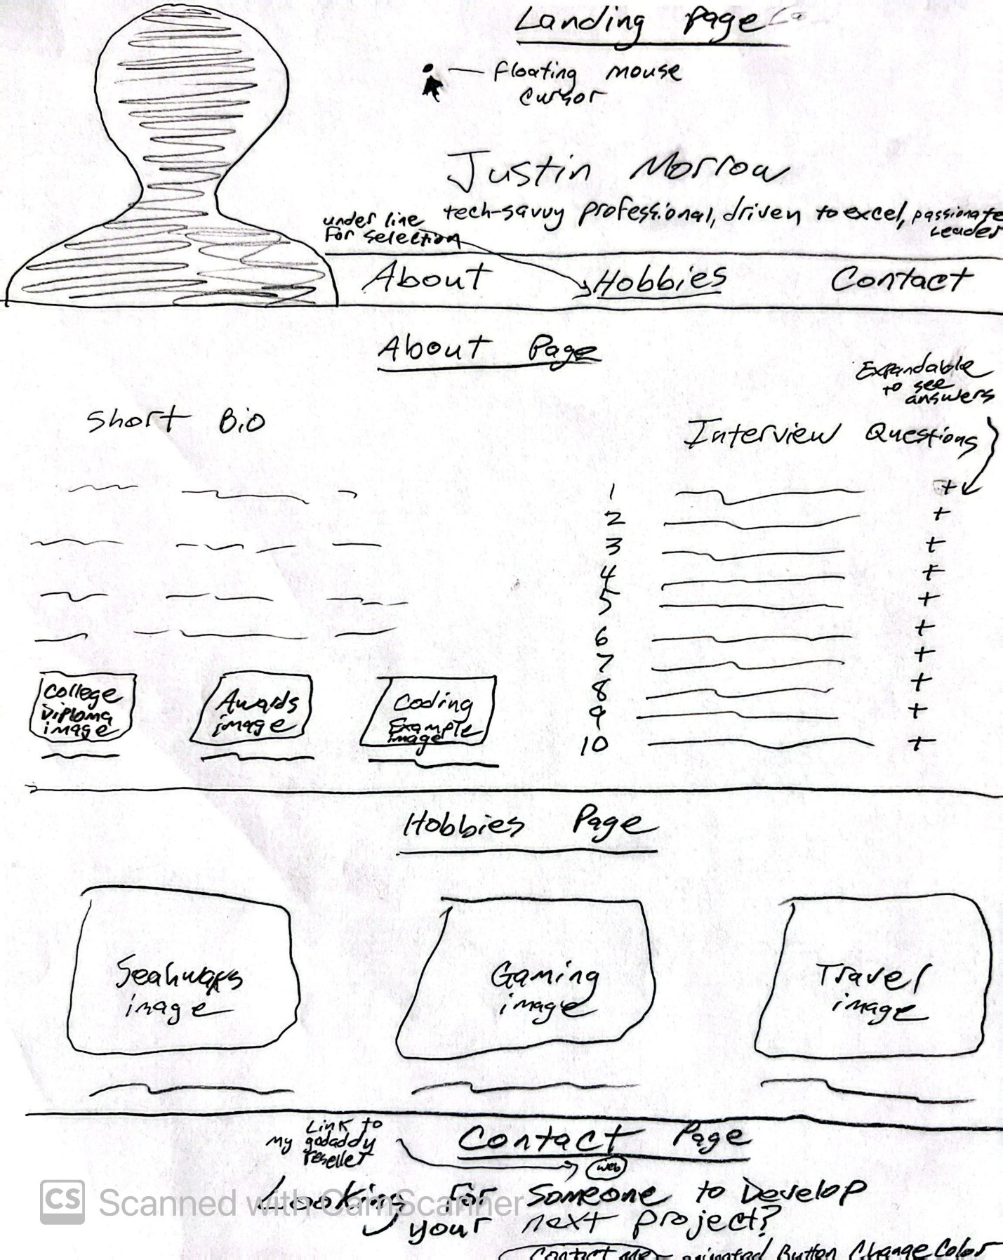

Self-Interview (Justin Morrow)
Note: the document must contain a minimum of 10 interview questions and responses from the subject.

- What’s your full name, and where are you from?
  - I was born as Justin D Jolley but later changed my last name to Morrow to honor my stepfather. Due to a clerical error, my middle name which was just the letter D was removed during the process.
- What are some of your hobbies or passions?
  - I'm a big Seattle Seahawks fan and excited to see them play the Texans in person in two weeks. I enjoy movies, especially action, drama, and comedy genres and spending time playing Xbox with my son. I also love relaxing in the backyard or going on vacation with my family. Hawaii was a favorite until we visited Costa Rica two years ago, which took the top spot. I’m passionate about technology and enjoy creating tools and resources that help people: websites, photo books, digital life celebration videos, coding apps, and more.
- What accomplishments are you most proud of?
  - I was the first in my family to graduate from college, earning an associate degree in Electronics from ITT Tech in 1999. Professionally, I’m proud of receiving multiple promotions and awards throughout my career. One highlight was becoming the youngest recipient of the Peak Achievement Award at VoiceStream (now T-Mobile), followed by the Pinnacle Award which is given to the top 250 employees which included a trip to Hawaii at age 21. At Verizon, I’ve received 10 "Coin of Excellence" awards and 2 "VP Coin of Excellence" awards in my 19 years with the company.
- What career or life goals are you currently working on?
  - While I hope to retire in my current role, I recognize how quickly technology and AI are evolving. That’s why I’ve returned to school to complete my bachelor’s degree and expand my programming skills. My goal is to remain relevant and bring value to my organization as I look ahead to 20 more years in the workforce.
- What motivates or inspires you in your daily life?
  - My Lord and Savior, Jesus Christ. I strive to serve and love others well and be a light in a world that often feels divided. Though I fall short, I’m encouraged by grace and forgiveness. That motivates me to show kindness, keep my word, and continue growing.
- Describe a challenge you’ve overcome and what you learned from it.
  - Losing both of my parents at a young age taught me the value of life and relationships. Life is short, and the people in it matter most. Being someone, others can depend on, whether in good times or bad, is something I’ve learned to prioritize. Every season, even the hard ones, offers something to learn or pass along to others.
- What does success mean to you?
  - Success used to mean awards, titles, and recognition, but over time, I’ve come to see success as something deeper. It's about my relationship with my family and my faith. If my wife of 22 years and my two kids feel loved and supported, and if I hear “Well done, my good and faithful servant” from my Creator one day, then I’ll know I’ve lived a successful life.
- If someone visited your site, what do you want them to take away from your story?
  - I want them to see that life is about purpose, service, and connection. You can thrive through adversity, grow through change, and live with intention. I hope they feel encouraged to be authentic and pursue what matters most to them.
- What colors, styles, or designs do you feel represent you?
  - Seahawks green has always been my favorite color, with midnight blue as a close second. While I like bold colors, my preferred design style is more traditional, nothing too loud or flashy. I appreciate clean, complementary designs that are timeless and effective.
- Anything else unique about your journey you want to share?
  - In a time when everything is more expensive, it's tempting to chase the highest paying job, but I’ve learned that money can’t buy fulfillment. I’ve left roles for more money, only to return to what I loved. When your work aligns with your passion, the reward is more than just financial, it’s peace, purpose, and joy.

Justin Morrow – Short Bio
Note: This will be added to the About page, in a later module.

Justin Morrow is a dedicated professional, lifelong learner, and passionate technologist. Born as Justin Jolley, he later took on the surname Morrow in honor of his stepfather, a decision rooted in gratitude and identity. He earned an associate degree in Electronics from ITT Tech in 1999, becoming the first in his family to graduate from college.
Justin's career has been marked by excellence and recognition. From early promotions in his teens to earning prestigious awards such as the Pinnacle Award at T-Mobile and multiple "Coin of Excellence" honors at Verizon, his work ethic and leadership stand out. For the past 19 years, he has been a consistent contributor at Verizon, blending reliability with a passion for innovation.
His love for technology fuels his creativity, whether developing custom tools, building websites, or creating digital celebration videos. Outside of work, Justin cherishes time with his wife of 22 years and their two children. He enjoys watching movies, relaxing in the backyard, traveling (with Costa Rica topping his list), and playing Xbox with his son.
Justin’s faith in Jesus Christ is the foundation of his daily life and purpose. He seeks to be a light in a divided world and live with integrity, compassion, and service. Currently pursuing a bachelor’s degree, Justin is committed to staying relevant in the ever-changing tech world while holding fast to what truly matters: faith, family, and making a difference.

Images for Final Project

- 3 Images should be related to the subject's hobbies
  - This will go under the hobby page, in a later module, and should include a small write-up explaining their relevance. Remember, you are trying to build a story/timeline for visitors to follow

Hobby – Family Vacations
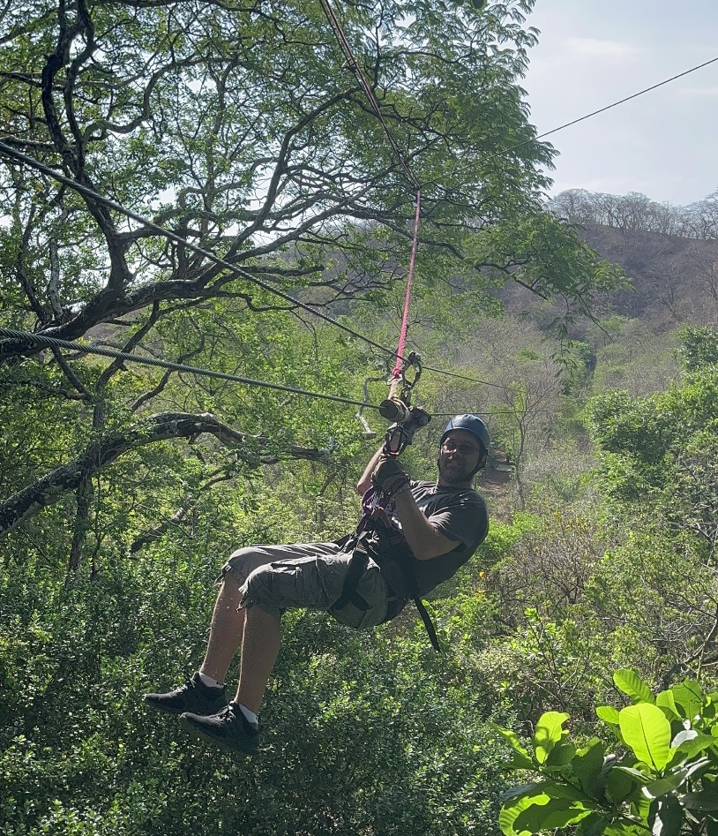
Exploring Costa Rica was a highlight of Justin's family travel adventures. The trip deepened his appreciation for culture, nature, and family time.

Hobby – Seattle Seahawks
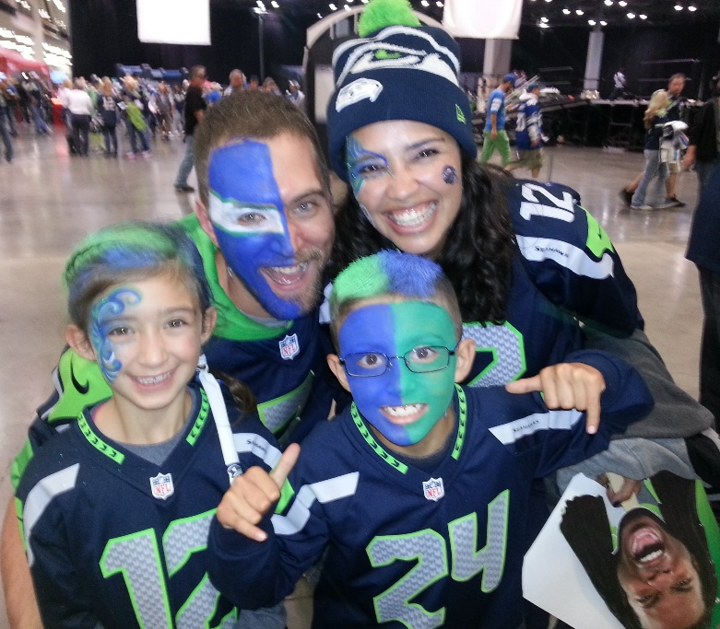
Justin is a huge Seattle Seahawks fan. He enjoys watching the games on TV and in person with his family.

Hobby – Playing Xbox with his son
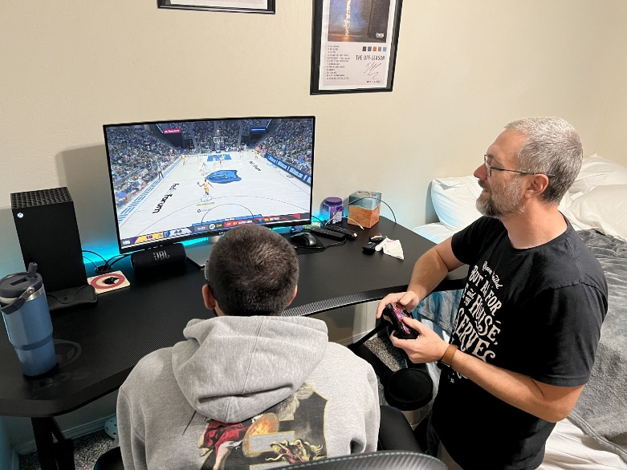
Justin enjoys bonding with his son through gaming on the Xbox playing 2 player co-op games.

- 3 images should be related to the subject’s goals, personal accomplishments, or embellishments
  - These will go on the landing page, in a later module, and should include a small write-up explaining their relevance. Remember, you are trying to build a story/timeline for visitors to follow

Accomplishment – Graduation
[placeholder for college diploma]
Justin became the first in his family to graduate from college, earning his associate degree in Electronics from ITT Tech in 1999.

Accomplishment – Awards
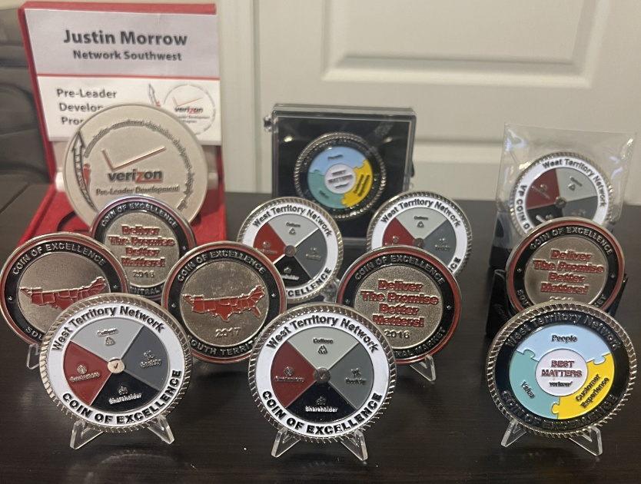
Over the years, Justin has received numerous work awards, including T-Mobile’s Peak and Pinnacle Awards, and Verizon’s Coin of Excellence honors.

Goal – Learning Today
[placeholder for image of coding]
Driven by a love for learning and innovation, Justin returned to school to finish his bachelor’s degree to deepen his knowledge in programming.

- 1 image should be a portrait of the subject
  - This image will be added to the About page, in a later module, above the formalized 250-word write-up

Justin Morrow is tech-savvy professional, driven to excel, and a passionate leader.

