Justin Morrow
Assignment: CSD 340 Module 3.2 GitHub Pages
09/18/2025

Deliverable 1: Validate the HTML by using the W3C HTML validator (There must be 0 errors)
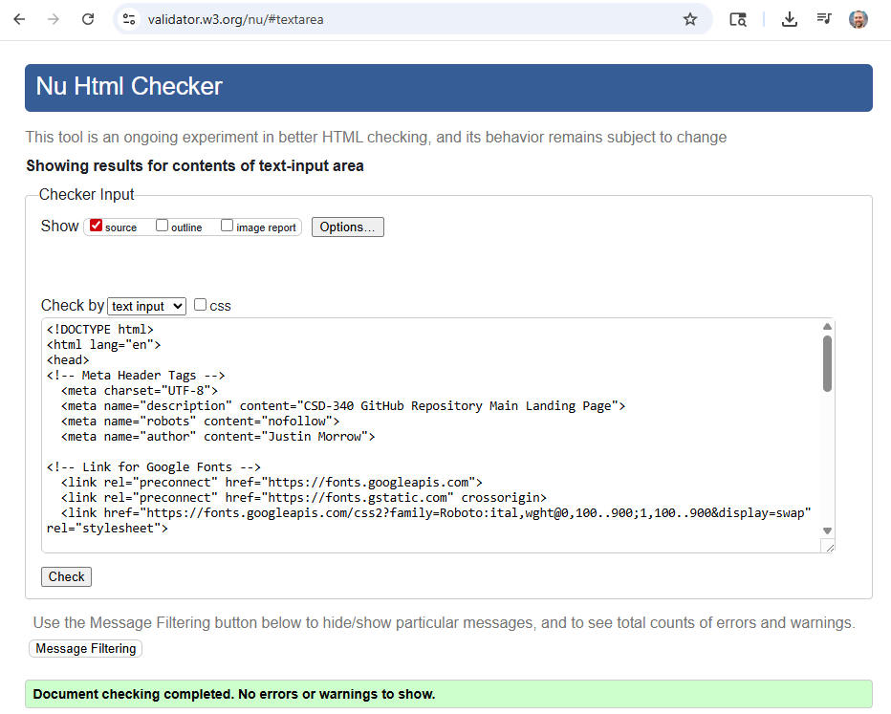

Deliverable 2: Validate the CSS by using the W3C CSS validator (There must be 0 errors)

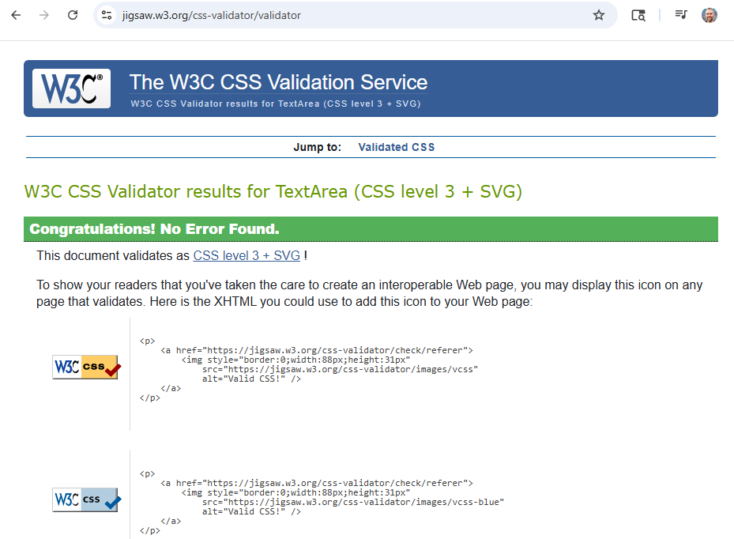

Deliverable 3: Open your index page in a browser and take a screen shot of the results
