Project: ToDo application Test Plan
Course: CSD380-340A - DevOps
Description: Five functional test cases covering ToDo application features
Date: 2026/06/24
To complete the test case plan, fill out the information for Project, Course, Description and Date in the header below.
.
TABLE OF CONTENTS
Website Access and Task List 2
Create Task 3
Edit Task 4
Delete Task 5
Invalid URL Page 6

Test 1 | Website Access and Task List
 | Test Objective: Verify that the standard URL opens the landing page and displays the existing Todo list. | Developer:  Date tested: 2026/06/24 | Peer tester: Justin Morrow  Date tested: 2026/06/27
Step | Action | Expected results: | Developer pass/fail | Tester pass/fail  + Screenshot
1 | Enter the web address https://buwebdev.github.io/todo/ in browser address bar | The ToDo Webapp loads in browser | Yes | Yes  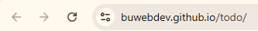
2 | Confirm the landing page displays "Welcome to the Todo App!", the Task Form, and the Todo List. | All required landing-page sections and elements are visible and readable. | Yes | Yes  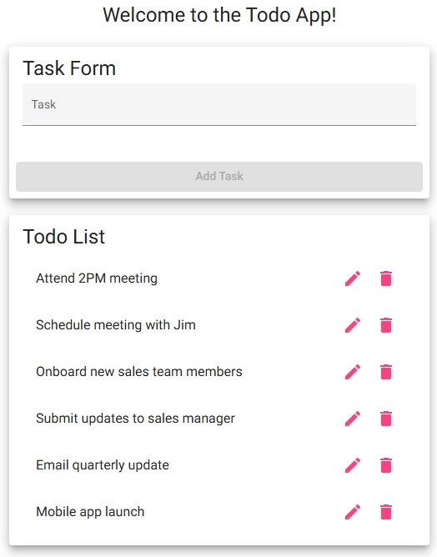
3 | Review the Todo List and the controls beside each item. | Existing task items appear, and each item has edit and delete controls. | Yes | Yes  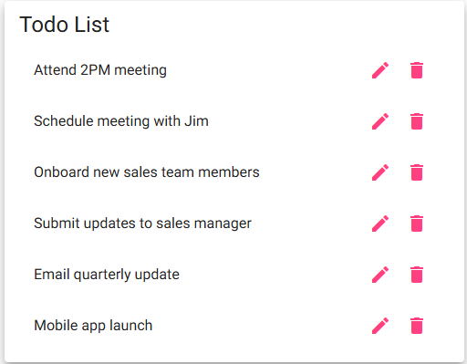
4 | Refresh the browser window | The page reloads correctly, and the landing page and task list display again without errors. | Yes | Yes  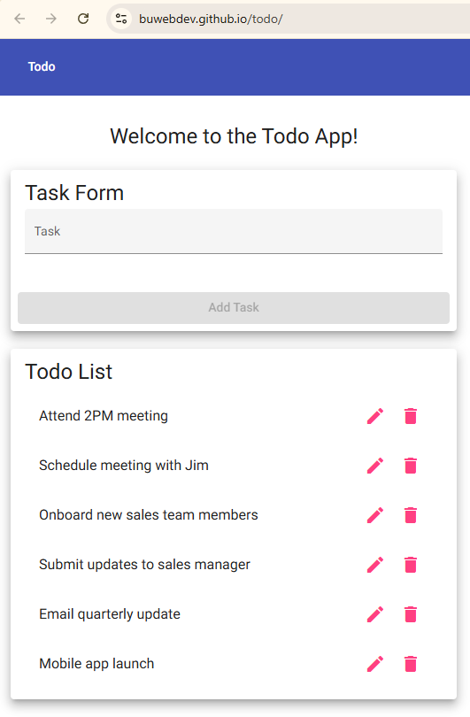
Comments | I tested the initial page load in both Google Chrome and Microsoft Edge browsers, and it loaded all elements correctly. I refreshed both browsers and the reloaded correctly.

Test 2 | Create Task
 | Test Objective: Verify that a user can create a task and cannot submit the task form while it is blank. | Developer:  Date tested: 2026/06/24 | Peer tester: Justin Morrow  Date tested: 2026/06/27
Step | Action | Expected results: | Developer pass/fail | Tester pass/fail
1 | Open the Todo website and leave the Task field blank. | The Add Task button is disabled while the Task field is blank. | Yes | yes  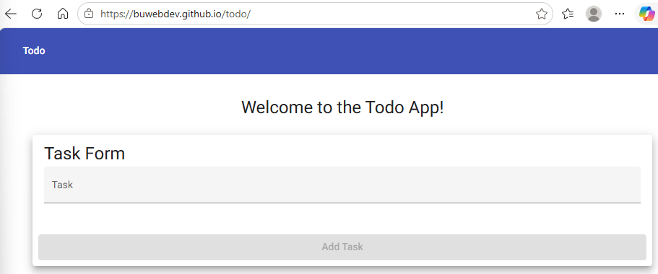
2 | Try to submit the blank Task form. | No blank item is added to the Todo List. | Yes | yes  
3 | Enter "Complete CSD 380 test plan" in the Task field. | The text appears in the field, and the Add Task button becomes enabled. | Yes | Yes  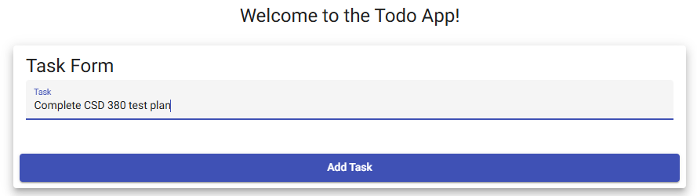
4 | Select Add Task. | A new Todo item named "Complete CSD 380 test plan" is added once to the list. | Yes | Yes  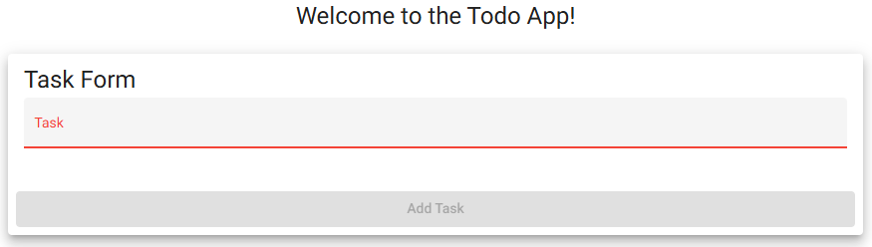
5 | Review the new item and the rest of the list. | The new item is visible, the input field is cleared, and the existing items remain unchanged. | Yes | Yes  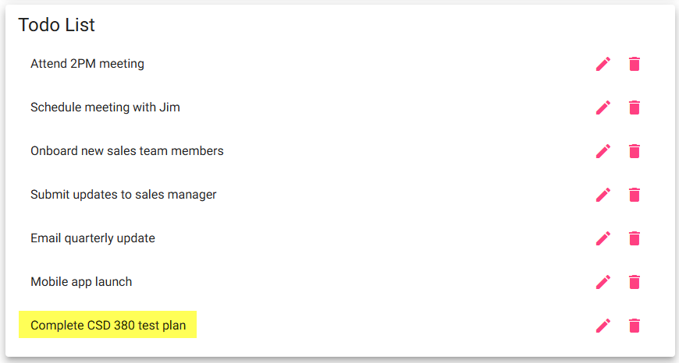
Comments | I confirmed the Add Task button remained greyed out until there were 4 characters typed into the Task field. Once the 4th character (which can include a space, number, or special character), the Add Task button turns blue, allowing me to add the new task. After pressing the Add Task button the Task name I typed in the box appears at the bottom of the Todo List and all previous Todo List items remained.

Test 3 | Edit Task
 | Test Objective: Verify that a user can edit a task and cannot save the edit form without task text. | Developer:  Date tested: 2026/06/24 | Peer tester: Justin Morrow  Date tested: 2026/06/27
Step | Action | Expected results: | Developer pass/fail | Tester pass/fail
1 | Select the edit icon beside "Complete CSD 380 test plan." | The Edit Form opens and displays the current task text. | Yes | yes  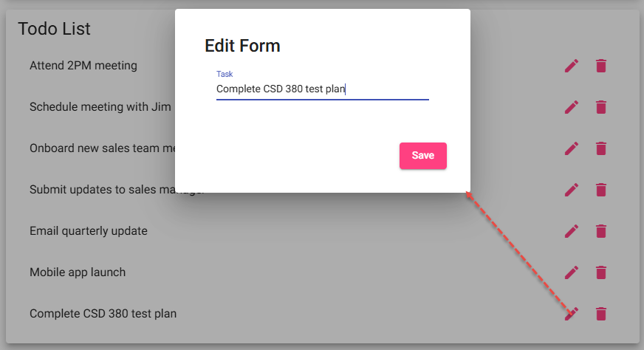
2 | Delete all text from the edit field. | The field becomes blank, and the application should prevent a blank update. | No | yes  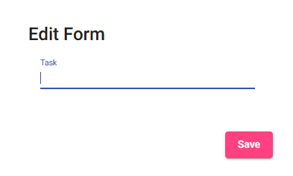
3 | Select Save while the edit field is blank. | The blank value is not saved, and the original task remains unchanged. | No | No  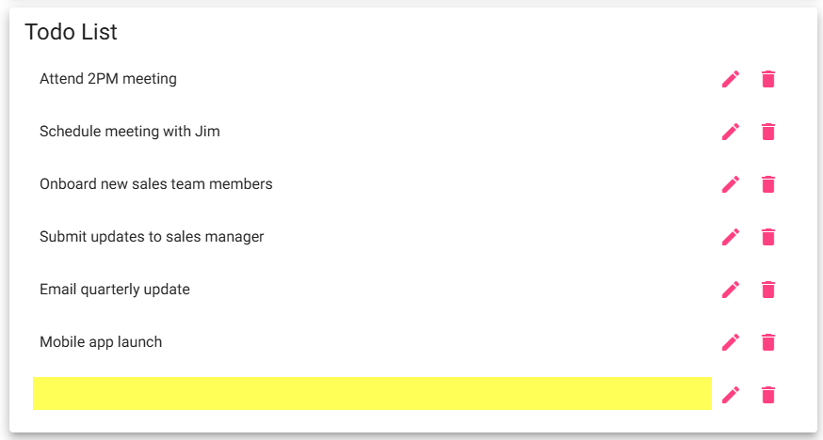
4 | Enter "Complete and submit CSD 380 test plan" in the edit field. | The replacement text appears and is ready to save. | Yes | Yes  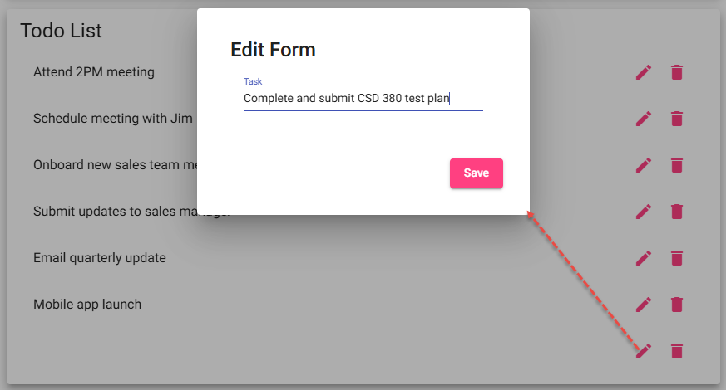
5 | Select Save and review the Todo List. | The Edit Form closes, the updated text appears, and the old text no longer appears. | Yes | Yes  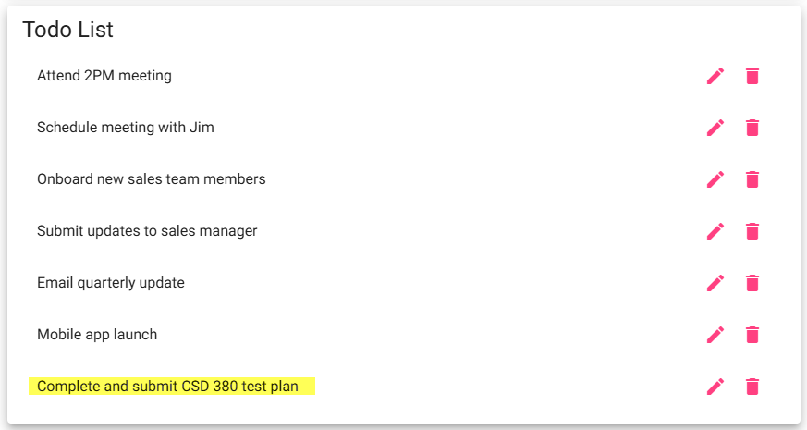
Comments | I was able to click the pencil edit icon on the “Complete and submit CSD 380 test plan” entry I created, and the Edit Form box appeared. I entered step 2 as “Yes” instead of “No” because the test case asked me to delete all the text. In step 3 it wants confirmation of clicking the Save button not allowing a blank entry to appear in the Todo List. I confirmed you are prevented from entering a blank Todo List task initially (but it will allow adding 4 blank spaces), we see that in the edit mode you can delete all text with no spaces which shouldn’t be allowed per the test case. I confirmed I could edit the blank name entry and put the text back in as “Complete and submit CSD 380 test plan” and save it successfully.

Test 4 | Delete Task
 | Test Objective: Verify that a user can delete a selected Todo item without changing other items. | Developer:  Date tested: 2026/06/24 | Peer tester: Justin Morrow  Date tested: 2026/06/27
Step | Action | Expected results: | Developer pass/fail | Tester pass/fail
1 | Locate "Complete and submit CSD 380 test plan" in the Todo List. | The edited task is visible with a delete control. | Yes | yes  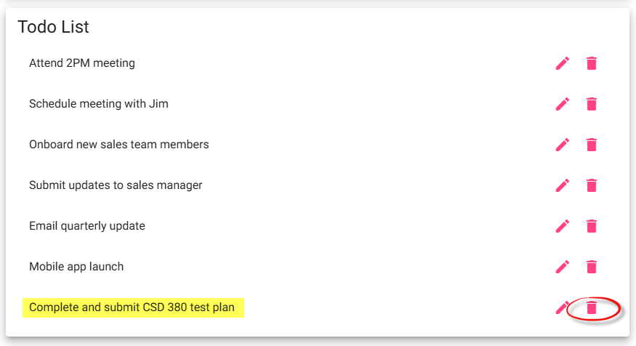
2 | Select the delete icon beside the edited task. | The selected delete action is processed. | Yes | yes  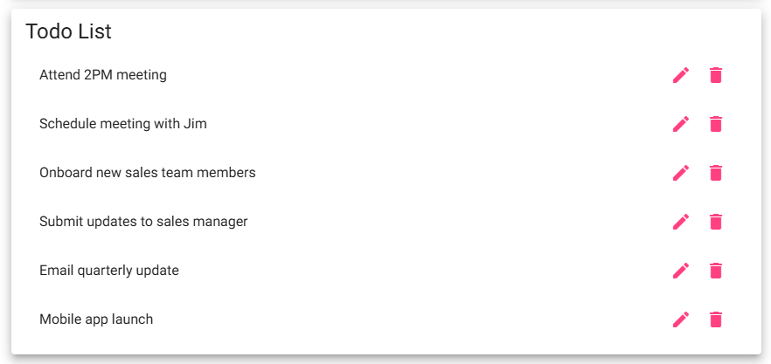
3 | Review the Todo List for the deleted task. | The selected task no longer appears in the list. | Yes | yes  
Comments | The delete “Trash Can” icon when pressed immediately deletes the task. There is no “Are you sure” notice to prevent accidental deletes. It does function as outlined though with no issues seen in my testing.

Test 5 | Invalid URL Page
 | Test Objective: Verify that an invalid application URL displays the custom not-found page and that the user can return to the application. | Developer:  Date tested: 2026/06/24 | Peer tester: Justin Morrow  Date tested: 2026/06/27
Step | Action | Expected results: | Developer pass/fail | Tester pass/fail
1 | Open a new browser tab. | A new blank tab opens without affecting the current Todo page. | Yes | Yes  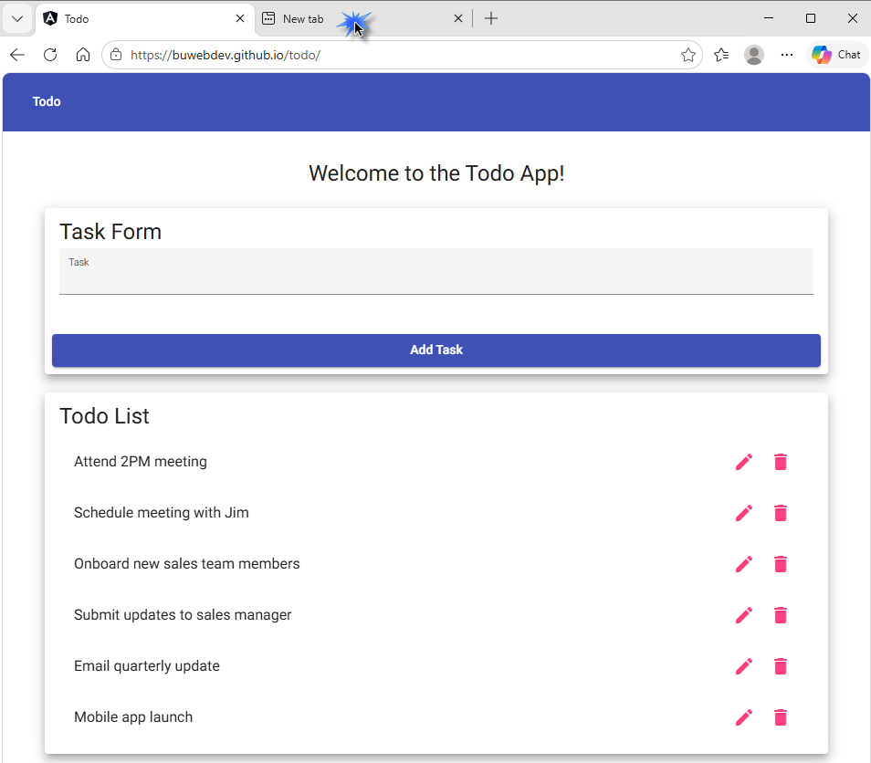
2 | Enter https://buwebdev.github.io/todo/not-a-real-page and press Enter. | The invalid application URL is requested. | Yes | yes  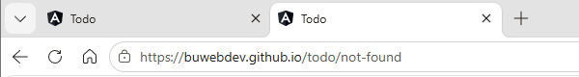
3 | Review the page displayed for the invalid URL. | A custom not-found message appears instead of the normal Todo landing page. | Yes | Yes  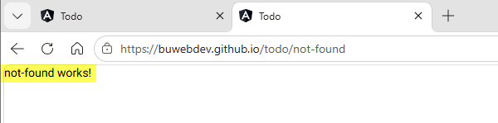
4 | Confirm the page does not display a blank screen or an unhandled application error. | The error state is understandable and presented as a page within the application experience. | Yes | Yes  
5 | Return to https://buwebdev.github.io/todo/. | The standard Todo landing page loads correctly again. | Yes | Yes  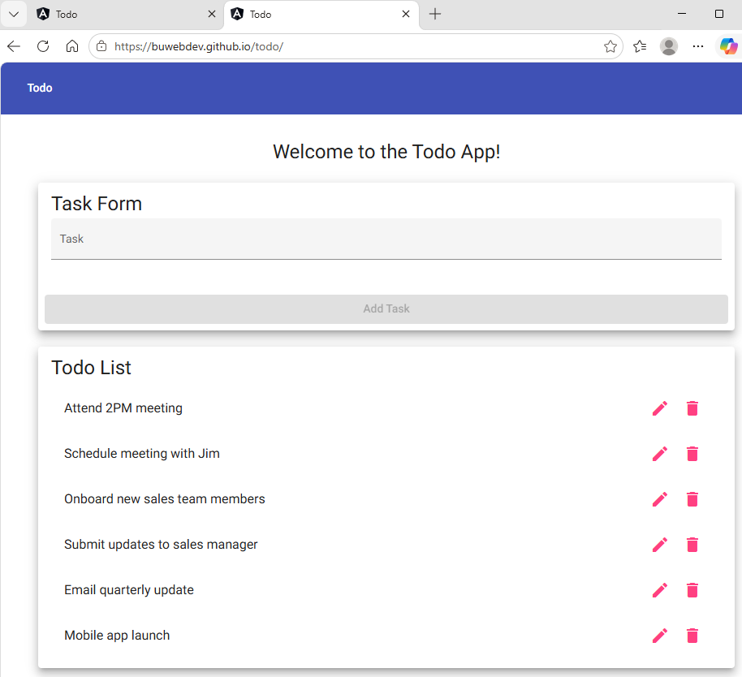
Comments | I verified that entering an invalid URL display the message “not-found works!” instead of the typical 404 Error Page not found message. Removing the invalid page reference to go back to the Todo List home page https://buwebdev.github.io/todo/ displays the Todo List web application correctly.

