Project: | Todo Application
Course: | CSD 380 Software Development
Description: | Functional test plan for the Todo web application based on the Todo Business Requirements Docs.
Date: | 2026/06/22
To complete the test case plan, fill out the information for Project, Course, Description and Date in the header below.

TABLE OF CONTENTS
Test Case 1 ………………………………………………………………………………………………………………………………………………………………………………………………………… 2
Test Case 2 ………………………………………………………………………………………………………………………………………………………………………………………………………… 3
Test Case 3 ………………………………………………………………………………………………………………………………………………………………………………………………………… 4
Test Case 4 ………………………………………………………………………………………………………………………………………………………………………………………………………… 5
Test Case 5 ………………………………………………………………………………………………………………………………………………………………………………………………………… 6

For each test, the developer should: provide a test description, a test objective, the developer name and date tested. For each step, fill out the actions to be taken and describe the expected results, and indicate yes or no for each step depending upon the result. The peer tester should provide their name, date tested, indicate yes or no for each step depending upon the result, and a screenshot (thumbnail) of the result.

Test 1 | Website Access and Custom 404 Error Page
 | Test Objective: Verify users can access the Todo application through the standard URL and receive a custom 404 page for invalid URLs. | Developer: Alexander Hunt  Date tested: 2026/06/22 | Peer tester: Justin Morrow  Date tested: 2026/06/27
Step | Action | Expected results: | Developer pass/fail | Tester pass/fail  + Screenshot
1 | Visit https://buwebdev.github.io/todo/. | The Todo application landing page loads without browser errors. | <yes/no> | Yes  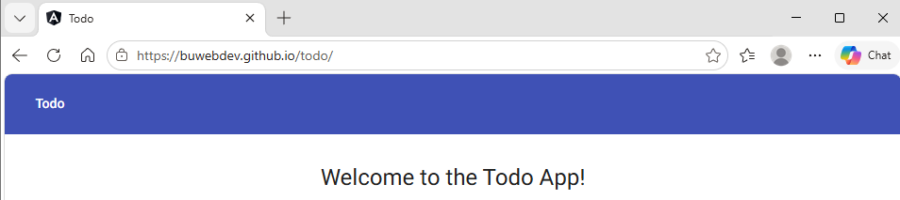
2 | Confirm the landing page displays the Task Form area and Todo List area. | The page shows the task entry form and the current todo list view. | <yes/no> | Yes  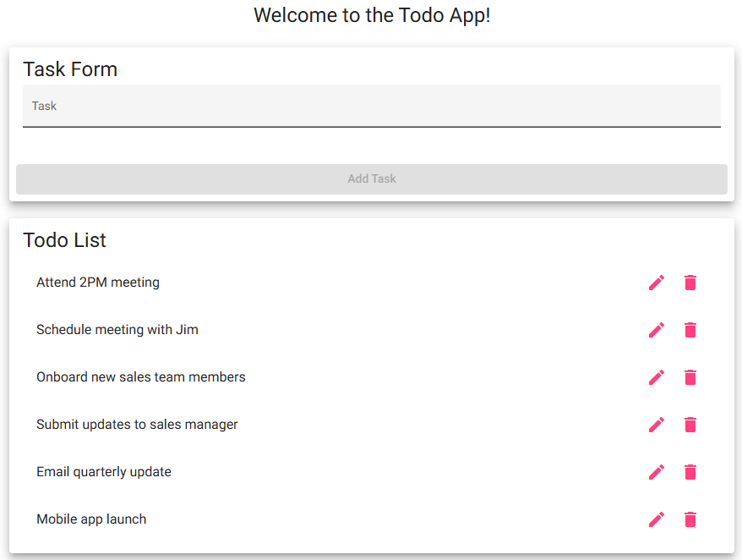
3 | Refresh the browser window. | The page reloads correctly and remains usable. | <yes/no> | Yes  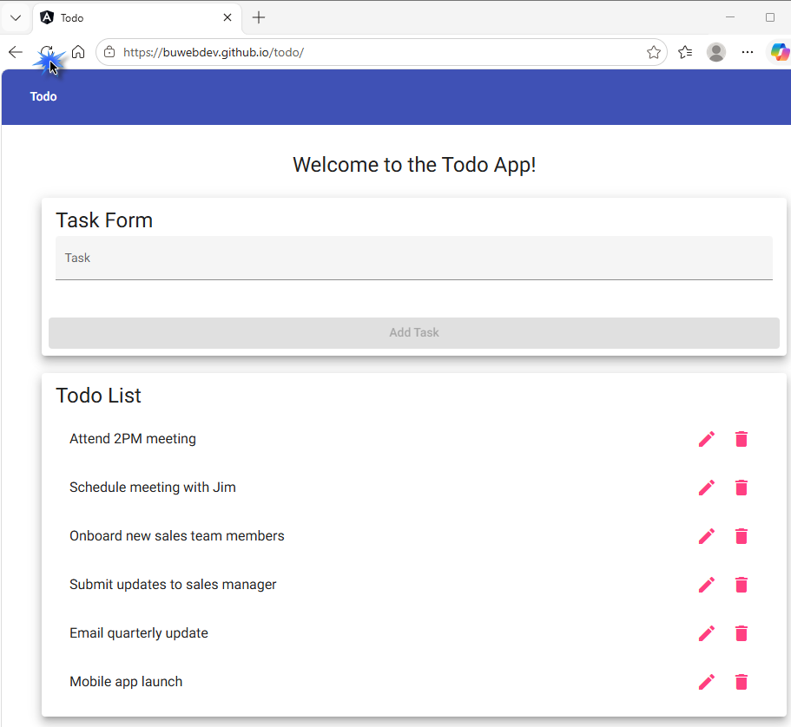
4 | Navigate to https://buwebdev.github.io/todo/invalid-test-page. | A custom 404 error page is displayed instead of a generic browser error. | <yes/no> | Yes  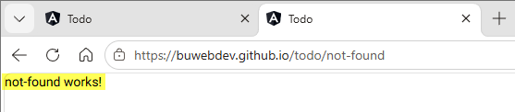
5 | Use the browser Back button to return to the Todo application. | The Todo application page is available again and loads correctly. | <yes/no> | Yes  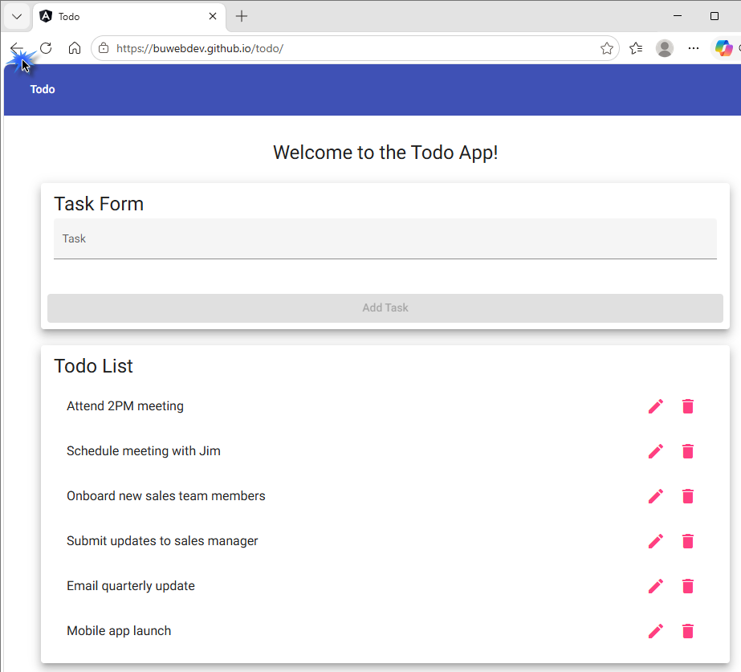
Comments | I was able to confirm that browsing to the Todo List web application https://buwebdev.github.io/todo in my web browser loaded correctly. If I pressed the refresh button it reloaded correctly. Navigating to an invalid URL https://buwebdev.github.io/todo/invalid-test-page loaded a custom message of “not-found works!”. Click the back button in my browser successfully took me back to the Todo App.

Test 2 | Create Task, View Todo List, and Add Form Validation
 | Test Objective: Verify users can create a new todo task, view the task in the Todo List, and cannot submit a blank task form. | Developer: Alexander Hunt  Date tested: 2026/06/22 | Peer tester: Justin Morrow  Date tested: 2026/06/27
Step | Action | Expected results: | Developer pass/fail | Tester pass/fail
1 | Open https://buwebdev.github.io/todo/. | The Todo application landing page loads. | <yes/no> | Yes  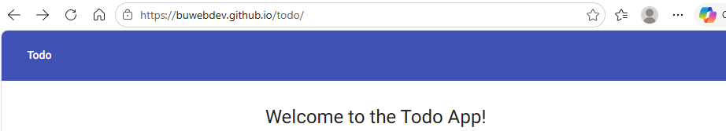
2 | Leave the task input field blank and click Add Task. | No blank todo item is added to the Todo List, and the form prevents submission. | <yes/no> | Yes  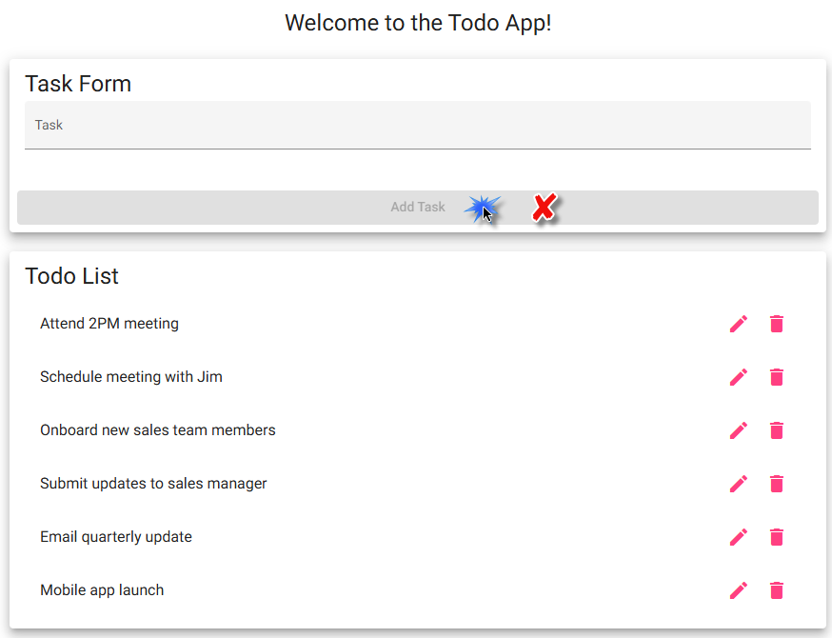
3 | Enter "Attend 2PM meeting" in the task input field. | The text appears in the task input field exactly as entered. | <yes/no> | Yes  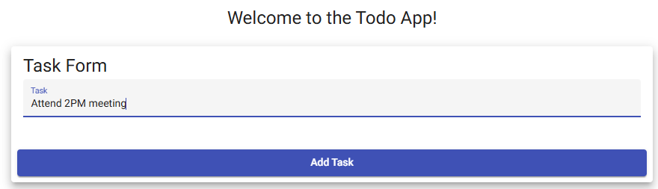
4 | Click Add Task. | The new task is added to the Todo List. | <yes/no> | Yes  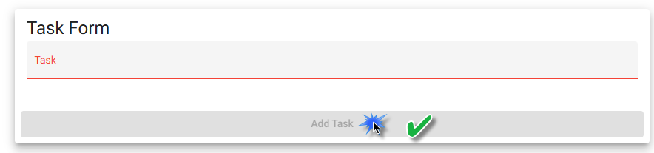
5 | Review the Todo List area. | The Todo List displays the newly created task with the other todo task items. | <yes/no> | Yes  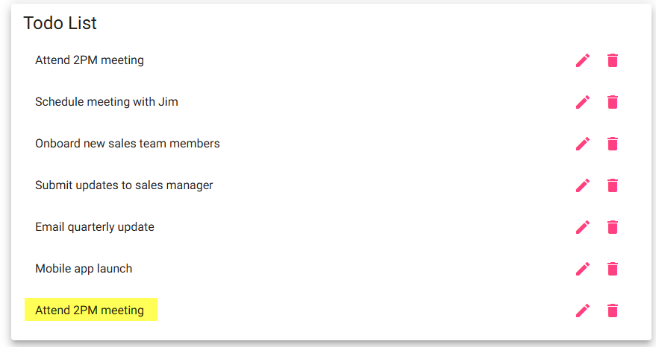
Comments | I confirmed that navigating to the web url loaded the page successfully. Clicking the Add Task button with nothing typed in did nothing as the Add Task button remained grey. No blank entry was added to the Todo List. I typed in the requested text of “Attend 2PM meeting” and the Add Task button turned blue after the 4th character was typed. When I clicked the Add Task button it submitted with no errors, the Add Task button turned grey. I the saw the new Todo Task entry successfully added to the bottom of the existing Todo List.

Test 3 | Edit Task and Edit Form Validation
 | Test Objective: Verify users can edit an existing todo task and cannot save an empty task from the edit form. | Developer: Alexander Hunt  Date tested: 2026/06/22 | Peer tester: Justin Morrow  Date tested: 2026/06/27
Step | Action | Expected results: | Developer pass/fail | Tester pass/fail
1 | Create or locate a todo task named "Attend 2PM meeting". | The task is visible in the Todo List. | <yes/no> | Yes  
2 | Open the edit form for the task. | The edit form opens and displays the selected task text. | <yes/no> | Yes  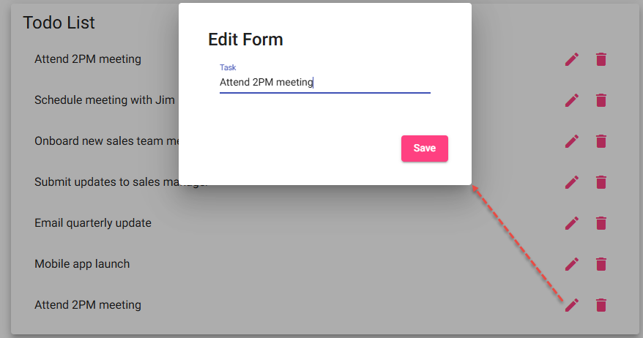
3 | Clear the edit input field and attempt to save. | The application prevents saving an empty todo item. | <yes/no> | No  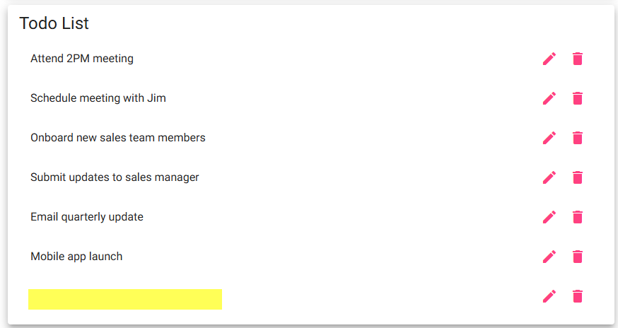
4 | Enter "Attend 3PM meeting" in the edit input field and click Save. | The edited value is accepted and the user returns to the Todo List. | <yes/no> | Yes  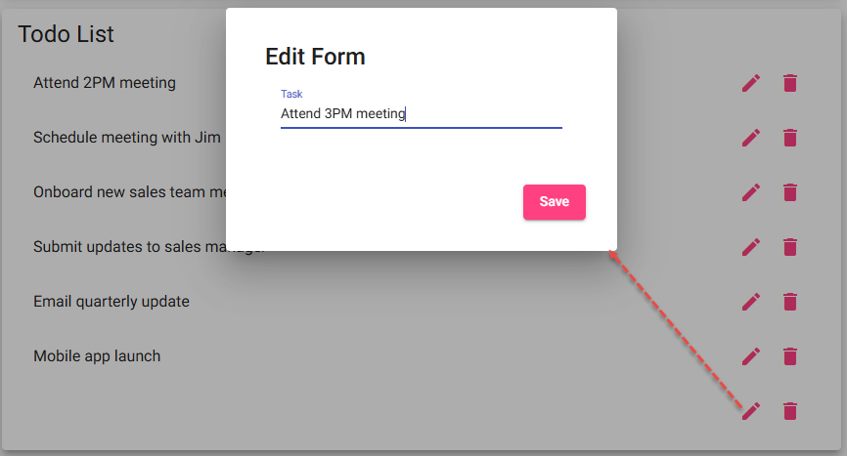
5 | Review the Todo List after saving. | The task now displays as "Attend 3PM meeting" and the old text is no longer shown for that task. | <yes/no> | Yes  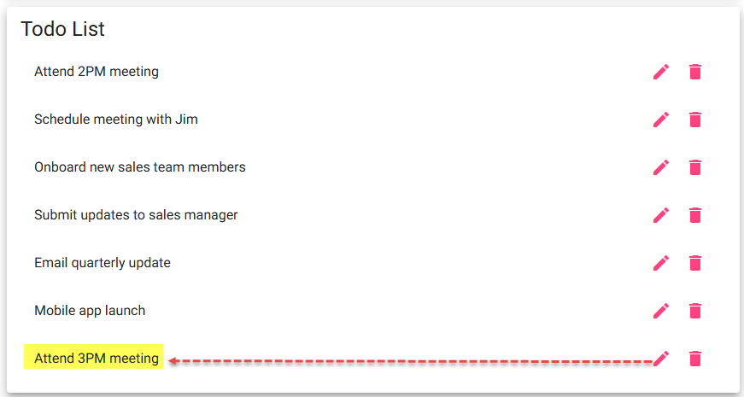
Comments | Comments should be substantive; this means there should be at least 2-3 well-structured sentences with constructive feedback.

Test 4 | Delete Todo Task Item
 | Test Objective: Verify users can delete an existing todo task item from the Todo List. | Developer: Alexander Hunt  Date tested: 2026/06/22 | Peer tester: Justin Morrow  Date tested: 2026/06/27
Step | Action | Expected results: | Developer pass/fail | Tester pass/fail
1 | Open https://buwebdev.github.io/todo/. | The Todo application landing page loads. | <yes/no> | Yes  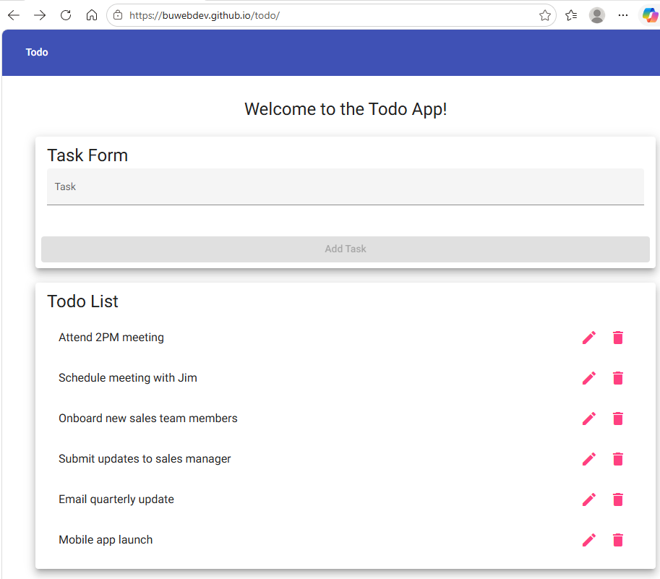
2 | Create a task named "Delete test task" if it is not already present. | The task appears in the Todo List. | <yes/no> | Yes  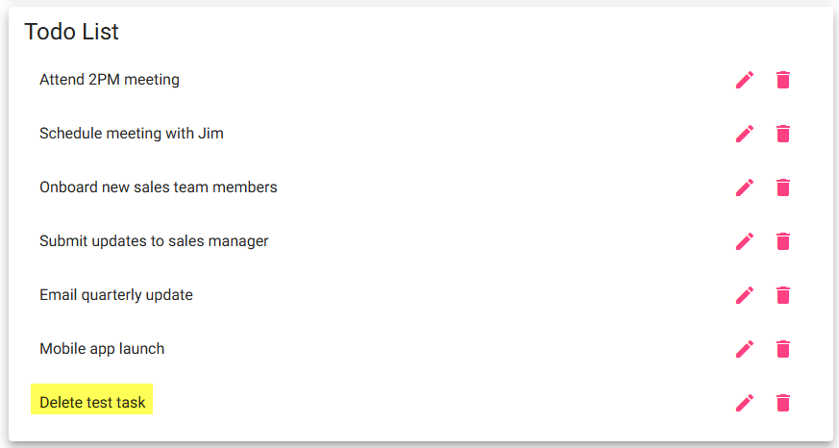
3 | Select the delete option for "Delete test task". | The delete action is triggered for the correct task item. | <yes/no> | Yes  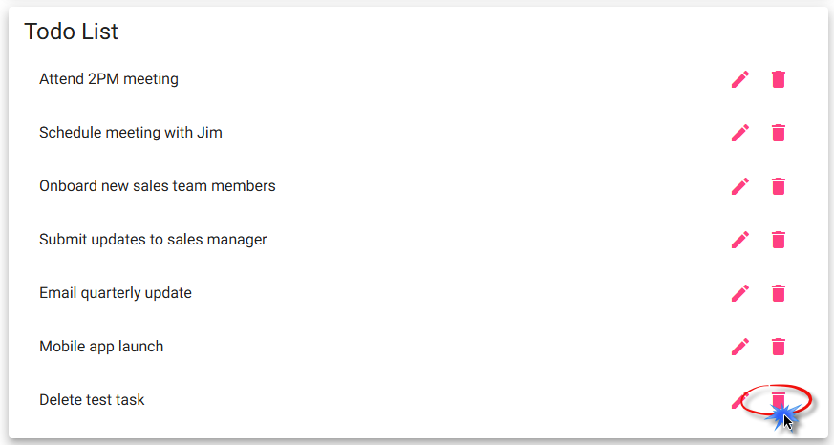
4 | Confirm the task deletion if the application prompts for confirmation. | The application accepts the delete confirmation. | <yes/no> | No
5 | Review the Todo List. | "Delete test task" is no longer visible in the Todo List. | <yes/no> | <yes/no>  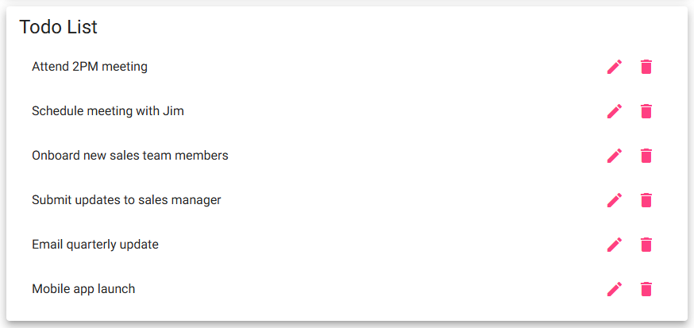
Comments | I confirmed the page loaded correctly, that I was able to create a new Todo task called “Delete test task” and that it added to the bottom of the Todo List. I clicked on the delete “Trash can” icon and confirmed the entry was deleted successfully. There was no pop-up alert or “Are you sure” option to prevent accidental deletes. It just deleted the entry immediately after pressing the button.

Test 5 | Responsive Views for Mobile and Tablet Devices
 | Test Objective: Verify the Todo application provides usable views for mobile and tablet device sizes across major browsers. | Developer: Alexander Hunt  Date tested: 2026/06/22 | Peer tester: Justin Morrow  Date tested: 2026/06/27
Step | Action | Expected results: | Developer pass/fail | Tester pass/fail
1 | Open https://buwebdev.github.io/todo/ in a desktop browser and enable responsive design or device toolbar mode. | The page remains available in responsive testing mode. | <yes/no> | Yes  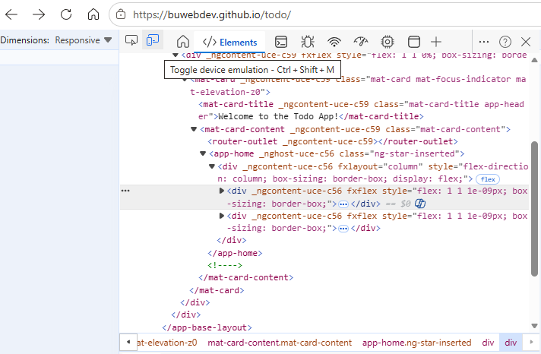
2 | Set the viewport to a mobile size such as 390 x 844. | The Task Form and Todo List fit the screen without horizontal scrolling or overlapping content. | <yes/no> | Yes  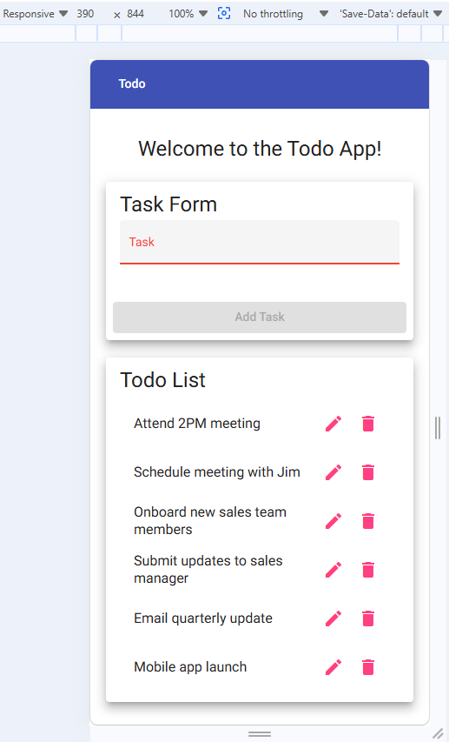
3 | Create a new task while in the mobile viewport. | The task can be entered and added successfully on a mobile-size screen. | <yes/no> | Yes  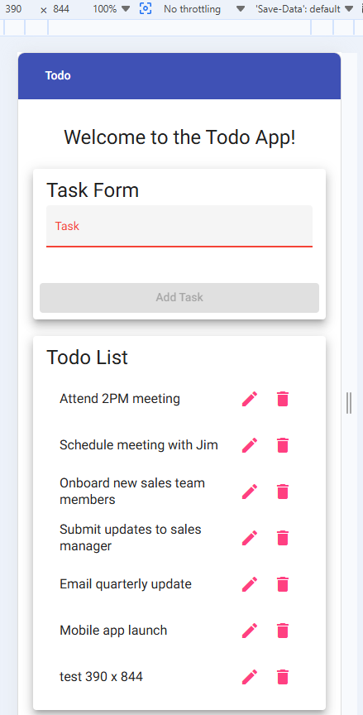
4 | Set the viewport to a tablet size such as 768 x 1024. | The Task Form and Todo List fit the tablet viewport and remain readable. | <yes/no> | Yes  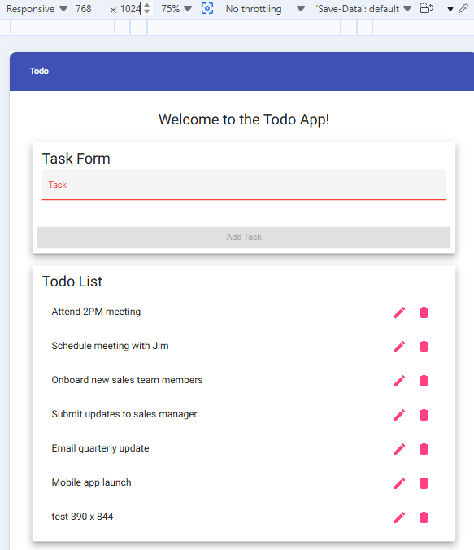
5 | Edit or delete a task while in the tablet viewport. | The application controls are usable and the selected task updates or deletes correctly. | <yes/no> | Yes  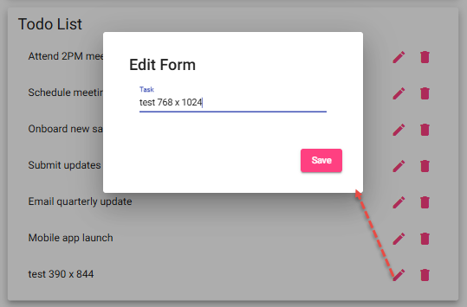
Comments | I confirmed that I was able to change the responsive size to 390 x 844 and 768 x 1024. In those modes the application was responsive and allowed me to create, edit and delete tasks successfully.

