Justin Morrow – 05/17/26
CSD 420 – Module 10.2 Modified Class Examples to Create the Fans Database GUI

Image of creating the entries for the fans table into the databasedb from last week and illustrated in a split screen to keep it all on a single image.
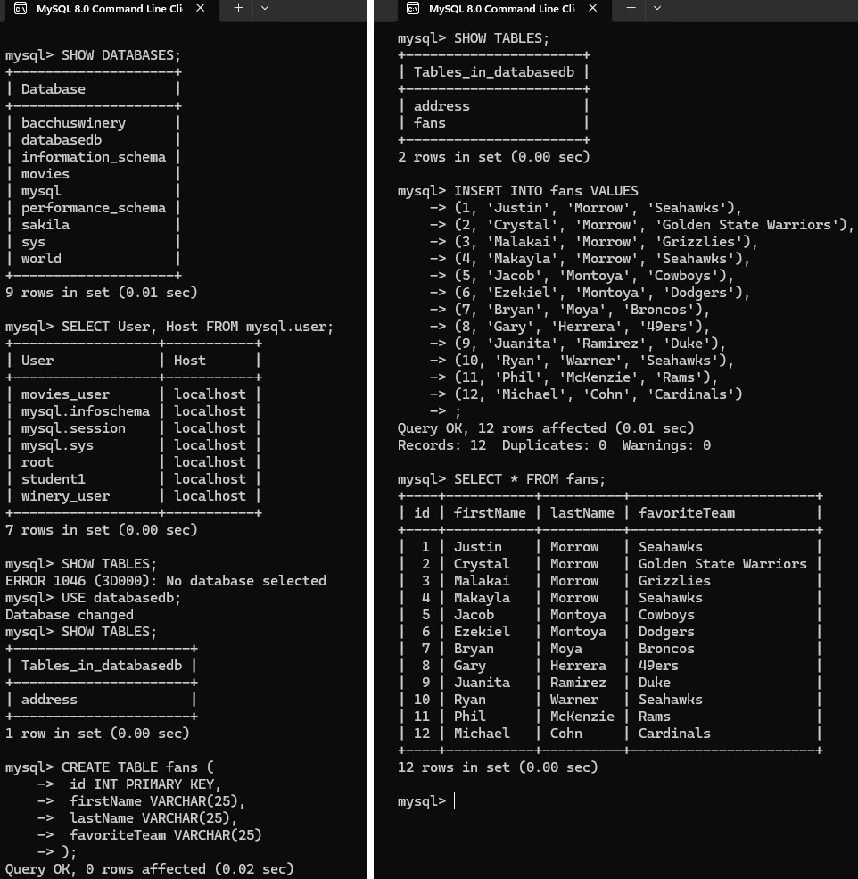

Here is the GUI output showing each GUI button being pressed in a single image.
