Justin Morrow – 05/09/26
CSD 420 – Module 9.2

Assumptions: Some of my assumptions differ from the instructions, so I apologize and am willing to adjust the setup if needed.
- I noticed the instructions state that the database setup should use the following values: databasedb, student1 and pass while the sample Java files used values database33, student33, and address33. I also changed address33 to address.
- The instructions also mention using MySQL 5. I already had MySQL 8.0 installed from a previous CSD 402 course, so I investigated whether it would still work with the provided Java code examples from the zipped file for this module. Based on what I found, the driver being used is (com.mysql.cj.jdbc.Driver) and compatible with MySQL 8.0. The older driver (com.mysql.jdbc.Driver) is used with MySQL 5 and is not seen in these examples so I continued using MySQL 8.0 for this assignment, so I didn't have to uninstall my current version and reinstall the older version.
- I usually use IntelliJ for my assignments, but I previously installed NetBeans 13 for an assignment in CSD 402. The instructions did not specifically require the newest NetBeans 29, so I didn't upgrade it.

Command ran in MySQL 8.0 Command Line Cli:
CREATE DATABASE databasedb;
CREATE USER IF NOT EXISTS 'student1'@'localhost' IDENTIFIED BY 'pass';
GRANT ALL PRIVILEGES ON databasedb.* TO 'student1'@'localhost';
FLUSH PRIVILEGES;
SHOW DATABASES;
SELECT User, Host FROM mysql.user;

Output seen after creating the databasedb and the user student1
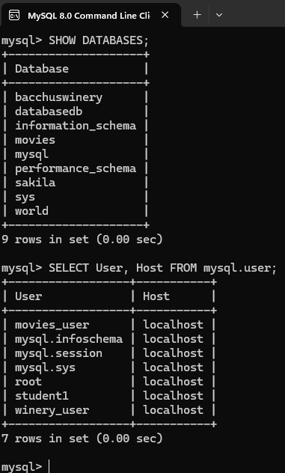

Output from running the modified CreateTable.java in NetBeans and the address table being created
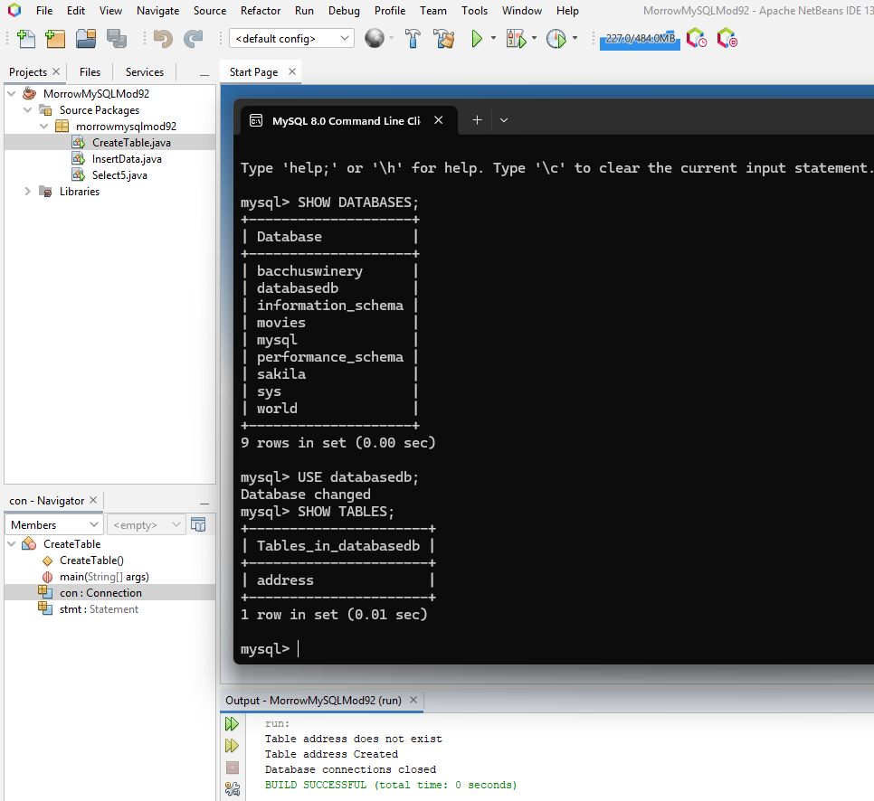

Output from running the modified InsertData.java in NetBeans and the data being populated in the address table
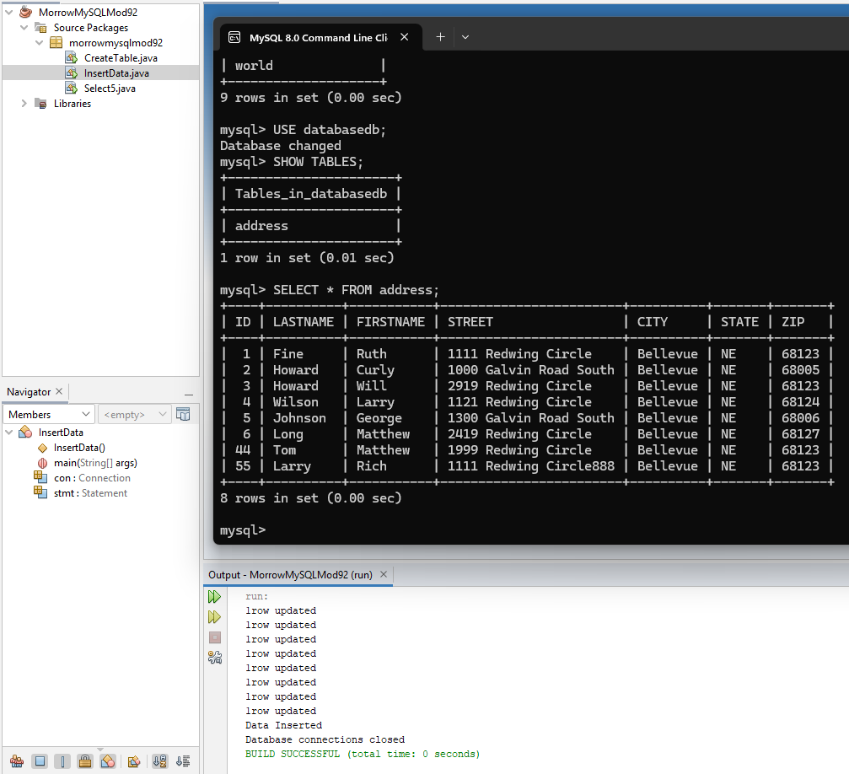

Output from running the modified Select5.java in NetBeans and the data being read from the address table. Note I modified the output to display side by side to view it all in the same output due to having to scroll.
