Justin Morrow
Assignment: CSD 420 Module 1.2 (GitHub Repository Setup)

Link to your GitHub repository
https://github.com/jumorrow-school/csd-420/tree/main/module-1

Screenshot of your GitHub repository
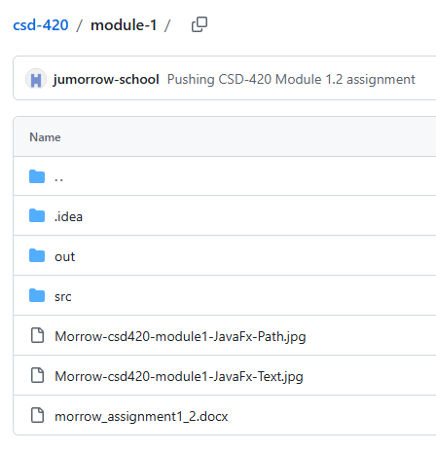
Screenshot of your local directory
