Justin Morrow – 06/28/26
CSD-430: Module 4.2

Image of 4.2 assignment
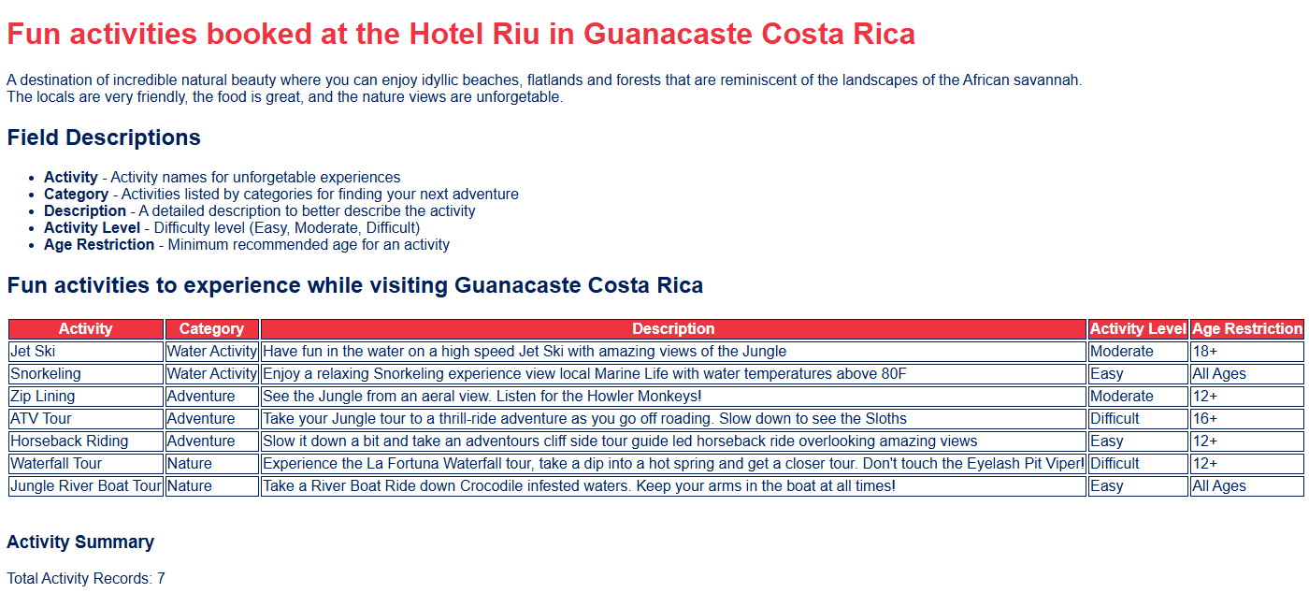

Image of 2.2 compared to 4.2
