Justin Morrow - 06/05/26
CSD 430 – Module 1.3

Screenshot of my previous CSD courses Java 17 installation
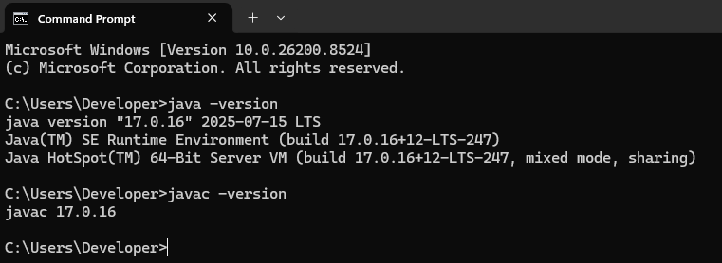

Successful installation of Apache Tomcat with server running and view from http://localhost:8080/
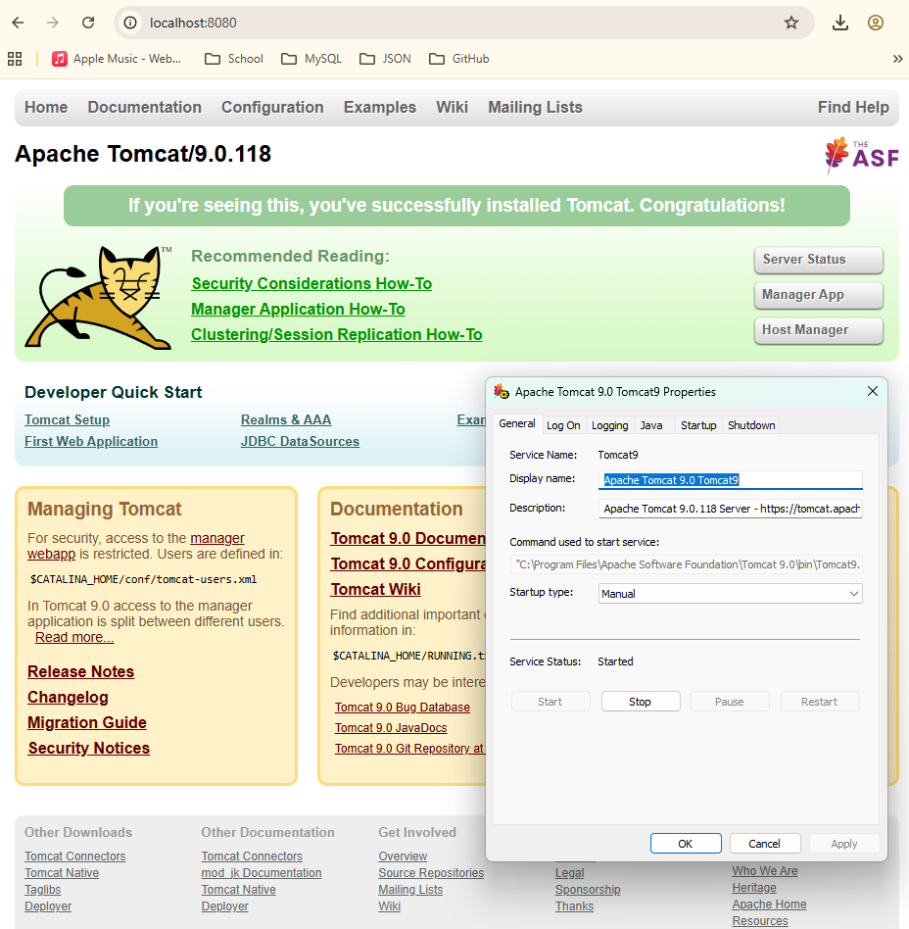

Successful installation of Eclipse with server running and view from http://localhost:8080/MyFirstApp/
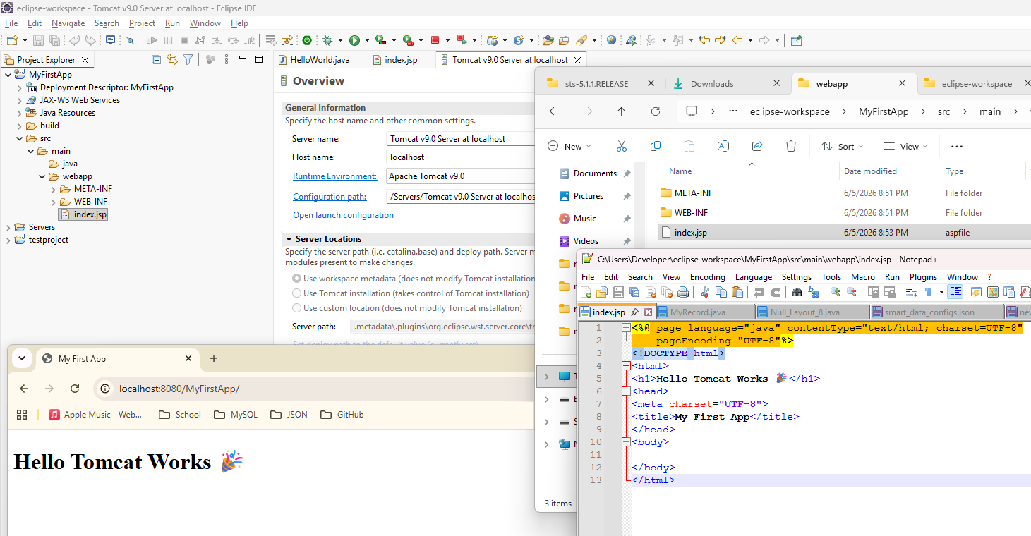

Successful installation of STS4 for Eclipse with server running and view from http://localhost:8080/ClassTableExample/Table.jsp which is just the class example file which has html and java

