Justin Morrow – 09/20/26
Assignment: Module 8.2
Use a DB called baseball_01 with user student1 and password pass
Create 4 PHP programs that use MySQLi on a topic that interests me
to Create a table, Populate the table, Query the table data, and Drop the table

http://localhost/JustinCreateTable.php
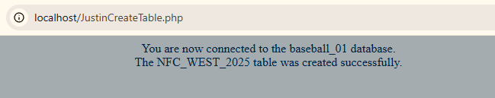
http://localhost/JustinPopulateTable.php
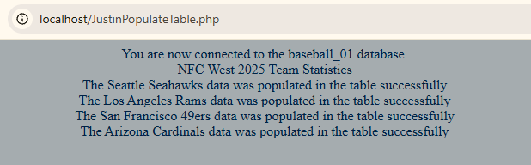
http://localhost/JustinQueryTable.php
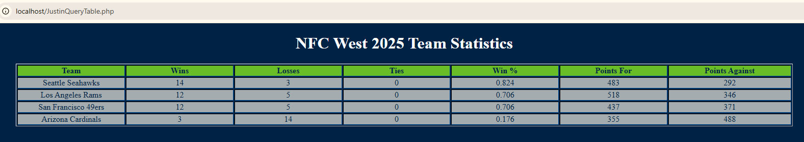

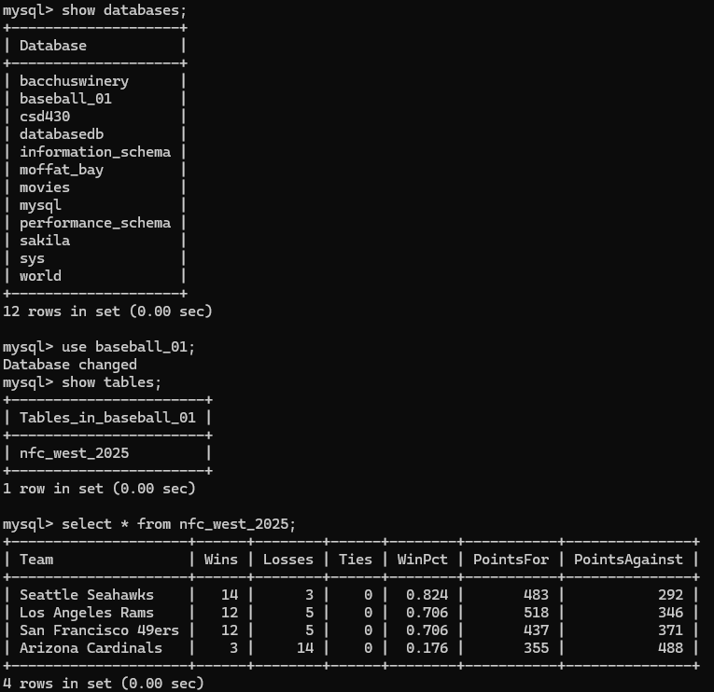
http://localhost/JustinDropTable.php
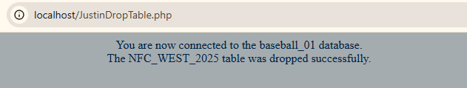
mysql> select * from nfc_west_2025;
ERROR 1146 (42S02): Table 'baseball_01.nfc_west_2025' doesn't exist

