Justin Morrow – 09/05/26
Assignment: Module 5.2 (Creating and Displaying Array Data)

Note: The 2 columns below were placed in a single image to display easier in this word document without shrinking the size. When viewing the page, the output will be displaying all 12 players/customers data in a single column.
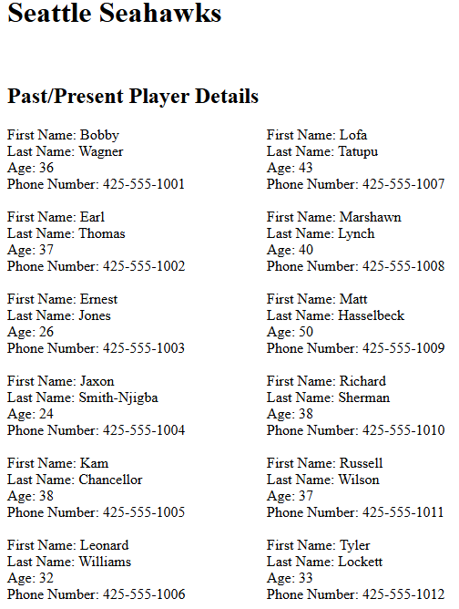
Note: The 2nd part of the assignment is to display various lookups using the arrays. When viewing the JustinCustomers.php page these searches are seen after the 12 players details. Captured as a separate image to display better on this page.

