Justin Morrow – 08/21/26
CSD440 - Module 2.2: Create an HTML table using PHP nested loops with random numbers

Initial load of the file populated with random numbers
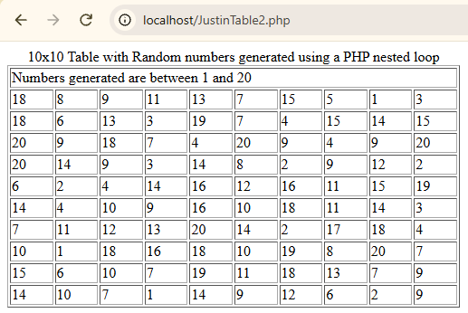
Refreshing the browser to demonstrate new random numbers
