Justin Morrow – 09/27/26
Assignment: Module 9.2
Use Module 8.2 DB called baseball_01 with user student1 and password pass. Continue using MySQLi and the files from Module 8.2. Create 3 new PHP programs:
Index Page to allow the user to easily select any of the 7 PHP Programs
Form to allow adding a new team and stats (We can assume it’s an expansion team)
Query Page since we have a Query all this one will query just the team selected

New Index page with links to Module 8.2 and Module 9.2 Assignments
http://localhost/JustinIndex.php
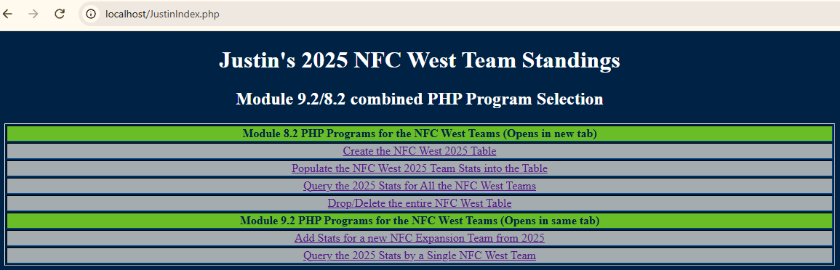

http://localhost/JustinDropTable.php
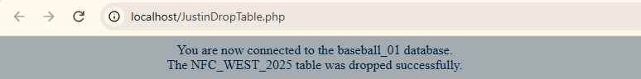
http://localhost/JustinCreateTable.php
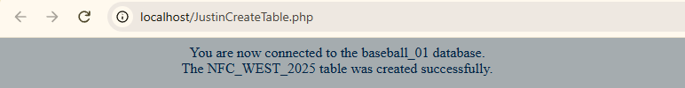
http://localhost/JustinPopulateTable.php
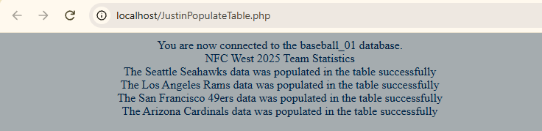

http://localhost/JustinQueryTable.php
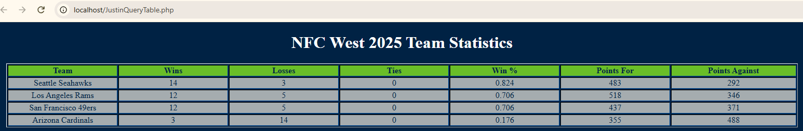

Note: Previous assignments open in new tabs and allow you to create, populate, query all teams and drop the table from Module 8.2. Module 9.2 offers an entry form to either add a new team or another entry for an existing team. Because I set this up to be 2025 NFC West we can add another team and act like it’s an expansion team.
http://localhost/JustinEntryForm.php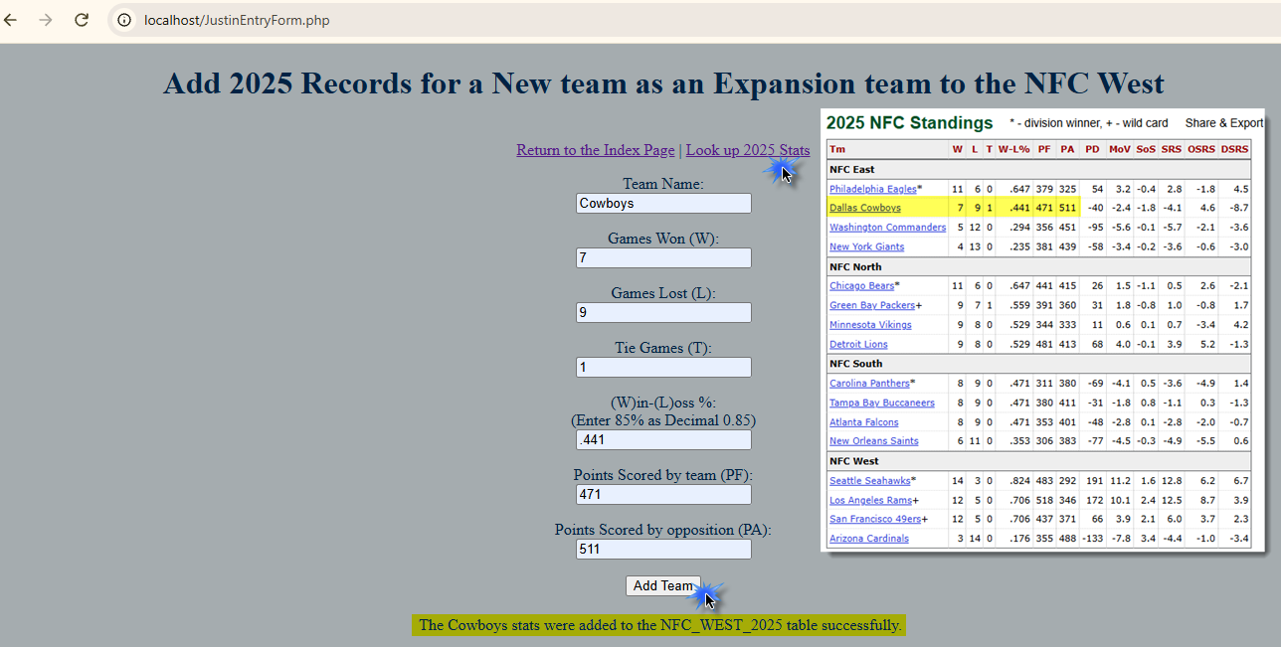
Below shows adding the Dallas Cowboys as an Expansion team to 2025 NFC West
http://localhost/JustinQueryTeam.php
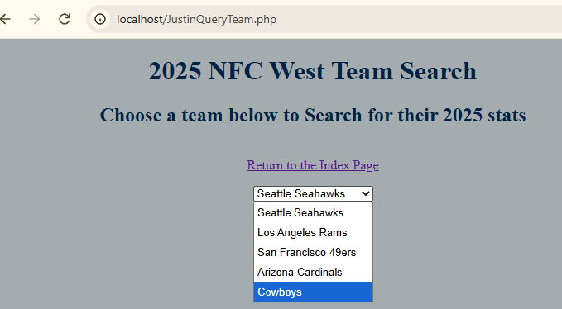
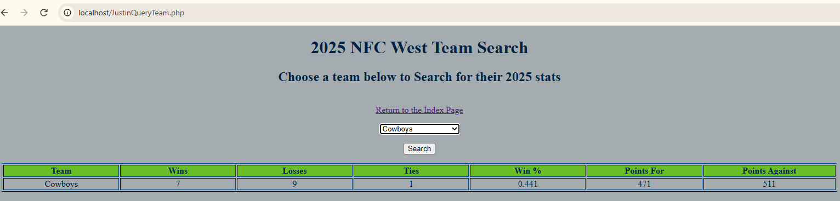

Below shows the Query All Teams from Module 8.2 now including the Cowboys
http://localhost/JustinQueryTable.php
