Justin Morrow – 09/13/2026
CSD-440 Module 7.2
Create an entry form with 7 fields that use 4 field types and post the data to a PHP file that checks for errors and display user friendly feedback. If submitted correctly display the results in a clean presentation using html tags

My form filled out correctly. View before pressing the Submit button
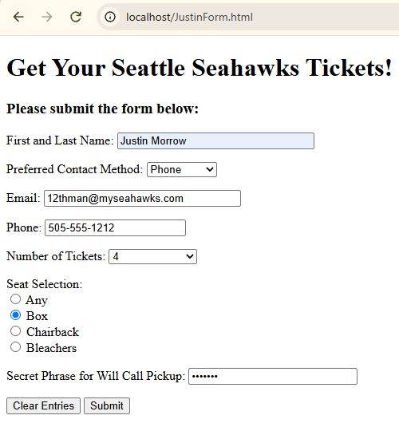

Displaying the results of a correctly submitted form
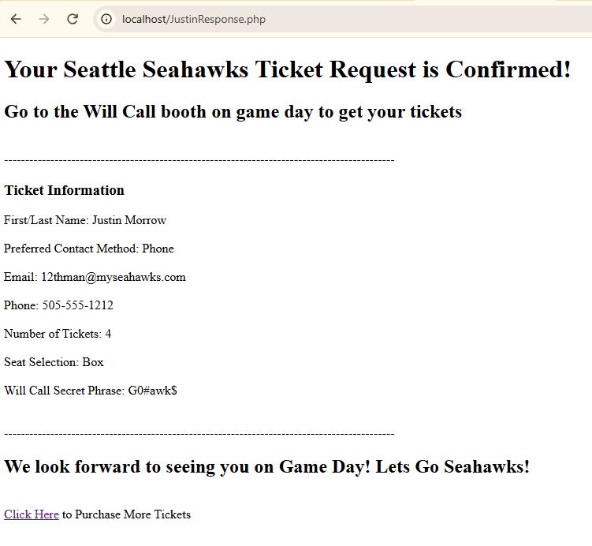

Error notification page displaying all the fields needing a selection based on me selecting nothing on the entry form and pressing submit
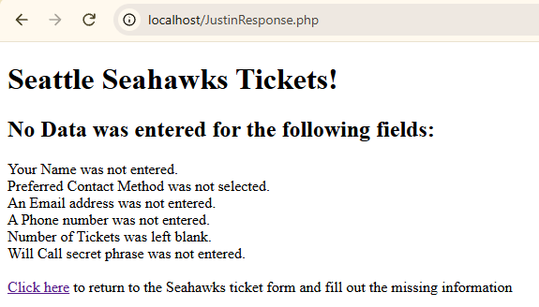

Side by side view of leaving email, number of tickets and Will Call Phrase blank to show that the Error checks work for each field instead of displaying all items
