Justin Morrow – 08/22/26
CSD440 – Module 3.2: Create HTML table using PHP nested loops with external function for adding the 2 random numbers
Initial load of the file populated with random numbers
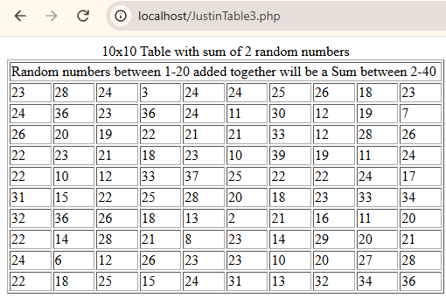
Refreshing the browser to demonstrate new random numbers
