Moffat Bay Lodge
Module 8 Test Plan

Project: Moffat Bay Lodge
Course: Capstone in Software Development
Description: Four manual functional tests for the authenticated reservation-lookup workflow.
Date: 09/14/2026
Version: v1.1

Test Completion Tracker
- Test 1 — Reservation lookup requires an authenticated customer
- Test 2 — My stays lists only the signed-in customer’s reservations
- Test 3 — Reservation ID lookup returns one matching customer stay
- Test 4 — Account-email lookup returns owned stays and validates input

Module Deliverable Tracker
- Complete all tests
- Zip up the code repository and the completed Module Test Plan Document.

Test 1 | Test title: Reservation lookup requires an authenticated customer  Test complete
 | Test Objective: Verify that unauthenticated visitors cannot view confirmed stays and that a signed-in customer can open and use the My stays lookup page. | Developer: Justin Morrow  Date tested: 09/15/2026 | Peer tester: Noor Al Salihi  Date tested: 09/17/2026
Step | Action | Expected results: | Developer pass/fail | Tester pass/fail  + Screenshot
1 | Start the Flask application. In a private browser window, open http://127.0.0.1:5000/reservations/stays. | The browser redirects to /account; no lookup form or reservation details are visible. | Pass | Pass + screenshot
2 | Log in through /account with a valid test customer. | Login succeeds, the home page opens, and the primary navigation shows “My stays.” | Pass | Pass + screenshot
3 | Select “My stays” in the primary navigation. | The browser opens /reservations/stays. The tab reads “My Stays | Moffat Bay Lodge,” and the page shows “My stays” and “Find a stay.” | Pass | Pass + screenshot
4 | Review the “Find a stay” lookup panel. | The panel shows the “Reservation ID or email address” field and a “Find stays” button. | Pass | Pass + screenshot
5 | Select “Log out,” then reopen http://127.0.0.1:5000/reservations/stays. | The browser redirects to /account, and the reservation lookup form and confirmed-stay details are not displayed. | Pass | Pass + screenshot
Comments | I completed all five peer testing steps, and everything passed. When I tried to access the My Stays page without being logged in, it redirected me to the account page. After logging in, I was able to access My Stays and see the Find a Stay section. After logging out, I tried to access the My Stays page again, and it redirected me back to the account page. Everything worked as expected.

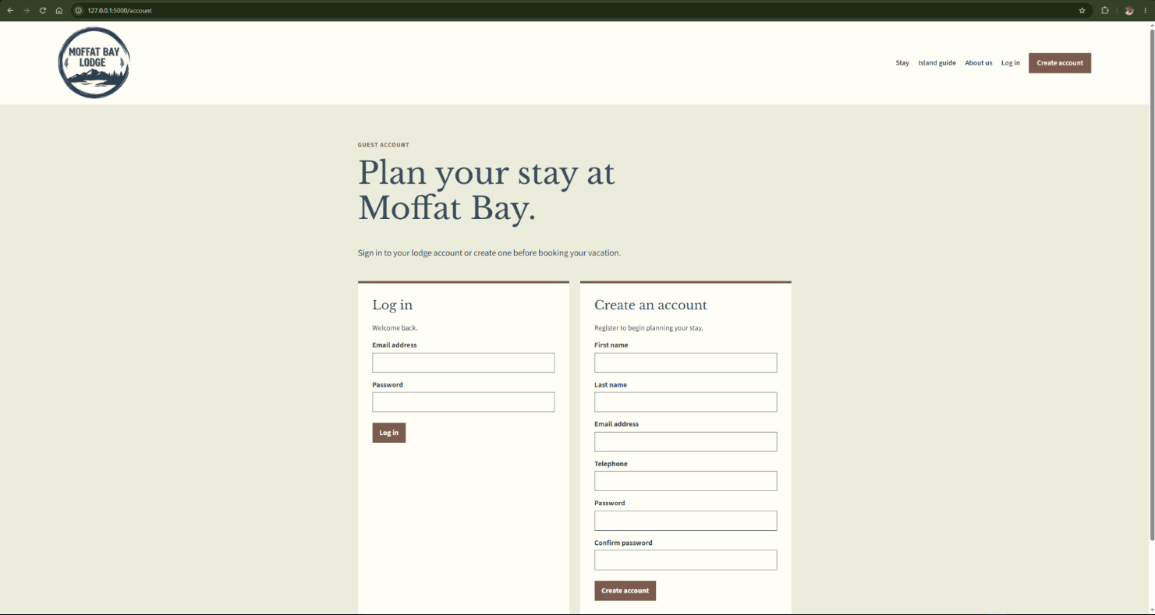

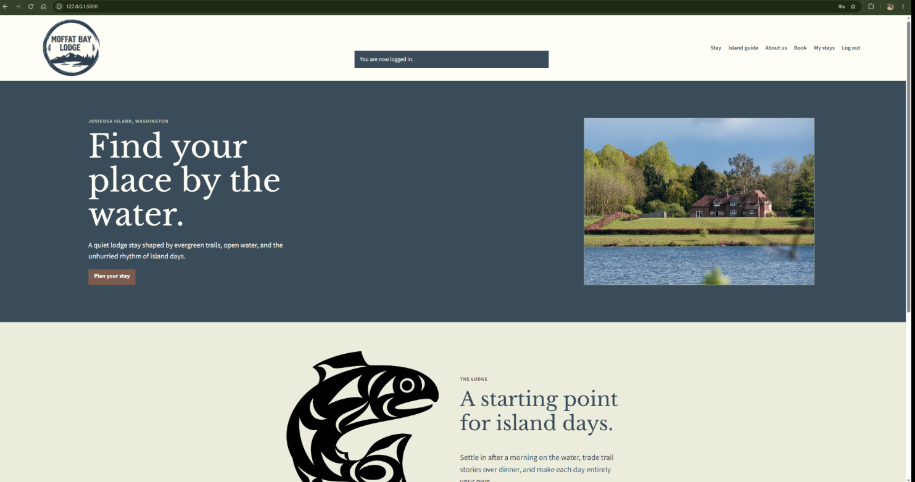

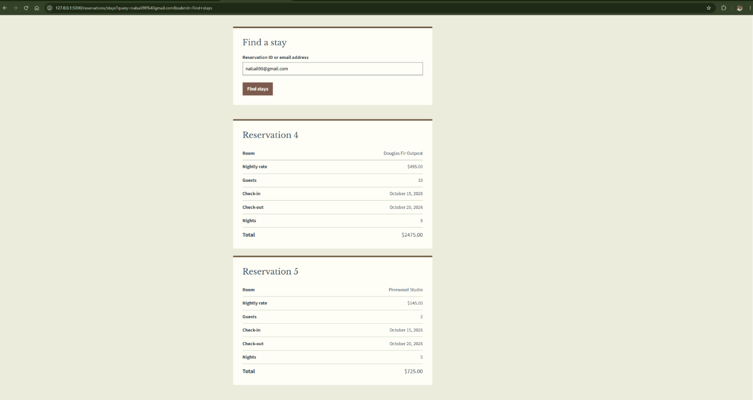

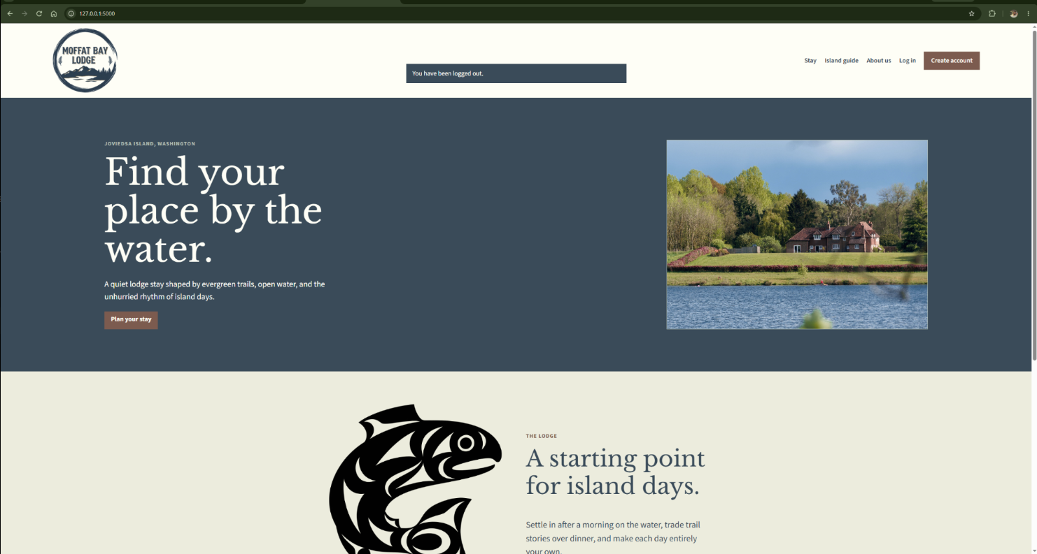

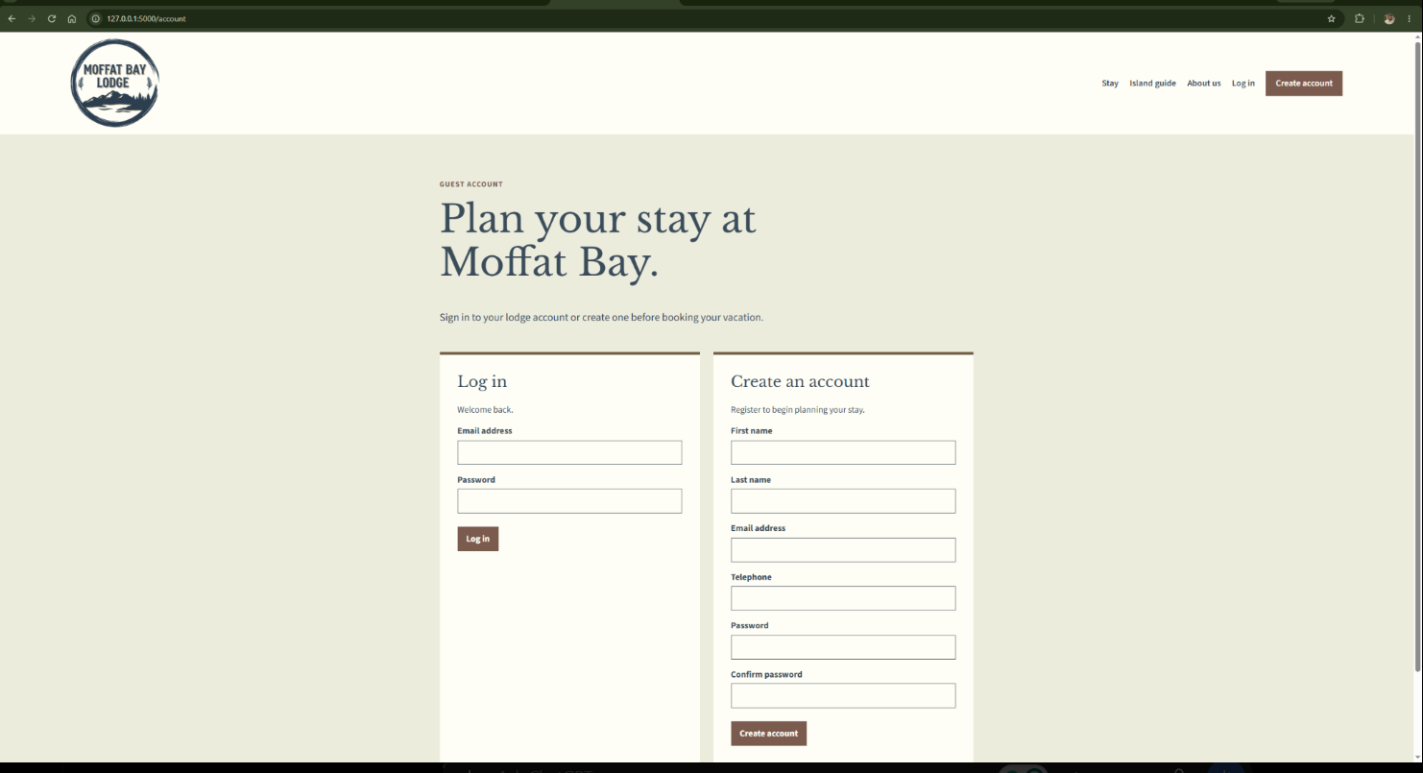

Test 2 | Test title: My stays lists only the signed-in customer’s reservations  Test complete
 | Test Objective: Verify that the unfiltered My stays page shows only the signed-in customer’s confirmed reservations, ordered by check-in date, with saved details and prices. | Developer: Justin Morrow  Date tested: 09/15/2026 | Peer tester: Alexander Hunt  Date tested: Pending 09/16/2026
Step | Action | Expected results: | Developer pass/fail | Tester pass/fail  + Screenshot
1 | Log in as a customer with two confirmed stays on different check-in dates. Ensure another customer has one confirmed stay. | The test customer has two confirmed reservations, and the other customer has a separate reservation. | Pass (Logging in as a customer with 2 reservations shows the 2, Logging in as a customer with 1 reservation shows the 1.) | Pass + screenshotted
2 | Open /reservations/stays with the lookup field blank. | Both signed-in customer reservations appear; the other customer’s reservation does not. | Pass (I can only view and filter/find the reservations for the customer that is logged in) | Pass + screenshotted
3 | Review every field in each reservation panel. | Each panel shows ID, room, nightly rate, guests, check-in, check-out, nights, and total. | Pass (I assume the ID references the Reservation ID number which is included at the top of each reservation tile) | Pass + screenshotted
4 | Compare the order of the displayed reservations. | Earlier check-in dates appear first; ties are ordered by reservation ID. | Pass (I changed the dates from my reservation 5 to be before reservation 4 and refreshed the page and reservation 5 appeared above reservation 4). | Pass + screenshotted
5 | Compare one reservation’s displayed rate and total with its confirmation. | The original nightly rate and calculated total match the confirmed reservation. | Pass | Pass + screenshotted
Comments | A customer with two confirmed stays is able to log in. It only shows that customers stays. Even with the lookup field blank all that customers stays are shown. Every field in the reservation lookup page is present as expected and the totals match the database and calculations required on ID, room, nightly rate, guest count, dates, and pricing.

Step 1 - 5:
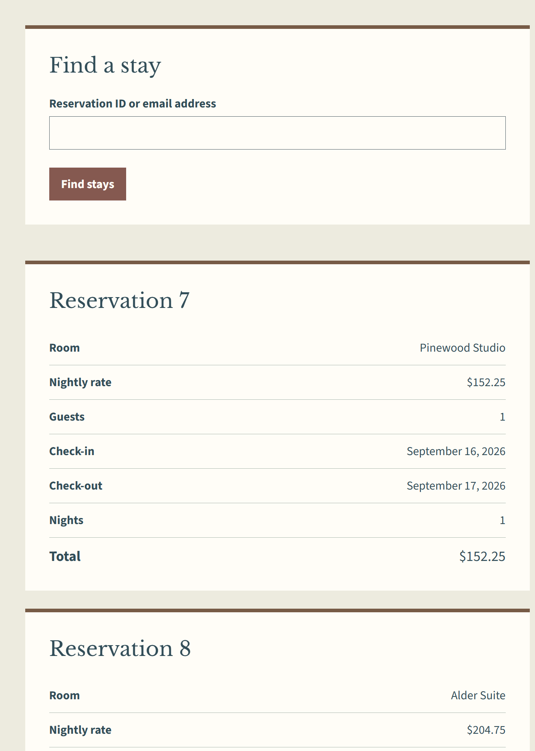
Test 3 | Test title: Reservation ID lookup returns one matching customer stay  Test complete
 | Test Objective: Verify that reservation ID lookup returns one owned stay and does not disclose an unknown or another customer’s reservation. | Developer: Justin Morrow  Date tested: 09/15/2026 | Peer tester: Alexander Hunt  Date tested: Pending 09/16/2026
Step | Action | Expected results: | Developer pass/fail | Tester pass/fail  + Screenshot
1 | Log in as a customer with two stays, open /reservations/stays, and note one reservation ID. | The page lists both reservations with distinct IDs. | Pass (Both reservation 4 & 5 are displayed) | Pass + screenshotted
2 | Enter that reservation ID and select “Find stays.” | Only that reservation appears; the customer’s other stay does not. | Pass (entering 5 filtered out reservation 4) | Pass + screenshotted
3 | Review the details in the returned reservation panel. | Room, saved rate, guests, dates, nights, and total match the selected stay. | Pass | Pass + screenshotted
4 | Search for an unused positive reservation ID, such as 999999. | The page shows the no-match message and no reservation details. | Pass (No confirmed stays match that lookup) | Pass + screenshotted
5 | Search for a reservation ID owned by another customer. | The same no-match message appears, and no other customer’s details are shown. | Pass (No confirmed stays match that lookup. I tried known reservation IDs belonging to a different customer not signed in). | Pass + screenshotted
Comments | A customer logged in with two stays lists both stays. Either of the two stays is able to be looked up. The review details for a reservation that was looked up by it’s id are accurate and displayed correctly. A reservation that is not used such as 999 shows up as nothing. A reservation owned by another customer is not able to be looked up while signed in as a different customer. The reservation lookup works as intended.
Step 1 - 3:
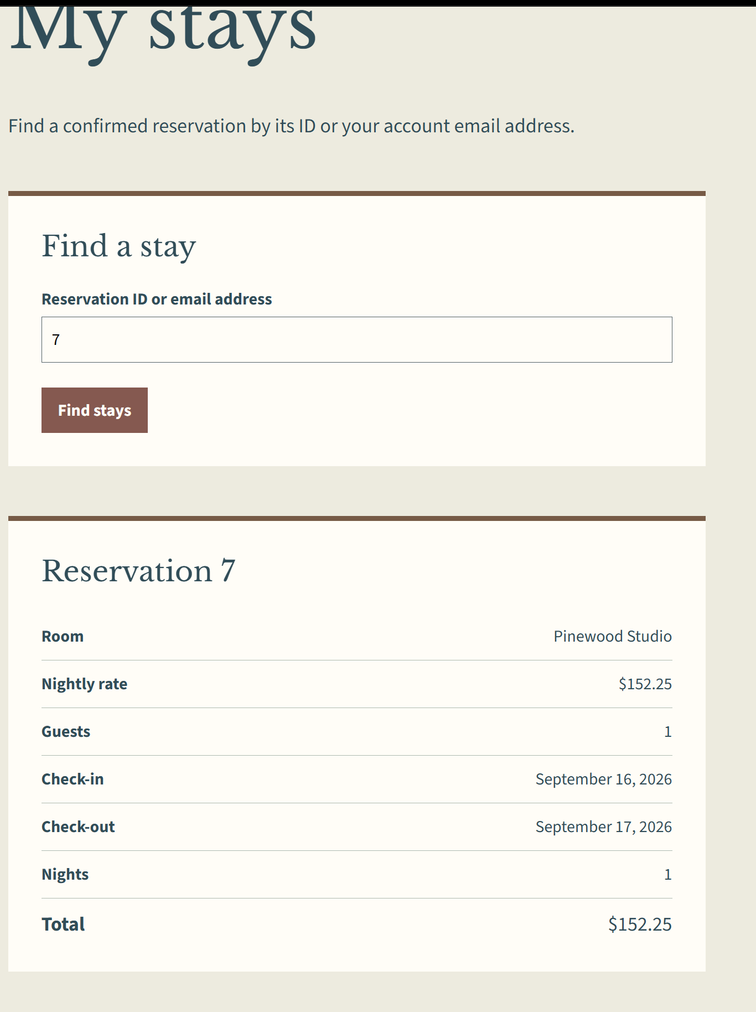
Step 4:
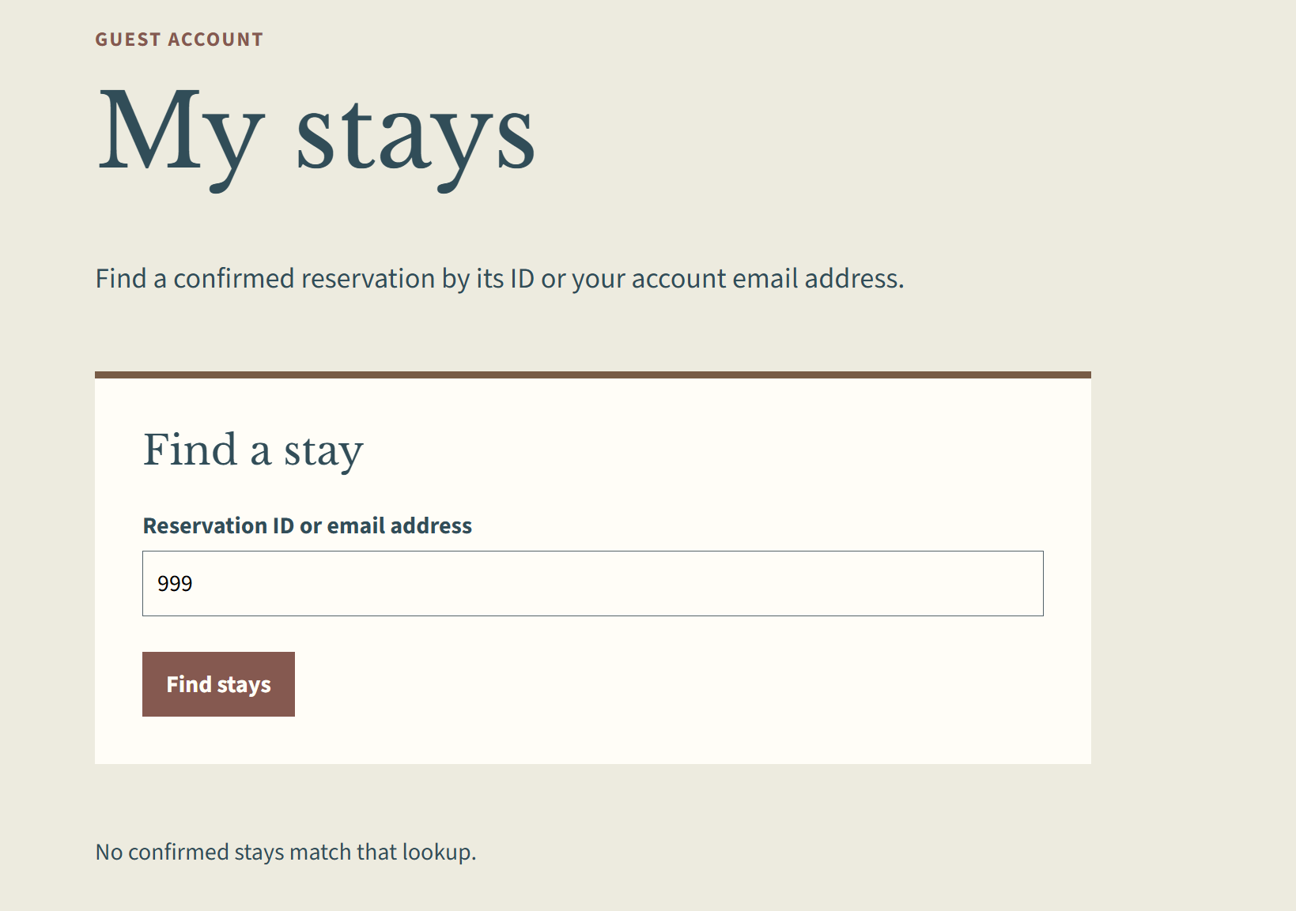

Step 5:
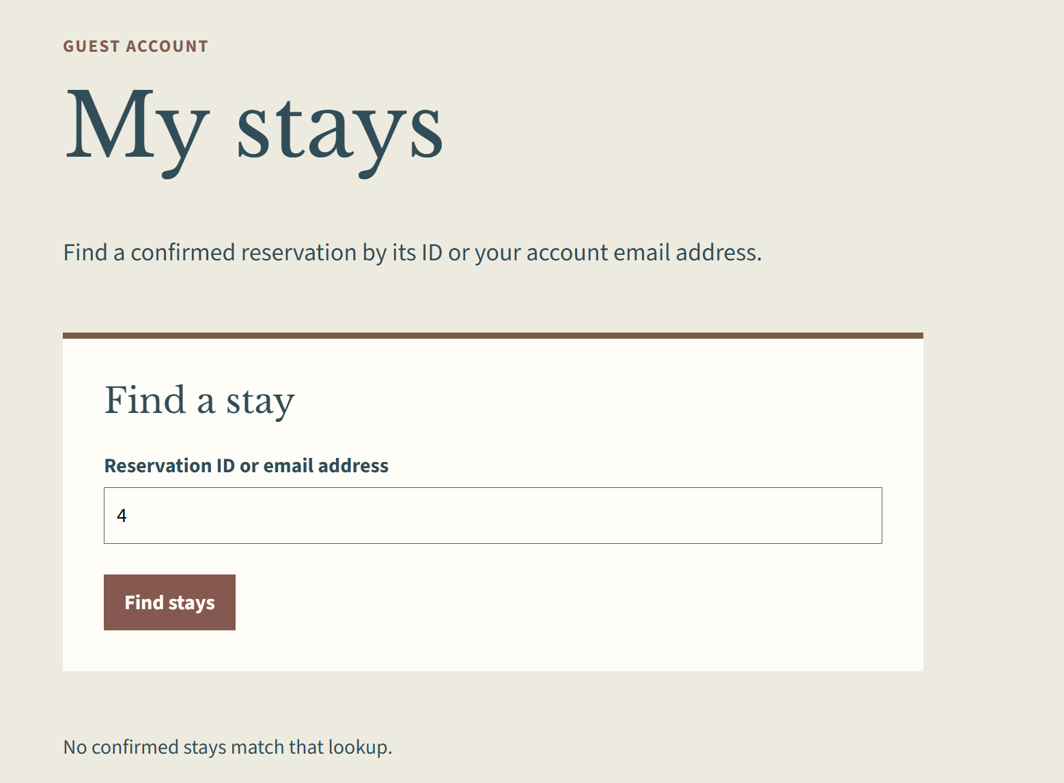
Test 4 | Test title: Account-email lookup returns owned stays and validates input  Test complete
 | Test Objective: Verify that account-email lookup returns only the signed-in customer’s stays, ignores spaces and case, and rejects invalid or other customers’ emails. | Developer: Justin Morrow  Date tested: 09/15/2026 | Peer tester: Carli McAvoy  Date tested: Pending 09/18/2026
Step | Action | Expected results: | Developer pass/fail | Tester pass/fail  + Screenshot
1 | Log in as a customer with at least two stays. Enter the account email and select “Find stays.” | All owned confirmed reservations appear; no other customer’s reservation does. | Pass | Pass + screenshot
2 | Repeat with the same email using mixed letter case. | Letter case are ignored, and the same owned reservations remain visible. | Pass | Pass + screenshot
3 | Enter a different customer’s valid email address and select “Find stays.” | The page shows “No confirmed stays match that lookup,” with no reservation details. | Pass (While logged in as one customer and putting the email for another customers in the Find a stay results in (No confirmed stays match that lookup). | Pass + screenshot
4 | Enter not-a-lookup and select “Find stays.” | The page shows “Enter a positive reservation ID or a valid email address,” no results, and remains on the lookup page. | Pass | Pass + screenshot
5 | Clear the lookup field and select “Find stays.” | The full customer-owned stay list returns in check-in-date order. | Pass | Pass + screenshot
Comments | Once logged in, all registered reservations appear in the “My stays” page for the logged in user. When entering the user’s email into the “Find a stay” search bar, the input is case-insensitive. When attempting to enter a different user’s active email into the search bar, the results for that user’s reservations do not show. The search bar only accepts email type inputs or ID numbers. When “Find stays” is selected with an empty search bar, the reservations for the current user is shown.

Step 1:
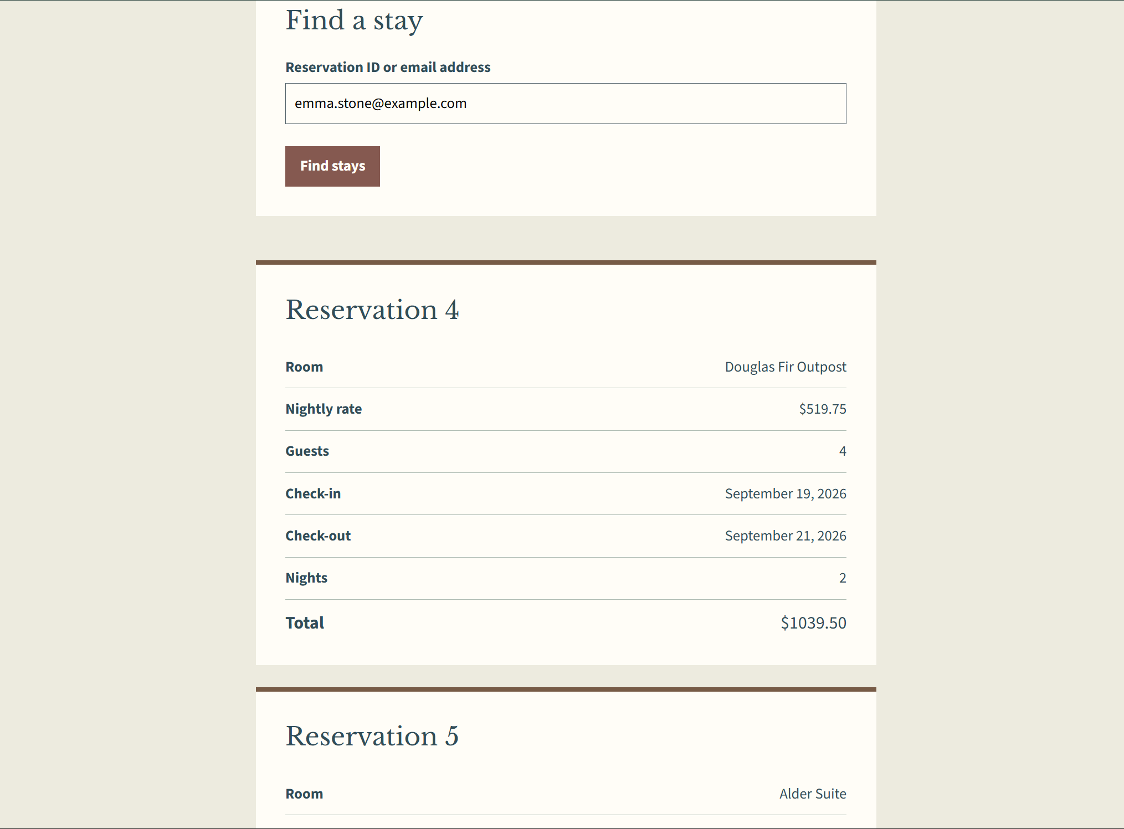

Step 2:
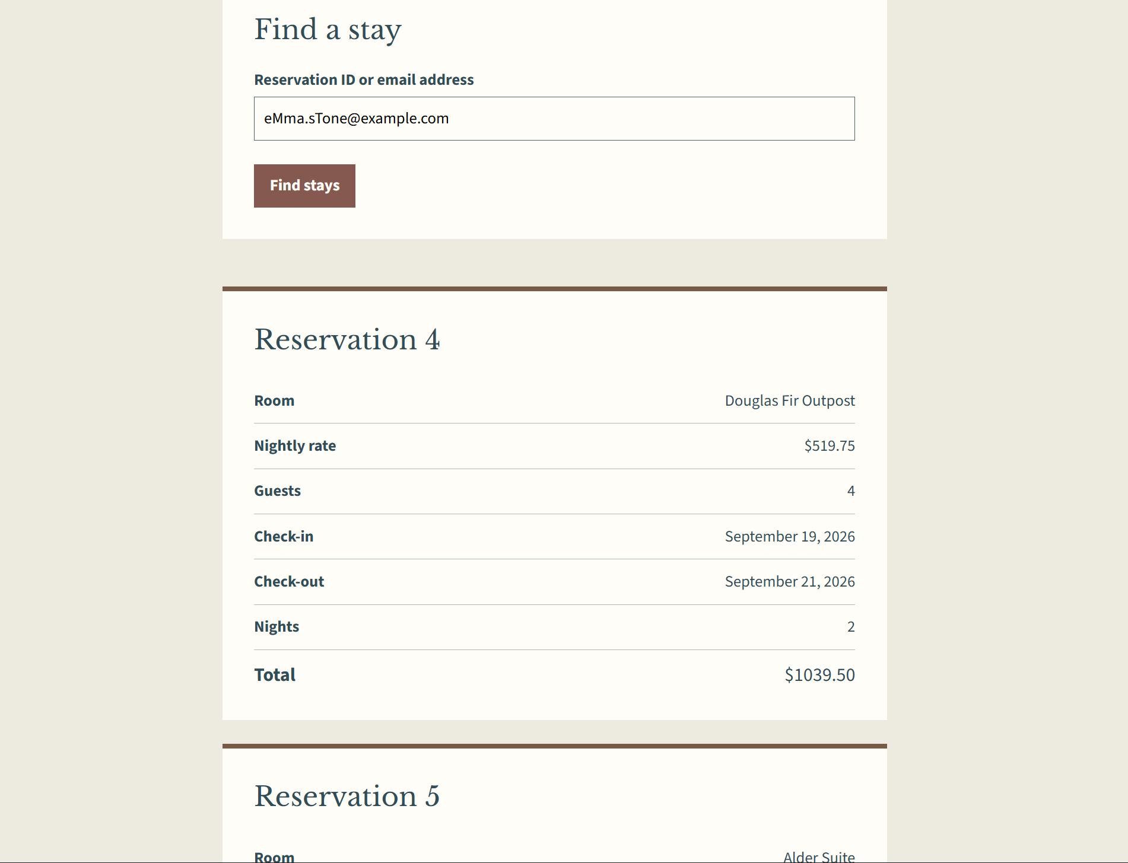

Step 3:
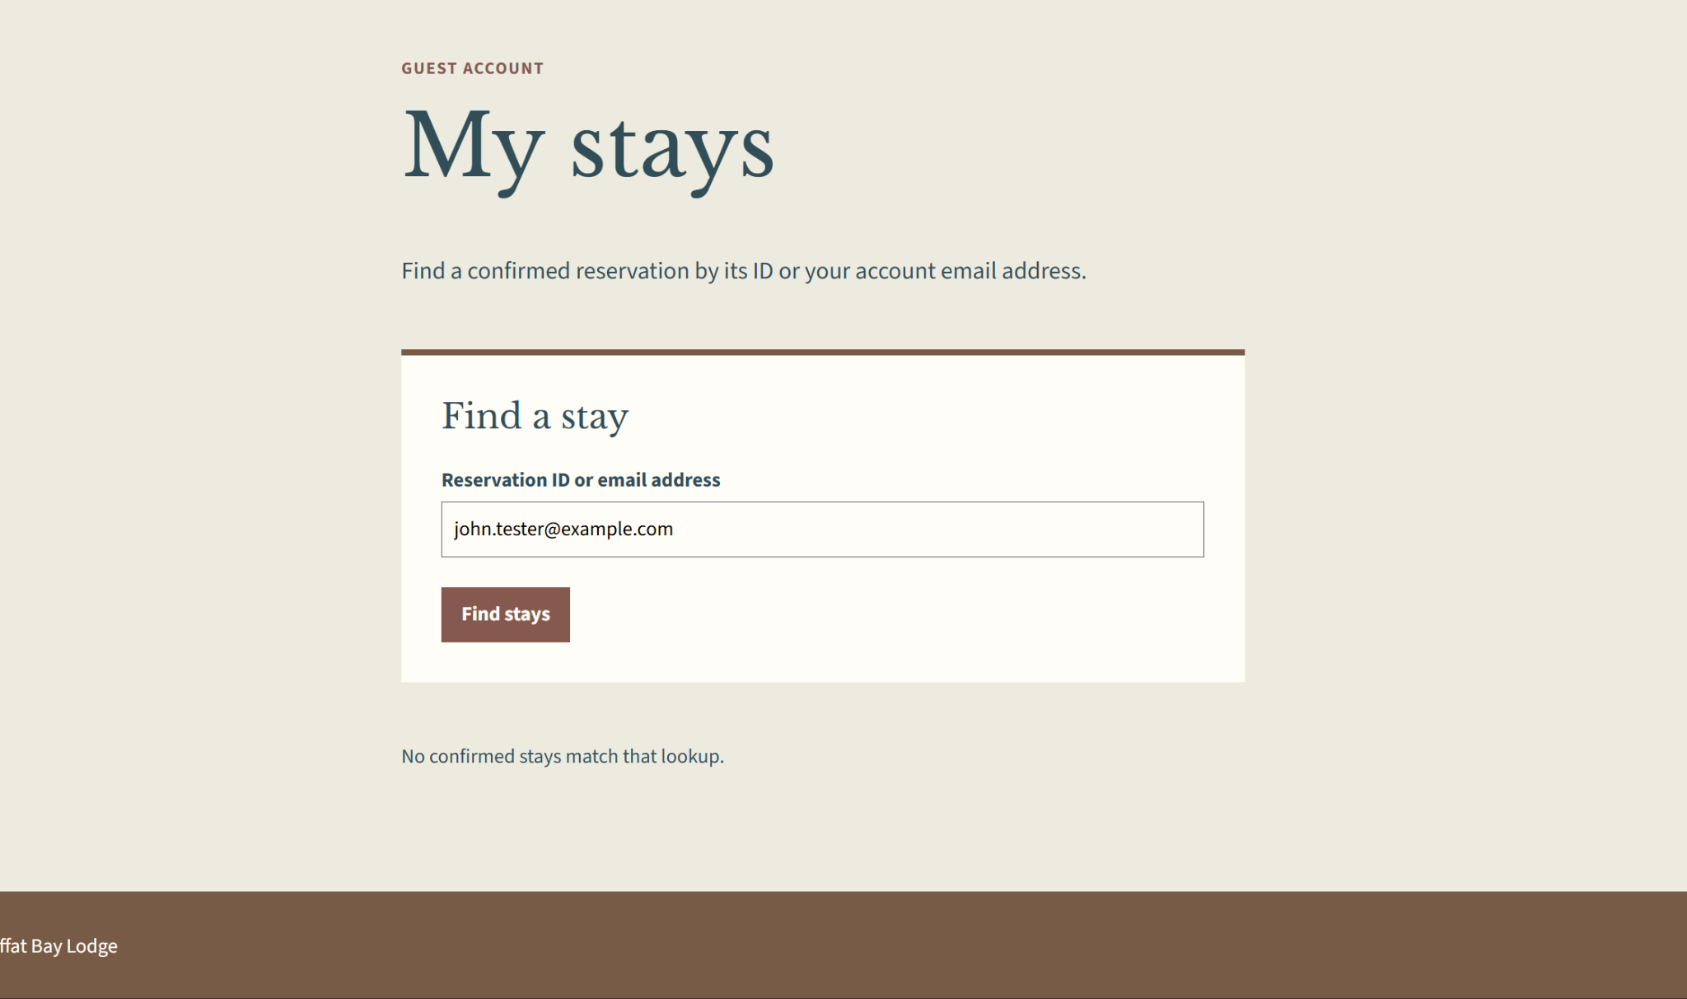

Step 4:
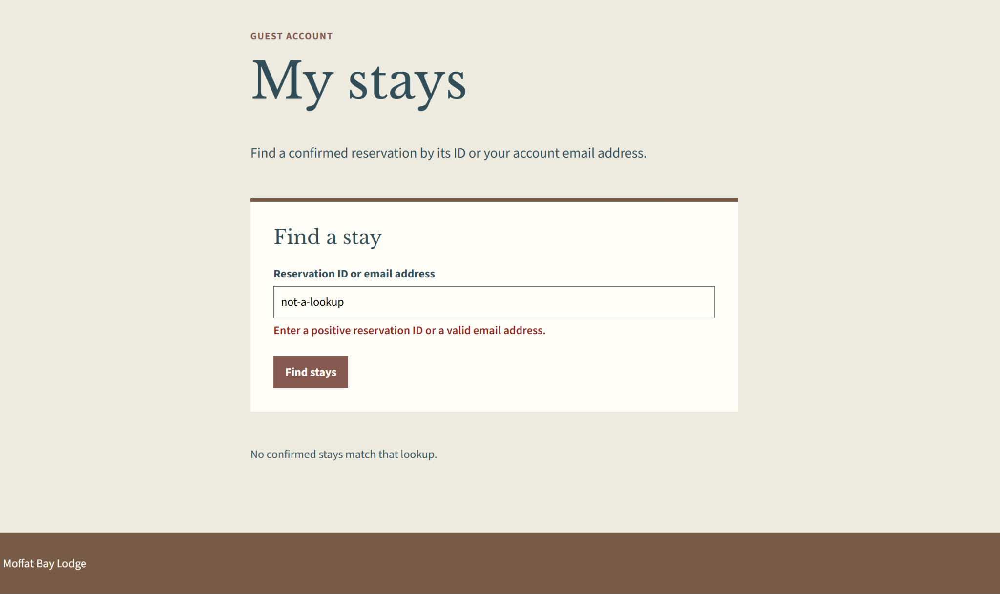

Step 5:
