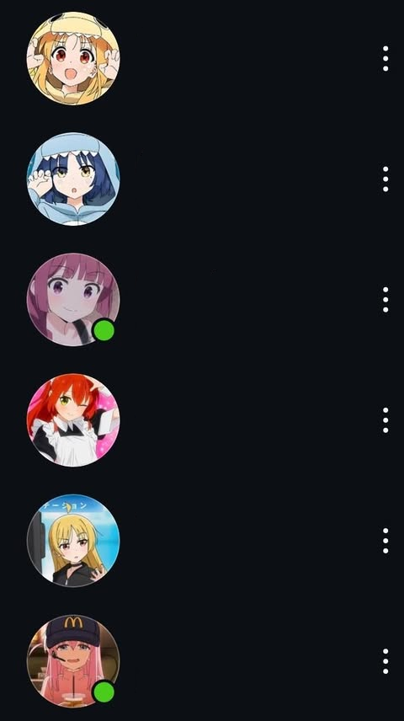1 second, 64 megabytes

You and your homies want to have matching profile pictures of anime characters. For the pictures to be considered matching, each person's friend list must contain only non-repeated characters. However, in the app, users can't see their own profile. Each person is interested in playing a different character. How many extra people are needed so that You and your homies want to have matching profile pictures of anime characters. For the pictures to be considered matching, each person's friend list must contain only non-repeated characters. However, in the app, users can't see their own profile. Each person is interested in playing a different character. How many extra people are needed so that everyone can be satisfied with the matching profile pictures?

input:

1st line n for number of characters

2nd line demand for each character

output:

1st line extra people needed

|  |  |
| --- | --- |
| Input | Output |
| 5  1 3 5 7 9 | 25 |

|  |  |
| --- | --- |
| Author: | Jump |