# UT4 TA10

## Visualización Dataset

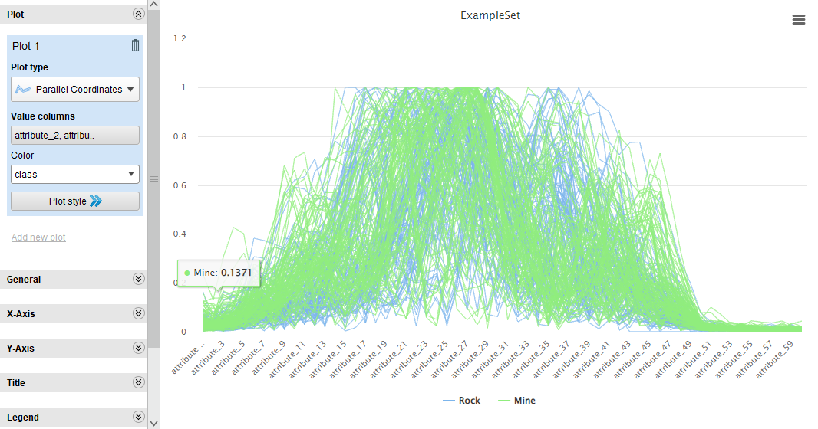

Deviation

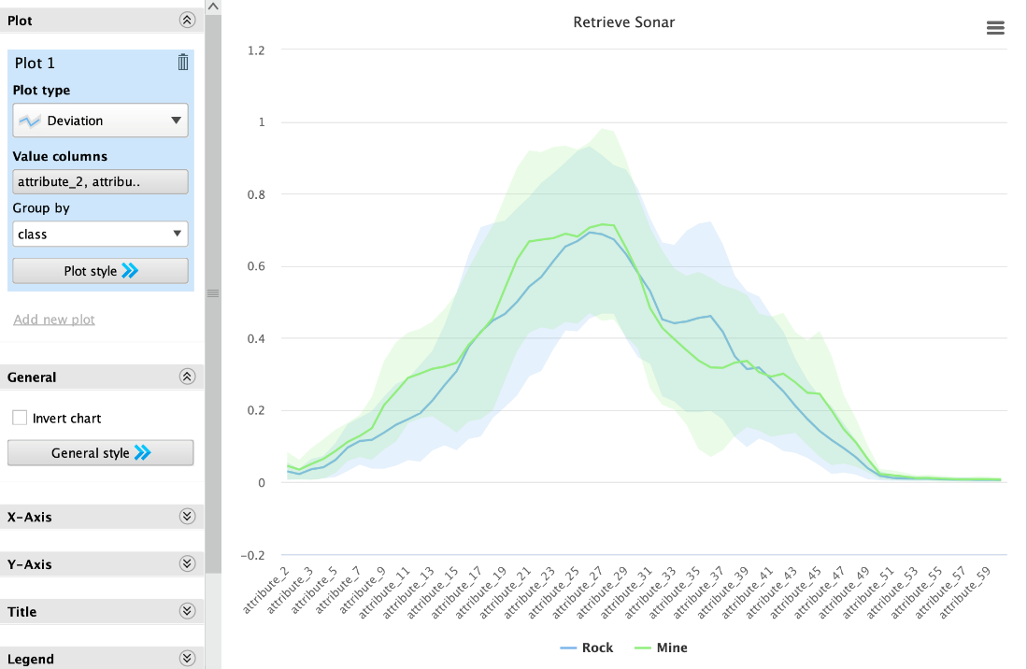

Áreas:

* Atributos del 7 al 15
* Atributos del 18 al 25
* Atributos del 32 al 38
* Atributos del 41 al 50

## Resultados de Modelo Naive Bayes sin Feature Selection:

Densidad de Probabilidades

Performance

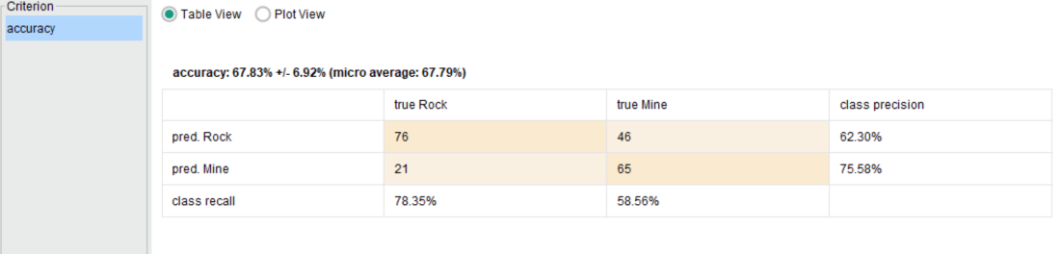

## Ejercicio 2:

## Forward Selection

Atributos retenidos del Feature Selection:

* 12,15,17,18

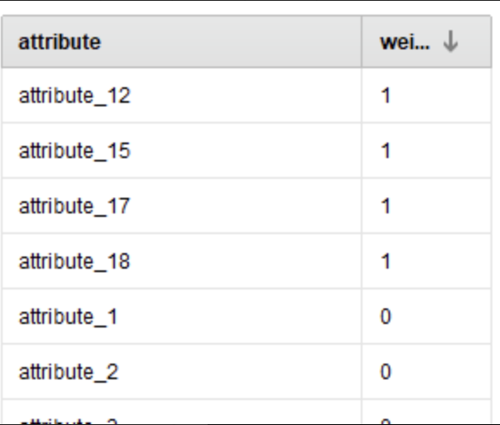

*Coinciden con el 1er área detectada en el primer ejercicio*

Performance:

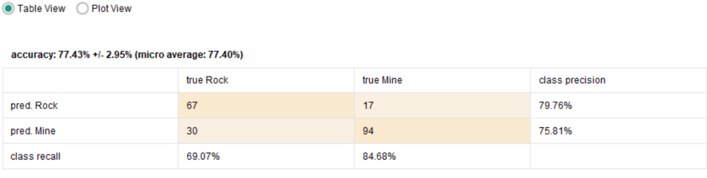

## Ejer3:

## Backward Selection

Atributos eliminados del Feature Selection:

Performance

## Ejer4: Evolutivos

Parámetros:

* use_exact_number_of_attributes
  + This parameter determines if only combinations containing exact numbers of attributes should be tested. The exact number is specified by the exact number of attributes parameter.
  + Range: boolean
* exact_number_of_attributes
  + This parameter is only available when the use exact number of attributes parameter is set to true. Only combinations containing this numbers of attributes would be generated and tested.
  + Range: integer
* restrict_maximum
  + If set to true, the maximum number of attributes whose combinations will be generated and tested can be restricted. Otherwise all combinations of all attributes are generated and tested. This parameter is only available when the use exact number of attributes parameter is set to true.
  + Range: boolean
* min_of_attributes
  + This parameter determines the minimum number of features used for the combinations to be generated and tested.
  + Range: integer
* max_number_of_attributes
  + This parameter determines the maximum number of features used for the combinations to be generated and tested. This parameter is only available when the restrict maximum parameter is set to true.
  + Range: integer
* population_size
  + This parameter specifies the population size i.e. the number of individuals per generation.
  + Range: integer
* maximum_number_of_generations
  + This parameter specifies the number of generations after which the algorithm should be terminated.
  + Range: integer
* use_early_stopping
  + This parameter enables early stopping. If not set to true, always the maximum number of generations are performed.
  + Range: boolean
* generations_without_improval
  + This parameter is only available when the use early stopping parameter is set to true. This parameter specifies the stop criterion for early stopping i.e. it stops after n generations without improvement in the performance. n is specified by this parameter.
  + Range: integer
* normalize_weights
  + This parameter indicates if the final weights should be normalized. If set to true, the final weights are normalized such that the maximum weight is 1 and the minimum weight is 0.
  + Range: boolean
* use_local_random_seed
  + This parameter indicates if a local random seed should be used for randomization. Using the same value of local random seed will produce the same randomization.
  + Range: boolean
* local_random_seed
  + This parameter specifies the local random seed. This parameter is only available if the use local random seed parameter is set to true.
  + Range: integer
* show_stop_dialog
  + This parameter determines if a dialog with a stop button should be displayed which stops the search for the best feature space. If the search for best feature space is stopped, the best individual found till then will be returned.
  + Range: boolean
* user_result_individual_selection
  + If this parameter is set to true, it allows the user to select the final result individual from the last population.
  + Range: boolean
* show_population_plotter
  + This parameter determines if the current population should be displayed in performance space.
  + Range: boolean
* plot_generations
  + This parameter is only available when the show population plotter parameter is set to true. The population plotter is updated in these generations.
  + Range: integer
* constraint_draw_range
  + This parameter is only available when the show population plotter parameter is set to true. This parameter determines if the draw range of the population plotter should be constrained between 0 and 1.
  + Range: boolean
* draw_dominated_points
  + This parameter is only available when the show population plotter parameter is set to true. This parameter determines if only points which are not Pareto dominated should be drawn on the population plotter.
  + Range: boolean
* population_criteria_data_file
  + This parameter specifies the path to the file in which the criteria data of the final population should be saved.
  + Range: filename
* maximal_fitness
  + This parameter specifies the maximal fitness. The optimization will stop if the fitness reaches this value.
  + Range: real
* selection_scheme
  + This parameter specifies the selection scheme of this evolutionary algorithms.
  + Range: selection
* tournament_size
  + This parameter is only available when the selection scheme parameter is set to 'tournament'. It specifies the fraction of the current population which should be used as tournament members.
  + Range: real
* start_temperature
  + This parameter is only available when the selection scheme parameter is set to 'Boltzmann'. It specifies the scaling temperature.
  + Range: real
* dynamic_selection_pressure
  + This parameter is only available when the selection scheme parameter is set to 'Boltzmann' or 'tournament'. If set to true the selection pressure is increased to maximum during the complete optimization run.
  + Range: boolean
* keep_best_individual
  + If set to true, the best individual of each generations is guaranteed to be selected for the next generation.
  + Range: boolean
* save_intermediate_weights
  + This parameter determines if the intermediate best results should be saved.
  + Range: boolean
* intermediate_weights_generations
  + This parameter is only available when the save intermediate weights parameter is set to true. The intermediate best results would be saved every k generations where k is specified by this parameter.
  + Range: integer
* intermediate_weights_file
  + This parameter specifies the file into which the intermediate weights should be saved.
  + Range: filename
* p_initialize
  + The initial probability for an attribute to be switched on is specified by this parameter.
  + Range: real
* p_mutation
  + The probability for an attribute to be changed is specified by this parameter. If set to -1, the probability will be set to 1/n where n is the total number of attributes.
  + Range: real
* p_crossover
  + The probability for an individual to be selected for crossover is specified by this parameter.
  + Range: real
* crossover_type
  + The type of the crossover can be selected by this parameter.
  + Range: selection

Atributos seleccionados:

attribute_19 attribute_20 attribute_24 attribute_25 attribute_27 attribute_31 attribute_35 attribute_36 attribute_37 attribute_41 attribute_43 attribute_44 attribute_46 attribute_49 attribute_54

Cubre 3 de las 4 áreas resaltadas en el ejercicio 1

Performance:

