**Supplementary Notes**

Comparison results 2

S1.1 ARI 2

S1.2 NMI 2

S1.3 Precision & Recall 3

S1.4 Running time 3

S1.5 Annotation error analysis 3

S1.6 Annotation with most variable genes 5

# Comparison results

S1.1 ARI

We use “adjustedRandIndex” in R (‘cidr’ package) to calculate Adjusted Rand Index (ARI).

**Supplementary Table 1 | ARI-Zeisel**

|  |  |  |  |  |  |  |  |  |  |  |  |  |
| --- | --- | --- | --- | --- | --- | --- | --- | --- | --- | --- | --- | --- |
|  | **pagoda2_infomap** | **pagoda2_multilevel** | **SC3** | **CIDR** | **Seurat** | **tSNE** | **SAFE** | **scRef::pearson** | **scRef::spearman** | **scRef::multinomial** | **scRef::kendall** | **scRef::semi-supervised** |
| **Original** | 0.235692663 | 0.590718097 | 0.424669823 | 0.367248095 | 0.180596042 | 0.862302873 | 0.718785282 | 0.4587997 | 0.4977975 | 0.4741055 | 0.5053194 | 0.5578852 |
| **Neuron merged** | 0.112323793 | 0.321984262 | 0.211593099 | 0.62575058 | 0.166885822 | 0.52733821 | 0.426741839 | 0.8210009 | 0.8626126 | 0.8495579 | 0.8624451 | 0.917321 |
| **Neuron removed** | 0.1739433 | 0.5899641 | 0.3259773 | 0.6563953 | 0.2497052 | 0.766662 | 0.4948344 | 0.6813724 | 0.8462789 | 0.8013861 | 0.8575611 | 0.9133551 |

**Supplementary Table 2 | ARI-Tasic**

|  |  |  |  |  |  |
| --- | --- | --- | --- | --- | --- |
|  | **scRef::pearson** | **scRef::spearman** | **scRef::multinomial** | **scRef::kendall** | **scRef::semi-supervised** |
| **Original** | 0.2063102 | 0.2139046 | 0.2195942 | 0.2178078 | 0.218299 |
| **Neuron merged + OTHER removed** | 0.9632103 | 0.987294 | 0.9990817 | 0.9911415 | 0.9956251 |
| **Neuron removed + OTHER removed** | 0.778748 | 0.8610543 | 0.9020829 | 0.8749216 | 0.9428578 |

**Supplementary Table 3 | ARI-Habib**

|  |  |  |  |  |  |
| --- | --- | --- | --- | --- | --- |
|  | **scRef::pearson** | **scRef::spearman** | **scRef::multinomial** | **scRef::kendall** | **scRef::semi-supervised** |
| **Original** | 0.8462835 | 0.9098513 | 0.8560124 | 0.9152363 | 0.9406015 |
| **OTHER removed** | 0.9830895 | 0.995678 | 0.9943954 | 0.9961101 | 0.9948532 |
| **Neuron removed + OTHER removed** | 0.8519236 | 0.9700085 | 0.8864094 | 0.97641 | 0.9435471 |

**Supplementary Table 4 | ARI-Hochgerner**

|  |  |  |  |  |  |
| --- | --- | --- | --- | --- | --- |
|  | **scRef::pearson** | **scRef::spearman** | **scRef::multinomial** | **scRef::kendall** | **scRef::semi-supervised** |
| **Original** | 0.1320347 | 0.1651151 | 0.1530798 | 0.1671729 | 0.1854772 |
| **Merged + OTHER removed** | 0.7888407 | 0.9600862 | 0.957464 | 0.950519 | 0.9086574 |
| **Merged + Neuron removed + OTHER removed** | 0.5974354 | 0.8854013 | 0.7476373 | 0.877548 | 0.8857942 |

S1.2 NMI

We use “NMI” in R (‘NMI’ package) to calculate Normalized Mutual Information (NMI).

**Supplementary Table 5 | NMI-Zeisel**

|  |  |  |  |  |  |  |  |  |  |  |  |  |
| --- | --- | --- | --- | --- | --- | --- | --- | --- | --- | --- | --- | --- |
|  | **pagoda2_infomap** | **pagoda2_multilevel** | **SC3** | **CIDR** | **Seurat** | **tSNE** | **SAFE** | **scRef::pearson** | **scRef::spearman** | **scRef::multinomial** | **scRef::kendall** | **scRef::semi-supervised** |
| **Original** | 0.584084877 | 0.699891534 | 0.639689618 | 0.47436346 | 0.360502588 | 0.814605826 | 0.697543949 | 0.5415847 | 0.631015 | 0.6096761 | 0.63135 | 0.6895258 |
| **Neuron merged** | 0.445871248 | 0.547903315 | 0.478455719 | 0.579934692 | 0.4063472 | 0.647942782 | 0.546309753 | 0.6572838 | 0.7720847 | 0.7460005 | 0.7714603 | 0.8373372 |
| **Neuron removed** | 0.5951252 | 0.7446338 | 0.5087087 | 0.6114579 | 0.5191517 | 0.7116153 | 0.5653107 | 0.4995832 | 0.702085 | 0.6362314 | 0.7113909 | 0.7955889 |

**Supplementary Table 6 | NMI-Tasic**

|  |  |  |  |  |  |
| --- | --- | --- | --- | --- | --- |
|  | **scRef::pearson** | **scRef::spearman** | **scRef::multinomial** | **scRef::kendall** | **scRef::semi-supervised** |
| **Original** | 0.4535323 | 0.4800227 | 0.4972161 | 0.4853185 | 0.4996632 |
| **Neuron merged + OTHER removed** | 0.8964497 | 0.9317615 | 0.9693537 | 0.9412241 | 0.9706097 |
| **Neuron removed + OTHER removed** | 0.8024618 | 0.8468327 | 0.9035316 | 0.862485 | 0.9343078 |

**Supplementary Table 7 | NMI-Habib**

|  |  |  |  |  |  |
| --- | --- | --- | --- | --- | --- |
|  | **scRef::pearson** | **scRef::spearman** | **scRef::multinomial** | **scRef::kendall** | **scRef::semi-supervised** |
| **Original** | 0.6880635 | 0.8247804 | 0.7485723 | 0.8320144 | 0.8733894 |
| **OTHER Removed** | 0.9165942 | 0.9776861 | 0.9582753 | 0.9805898 | 0.9708615 |
| **Neuron removed + OTHER removed** | 0.8289337 | 0.9560601 | 0.8919929 | 0.9635546 | 0.9368758 |

**Supplementary Table 8 | NMI-Hochgerner**

|  |  |  |  |  |  |
| --- | --- | --- | --- | --- | --- |
|  | **scRef::pearson** | **scRef::spearman** | **scRef::multinomial** | **scRef::kendall** | **scRef::semi-supervised** |
| **Original** | 0.3528099 | 0.46532 | 0.4422228 | 0.4561949 | 0.499306 |
| **Merged + OTHER removed** | 0.6654204 | 0.8837054 | 0.8433564 | 0.8652991 | 0.8310937 |
| **Merged + Neuron removed + OTHER removed** | 0.5565025 | 0.8295062 | 0.6925935 | 0.8125795 | 0.8440822 |

S1.3 Precision & Recall

For precision and recall, we only show the result of scRef::kendall and scRef::semi-supervised in Zeisel test data (**Suppplementary Table 9**). For the precision and recall of other test data, readers can calculate them by using the results of scRef. Users can download the results of scRef from:

<https://github.com/jumphone/scRef/tree/master/Benchmark>

**Supplementary Table 9 | Precision&Recall-Zeisel**

|  |  |  |  |  |
| --- | --- | --- | --- | --- |
|  | **scRef::kendall** | | **scRef::semi-supervised** | |
|  | **Precision** | **Recall** | **Precision** | **Recall** |
| **Astrocytes** | 94.44% | 75.89% | 96.41% | 83.93% |
| **Endothelial.Cells** | 88.18% | 76.17% | 89.18% | 87.66% |
| **Microglia** | 100.00% | 66.33% | 100.00% | 71.43% |
| **Oligodendrocytes** | 94.10% | 97.32% | 95.18% | 98.78% |
| **Neuron** | 94.32% | 97.97% | 97.91% | 97.79% |

S1.4 Running time

For methods which can use multicores, we use 10 threads to run. The CPU of used server is Intel(R) Xeon(R) CPU E5-2650 v3 @ 2.30GHz. This result doesn’t include the time cost of loading data.

**Supplementary Table 10 | Running time-Zeisel**

|  |  |  |  |  |  |  |  |  |  |  |  |  |
| --- | --- | --- | --- | --- | --- | --- | --- | --- | --- | --- | --- | --- |
|  | **pagoda2_infomap** | **pagoda2_multilevel** | **SC3** | **CIDR** | **Seurat** | **tSNE** | **SAFE** | **scRef::pearson** | **scRef::spearman** | **scRef::multinomial** | **scRef::kendall** | **scRef::semi- supervised** |
| **Time (minute)** | <1 | <1 | 32 | 2 | 2 | 18 | 61 | <1 | <1 | <1 | <1 | <1 |

S1.5 Annotation error analysis

We have analyzed the annotation error in Zeisel’s data: We define cells having wrong annotation in all five methods of scRef as “Error”, and define cells having at least one correct annotation as “Correct”. 75 out of 3005 cells are Errors. tSNE plot shows that Errors are randomly distributed in different cell types (**Suppplementary Figure 1**). In addition, we find that Errors occupy a large proportion in the cells having wrong labels of each measurements (see **Supplementary Table 11** and **Suppplementary Figure 2**). Finally, by comparing the sequenced gene number between Errors and Corrects, we find that the wrong annotation of Errors may be caused by the low sequence depth of these cells (**Suppplementary Figure 3**).

**Supplementary Figure 1 | “0” means Error; “1” means Correct.**

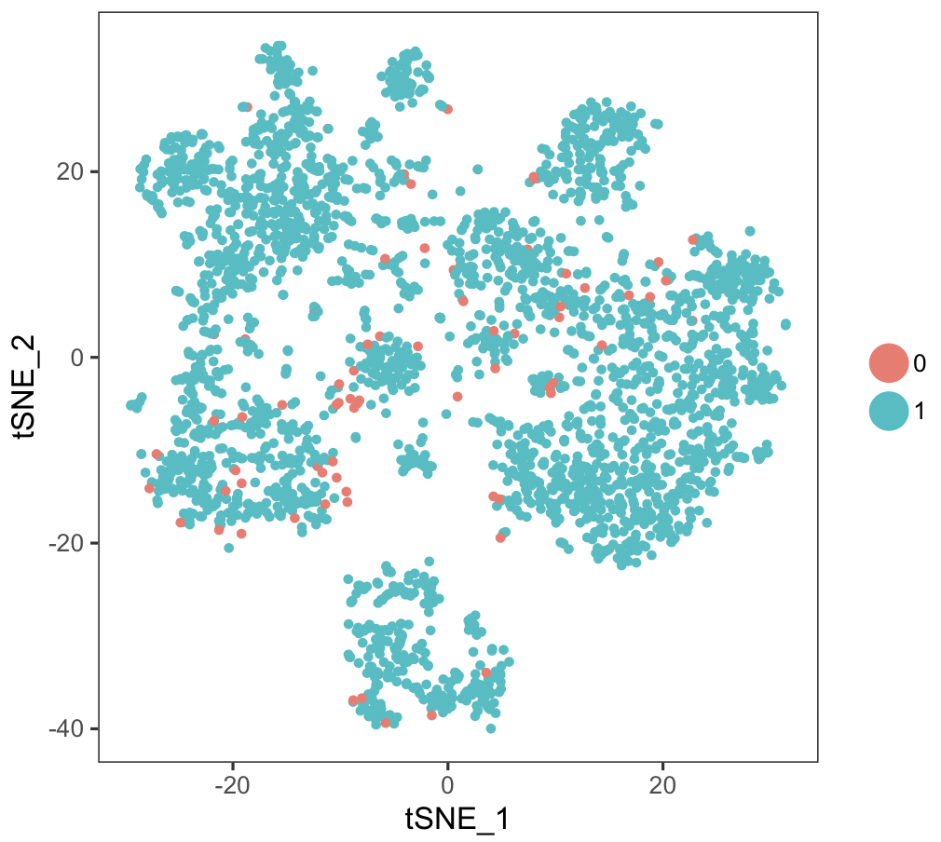

**Supplementary Table 11 | Errors in five methods of scRef**

|  |  |  |  |  |  |
| --- | --- | --- | --- | --- | --- |
|  | **scRef::pearson** | **scRef::spearman** | **scRef::multinomial** | **scRef::kendall** | **scRef::semi-supervised** |
| **#correct cells** | 2630 | 2804 | 2732 | 2807 | 2866 |
| **#wrong cells** | 375 | 201 | 273 | 198 | 139 |
| **#Errors / #wrong cells** | 20.00% | 37.31% | 27.47% | 37.88% | 53.96% |

**Supplementary Figure 2 | Venn plot of correct cells**

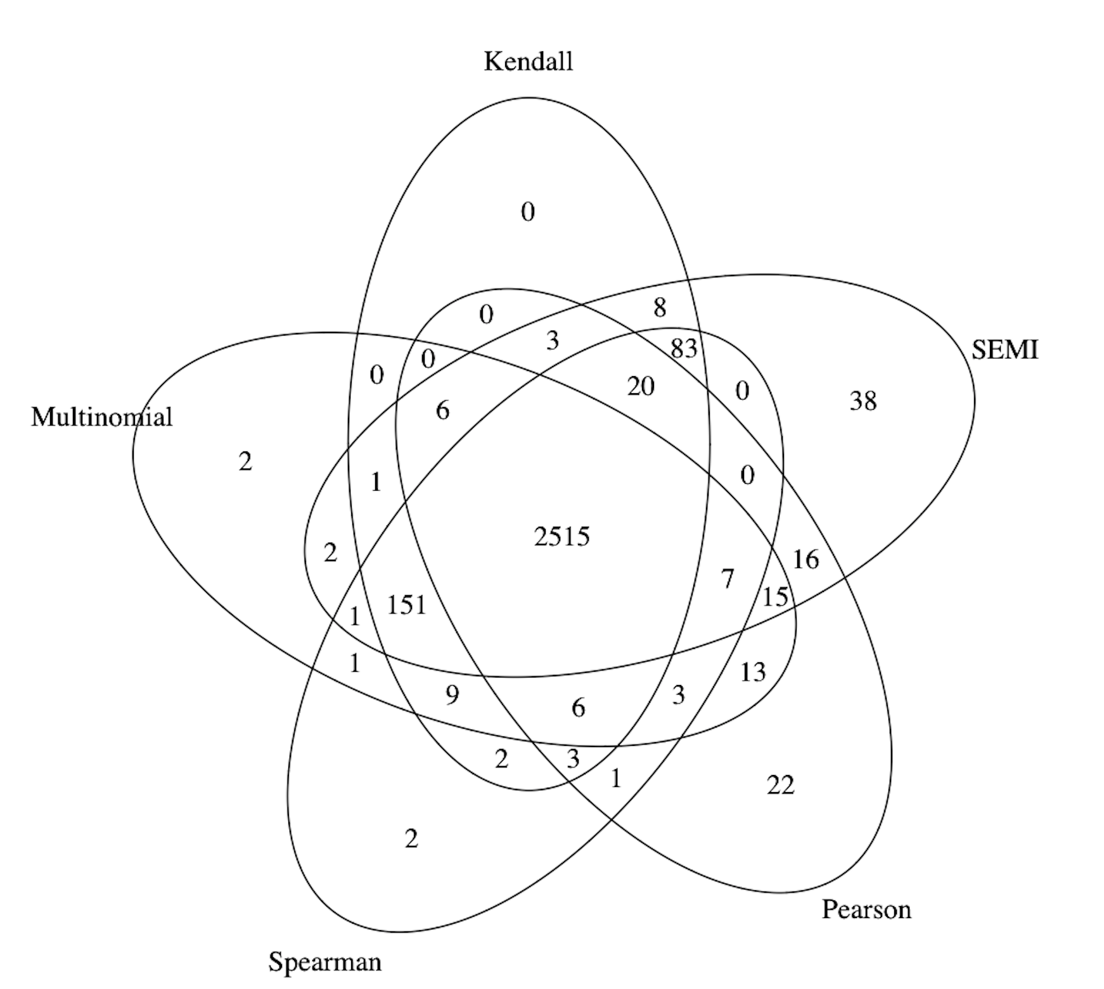

**Supplementary Figure 3 | Number of sequenced genes**

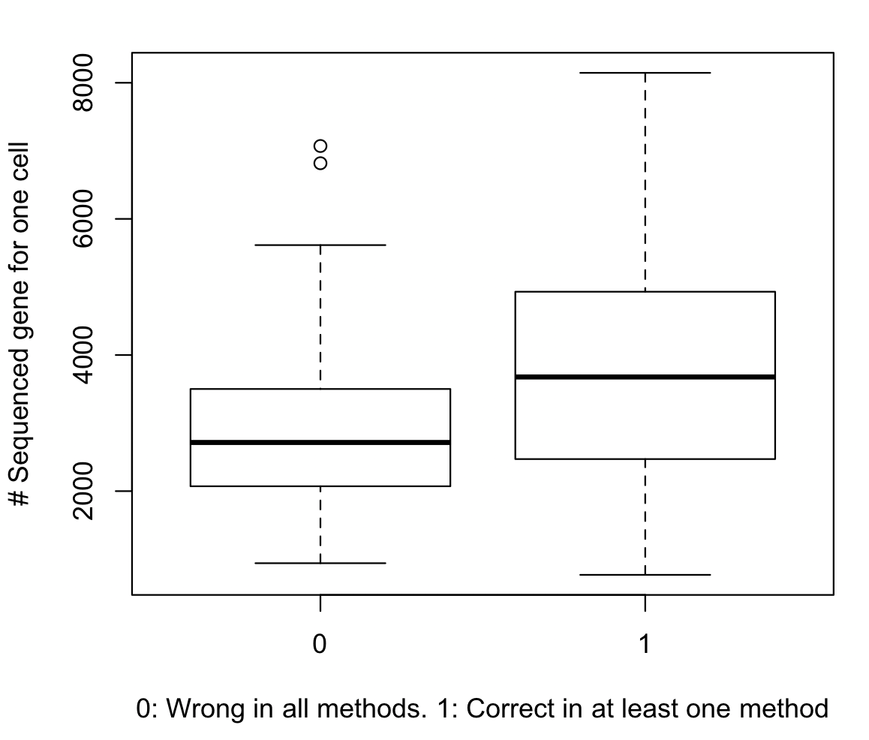

S1.6 Annotation with most variable genes

“Ref-var” and “Sc-var” means that scRef only uses top 20% variable genes in reference and single-call data, respectively. We use “var” function in R to calculate the variance of each gene.

**Supplementary Table 12 | Variable gene performance-Zeisel**

|  |  |  |  |  |
| --- | --- | --- | --- | --- |
|  | **Zeisel** | **scRef::semi (All genes)** | **scRef::semi (Ref-var)** | **scRef::semi (Sc-var)** |
| **ARI** | **Original** | 0.5578852 | 0.5604749 | 0.5618369 |
| **Merged + OTHER removed** | 0.917321 | 0.9280562 | 0.8955228 |
| **Merged + Neron removed + OTHER removed** | 0.9133551 | 0.9191855 | 0.9163205 |
| **NMI** | **Original** | 0.6895258 | 0.7024494 | 0.6874412 |
| **Merged + OTHER removed** | 0.8373372 | 0.853632 | 0.8315773 |
| **Merged + Neron removed + OTHER removed** | 0.7955889 | 0.8072065 | 0.8171042 |

**Supplementary Table 13 | Variable gene performance-Tasic**

|  |  |  |  |  |
| --- | --- | --- | --- | --- |
|  | **Tasic** | **scRef::semi (All genes)** | **scRef::semi (Ref-var)** | **scRef::semi (Sc-var)** |
| **ARI** | **Original** | 0.218299 | 0.2183459 | 0.2196549 |
| **Merged + OTHER removed** | 0.9956251 | 0.9957325 | 0.9959257 |
| **Merged + Neron removed + OTHER removed** | 0.9428578 | 0.9543684 | 0.9748919 |
| **NMI** | **Original** | 0.4996632 | 0.5024584 | 0.5047601 |
| **Merged + OTHER removed** | 0.9706097 | 0.976027 | 0.9822003 |
| **Merged + Neron removed + OTHER removed** | 0.9343078 | 0.9513827 | 0.9707728 |

**Supplementary Table 14 | Variable gene performance-Habib**

|  |  |  |  |  |
| --- | --- | --- | --- | --- |
|  | **Habib** | **scRef::semi (All genes)** | **scRef::semi (Ref-var)** | **scRef::semi (Sc-var)** |
| **ARI** | **Original** | 0.9406015 | 0.8800211 | 0.9503378 |
| **Merged + OTHER removed** | 0.9948532 | 0.9959139 | 0.9950213 |
| **Merged + Neron removed + OTHER removed** | 0.9435471 | 0.9809136 | 0.9187328 |
| **NMI** | **Original** | 0.8733894 | 0.7894564 | 0.8682525 |
| **Merged + OTHER removed** | 0.9708615 | 0.9818982 | 0.9673631 |
| **Merged + Neron removed + OTHER removed** | 0.9368758 | 0.9665326 | 0.9225051 |

**Supplementary Table 15 | Variable gene performance-Hochgerner**

|  |  |  |  |  |
| --- | --- | --- | --- | --- |
|  | **Hochgerner** | **scRef::semi (All genes)** | **scRef::semi (Ref-var)** | **scRef::semi (Sc-var)** |
| **ARI** | **Original** | 0.1854772 | 0.1826365 | 0.1944175 |
| **Merged + OTHER removed** | 0.9086574 | 0.9211051 | 0.8647135 |
| **Merged + Neron removed + OTHER removed** | 0.8857942 | 0.8320005 | 0.8801124 |
| **NMI** | **Original** | 0.499306 | 0.5045318 | 0.5019407 |
| **Merged + OTHER removed** | 0.8310937 | 0.8422553 | 0.8051473 |
| **Merged + Neron removed + OTHER removed** | 0.8440822 | 0.8076233 | 0.8167469 |