FDO SDF ODBC Driver

Driver Registration
The FDO SDF ODBC Driver shall be registered on a Windows environment with the following values

Driver Name
The name of the ODBC driver will be “OSGeo FDO SDF Driver (*.sdf)”

Driver DLL
The driver name of the ODBC driver DLL will be SDFOdbcDriver.dll

Setup DLL
The name of the ODBC setup DLL will be SDFOdbcSetup.dll.

Driver Location
The install location for the driver and setup DLLs will be: <FDO Install Directory>\Bin

API Level
The ODBC Driver API Level is a number indicating the ODBC interface conformance level supported by the driver:
0 = Core
1 = Level 1 supported
2 = Level 2 supported
This will be the same as the value returned for the SQL_ODBC_INTERFACE_CONFORMANCE option in SQLGetInfo.

Core Level Compliance
All ODBC drivers must exhibit at least Core-level interface conformance. Because the features in the Core level are those required by most generic interoperable applications, the driver can work with such applications. The features in the Core level also correspond to the features defined in the ISO CLI specification and to the no optional features defined in the X/Open CLI specification.
The FDO SDF Driver will be Core-level interface–conformant.
A Core-level interface-conformant ODBC driver allows the application to do all of the following:
- Allocate and free all types of handles, by calling SQLAllocHandle and SQLFreeHandle.
- Use all forms of the SQLFreeStmt function.
- Bind result set columns, by calling SQLBindCol.
- Handle dynamic parameters, including arrays of parameters, in the input direction only, by calling SQLBindParameter and SQLNumParams.
- Specify a bind offset.
- Use the data-at-execution dialog, involving calls to SQLParamData and SQLPutData.
- Manage cursors and cursor names, by calling SQLCloseCursor, SQLGetCursorName, and SQLSetCursorName.
- Gain access to the description (metadata) of result sets, by calling SQLColAttribute, SQLDescribeCol, SQLNumResultCols, and SQLRowCount.
- Query the data dictionary, by calling the catalog functions SQLColumns, SQLGetTypeInfo, SQLStatistics, and SQLTables.
- Manage data sources and connections, by calling SQLConnect, SQLDataSources, SQLDisconnect, and SQLDriverConnect. Obtain information on drivers, no matter which ODBC level they support, by calling SQLDrivers.
- Prepare and execute SQL statements, by calling SQLExecDirect, SQLExecute, and SQLPrepare.
- Fetch one row of a result set or multiple rows, in the forward direction only, by calling SQLFetch or by calling SQLFetchScroll with the FetchOrientation argument set to SQL_FETCH_NEXT.
- Obtain an unbound column in parts, by calling SQLGetData.
- Obtain current values of all attributes, by calling SQLGetConnectAttr, SQLGetEnvAttr, and SQLGetStmtAttr, and set all attributes to their default values and set certain attributes to non-default values by calling SQLSetConnectAttr, SQLSetEnvAttr, and SQLSetStmtAttr.
- Manipulate certain fields of descriptors, by calling SQLCopyDesc, SQLGetDescField, SQLGetDescRec, SQLSetDescField, and SQLSetDescRec.
- Obtain diagnostic information, by calling SQLGetDiagField and SQLGetDiagRec.
- Detect driver capabilities, by calling SQLGetFunctions and SQLGetInfo. Also, detect the result of any text substitutions made to an SQL statement before it is sent to the data source, by calling SQLNativeSql.
- Use the syntax of SQLEndTran to commit a transaction. A Core-level driver need not support true transactions; therefore, the application cannot specify SQL_ROLLBACK nor SQL_AUTOCOMMIT_OFF for the SQL_ATTR_AUTOCOMMIT connection attribute.
- Call SQLCancel to cancel the data-at-execution dialog and, in multithread environments, to cancel an ODBC function executing in another thread. Core-level interface conformance does not mandate support for asynchronous execution of functions, nor the use of SQLCancel to cancel an ODBC function executing asynchronously. Neither the platform nor the ODBC driver need be multithread for the driver to conduct independent activities at the same time. However, in multithread environments, the ODBC driver must be thread-safe. Serialization of requests from the application is a conformant way to implement this specification, even though it might create serious performance problems.
- Obtain the SQL_BEST_ROWID row-identifying column of tables, by calling SQLSpecialColumns.

Level 1Compliance
The Level 1 interface conformance level includes the Core interface conformance level functionality plus additional features, such as transactions, that are usually available in an OLTP relational DBMS.
The FDO SDF Driver will not be Level 1 compliant. The ODBC Driver shall support a subset of Level 1 functionality. The driver shall only support the following functionality:
- Specify the schema of database tables and views (using two-part naming).
- Obtain primary keys of tables, by calling SQLPrimaryKeys.

Connect Functions
A three-character string indicating whether the driver supports SQLConnect, SQLDriverConnect, and SQLBrowseConnect. If the driver supports SQLConnect, the first character is "Y"; otherwise, it is "N". If the driver supports SQLDriverConnect, the second character is "Y"; otherwise, it is "N". If the driver supports SQLBrowseConnect, the third character is "Y"; otherwise, it is "N". For example, if a driver supports SQLConnect and SQLDriverConnect but not SQLBrowseConnect, the three-character string is "YYN".
The FDO SDF Driver shall support the ConnectFuntion setting of YYY. SQLConnect , SQLDriverConnect and SQLBrowseConnect will all be supported.

ODBC Version
A character string with the version of ODBC that the driver supports. The version is of the form nn.nn, where the first two digits are the major version and the next two digits are the minor version.
The FDO SDF ODBC driver will support an ODBC version of "03.00".
This must be the same as the value returned for the SQL_DRIVER_ODBC_VER option in SQLGetInfo.

File Extensions
For file-based drivers, a comma-separated list of extensions of the files the driver can use. For example, a dBASE driver might specify *.dbf .
The ODBC FDO SDF Driver shall support a fie extension of *.sdf

File Usage
A number indicating how a file-based driver directly treats files in a data source.
0 = The driver is not a file-based driver. For example, an ORACLE driver is a DBMS-based driver.
1 = A file-based driver treats files in a data source as tables. For example, an Xbase driver treats each Xbase file as a table.
2 = A file-based driver treats files in a data source as a catalog. For example, a Microsoft® Access driver treats each Microsoft Access file as a complete database.
The ODBC FDO SDF Driver shall support a fie usage level of 2.

SQL Level
A number indicating the SQL-92 grammar supported by the driver:
0 = SQL-92 Entry
1 = FIPS127-2 Transitional
2 = SQL-92 Intermediate
3 = SQL-92 Full
This will be the same as the value returned for the SQL_SQL_CONFORMANCE option in SQLGetInfo.
The ODBC FDO SDF Driver shall support a SQL level of 0 –SQL-92 Entry

Windows Registry
The ODBC Driver properties listed above shall be registered in the Windows registry under: KEY_LOCAL_MACHINE\SOFTWARE\ODBC\ODBCINST.INI as follows
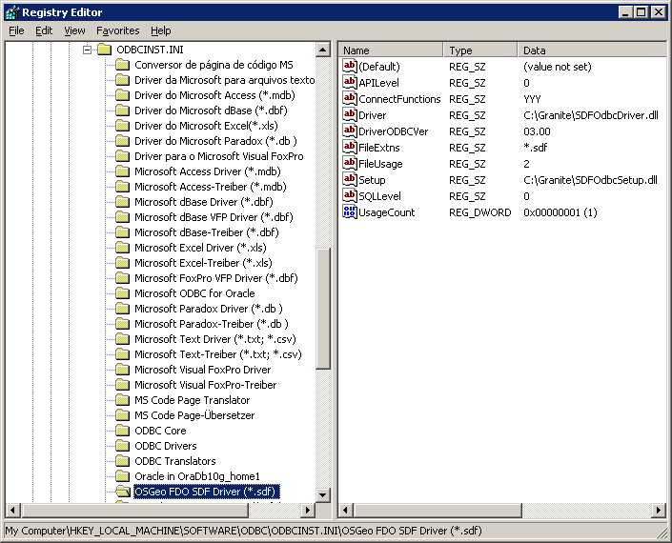

Data Source Configuration
The SDF ODBC Driver shall be registered in the list of drivers specified in the ODBC Data Source Administrator.

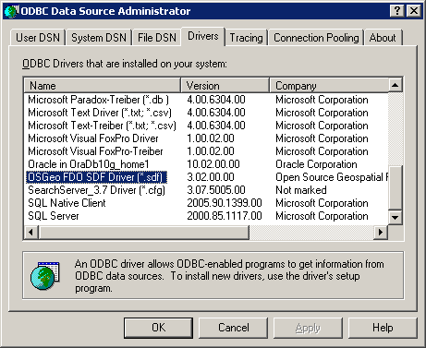

Figure 1: ODBC Data Source Administrator

The properties of the driver shown in the Drivers tab are taken from the version information of the SDF Driver:

Version Attribute | Version Property Value
CompanyName | Open Source Geospatial Foundation
FileDescription | SDF ODBC Driver Dynamic Link Library
FileVersion | 3, 2, 0, 0
InternalName | SDFOdbcDriver
LegalCopyright | Copyright (C) 2006
OriginalFilename | SDFOdbcDriver.dll
ProductName | Feature Data Objects
ProductVersion | 3, 2, 0, 0

Using the ODBC Administrator, a user will be able to Add a new instance of the SDF Driver from the User|System|File DSN tabs

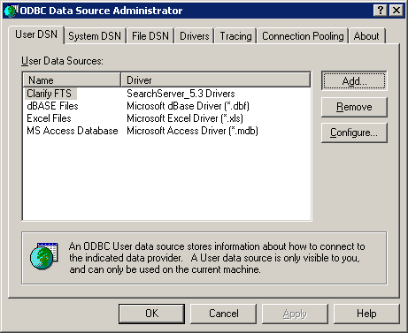

Figure 2: Add ODBC Data Source

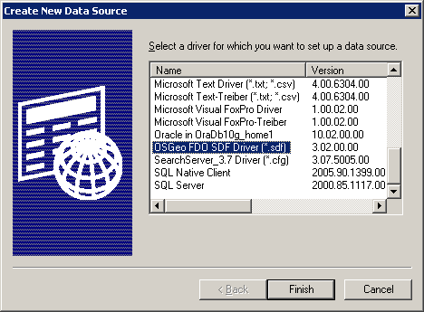

Figure 3: Create New SDF Driver Data Source

In order to add a new DSN, the user will have to enter the new Data Source Name and Description.

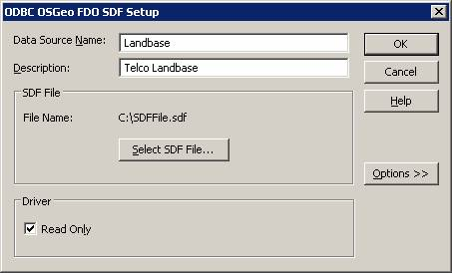

Figure 4: ODBC OSGeo FDO SDF Setup

The user will also have to select the SDF file to be accessed by the ODBC driver by selecting the “Select SDF File…” button. The user will have the option to specify that the file will be opened as read only. The default behavior shall be that the file is opened Read Only.

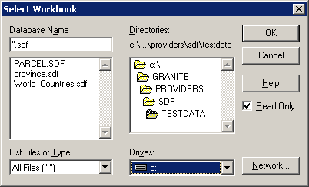

Figure 5: ODBC Select SDF File

Driver Connections
The FDO SDF Driver will allow calling application to establish a connection to an SDF FdoIConnection object using standard ODBC functions that allocate/fee environment and connection handles, set connection attributes, connect and disconnect.

ODBC Handles
The first step in an ODBC application is to initialize the ODBC environment and allocate ODBC handles. The SDF driver shall support this mechanism through the SQLAllocHandle and SQLFreeHandle methods.
There are two types of handles that need to be managed as a part of the connection process:
Environment Handles: An environment is a global context in which to access data; associated with an environment is any information that is global in nature, such as:
- The environment's state
- The current environment-level diagnostics
- The handles of ODBC connections currently allocated on the environment
- The current settings of each environment attribute
Connection Handles: A connection consists of a driver and a data source. A connection handle identifies each connection. The connection handle defines not only which driver to use but which data source to use with that driver. The connection handle identifies a structure that contains connection information, such as:
- The connection's state
- The current connection-level diagnostics
- The handles of ODBC statements and descriptors currently allocated on the connection
- The current settings of each connection attribute

Connection Attributes
Connection attributes are characteristics of the connection. Connection attributes are set with SQLSetConnectAttr and their current settings retrieved with SQLGetConnectAttr. If SQLSetConnectAttr is called before the driver is loaded, the Driver Manager stores the attributes in its connection structure and sets them in the driver as part of the connection process.
The following table indicates those connection attributes that must be set either before or after a connection has been made. Either indicates that the attribute can be set either before or after connection. The table also provides a list of driver manager or driver supported attributes. There is no requirement that an application set any connection attributes; all connection attributes have defaults.
Attribute | Can set before or after connection | Supported options
SQL_ATTR_ACCESS_MODE | Either | SQL_MODE_READ_ONLY  SQL_MODE_READ_WRITE
SQL_ATTR_ASYNC_ENABLE | Either | SQL_ASYNC_ENABLE_OFF  SQL_ASYNC_ENABLE_ON
SQL_ATTR_AUTO_IPD | Neither | SQL_FALSE
SQL_ATTR_ENABLE_AUTO_IPD | Neither | SQL_FALSE
SQL_ATTR_AUTOCOMMIT | Neither | SQL_AUTOCOMMIT_ON
SQL_ATTR_CONNECTION_DEAD | Either | SQL_CD_TRUE  SQL_CD_FALSE
SQL_ATTR_CONNECTION_TIMEOUT | Neither | 0 (No Timeout)
SQL_ATTR_CURRENT_CATALOG | Neither | Not Supported by Driver
SQL_ATTR_LOGIN_TIMEOUT | Neither | 0
SQL_ATTR_METADATA_ID | Either | SQL_TRUE  SQL_FALSE
SQL_ATTR_ODBC_CURSORS | Before | SQL_CUR_USE_IF_NEEDED  SQL_CUR_USE_ODBC  SQL_CUR_USE_DRIVER
SQL_ATTR_QUIET_MODE | Either | 32-bit window handle (HWND)
SQL_ATTR_TRACE | Either | SQL_OPT_TRACE_OFF  SQL_OPT_TRACE_ON
SQL_ATTR_TRACEFILE | Either | A null-terminated character string containing the name of the trace file.
SQL_ATTR_TXN_ISOLATION | Neither | SQL_TXN_READ_COMMITTED
SQL_ATTR_PACKET_SIZE | Neither | Not Supported by Driver
SQL_ATTR_TRANSLATE_LIB | After | TBD
SQL_ATTR_TRANSLATE_OPTION | After | TBD

SQLConnect

SQLDriverConnect

SQLBrowseConnect

SQLDisconnect

SQLFreeHandle

