Overview
The purpose of this project was to research and document the Arrow Operator within JavaScript. We were tasked with creating some small code examples to demonstrate the functionality of the operator.

Constraints
- Work only in groups of 2

Available Resources
- Provided example codes
- Any information that we could locate/adapt from the internet

Challenges
- Understanding the more complex math and counter based functions

Simple Tasks
- Basic print statements

Order of Accomplishments
- Perform research
- Develop base html structure
- Develop base javascript structure
- Experiment with the operator

Resources Used
- Codeburst.io
- W3 Schools
- GeeksforGeeks
- MDN web docs

Conclusion
The arrow operator for the most part appears to be a method of minimizing syntax. However, it also operates in a different manner with regards to scope. In this case it can be used for different purposes.

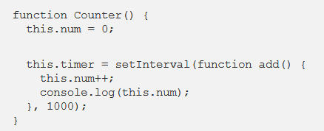
With each call of add() this is improperly scoped. This results in a function that returns NaN every time it is meant to increment num.
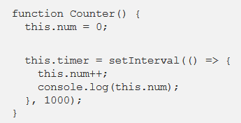
By bypassing add() with the Arrow Operator this is properly scoped and num is able to increment as intended.

