Overview
In this project we were tasked with taking our research of the arrow operator and applying it to the existing Timer Animation project. Given that this is meant to be an optimization project, there will be no change in the functionality of the code.

Constraints
- Work only in groups of 2
- Do not change the functionality of the given code

Available Resources
- Provided example codes
- Any information that we could locate/adapt from the internet

Challenges
- Confirming which initial functions should and should not be converted
- Examining the effected portions of this
- As we were rapping up an error occurred

Simple Tasks
- Identifying target functions for optimization
- Converting the functions syntax

Order of Accomplishments
- Prepare the host environment with XAMPP
- Examine the provided code for target areas of optimization
- Convert target areas
- Confirm program works as intended

Resources Used
- Codeburst.io
- W3 Schools
- GeeksforGeeks
- MDN web docs

Conclusion
This proved to be a straightforward project. As far as the optimization portion, the target areas did get noticeably “thinner” as far as the syntax is concerned.

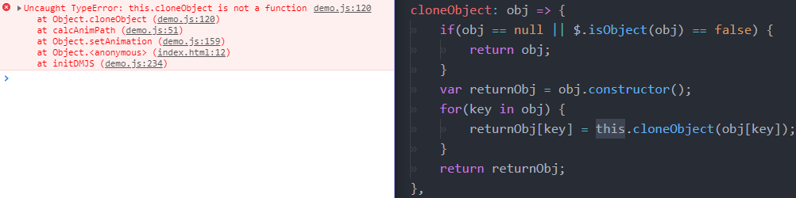
This was relatively simple to resolve but it was an issue primarily as a result of when it occurred. As we were rapping up the assignment, suddenly we experienced a compilation error.

