**Project 3 Documentation**

**Overview**

The purpose of the test is to demonstrate good architectural design. The main 2 aspects of such design will be:

* Modularisation: Ability to reuse the module(s).
* Scalability: Extend the functionality of the module(s).

**Constraints**

Browser support is the latest version of Google Chrome.

No full frameworks such as Angular or Bootstrap are permitted.

**Background**

I am an entry-level software developer with a background in computer hardware and system administration.

**File Structure**

* Project3.html
* Nations.js

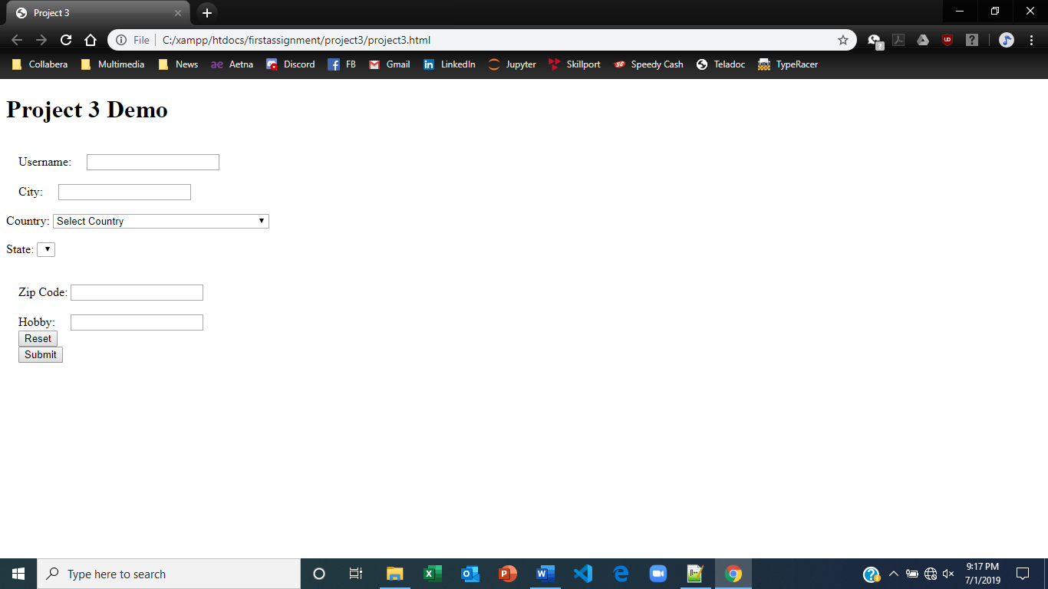

**Potential Improvement**

* I need to add more CSS elements.