JS Text Exercise Documentation

Overview

The purpose of this assignment is to complete two projects:

- Project 1: Add a data entry feature to the rawMVC app

- Project 2: Make an interactive quiz app

Constraints

- Browser support is latest Chrome.

- No frameworks or libraries such as jQuery are acceptable.

- Exactly replicating the design pictured above isn’t necessary.

- A written description and/or comments in your code explaining the rationalization behind your architectural decisions, and what you would have done with more time, is acceptable.

Extra points

- Running quiz app 5 times without reusing any quiz questions or answers.

- Completing Project 3 which involves a form to collect user demographics.

Background

I have a Bachelor’s of Science in Computer Science from the University of Texas at Dallas. I have an education background in programming. Considering the amount of time I had for this particular challenge and the lack of complete understanding of advanced JavaScript, I completed what I was able to get working.

I tackled the project as follows:

- Design diagram (schematics)

- .html files including the .css and.js

- This document was written in a ongoing manner during development

Diagram
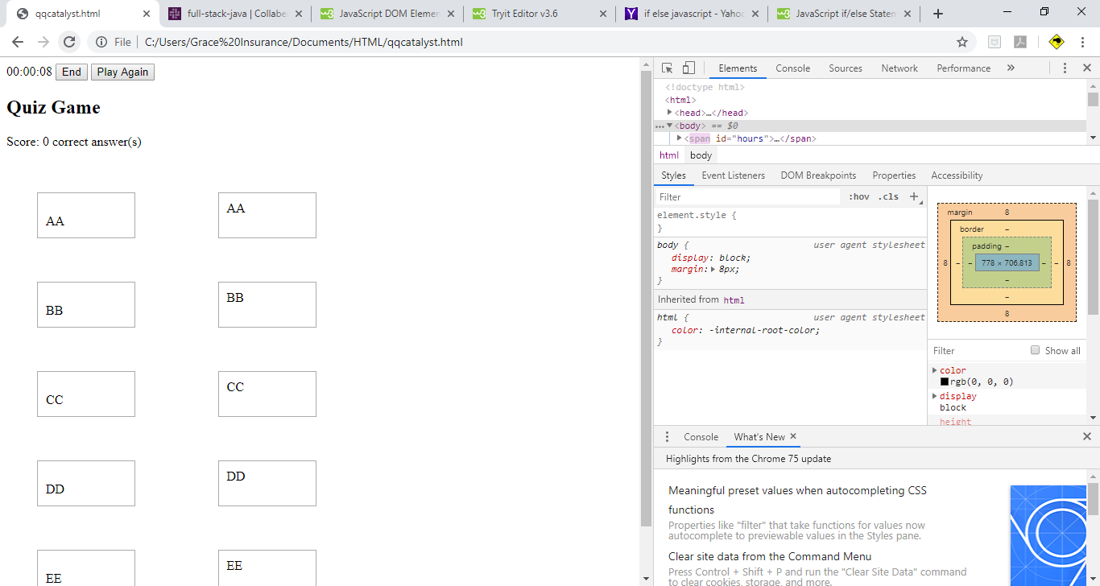

Potential Improvement

There are many things that can be done from this work in order to improve upon it. The list is far from exhaustive by any means.

- Completing the project as per specifications.

- Dividing the .html into smaller files such as .json, .js and .css

- adding unit test and functional test

- Look and feel of the app..

- Usability

- Code optimization

Conclusion

I believe more practical knowledge of JavaScript would have helped me complete the project to specifications. I spend quite a bit of time and finished up what I could understand. The basic premise of the game I was not able to successfully execute. I utilized search engines and tutorials to a bigger extent than what I would have liked.

Marilyn John

