Student ID: 6820492

Name: Zakary Smith

# Setup Screenshot

# Task 2 Screenshot

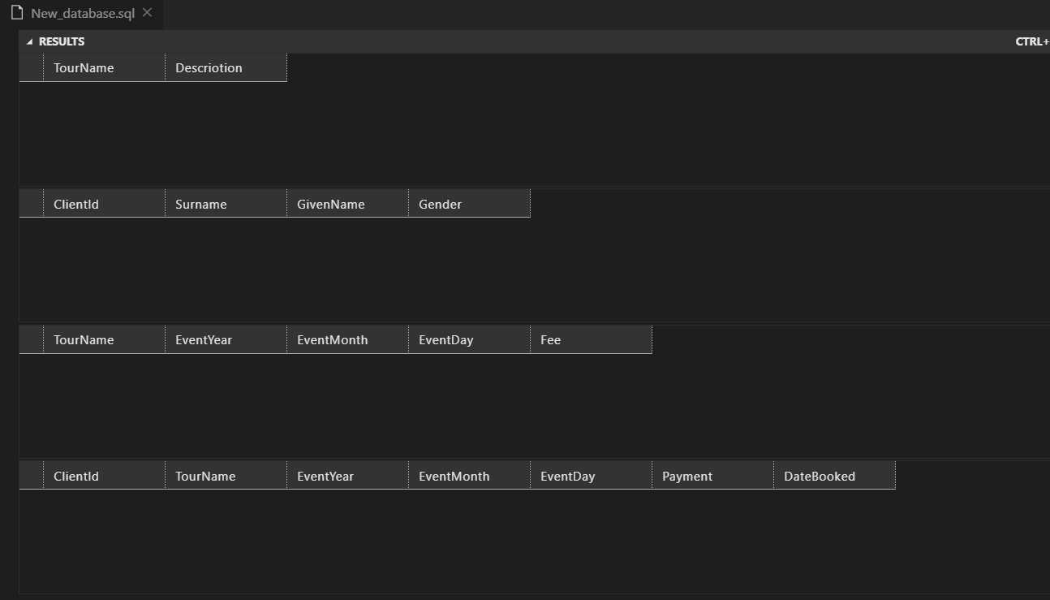

# Task 3 Screenshot

