Student ID:6820492

Name:Zakary Smith

# Setup Screenshot

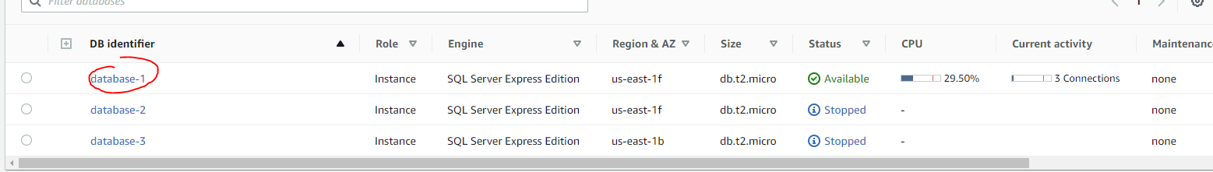

# Task 2 Screenshot

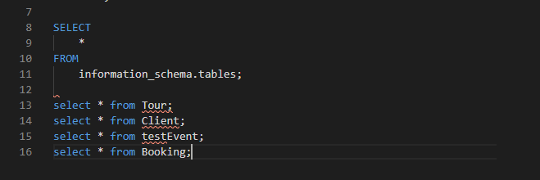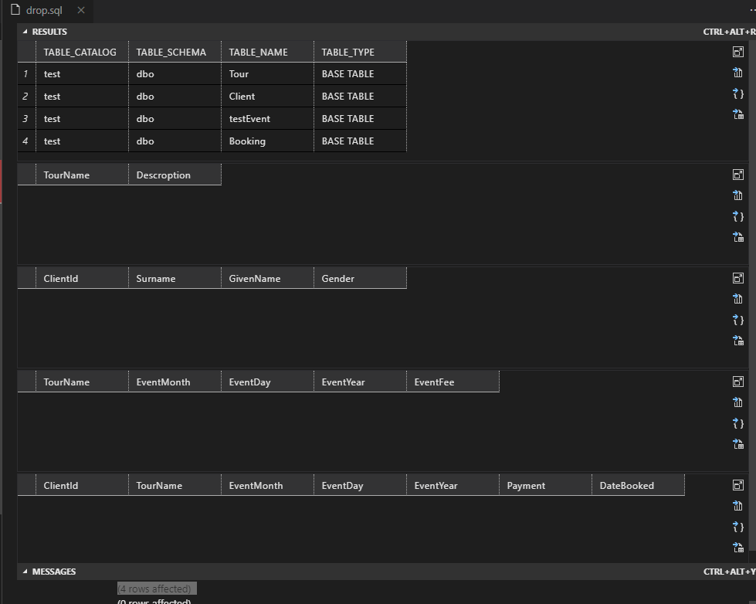

# Task 3 Screenshot

