ICT PROJECT

*NAIL-PALETTES*

***D***

***11/05/2024***

This report presents a comprehensive exploration and design proposal for an innovative ebookstore website, meticulously crafted on Figma to seamlessly blend functionality and aesthetics.

**Project Name:**

***Nailpalettes-org***

**Website Name:**

# np

**Project Members:**

|  |  |  |
| --- | --- | --- |
| NAME | ID | ROLE |
| Malik Ayaan Mehmood | 240007 | **Designer and Contant writer** |
| Laraib Khadim | 240014 | Editor |

**Purpose of Website**

* We've got a ton of awesome products for you to check out. Whether you like sparkly,shink or matt, there's something for everyone.
* Our website is super easy to use. You can find your favorite colours without any trouble, and buying them is a breeze. It's all about making things simple and fun for you.
* We picked out some really cool flavours for you to explore. It's like a treasure hunt for great . Whether you like sparkly, shiny or matt, there's something for everyone.
* and we're here to help you discover new favorites.
* Imagine talking to the people who write your favorite books! Our website lets you do just that. Connect with writers, talk about books, and be part of a fun book-loving community.

# Features of website

The main features of our website are given below

* Our website provide you Intuitive navigation and a clean layout. Easy search options, categorized sections, and a straightforward checkout process.
* Comprehensive database of palettes. Filter and sort options, book recommendations, and detailed book pages with descriptions, reviews, and author information.
* Personalized colors recommendations based on past searches and purchases.
* **:** Responsive design ensuring a seamless experience on smartphones, tablets, and computers.

## Constrainsts and consideration

**Mobile Responsiveness:**

* Given the increasing use of mobile devices, ensure the website is responsive and provides an optimal user experience across various screen sizes and devices.

**Budget Constraints:**

* Consider the financial limitations for development, hosting, maintenance, and potential marketing efforts. Be mindful of cost-effective solutions without compromising essential features.

**Data Security and Privacy:**

* Insure the security measures to protect customer data and transactions. Ensure compliance with data protection laws and industry standards to build trust with users.

**Content Management:**

* Consider how easily content, including book listings and promotional materials, can be managed. Implement a user-friendly content management system (CMS) for efficient updates.

**Wireframes:**

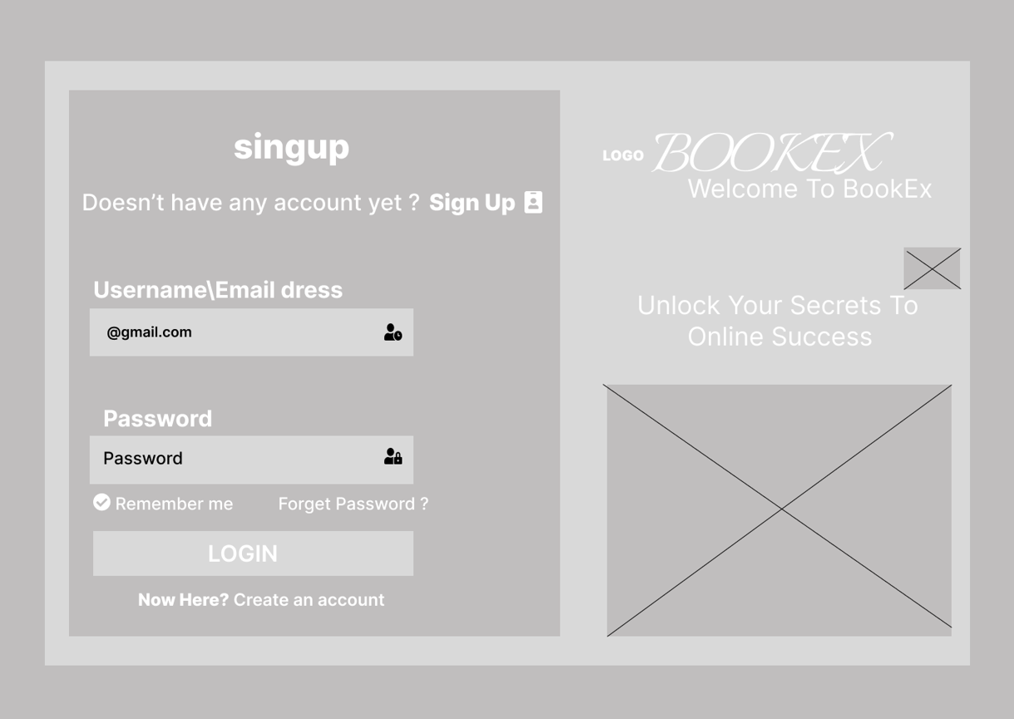**B**