## 题目

1） We have a list of bus routes. Each routes[i] is a bus route that the i-th bus repeats

forever. For example if routes[0] = [1, 5, 7], this means that the first bus (0-th

indexed) travels in the sequence 1->5->7->1->5->7->1->... forever. We start at bus

stop S (initially not on a bus), and we want to go to bus stop T. Travelling by buses

only, what is the least number of buses we must take to reach our destination? Return

-1 if it is not possible.

Example:

Input:

routes = [[1, 2, 7], [3, 6, 7]]

S = 1

T = 6

Output: 2

Explanation:

The best strategy is take the first bus to the bus stop 7, then take the

second bus to the bus stop 6.

Note:

• 1 <= length of routes <= 500.

## 中文题意

根据给出不同的公交车序列，来选择从起始站到终点站最少需要坐几次公交车。

## 解题思路

把所有公交车路线放入序列中，记录每个站点有哪几个公交车可以经过。然后采用广度优先搜索，对一个站点内所有经过的公交车来搜索，再把公交车的所有站点压入栈中，进行搜索，最终找到可以到达终点站。

## 测试

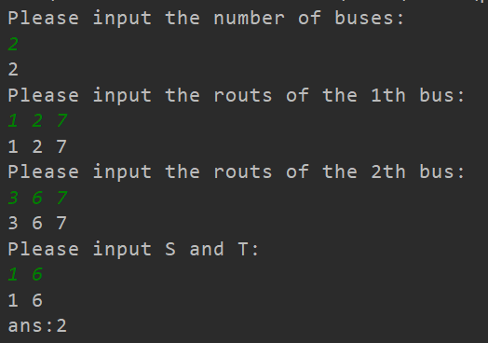

先对测试样例进行测试。

再测试一些其他情况

