## 题目

1 1） Given a list of airline tickets represented by pairs of departure and arrival airports

[from, to], reconstruct the itinerary in order. All of the tickets belong to a man who

departs from JFK. Thus, the itinerary must begin with JFK.

Note:

1. If there are multiple valid itineraries, you should return the itinerary that has the

smallest lexical order when read as a single string. For example, the itinerary

["JFK", "LGA"] has a smaller lexical order than ["JFK", "LGB"].

2. All airports are represented by three capital letters (IATA code).

3. You may assume all tickets form at least one valid itinerary.

Example 1:

tickets = [["MUC", "LHR"], ["JFK", "MUC"], ["SFO", "SJC"], ["LHR", "SFO"]]

Return ["JFK", "MUC", "LHR", "SFO", "SJC"].

Example 2:

tickets =

[["JFK","SFO"],["JFK","ATL"],["SFO","ATL"],["ATL","JFK"],["ATL","SFO"]]

Return ["JFK","ATL","JFK","SFO","ATL","SFO"].

Another possible reconstruction is ["JFK","SFO","ATL","JFK","ATL","SFO"]. But it is

larger in lexical order.

## 中午题意：

给定一个tickets序列，先在JFK出发，重新安排行程，如果出现多种选择时，以降序来选择

## 解题思路：

本题采用字典+DFS，遍历tickets，构造起点到终点的字典，需要注意的是采用multiset

允许重复元素出现，同时内部也默认升序排序。接着进行深度优先搜索即可。

所用函数：

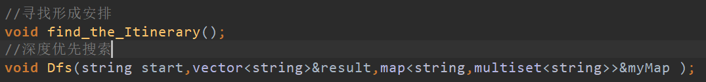

## 测试

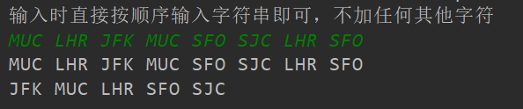

先对题目中两个情况进行测试。

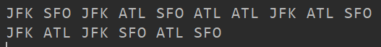

同时测试其他情况，当改变第二种测试条件时，改变其顺序，发现结果也正确

