Boardy Document Interaction Test
A four page Word fixture for validating upload, multipage navigation, editing, comments, revision history, and format-preserving download behavior.
4 | 3 | 2 | 1
Pages | File formats | Visual systems | Revision trail

Testing objective
Insert this file on the canvas, double click it, add a comment and a visible edit, wait for autosave, then download the newest revision. The downloaded copy should preserve the change while the original revision remains available in history.

Workflow diagram
This page checks image rendering, wide visual scaling, text flow, and comments placed beside mixed content.
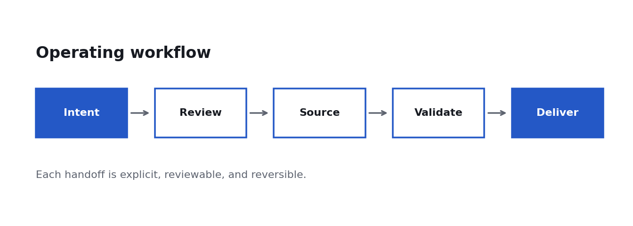

Interaction matrix
Checkpoint | Expected interaction | Pass condition
Upload | Select PDF DOCX or DOC | Canvas element appears
Activate | Double click document | Editor receives pointer input
Annotate | Draw or comment | Mark is visible and saveable
Download | Export latest revision | Correct filename and bytes

Performance graph
A line chart with legend, labels, gridlines, and filled variance makes clipping and image degradation easy to spot.
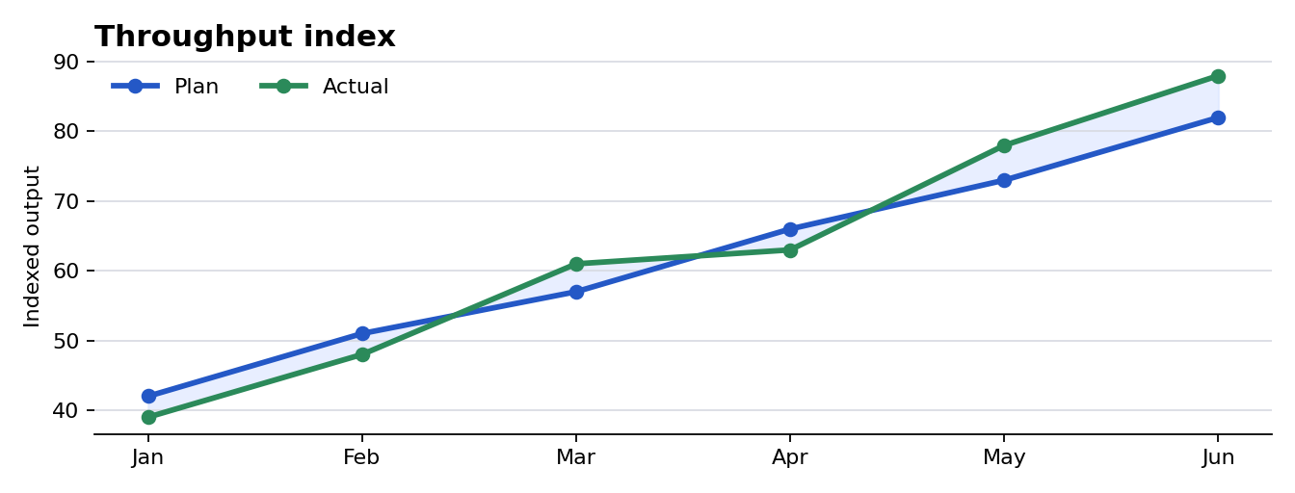

Interpretation
The illustrative series crosses twice and ends six points above plan. Values are synthetic and exist only to exercise chart rendering, not to make a business claim.
Annotation target: highlight the final green point and add the comment approved for test.

Multipage acceptance checklist
Complete these checks in both Chrome and Safari. Repeat at desktop width and below 720 pixels.
Check | Chrome | Safari
All four pages render | ☐ | ☐
Text selection and zoom work | ☐ | ☐
Comment persists after save | ☐ | ☐
New revision downloads | ☐ | ☐
Filename and format are correct | ☐ | ☐

Expected save result
The newest revision should be downloadable without replacing the original. For legacy DOC, the edited result may be upgraded to DOCX and must be labeled accordingly.

