DETERMINANTS OF CHINESE INVESTMENT IN BELT AND ROAD INITIATVE

Supervisor: Dr. Stephen Chiu

Lam Ho Ching (3035469267)

Lau Yue Kan (3035593757)

Hyukjun Kim (3035241897)

Antonozzi Vincent Paris (3035606607)

FINAL REPORT

7 MAY 2022

# 1. **ABSTRACT** In 2013, China launched a global infrastructure development strategy, the Belt and Road Initiative, formerly known as One Belt One Road, in order to invest in different countries and international corporations. The development strategy was initially announced by the paramount leader and general secretary of the Chinese Communist Party, Xi Jinping, during his trip to Kazakhstan in September 2013 (People’s daily, 2016). The development strategy was originally named as “Silk Road Economic Belt”, in which “Belt” refers to the proposed new trade route for transportation through Central Asia, while “Road” represents the marine route through South-East Asia and South Asia to Africa and the Middle East (Kuo, Kommenda, 2018).

The main objective of the Belt and Road Initiative is to make use of the domestic markets of the member countries and the international market to create a unified big market through integration in order to achieve an economic boost in Asia, Africa, Central Europe and Eastern Europe region. China also aims to develop the reputation of Renminbi as an international currency, strengthen the relationships with other countries and reduce the dependency of the international market on the US and to explore new markets for the exports of China (Dhaka Tribune, 2017). The Belt and Road Initiative focuses on a lot of aspects, including infrastructure investment, transportation including railway and highway, real estate, power station and raw materials like steel and iron, etc. Due to the huge demand for infrastructure investment from the countries in Asia, Africa, Central Europe and Eastern Europe, many countries joined the Belt and Road Initiative, making the Belt and Road Initiative one of the biggest investment and infrastructure projects in history.

By 2019, China has approximately invested 716 trillion in over 140 countries in the Asia, Africa, Central Europe and Eastern Europe region. According to results of different researches, the Belt and Road Initiative is benefitting approximately 35% of the global economy and the trade routes developed are accountable for approximately 60% of the world trade.

# **2. RESEARCH QUESTION**

With the huge number of countries being a part of the Belt and Road Initiative, the number of investments China makes in these countries varies. Therefore, we want to find out what kind of factors will increase or decrease the Foreign Direct Investment amount from China in those countries.

Our main research questions consist of

**“What are the key determinants leading to an increase in China FDI level?”**

**“How does a country’s US and Chinese trade relations impact Chinese FDI?”**

We have also made somehypothesis on factors affecting China’s Foreign Direct Investment

**Trade Volume** - China may return favors by investing more in countries that purchase more exports from China and limit the amount of investment in countries that are actively trading with the US

**Population Growth** - China may consider investing more in countries which have higher population growth rates as such countries may have growing market size and wider business potentials

**Religion** - China may consider investing more in countries with similar beliefs

# **3. LITERATURE REVIEW**

This chapter discusses literature review regarding past researches related to Foreign Direct Investment plus preliminary studies related to Belt and Road Initiatives.

**3.1 Considerations of Foreign Direct Investment**

The following literatures have outlined some considerations behind a country’s Foreign Direct Investment decision.

The most widely accepted theoretical framework for outward FDI was developed by Dunning (1977) with three advantages: Ownership, Location, and Internalization alongside four categories: market-seeking investment, resource seeking investment, strategic asset-seeking investment and efficiency seeking investment. Market seeking investment aims to expand new markets. Resource seeking investment focuses on finding resources in foreign countries. Strategic asset-seeking investment aims to increase the company’s property resource. Efficiency seeking investment aims to increase the company’s operation efficiency.

Same aspect applies to China's outward FDI. The motivation for a company's overseas direct investment is explained in various ways, but it is largely classified into four categories. The first is aimed at increasing corporate profits through entry into overseas markets. Athreye & Kapur (2009) argued that the direct motivation of Chinese companies' overseas direct investment is to develop overseas markets. It increases profits by securing a stable market through the expansion of overseas markets. In addition, Kolstad & Wiig (2012) argued that as a result of empirically analyzing related data on overseas direct investment by Chinese companies, the rich resources of the other country, the market size of the other country, and the rationality of the policy system had the greatest influence on Chinese companies' preferences.

Second, the purpose is to stably secure resources abroad and avoid tariffs and trade barriers in order to improve corporate price competitiveness. Helpman (1984) analyzed that the purpose of a company's overseas direct investment is to secure abundant foreign natural resources to alleviate the shortage of domestic resources, and Amighini et al. (2011) said that the motivation for resource exploration is the main driving force for overseas investment in the resource sector. According to Xiang (2006), the higher the level of economic development of the other country, the greater China's overseas direct investment in the country. This shows that China's overseas direct investment is motivated by securing natural resources.

The third is for companies to invest in developed countries to secure advanced technologies. It is to secure the competitiveness of companies by securing strategic assets by securing technology and human resources in developed countries. Buckley et al. (2010) argued that China's foreign direct investment entry model has evolved into strategic resources and efficiency, and its importance is expanding. Most Chinese investors tend to choose high-quality, low-risk overseas investment projects, invest in traditional industries in developed countries, and invest in technology-related fields in emerging countries. This means that investment in developed countries is centered on securing advanced technologies and securing resources for emerging countries.

Fourth is strategic motivation for risk management. This means diversifying the market to efficiently respond to changes in the market environment. However, China's overseas direct investment does not seem to have much motivation for risk management. This is because China also has relatively large investments in emerging countries that have not expanded its market system. This shows that Chinese companies' overseas direct investment is aimed at expanding the market and securing competitiveness.

**3.2 Results of Previous Studies**

The following scholars have analyzed some variables which would affect the magnitude of Foreign Direct Investment.

First, Liu et al. (2017) conducted a research using 49 countries in OBOR (one belt one road) and 44 countries non-OBOR. Their dependent variable is Chinese FDI during 2003-2015. On the other hand, their independent variables are exchange rate, GDP of host country, trade volume per GDP, GDP per capita, political instability, natural resource export share, telephone line per capita, technological export share. As a result, they found that “Exchange rate”, “trade volume”, “GDP”, “GDP per capita” have positive effects of FDI while “Infrastructure” has negative effects on FDI. However, “Political instability” and “Natural resource” are insignificant.

Second, Amighini et al. (2011) conducted a research using 81 countries. Their dependent variable is Chinese FDI during 2003-2008. The independent variables are GDP, inflation, natural resource, import, export, distance, education, telephone per capita, corruption. As a result, “GDP” has a positive effect on FDI while “Infrastructure” and “corruption” have negative results. However, “Trade” and “Natural resource” are insignificant.

Third, J Buckley (2007) conducted a research using 49 countries (among 22 OECD countries). Their dependent variable is Chinese FDI during 1992-2001. The independent variables are GDP, inflation, natural resource, china import, china export, distance, political risk. As a result, “GDP”, “natural resources” and “export” have positive effects while “political risk” and “import” have negative results. However, “distance” and “inflation” are insignificant.

Overall, all these studies support the fact that GDP has a positive effect of FDI.

**3.3 Literature analysis about One Belt One Road Initiatives**

The following are some literature about the effect and analysis of One Belt One Road.

The Belt and Road Initiative is a key strategy in China's foreign and economic policy. The Belt and Road initiative has been established, so there are many studies analyzing its expected effects. Those studies also focus on analyzing the effects of foreign and economic policies. One focus of research on Belt and Road initiatives is about the justification of policy.

Brandt (2015) is discussing the expectations and direction of the Belt and Road initiative. Belt and Road initiatives can create opportunities to promote economic development in China and neighboring countries. However, the policy is reciprocal and argues that in order to achieve joint development, China should avoid the direction of becoming a regional hegemon. In addition, Djankov & Miner (2016) argues that in the process of implementing the Belt and Road initiative, China should respect the opinions of its counterparts. To this end, China argues that when it can lead cooperation with neighboring countries, it will be able to achieve progress and development not only in China but also around the world.

Second, one flow of research on Belt and Road initiatives is to analyze them in connection with trade. Liang (2015) argues that in the current economic situation, a Belt and Road initiative can cause changes in trade patterns by itself and promote foreign direct investment. Therefore, it is argued that international cooperation should be promoted and support and cooperation from countries around the world should be promoted to maximize the effectiveness of the Belt and Road Initiative. It is necessary to efficiently utilize the port and rail infrastructure of the countries subject to the Belt and Road Initiative, which will reduce transportation costs and lead to the expansion of trade.

Third, there is also a research flow that analyzed the Belt and Road initiative from the perspective of foreign direct investment. Swayne (2015) said that China's Belt and Road Initiative will promote China's overseas direct investment to evaluate the effectiveness of China's overseas direct investment policy. In addition, Wu & Dong (2015) analyzes that China's direct overseas investment in the target countries of the Belt and Road Initiative will expand, promoting economic growth and development of the target countries.

Finally, the flow of research on Belt and Road initiatives is being conducted in connection with development. Hoffman (2015) will help China's sustainable development in implementing the Belt and Road initiative. In particular, he stressed that it will be an important stimulus for Asian and global economic growth. In particular, the relevant developing countries argue that the Belt and Road initiative will improve national and regional infrastructure, thereby improving income and living standards. It also expects to secure China's supply chain for energy and raw materials more safely. Kennedy & Parker (2015) argues that China has weakened its political and diplomatic role and that its focus on infrastructure has facilitated a shift in the regional economic structure and reduced regional conflicts such as terrorism.

In this way, research on Belt and Road initiatives is characterized by the purpose of proving the necessity of policies in connection with trade, investment, and economic development. It is expected that trade and investment will be activated through a reduction in transportation and trade costs through a Belt and Road initiative to achieve economic development. To this end, previous studies focused on the target countries of the Belt and Road initiative and analyzed them. It was analyzed focusing on the effect on the participating countries of the Belt and Road initiative.

However, the policy of the Belt and Road initiative should be careful to analyze and evaluate its effectiveness as an implementation stage. Rather, in order to analyze the effectiveness of policies, it is necessary for a Belt and Road initiative to analyze the responses of economic actors, especially those of trade and investment. This is because it shows how the policy effect will be achieved. Therefore, this study analyzed the effect of the Belt and Road initiative on the flow of overseas investment in China. This study aims to empirically analyze the determinants of overseas investment in China by selecting a total of 147 countries subject to Belt and Road initiative.

**4. Data Collection**

We collected data from 147 countries, from 2013 to 2019**.**

Our data consists of:

**China Investment (In USD million)**

**Population (In million)**

**GDP (In USD million)**

**Trade volume with US (in USD thousand)**

**Trade volume with China (in USD thousand)**

**Distance from China (in kilometer)**

**Religious Majority**

**Political regime**

After collecting these data, we did some steps to process our data.

First, we remove irrelevant countries which were not in BRI

Second, we match country names and order as different sources of data had different name and order of countries.

Third, we make sure all data collected are in panel data format as data collected have some missing values over time period (especially for FDI).

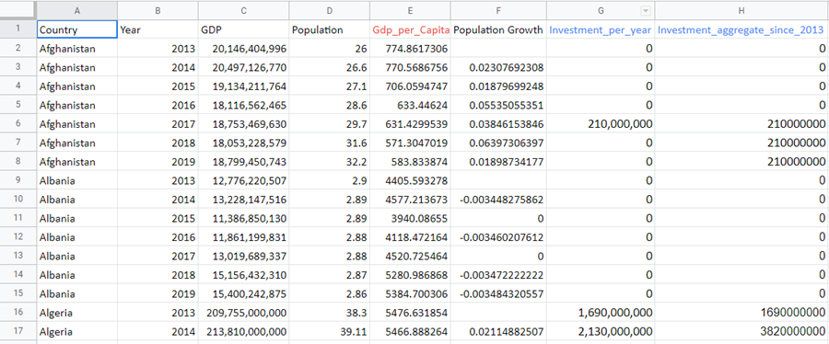

**5. MODEL**

**5.1 Regressions**

Our model consists of a regression analysis using standard Ordinary least squares on panel data consisting of 147 countries from 2013 to 2019.

**5.2 Variables**

**5.2.1 Dependent variable**

Our initial dependent variable was investment from China in a specific year (**investment_per_year**). Meaning that if China invested in Thailand in 2013, the amount invested would be written in the Thailand line in 2013 only. We believe that this is not satisfactory as such foreign investment takes longer than a year to have its full impact, it also means that most countries for most years would have zero as the value of the independent. After preliminary regressions we decided to use an aggregate measure of investment, meaning that all investment since 2013 would be aggregated in the current year.

Aggregate_investment_since_2013 = Investment_per_year in 2013 + investment_per_year in 2014 …. To current year

**5.2.2 Independent variables**

With our independent variables we tried to cover as many characteristics of the receiving countries as we could. This translates to a wide variety of variables:

* **Pop** = Population of receiving country (in millions)
* **Pop_growth** = Population growth rate (Pop(n)/Pop(n-1)*100)
* **GDP** = Gross domestic product of receiving country (in USD)
* **GDP_Capita** = (GDP/(pop*1000000))
* **Chin_imp** = China imports from that country (china buys from country) (in thousand USD)
* **Chin_exp** = China’s exports to that country (china sells to that country) (in thousand USD)
* **US_imp** = US imports from that country (in thousand USD)
* **US_exp** = US exports to that country (in thousand USD)
* **China_distance** = distance between china and receiving country (in km)
* **Islam** = dummy variable =1 if majority islamic population
* **Buddhism** = dummy variable =1 if majority buddhist or hindu population
* **Christianity** = dummy variable =1 if majority christian population
* **Democracy** = dummy variable =1 if the country is classified as either full or flawed democracy, 0 if classified as hybrid or authoritarian regime.

Our variables **Pop, Pop_growth, GDP, GDP_capita** aim to capture the demographic and economic situation of the country. As we hypothesize that a bigger market, higher purchasing power and growing population are all good for future investment returns.

**Chin_imp, Chin_exp, Us_imp, Us_exp** are our key variables of interest. Initially, our project aimed to determine whether a country's trade relations with the United States would influence China’s investment decision. At first these four variables were merged into one as the ratio of trade volume between USA and China, however the regression results were unconducive and we decided to investigate all these variables individually.

The rest of our variables: **China_distance, Islam, Buddhism, Christianity and Democracy**, aim to capture the closeness between the receiving country and china, in the three dimensions of physical distance, cultural/religious distance and political distance. We hypothesize that countries being closest and most resembling China will be more likely candidates to receive investment.

**6. RESULT(STANDARD OLS)**

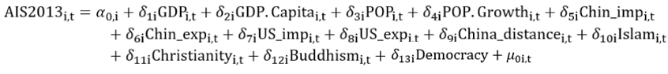

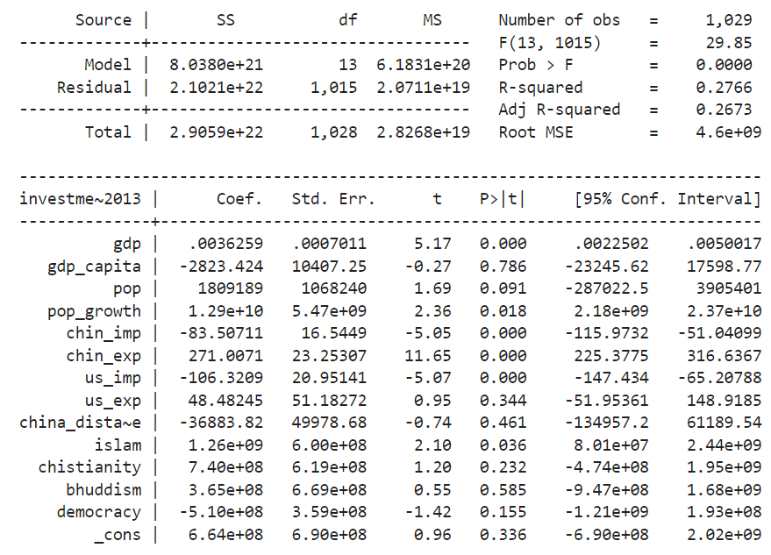

The variables of **Gdp, Pop_Growth**, **Chin_imp, Chin_exp, US_imp** and **Islam** all have P values below 5% and hence are statistically significant. The R-squared and adjusted R-squared are 27.7% and 26.7%, meaning that our variables explain up to 27% of the observed China’s investment behavior.

Here is a recap of the correlations to investment we have observed:

GDP **(+)**,

Population growth**(+)**,

China Imports**(-)**,

China Exports **(+)**,

Us imports**(-)**,

Islam**(+)**.

The positive association between GDP and China FDI was expected and had been noted in the studies we covered in the literature review. It is logical that any investor, be it government or individuals would consider GDP an important factor in investment decisions. A bigger market likely means an increased return on investment thanks to a more developed economy.

Population and population growth were also expected to be positively correlated to investment. As China would see stronger aspects of growth in demographically developing countries.

When China imports from a country it seems to invest less in FDI. While when China exports to a country it invests more. This is one of the main findings of our research. Running a regression with only these variables looks like this.

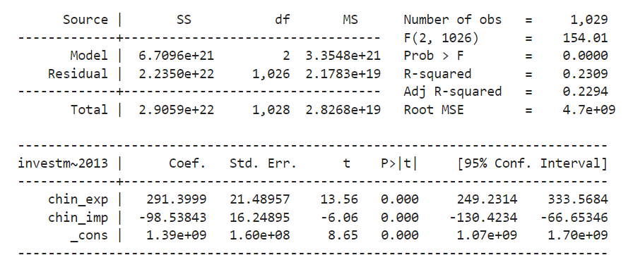

With only these two variables, the model reaches an R-Squared of 23%, not far from our total regression R squared. These two variables are therefore very significant and important as they alone can explain up to 23% of the investment variation.

The US import variable being negatively correlated to China OBOR FDI confirms our hypothesis that China will limit investment to countries dealing with the United States. This is likely for political and strategic reasons.

Our cultural fit variables did give surprising results. Firstly we did not reproduce the result observed in previous studies where a smaller distance between a country and China would lead to high investment. Second, only 1 of our 3 religious variables came out to be statistically significant, and it was Islam, which was also positive, meaning that Islamic countries were more likely to receive investment compared to others. We did not anticipate this result and we believe it could be explained by correlation with population and other variables

.

Lastly the variable democracy has a negative coefficient, implying that democratic countries would receive less investment from China, which we expected. However the PV value is elevated and we cannot consider this as statistically significant.

**7. LIMITATIONS**

We face different difficulties in this research project, mainly difficulties related to adding “Natural Resources” as our new variables, as well as its derived research problem like the challenges in collecting possible and sufficient data if we want to include it in our model.

We hope to include this variable as we think it can explain our dependent variable. In particular, we thought that “Natural Resources” is useful for us to better illustrate and explain the “China Investment”. We assume it is related to China’s investment decision as countries which possess abundant natural resources (which are crucial for China’s production and development) may easily attract investment from it. Therefore, we assume that countries which have higher levels of natural resources such as crude oil may have a more important business status and bonding with China, hence receiving a higher level of investment from it.

However, when it comes to data collection and sorting, we face huge challenges. First, different countries have different types of natural resources, plus different levels of storage. It is difficult to sort different kinds of natural resources, let alone comparing and turning them into “numbers” and standardizing the “unit”. Second, we face difficulties in collecting reliable and precise data about the levels of storage of natural resources in various countries. Therefore, collecting sufficient data of “Natural Resources” to systematically analyze FDI from China is almost impossible.

Overall, we face difficulties in integrating this variable in our model.

**8. CONCLUSION**

In our research, we collected data for 147 countries which have participated in the Belt and Road Initiatives. We study how different variables such as GDP, Population Growth, Trade Volume, religion, etc, will affect the amount of Foreign Direct Investment from China in these participating countries.

We found that these variables: “GDP”, “Population Growth”, “China’s Export” (To that country), “Islam Religion” are positively correlated with China’s investment.

First, the fact that “GDP” has a positive correlation with China’s investment matches our assumption. It is because the higher GDP level of a country, the stronger the economy and better business environment a country is likely to have. Such countries will likely have a stronger business attractiveness and relationship with China, hence receiving a higher level of investment. Therefore, the result matches our expectation.

Second, the fact that “Population Growth” has a positive correlation with China’s investment matches our assumption. It is because the higher population growth rate may indicate that the country may have a more abundant labor supply, which may lead to a larger potential for future economic and social development, hence better business development and investment environment.

Third, the fact that “China’s Export” (To that country) has a positive correlation with China’s investment also matches our assumption. It is because the larger the export amount from China to a particular country, the higher chance that China can gain from the trade with these countries in theory. Therefore, we expect China will invest more in those countries as it may find a higher possibility to have more investment return.

However, it is difficult to explain why “Islam Religion” is positively correlated with China’s investment.

On the other hand, these two variables: “China’s Import” (From that country) and “US Import” (From that country) are negatively correlated with China’s investment.

The fact that “China’s Import” (From that country) has a negative correlation with China’s investment matches our assumption. It is because in theory, when a country imports more from the other, it has a higher chance to bear a trade deficit (loss in general), given the “export” amount remains unchanged. Therefore, we expect China will think that it will be more difficult to earn a return even though they invest in those countries, hence they are not likely to invest.

The fact that “US Import” (From that country) has a negative correlation with China’s investment also matches our assumption. It is because the US is the rival of China, when there is a closer business relationship between the US and a certain country, the lower possibility China will choose to invest in that country.

Overall, Belt and Road Initiatives have tremendous benefits to the world economy. The rising investment from China and closer bonding between countries will unleash the potential of the global market. It will lead to a higher level of global economic integration. We understand that Belt and Road will heavily change the landscape of the global economic environment by building up cultural bondings, infrastructure, policy integration, capital mobility, etc. The world is more connected than before, particularly between Asia, Europe, and many other places. Therefore, with the growing importance of the Belt and Road Initiatives, we want to enable readers to further understand this topic through our research. We hope that our research can bring some insight to our readers.

**9. REFERENCE**

Dunning, J. H. (1977). The eclectic paradigm as an envelope for economic and business theories of MNE activity. International Business Review, 9(2), 163–190.

Kolstad, I., & Wiig, A. (2012). What determines Chinese outward FDI? Journal of World Business, 47(1), 26–34.

Athreye, S. and S. Kapur (2009). “Introduction: The internationalization of Chinese and Indian firms: Industrial and Corporate Change.” Industrial and Corporate Change. Vol. 18. Issue. 2, pp. 209-221

Helpman, E. (1984). “A simple theory of international trade with multinational corporations.” Journal of political economy. Vol. 92. No. 3, pp. 451-471

Amighini, A., R. Rabellotti and M. Sanfilippo (2013). “China’s outward FDI: An industry-level analysis of host-country determinants.” Frontiers of Economics in China. Vol. 8. No. 3, pp. 309-336.

Xiang, Benwu (2006). “The effects of foreign direct investment trade on empirical analysis on China’s evidence.” Journal of Zhongnan University of Economics and Law. No. 3, pp. 9-15

Buckley, P. J., L. J. Clegg, A. R. Cross, X. Liu, H. Voss and P. Zheng (2007). “The determinants of Chinese outward foreign direct investment.” Journal of international business studies. Vol. 38. No. 4, pp. 499-518

Brant, P. (2015). “One Belt, One Road? China’s community of common destiny.” The Interpreter. Vol. 2, pp. 3-31.

Djankov, S. and S. Miner (2016). China’s Belt and Road Initiative: Motives, Scope, and Challenges. No. PIIEB16-2. Peterson Institute for International Economics.

Liang, W. (2015). “New ideas of the reform in the view of globalization: Shanghai pilot free trade zone and one belt and one road.” Open Journal of Social Sciences. Vol. 3. No. 12, 149-155.

Swaine, M. D. (2015). “Chinese views and commentary on the ‘One Belt, One Road’ initiative.” China Leadership Monitor. No. 47(2), pp. 1-24.

Wu, Zhicheng and Dong Zhuangzhuang (2015). “The maintenance of China’s overseas interests in the implementation of the ‘Belt and Road’ strategy.” Tianjin Social Sciences. Vol. 6, pp. 69-75.

Hofman B. (2015). China’s One Belt One Road initiative: What we know thus far. The World Bank.

Liu, H. Y., Tang, Y. K., Chen, X. L., & Poznanska, J. (2017). The Determinants of Chinese Outward FDI in Countries Along “One Belt One Road.” Emerging Markets Finance and Trade, 53(6), 1374–1387.

"Chronology of China's Belt and Road Initiative". People's Daily. Xinhua News Agency. 24 June 2016.

Kuo, Lily; Kommenda, Niko. "What is China's Belt and Road Initiative?". The Guardian. 5 September 2018.

"What One Belt One Road means for Bangladesh". Dhaka Tribune. 3 October 2017.