
HEALCARE
23INMCA310 - Mini Project 1

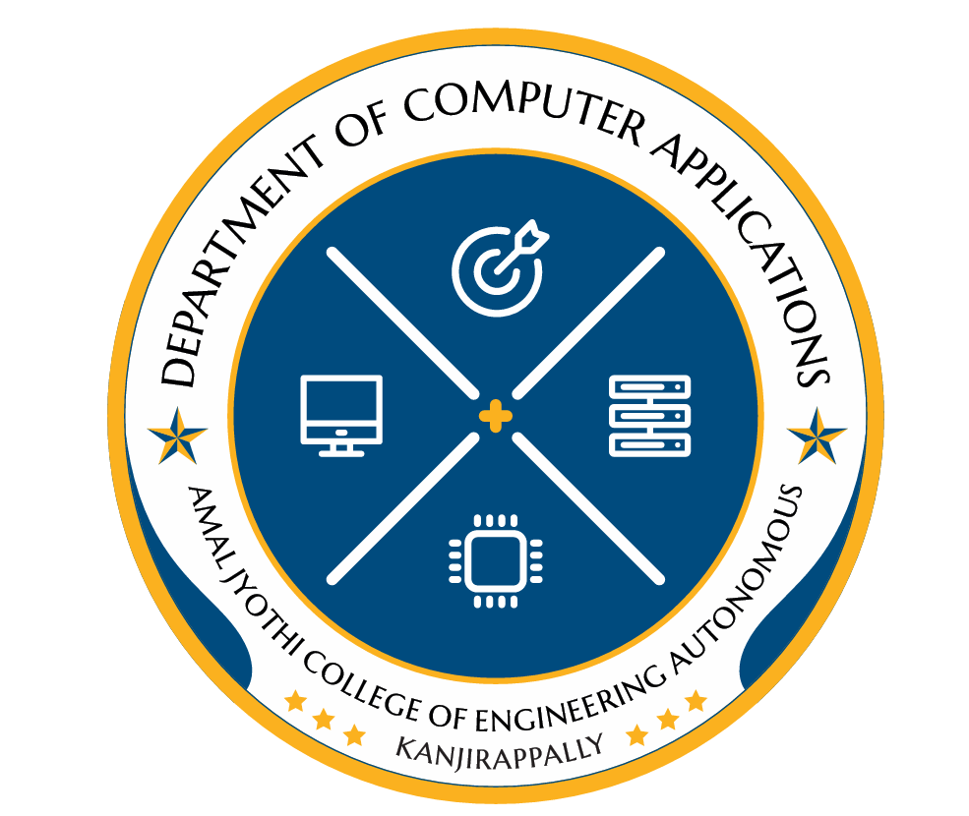
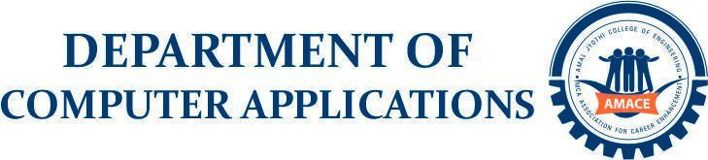
JUNA ELSA MATHEW
AJC23MCA-I040
INTMCA2023-28 S6
Roll No. 39

Scrum Master
Paulin Paul
Assistant Professor
Department of Computer Applications
ABSTRACT

HealCare is an online hospital management system integrating various hospital operational and clinical services within one unified digital platform, covering major healthcare domains such as patient services (registration, appointment booking, medical records, report downloads, e-prescriptions, canteen food ordering, queue status view,feedback), doctor services ( patient record access, diagnosis entry, e-prescription generation, uploading notes/attachments, lab test requests, health analysis chart, report review, treatment feedback), staff operations (reception management, queue regulation, patient assistance, pharmacy handling, billing generation, report uploads, canteen management), laboratory management (sample collection, test assignment, processing, report generation, result syncing with doctors), and administrative control (user roles & permissions, department management). The system users include patients, doctors, hospital staff, and administrators, working together within a centralized digital environment that ensures fast processing, secure handling of medical data, and seamless workflow interaction across hospital units. There are three main modules in the system — Patient–Doctor Interaction Module, Medical Workflow & Records Module, and Administration & Hospital Support Module. The Patient–Doctor Interaction Module enables real-time healthcare flow through features like appointment scheduling, prescription management, treatment tracking. The Medical Workflow & Records Module manages internal hospital processes such as laboratory reporting, pharmacy inventory, inpatient/outpatient tracking, queue movement, billing, canteen orders, ward and service allocation. The Administration & Hospital Support Module supervises high-level functions including user authentication, system-wide monitoring, data access control, department updates, financial statistics, operational reports, policy settings. By digitally connecting patients, doctors, staff, labs, pharmacy, and administrators within one platform, HealCare offers a reliable, efficient, and centralized healthcare solution that enhances treatment quality and operational excellence. The useful reports of the project are also generated by the admin in various categories like patient admission details, appointment statistics, patient visit history, inpatient/outpatient census, bed occupancy status, patient discharge summaries, feedback analysis reports, and daily/weekly hospital activity summaries.

