EXPERIMENT:01
CO1: Build structured layouts using modern HTML/CSS practices
AIM: You are tasked with designing a homepage for your college's annual techfest. The page must be responsive and look appealing across devices. You will use HTML5, CSS3, and Flexbox/Grid for layout and style. Develop a visually appealing layout with sections for event highlights, speakers, and registration. Implement responsiveness using Flexbox or CSS Grid. Apply a consistent style guide with color themes and font styles.
PROCEDURE:

<!DOCTYPE html>
<html lang="en">
<head>
<meta charset="UTF-8">
<meta name="viewport" content="width=device-width, initial-scale=1.0">
<title>TechFest 2025 - College Annual Tech Festival</title>
<link href="https://fonts.googleapis.com/css2?family=Poppins:wght@600&family=Roboto:wght@400;500&display=swa p" rel="stylesheet">
<p>Unleash Innovation at Our Annual Tech Festival!</p>
</header>
<main>
<section class="hero" id="home">
<h2>Welcome to TechFest 2025</h2>
<p>Join us to explore cutting-edge technology, innovation, and creativity!</p>
<button onclick="document.getElementById('register').scrollIntoView()">Register Now</button>
</section>

<section class="highlights" id="highlights">
<h2>Event Highlights</h2>
<div class="card">
<div class="card-placeholder">Hackathon</div>
<h3>Hackathon</h3>
<p>Compete in a 24-hour coding challenge to build innovative solutions.</p>
</div>
<div class="card">
<div class="card-placeholder">Robotics</div>
<h3>Robotics Workshop</h3>
<p>Learn to build and program robots with hands-on sessions.</p>
</div>
<div class="card">
<div class="card-placeholder">AI Talk</div>
<h3>AI Talk</h3>
<p>Hear from experts on the future of artificial intelligence.</p>
</div>
</section>

<section class="speakers" id="speakers">
<h2>Featured Speakers</h2>
<div class="card">
<div class="card-placeholder">Speaker</div>
<h3>Dr. Jane Smith</h3>
<p>AI Researcher at Tech Corp</p>
</div>
<div class="card">
<div class="card-placeholder">Speaker</div>

<h3>John Doe</h3>
<p>CEO of Innovate Labs</p>
</div>
<div class="card">
<div class="card-placeholder">Speaker</div>
<h3>Emily Chen</h3>
<p>Robotics Engineer</p>
</div>
</section>

<section class="registration" id="register">
<h2>Register Now</h2>
<form method="POST" action="" id="registrationForm">
<input type="text" name="name" placeholder="Full Name" required autocomplete="off">
<input type="email" name="email" placeholder="Email Address" required autocomplete="off">
<input type="text" name="college" placeholder="College Name" required autocomplete="off">
<button type="submit" name="submit">Register</button>
</section>
</main>

<footer>
<p>© 2025 TechFest. All rights reserved.</p>
</footer>
</div>

</body>
</html>

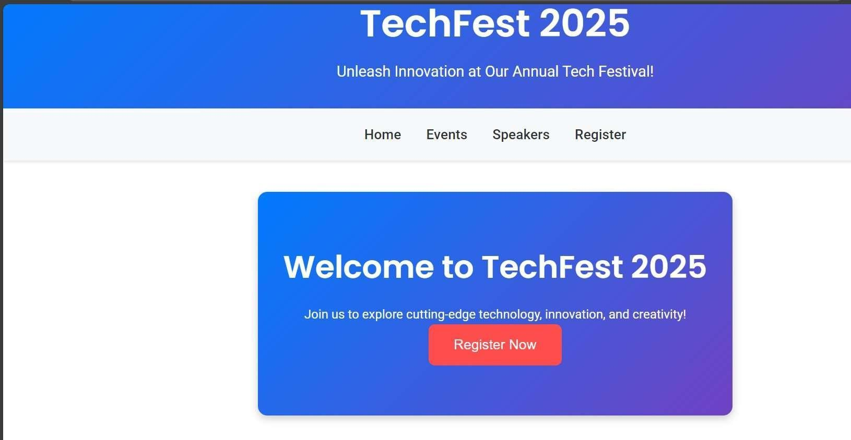
OUTPUT

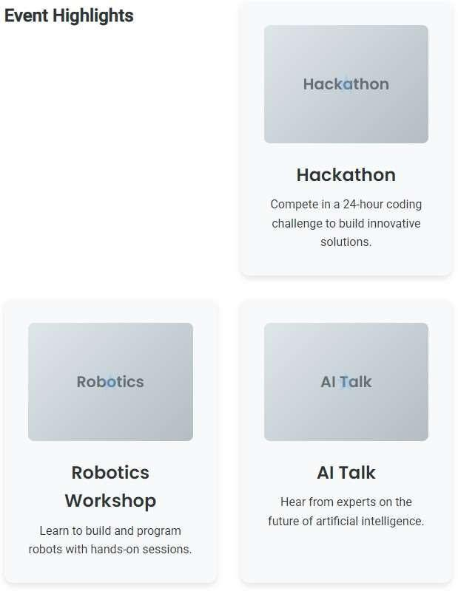

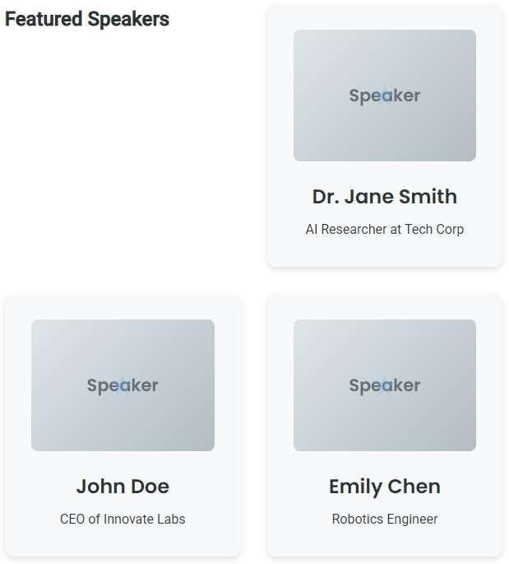

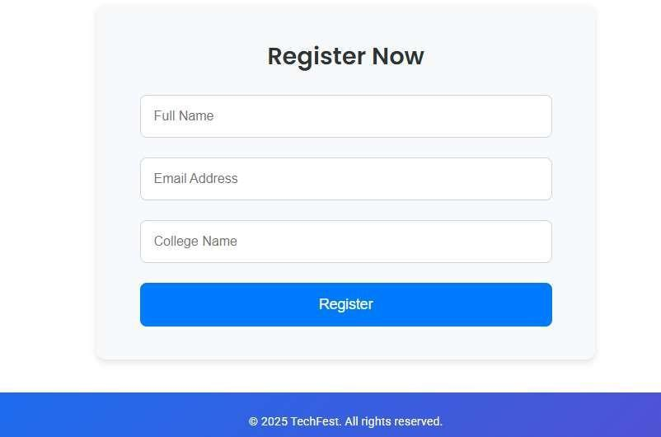

EXPERIMENT:02

CO1: Build structured layouts using modern HTML/CSS practices

AIM: You are creating a personal portfolio homepage. It should reflect your UI skills and be responsive. Use HTML5 and CSS3 to design a homepage with an intro section, project links, and contact form. Design should adapt to both desktop and mobile views. Submit a Figma/Adobe XD mockup as a design reference.

PROCEDURE:
<!DOCTYPE html>
<html lang="en">
<head>
<meta charset="UTF-8">
<meta name="viewport" content="width=device-width, initial-scale=1.0">
<title>Jewel Biju's Portfolio</title>
<link href="https://fonts.googleapis.com/css2?family=Poppins:wght@300;400;600&dis play=swap" rel="stylesheet">

<section id="intro">
<h1>Hi, I'm Jewel Biju</h1>
<p>Crafting beautiful and functional digital experiences.</p>
<a href="#projects" class="cta-button">View My Work</a>
</section>

<section id="projects">
<h2>My Projects</h2>
<div class="project-grid">
<article class="project-card">
<h3> Word Guessing Game</h3>
<p>An interactive game where players guess words based on difficulty levels, featuring a timer and scoring system.</p>
<div>
<span>HTML</span>
<span>CSS</span>
<span>JavaScript</span>
</div>
</article>
<article class="project-card">
<h3> Laptop Specification Comparison</h3>
<p>A web page comparing laptop specifications, including price, RAM, storage, and more, with a clean table layout.</p>
<div>
<span>HTML</span>
<span>CSS</span>
</div>
</article>

<article class="project-card">
<h3> Enhanced To-Do List</h3>
<p>A dynamic to-do list application allowing users to add tasks and clear all tasks with a responsive interface.</p>
<div>
<span>HTML</span>
<span>CSS</span>
<span>JavaScript</span>
</div>
</article>
</div>
</section>

<section id="contact">
<h2>Contact Me</h2>
<form onsubmit="submitContact(event)">
<input type="text" name="name" placeholder="Your Name" required>
<input type="email" name="email" placeholder="Your Email" required>
<textarea name="message" rows="5" placeholder="Your Message" required></textarea>
<button type="submit">Send Message</button>
</form>
</section>

</body>
</html>

OUTPUT

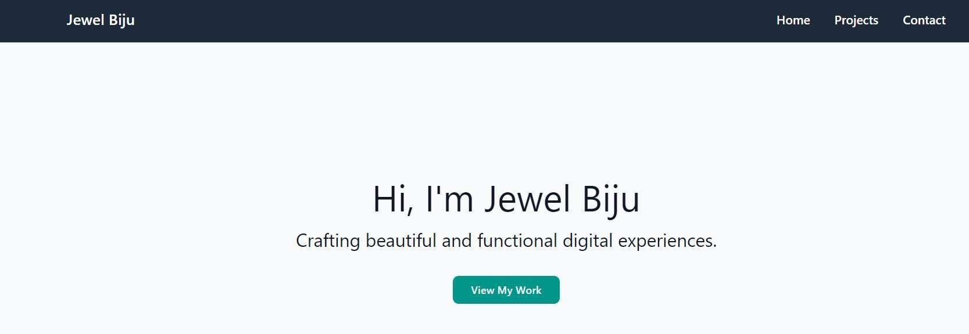

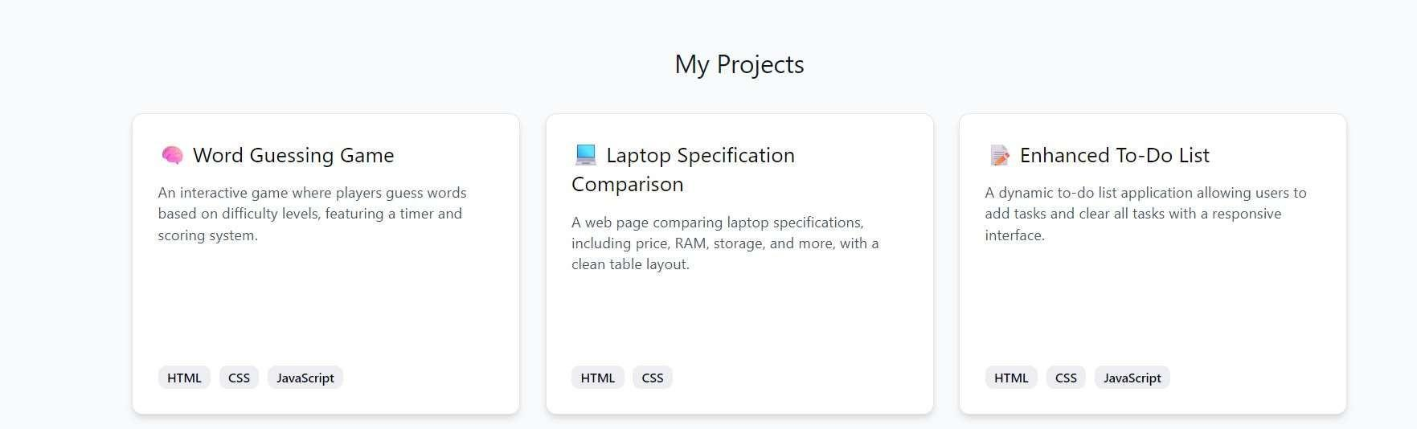

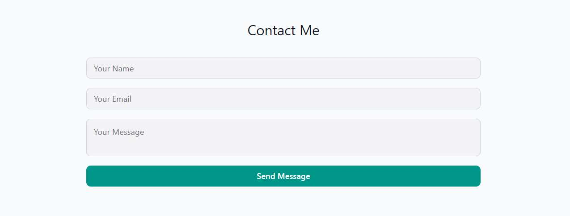

EXPERIMENT:03

CO2: Create user-centered wireframes and design documents

AIM: A startup wants you to conceptualize a productivity app for students to manage tasks, timetables, and reminders. Your role is to apply user-centered design principles. Create user personas and empathy maps. Map task flows and design wireframes in Figma or Balsamiq. Justify your design choices based on user needs.

PROCEDURE:
<!DOCTYPE html>
<html lang="en">
<head>
<meta charset="UTF-8">
<meta name="viewport" content="width=device-width, initial-scale=1.0">
<title>Student Productivity App</title>
<link href="https://fonts.googleapis.com/css2?family=Poppins:wght@300;400;600;700 &display=swap" rel="stylesheet">
</head>
<body>
<div class="header">
<h1>Student Productivity App</h1>
</div>

<div class="nav" role="navigation" aria-label="Main navigation">
<a href="#dashboard" class="active" aria-current="page">Dashboard</a>
<a href="#tasks">Tasks</a>
<a href="#timetable">Timetable</a>
</div>
<div class="container">
<div id="dashboard">
<h2>Dashboard</h2>
<div class="quick-add">
<h3>Add Task</h3>
<form id="add-task-form">
<input type="text" id="task-name" placeholder="Task name" required aria-label="Task name">
<input type="date" id="task-due" required aria-label="Due date">
<select id="task-priority" required aria-label="Priority">
<option value="high">High</option>
<option value="medium">Medium</option>
<option value="low">Low</option>
</select>
<select id="task-category" required aria-label="Category">
<option value="academic">Academic</option>
<option value="personal">Personal</option>
<option value="extracurricular">Extracurricular</option>

</select>
<button type="submit">Add Task</button>
</form>
</div>
<div class="timetable-box">
<h3>Weekly Timetable</h3>
<table>
<tr>
<th>Time</th>
<th>Mon</th>
<th>Tue</th>
<th>Wed</th>
<th>Thu</th>
<th>Fri</th>
</tr>
<tr>
<td>9:00 AM</td>
<td>Math<br><span class="notes-indicator">Notes: Review chapter 5</span></td>
<td>Biology</td>
<td></td>
<td>Physics<br><span class="notes-indicator">Notes: Lab prep</span></td>

<td>Study</td>
</tr>
<tr>
<td>10:00 AM</td>
<td></td>
<td>Study Group</td>
<td>Club</td>
<td></td>
<td>Math</td>
</tr>
<tr>
<td>11:00 AM</td>
<td>Chemistry</td>
<td></td>
<td>English</td>
<td>Study</td>
<td></td>
</tr>
</table>
</div>
</div>
<div id="tasks" style="display: none;">

<div class="task-list">
<h3>All Tasks</h3>
<ul id="task-list">
<!-- Tasks will be dynamically inserted here -->
</ul>
</div>
</div>
<div id="timetable" style="display: none;">
<h2>Timetable</h2>
<div class="timetable-box">
<table>
<tr>
<th>Time</th>
<th>Mon</th>
<th>Tue</th>
<th>Wed</th>
<th>Thu</th>
<th>Fri</th>
</tr>
<tr>
<td>9:00 AM</td>
<td>
<input type="text" value="Math" aria-label="Monday 9:00 AM subject">

<textarea placeholder="Notes" aria-label="Monday 9:00 AM notes">Review chapter 5</textarea>
<span class="notes-indicator">Notes</span>
</td>
<td>
<input type="text" value="Biology" aria-label="Tuesday 9:00 AM subject">
<textarea placeholder="Notes" aria-label="Tuesday 9:00 AM notes"></textarea>
</td>
<td>
<input type="text" aria-label="Wednesday 9:00 AM subject">
<textarea placeholder="Notes" aria-label="Wednesday 9:00 AM notes"></textarea>
</td>
<td>
<input type="text" value="Physics" aria-label="Thursday 9:00 AM subject">
<textarea placeholder="Notes" aria-label="Thursday 9:00 AM notes">Lab prep</textarea>
<span class="notes-indicator">Notes</span>
</td>
<td>
<input type="text" value="Study" aria-label="Friday 9:00 AM subject">

<textarea placeholder="Notes" aria-label="Friday 9:00 AM notes"></textarea>
</td>
</tr>
<tr>
<td>10:00 AM</td>
<td>
<input type="text" aria-label="Monday 10:00 AM subject">
<textarea placeholder="Notes" aria-label="Monday 10:00 AM notes"></textarea>
</td>
<td>
<input type="text" value="Study Group" aria-label="Tuesday 10:00 AM subject">
<textarea placeholder="Notes" aria-label="Tuesday 10:00 AM notes"></textarea>
</td>
<td>
<input type="text" value="Club" aria-label="Wednesday 10:00 AM subject">
<textarea placeholder="Notes" aria-label="Wednesday 10:00 AM notes"></textarea>
</td>
<td>

<input type="text" aria-label="Thursday 10:00 AM subject">
<textarea placeholder="Notes" aria-label="Thursday 10:00 AM notes"></textarea>
</td>
<td>
<input type="text" value="Math" aria-label="Friday 10:00 AM subject">
<textarea placeholder="Notes" aria-label="Friday 10:00 AM notes"></textarea>
</td>
</tr>
<tr>
<td>11:00 AM</td>
<td>
<input type="text" value="Chemistry" aria-label="Monday 11:00 AM subject">
<textarea placeholder="Notes" aria-label="Monday 11:00 AM notes"></textarea>
</td>
<td>
<input type="text" aria-label="Tuesday 11:00 AM subject">
<textarea placeholder="Notes" aria-label="Tuesday 11:00 AM notes"></textarea>
</td>
<td>

<input type="text" value="English" aria-label="Wednesday 11:00 AM subject">
<textarea placeholder="Notes" aria-label="Wednesday 11:00 AM notes"></textarea>
</td>
<td>
<input type="text" value="Study" aria-label="Thursday 11:00 AM subject">
<textarea placeholder="Notes" aria-label="Thursday 11:00 AM notes"></textarea>
</td>
<td>
<input type="text" aria-label="Friday 11:00 AM subject">
<textarea placeholder="Notes" aria-label="Friday 11:00 AM notes"></textarea>
</td>
</tr>
</table>
<button style="margin-top: 20px;">Save Timetable</button>
</div>
</div>
</div>
</body>
</html>

OUTPUT:
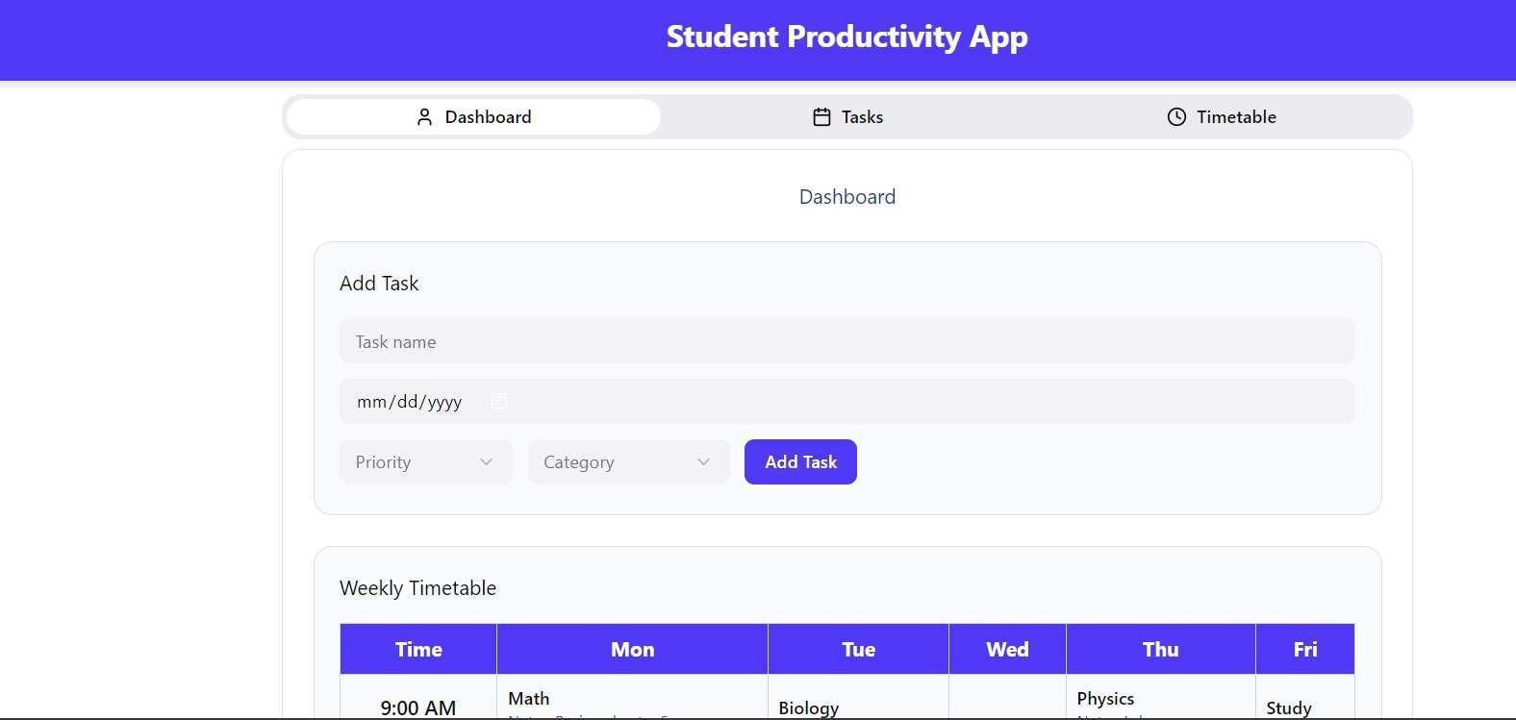

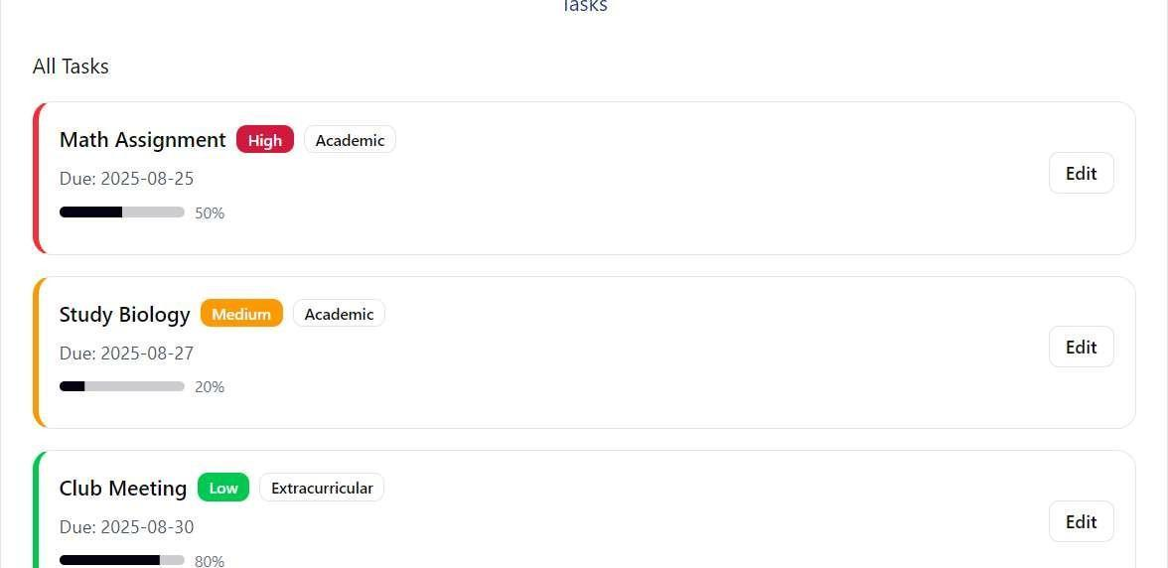

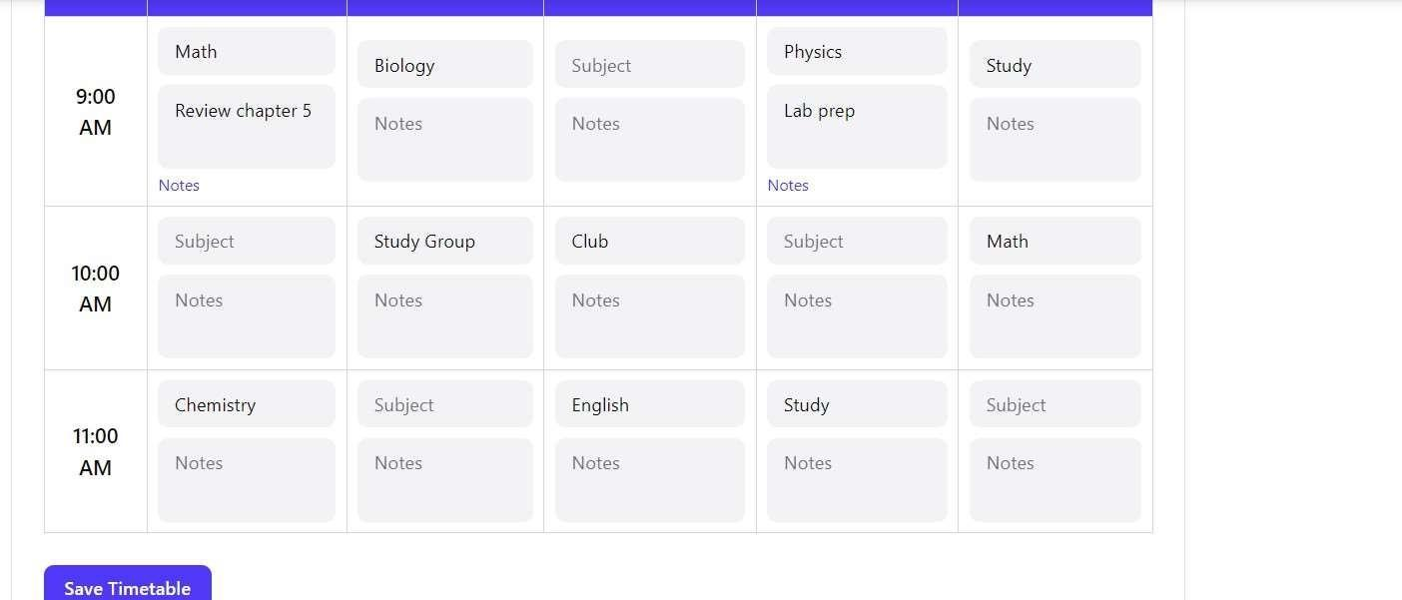

EXPERIMENT:04
CO2: Create user-centered wireframes and design documents

AIM: A small local business plans to launch an online store. You need to wireframe the layout before development begins. Conduct user scenario mapping for customer journeys. Design wireframes for homepage, product detail, and cart screens. Present feedback loops from peer reviews.

PROCEDURE:
<!DOCTYPE html>
<html lang="en">
<head>
<meta charset="UTF-8">
<meta name="viewport" content="width=device-width, initial-scale=1.0">
<title>UrbanThreads</title>
<style>
<link href="https://fonts.googleapis.com/css2?family=Inter:wght@400;500;600;700&di splay=swap" rel="stylesheet">
</head>
<body>
<!-- Header -->
<header>
<nav>
<div class="logo">UrbanThreads</div>

<ul>
<li><a href="#home">Home</a></li>
<li><a href="#products">Products</a></li>
<li><a href="#contact">Contact</a></li>
<li><a class="cart-icon" href="#cart">Cart <span id="cart-count">0</span></a></li>
</ul>
<div class="search-bar">
<input type="text" placeholder="Search bags...">
<button onclick="searchProducts()">Search</button>
</div>
</nav>
</header>

<section id="home" class="container">
<div class="hero">
<video autoplay loop muted playsinline>
<source src="video.mp4.mov" type="video/mp4" /> Your browser does not support the video tag.
</video>
<h1>Discover Your Perfect Bag</h1>
<p>Elevate your style with our curated collection of bags</p>
<button onclick="showSection('products')">Shop Now</button>

</div>
</section>
<section id="products" class="container product-section">
<h2>Our Bags</h2>
<div class="product-grid">
<div class="product-card">
<img
src="https://images.pexels.com/photos/1152077/pexels-photo-1152077.jpeg?aut o=compress&cs=tinysrgb&w=1060" alt="Leather Tote Bag">
<div class="product-card-content">
<h3>Leather Tote Bag</h3>
<p>$79.99</p>
<button onclick="addToCartFromCard('Leather Tote Bag', 79.99, 'https://images.pexels.com/photos/1152077/pexels-photo-1152077.jpeg?auto=co mpress&cs=tinysrgb&w=1060')">Add to Cart</button>
</div>
</div>
<div class="product-card">
<img
src="https://images.unsplash.com/photo-1553062407-98eeb64c6a62?q=80&w=1 060" alt="Canvas Backpack">
<div class="product-card-content">
<h3>Canvas Backpack</h3>
<p>$59.99</p>

<button onclick="addToCartFromCard('Canvas Backpack', 59.99, 'https://images.unsplash.com/photo-1553062407-98eeb64c6a62?q=80&w=1060'
)">Add to Cart</button>
</div>
</div>
<div class="product-card">
<img
src="https://images.unsplash.com/photo-1548036328-c9fa89d128fa?q=80&w=10 60" alt="Satchel Bag">
<div class="product-card-content">
<h3>Satchel Bag</h3>
<p>$74.99</p>
<button onclick="addToCartFromCard('Satchel Bag', 74.99, 'https://images.unsplash.com/photo-1548036328-c9fa89d128fa?q=80&w=1060')"
>Add to Cart</button>
</div>
</div>
</div>
</section>
<section id="reviews" class="review-section container">
<h2>Customer Reviews</h2>
<div class="review-form">
<select id="review-product" required>
option value="Leather Tote Bag">Leather Tote Bag</option>
<option value="Canvas Backpack">Canvas Backpack</option>
<option value="Satchel Bag">Satchel Bag</option>
</select>
<div class="star-rating">
<input type="radio" name="rating" id="rating-5" value="5"><label for="rating-5">★</label>
<input type="radio" name="rating" id="rating-4" value="4"><label for="rating-4">★</label>
<input type="radio" name="rating" id="rating-3" value="3"><label for="rating-3">★</label>
<input type="radio" name="rating" id="rating-2" value="2"><label for="rating-2">★</label>
<input type="radio" name="rating" id="rating-1" value="1"><label for="rating-1">★</label>
</div>
<textarea id="review-text" placeholder="Write your review..." required></textarea>
<button onclick="submitReview()">Submit Review</button>
</div>
<div class="review-list" id="review-list">
<!-- Reviews will be added dynamically -->
</div>
</section>

<!-- Sidebar -->
<div id="sidebar" class="sidebar">
<button class="sidebar-close" onclick="closeSidebar()">Close</button>
<h2>Your Cart</h2>
<div id="sidebar-cart-items">
<!-- Cart items will be added dynamically -->
</div>
<button class="checkout-btn" onclick="showPopup()">Order Now</button>
</div>

<!-- Popup -->
<div id="popup" class="popup">
<div class="popup-content">
<h2>Choose Payment Option</h2>
<p>Select how you'd like to pay for your order:</p>
<button onclick="alert('Proceeding with Online Payment...')">Online Payment</button>
<button onclick="alert('Proceeding with Cash on Delivery...')">Cash on Delivery</button>
<button class="close-popup" onclick="closePopup()">Cancel</button>
</div>
</div>

<!-- Footer -->
<footer id="contact">
<p>Contact Us: Reach out at support@urbanthreads.com</p>
<p>Phone: +1 (555) 987-6543 | Address: 456 Fashion Ave, Style City, USA</p>
<div class="social-links">
<a href="https://facebook.com/urbanthreads" target="_blank">Facebook</a>
<a href="https://instagram.com/urbanthreads" target="_blank">Instagram</a>
<a href="https://twitter.com/urbanthreads" target="_blank">Twitter</a>
</div>
<p>&copy; 2025 UrbanThreads. All rights reserved.</p>
</footer>
<div class="cart-item-details">
<div>${item.name}</div>
<div>$${item.price.toFixed(2)}</div>
</div>
<div class="cart-item-controls">
<label for="size-${index}">Size:</label>
<select id="size-${index}" onchange="updateSize(${index},
this.value)"><option value="Small" ${item.size === 'Small' ? 'selected' :

<option value="Medium" ${item.size === 'Medium' ? 'selected' : ''}>Medium</option>
<option value="Large" ${item.size === 'Large' ? 'selected' : ''}>Large</option>
</select>
<label for="material-${index}">Material:</label>
<select id="material-${index}" onchange="updateMaterial(${index},
this.value)">
<option value="Leather" ${item.material === 'Leather' ? 'selected'
: ''}>Leather</option>
<option value="Canvas" ${item.material === 'Canvas' ? 'selected' : ''}>Canvas</option>
<option value="Suede" ${item.material === 'Suede' ? 'selected' : ''}>Suede</option>
<option value="Nylon" ${item.material === 'Nylon' ? 'selected' : ''}>Nylon</option>
</select>
<div>
<button onclick="updateQuantity(${index}, -1)">-</button>
<span>${item.quantity}</span>
<button onclick="updateQuantity(${index}, 1)">+</button>
</div>
<button class="cancel-btn" onclick="cancelOrder(${index})">Cancel</button>
</div>

`; sidebarCartItems.appendChild(cartItem);
});
}

</body>
</html>

OUTPUT:
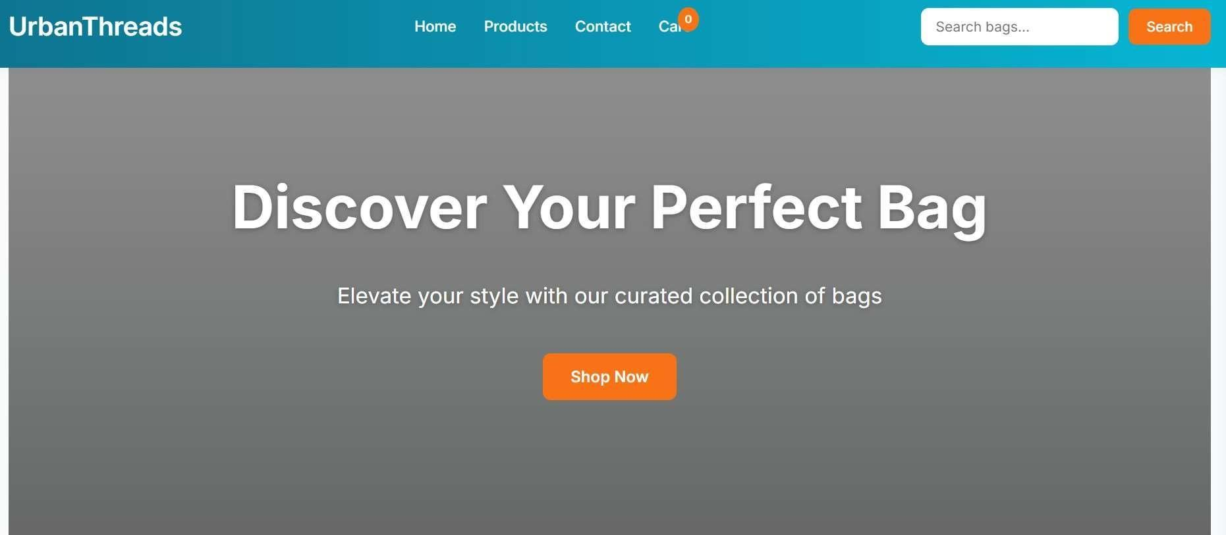

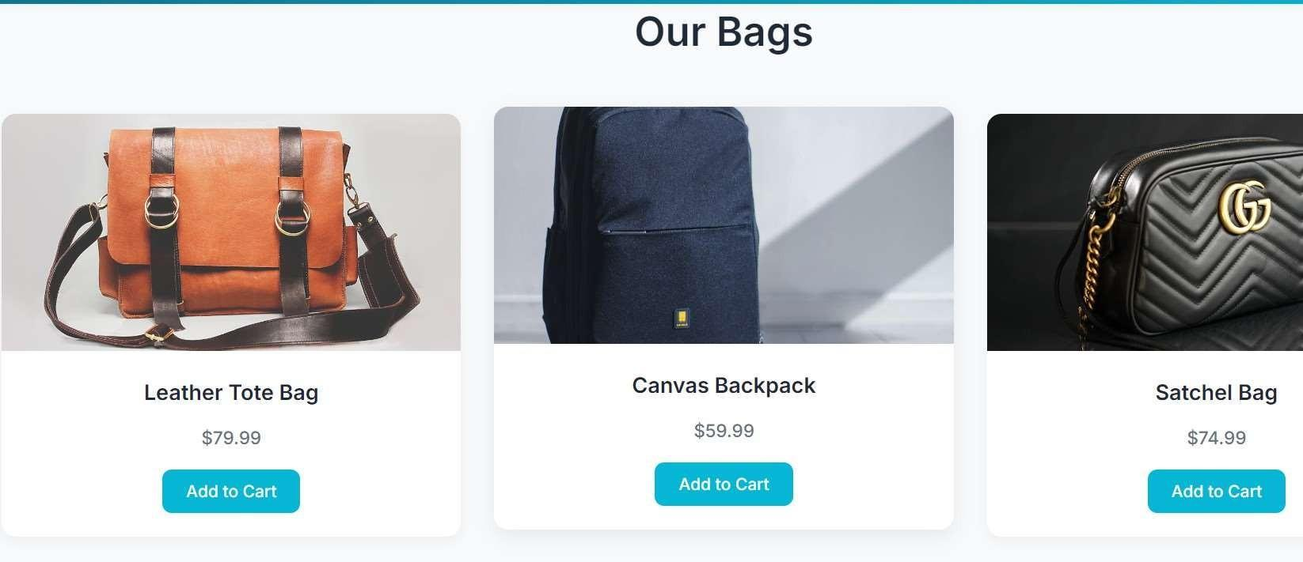



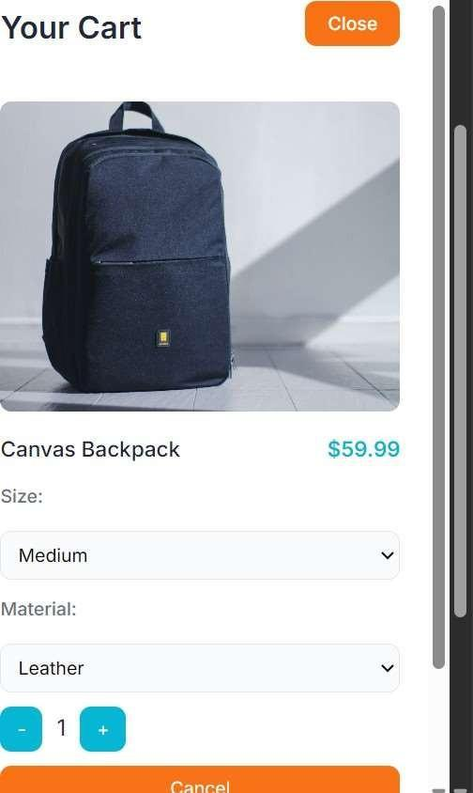

EXPERIMENT:05

CO3: Develop interactive prototypes using professional tools.

AIM: You are designing a digital diary app prototype. The app should allow basic note-taking and navigation between sections. Design a high-fidelity prototype using Adobe XD/Figma. Add interactive navigation between notes, calendar, and settings pages. Explain transition flow and usability features.

PROCEDURE:

<!DOCTYPE html>
<html lang="en">
<head>
<meta charset="UTF-8">
<meta name="viewport" content="width=device-width, initial-scale=1.0">
<title>Digital Diary App</title>
<link href="https://fonts.googleapis.com/css2?family=Poppins:wght@300;400;600;700&display=swap" rel="stylesheet">
<link rel="stylesheet" href="https://cdnjs.cloudflare.com/ajax/libs/font-awesome/6.4.0/css/all.min.css"> body.font-medium { font-size: 16px; }
body.font-large { font-size: 18px; }
</head>
<body class="font-medium">
<header>
<h1>Digital Diary</h1>
<nav>
<div class="container">

<a href="#notes" class="nav-link" data-page="notes" onclick="navigateTo('notes')" aria-label="Notes page"><i class="fas fa-note-sticky"></i> Notes</a>
<a href="#all-notes" class="nav-link" data-page="all-notes" onclick="navigateTo('all-notes')" aria-label="All Notes page"><i class="fas fa-notes"></i> All Notes</a>
<a href="#calendar" class="nav-link" data-page="calendar" onclick="navigateTo('calendar')" aria-label="Calendar page"><i class="fas fa-calendar"></i> Calendar</a>
<a href="#settings" class="nav-link" data-page="settings" onclick="navigateTo('settings')" aria-label="Settings page"><i class="fas fa-cog"></i> Settings</a>
</div>
</nav>
</header>

<div class="container">
<!-- Notes Page -->
<section id="notes" class="page active">
<div class="notes-header">
<div class="selected-date" id="selected-date">Selected Date: None</div>
</div>
<div class="notes-form">
<input type="text" id="note-title" placeholder="Note Title" aria-label="Note Title" required>
<textarea id="note-content" placeholder="Write your note..." aria-label="Note Content" required></textarea>
<select id="note-category" aria-label="Note Category">
<option value="personal">Personal</option>
<option value="work">Work</option>
<option value="other">Other</option>
</select>
<button onclick="addNote()" id="add-note-btn"><i class="fas fa-plus"></i> Add Note <span class="spinner"></span></button>
</div>

<!-- All Notes Page -->
<section id="all-notes" class="page">
<div class="all-notes">
<h2>All Notes</h2>
<div class="all-notes-list" id="all-notes-list"></div>
<div class="no-results" id="no-all-results">No notes found.</div>
</div>
</section>

<!-- Calendar Page -->
<section id="calendar" class="page">
<div class="calendar">
<div class="calendar-header">
<button onclick="prevMonth()" aria-label="Previous month"><i class="fas fa-chevron-left"></i> Previous</button>
<h2 id="calendar-title"></h2>
<button onclick="nextMonth()" aria-label="Next month"><i class="fas fa-chevron-right"></i> Next</button>
</div>
<div class="calendar-grid" id="calendar-grid">
<div class="day-name">Sun</div>
<div class="day-name">Mon</div>
<div class="day-name">Tue</div>
<div class="day-name">Wed</div>
<div class="day-name">Thu</div>
<div class="day-name">Fri</div>
<div class="day-name">Sat</div>

</div>
</section>

<!-- Settings Page -->
<section id="settings" class="page">
<div class="settings">
<h2>Settings</h2>
<div class="settings-item">
<label for="font-size"><i class="fas fa-text-height"></i> Font Size</label>
<select id="font-size" aria-label="Select font size" onchange="changeFontSize()">
<option value="small">Small</option>
<option value="medium" selected>Medium</option>
<option value="large">Large</option>
</select>
</div>
<div class="settings-item">
<label for="theme"><i class="fas fa-palette"></i> Theme</label>
<select id="theme" aria-label="Select theme" onchange="changeTheme()">
<option value="light">Light</option>
<option value="dark">Dark</option>
</select>
</div>
</div>
</section>
</div>

<div class="toast" id="toast"></div>
<div class="modal" id="delete-modal">

<div class="modal-content">
<h3>Are you sure you want to delete this note?</h3>
<button class="confirm" onclick="confirmDelete()" aria-label="Confirm delete">Delete</button>
<button class="cancel" onclick="closeModal()" aria-label="Cancel delete">Cancel</button>
</div>
</div>
<div class="modal" id="read-modal">
<div class="modal-content">
<h3 id="read-modal-title"></h3>
<p id="read-modal-content"></p>
<button class="close" onclick="closeReadModal()" aria-label="Close modal">Close</button>
</div>
</div>
</body>
</html>

OUTPUT:
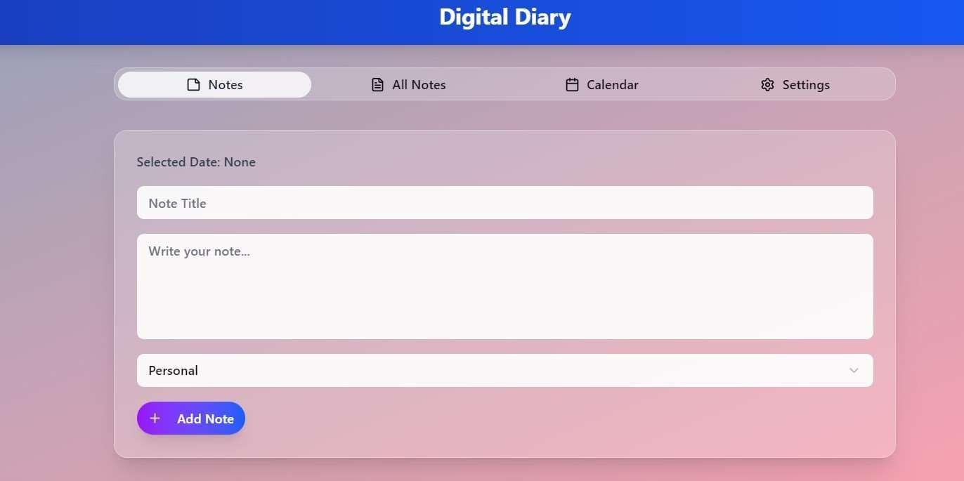

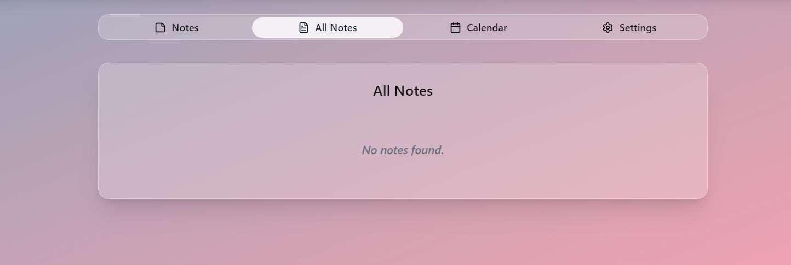

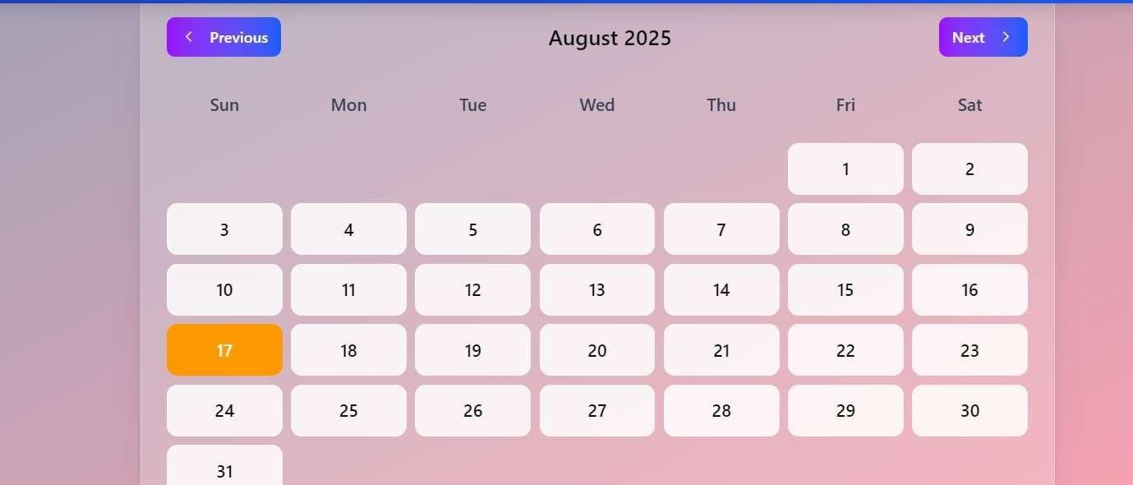

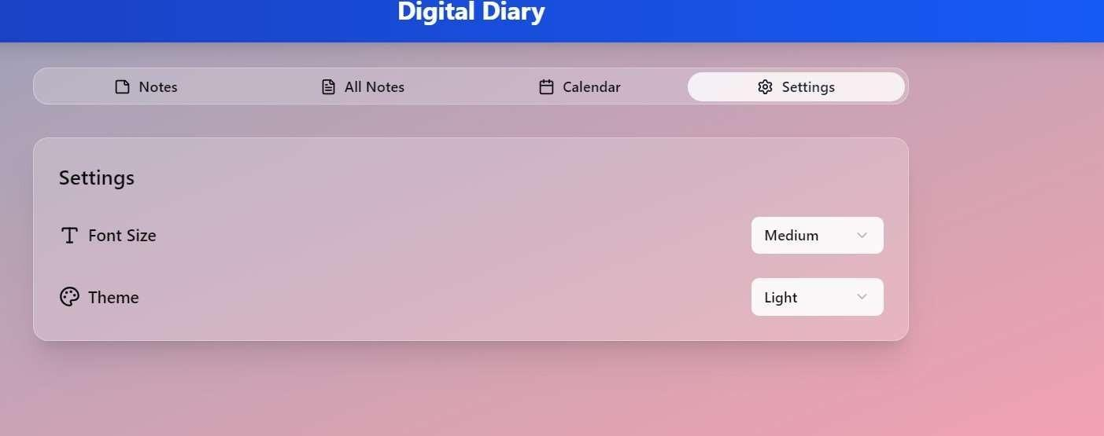

EXPERIMENT:06

CO3: Develop interactive prototypes using professional tools.
AIM: Create a dynamic "Welcome" web page that greets the user with their name. Accept user input via form (name). Use embedded PHP to greet the user dynamically. Include time-based messages (e.g., "Good Morning").

PROCEDURE:
<!DOCTYPE html>
<html lang="en">
<head>
<meta charset="UTF-8">
<meta name="viewport" content="width=device-width, initial-scale=1.0">
<title>Welcome Page</title>
<script src="https://cdn.tailwindcss.com"></script>
</head>
<body class="min-h-screen flex items-center justify-center p-6">
<div class="glass-effect rounded-2xl shadow-xl p-8 w-full max-w-md transition-all duration-300 hover:shadow-2xl">
<h1 class="text-4xl font-extrabold text-center text-white mb-6 drop-shadow-lg">Welcome to Our Site</h1>

<!-- Form for user name input -->
<form method="POST" action="" class="space-y-5">

<div>
<label for="name" class="block text-sm font-medium text-white">Your Name</label>
<input type="text" name="name" id="name" required
class="mt-1 w-full px-4 py-3 bg-white bg-opacity-20 text-white border border-white border-opacity-30 rounded-lg focus:outline-none focus:ring-2 focus:ring-white focus:border-white placeholder-white placeholder-opacity-70"
placeholder="Enter your name">
</div>
<button type="submit"
class="w-full bg-white text-indigo-600 py-3 rounded-lg font-semibold hover:bg-opacity-90 transition duration-200">
Greet Me!
</button>
</form>

<!-- PHP for dynamic greeting -->
<?php
if ($_SERVER["REQUEST_METHOD"] == "POST") {
// Sanitize user input
$name = filter_input(INPUT_POST, 'name', FILTER_SANITIZE_STRING) ?: "Guest";time zone to IST (UTC+5:30)

// Get current hour (based on provided time: 10:44 AM IST)
$hour = date('H');
// Time-based greeting
$greeting = match (true) {
$hour < 12 => "Good Morning",
$hour < 18 => "Good Afternoon", default => "Good Evening"
};
?>
<div class="mt-6 text-center animate-fade-in">
<p class="text-2xl font-semibold text-white drop-shadow-md"><?php echo "$greeting, $name!"; ?></p>
<p class="text-white text-opacity-90 mt-2">We're delighted to see you!</p>
</div>
<?php } ?>
</div>
</body>
</html>

OUTPUT:

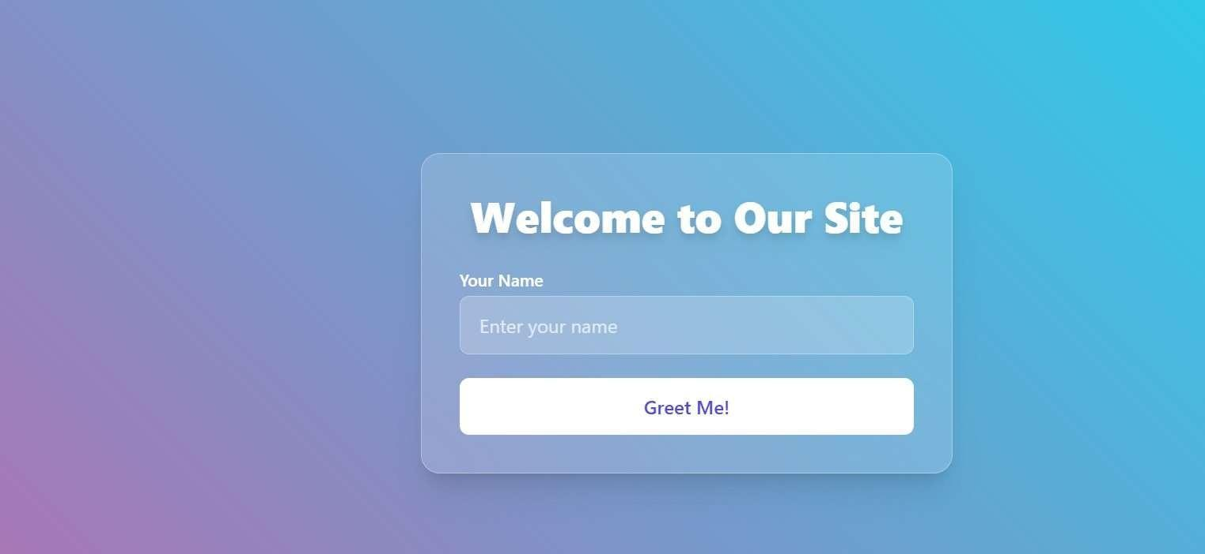

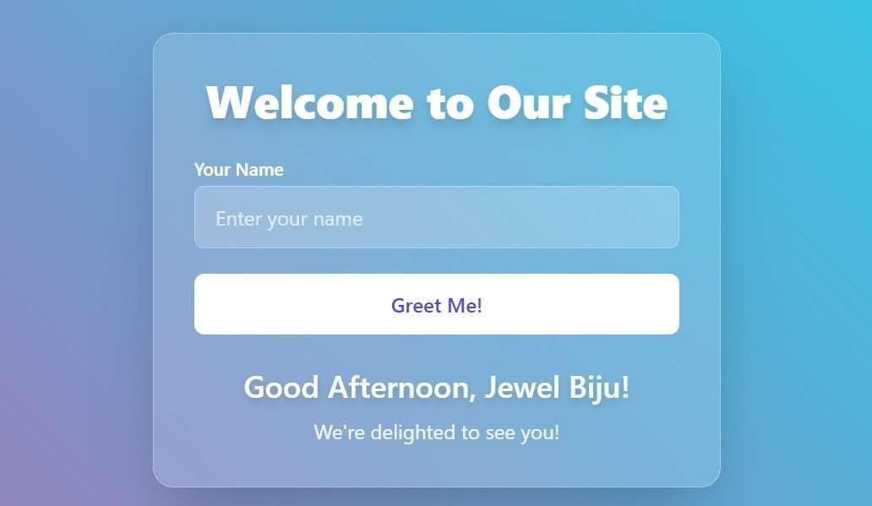

EXPERIMENT:07

CO4: Evaluate interfaces for usability and accessibility..
AIM: You are building a student portal with login functionality.Create a login form validated with PHP and JavaScript. Store user credentials in a MySQL database. Maintain session after login and restrict access to certain pages.

PROCEDURE:
<?php
// single_page.php - Stylish Student Portal with Authentication

session_start(); // Start session

// Database configuration
$host = 'localhost';
$dbname = 'student_portal';
$username = 'root'; // Default XAMPP MySQL user
$password = ''; // Default empty

try {
$pdo = new PDO("mysql:host=$host;dbname=$dbname", $username, $password);
$pdo->setAttribute(PDO::ATTR_ERRMODE, PDO::ERRMODE_EXCEPTION);
} catch(PDOException $e) {
die("Connection failed: " . $e->getMessage());
}

// Handle Logout
if (isset($_POST['logout'])) {
session_destroy();
header('Location: ' . $_SERVER['PHP_SELF']);
exit();
}

// Handle Login (POST request)
$error = '';
if ($_SERVER['REQUEST_METHOD'] === 'POST' && isset($_POST['login'])) {
$email = trim($_POST['email']);
$password = $_POST['password'];

// Server-side validation
if (empty($email) || empty($password)) {
$error = 'Email and password are required.';
} else {
// Query user
$stmt = $pdo->prepare("SELECT id, email, password FROM users WHERE email = ?");
$stmt->execute([$email]);
$user = $stmt->fetch(PDO::FETCH_ASSOC);

if ($user && password_verify($password, $user['password'])) {
// Successful login: Set session variables
$_SESSION['user_id'] = $user['id'];
$_SESSION['user_email'] = $user['email'];
header('Location: ' . $_SERVER['PHP_SELF']);
exit();
} else {
$error = 'Invalid email or password.';
}
}
}

// Check if user is logged in
$loggedIn = isset($_SESSION['user_id']);
$userEmail = $loggedIn ? $_SESSION['user_email'] : '';
?>
<!DOCTYPE html>
<html lang="en">
<head>
<meta charset="UTF-8">
<meta name="viewport" content="width=device-width, initial-scale=1.0">
<title>Student Portal</title>
<link href="https://cdnjs.cloudflare.com/ajax/libs/font-awesome/6.0.0/css/all.min.css" rel="stylesheet">
<style>
* {
margin: 0;
padding: 0;
box-sizing: border-box;
}
body {
font-family: 'Segoe UI', Tahoma, Geneva, Verdana, sans-serif;
background: linear-gradient(135deg, #667eea 0%, #764ba2 100%);
min-height: 100vh;
display: flex;
align-items: center;
justify-content: center;
padding: 20px;
}
.container {
background: white;
border-radius: 20px;
box-shadow: 0 15px 35px rgba(0, 0, 0, 0.1);
padding: 40px;
width: 100%;
max-width: 400px;
text-align: center;
transition: transform 0.3s ease;
}
.container:hover {
transform: translateY(-5px);
}
h2 {
color: #333;
margin-bottom: 20px;
font-size: 28px;
font-weight: 600;
}
.form-group {
position: relative;
margin-bottom: 25px;
text-align: left;
}
label {
display: block;
color: #555;
margin-bottom: 8px;
font-weight: 500;
}
input {
width: 100%;
padding: 15px 20px;
border: 2px solid #e1e5e9;
border-radius: 10px;
font-size: 16px;
transition: border-color 0.3s ease, box-shadow 0.3s ease;
background: #f8f9fa;
}
input:focus {
outline: none;
border-color: #667eea;
box-shadow: 0 0 0 3px rgba(102, 126, 234, 0.1);
background: white;
}
button {
width: 100%;
padding: 15px;
background: linear-gradient(135deg, #667eea 0%, #764ba2 100%);
color: white;
border: none;
border-radius: 10px;
font-size: 16px;
font-weight: 600;
cursor: pointer;
transition: transform 0.2s ease, box-shadow 0.2s ease;
}
button:hover {
transform: translateY(-2px);
box-shadow: 0 5px 15px rgba(102, 126, 234, 0.4);
}
.error {
color: #e74c3c;
background: #fdf2f2;
padding: 12px;
border-radius: 8px;
margin-bottom: 20px;
border-left: 4px solid #e74c3c;
font-size: 14px;
}
.success {
color: #27ae60;
background: #f0fff4;
padding: 15px;
border-radius: 10px;
margin-bottom: 20px;
border-left: 4px solid #27ae60;
font-size: 18px;
font-weight: 600;
animation: fadeIn 0.5s ease-in;
}
@keyframes fadeIn {
from { opacity: 0; transform: translateY(-10px); }
to { opacity: 1; transform: translateY(0); }
}
.welcome {
color: #27ae60;
font-size: 20px;
margin-bottom: 15px;
font-weight: 500;
}
.protected-text {
color: #7f8c8d;
font-size: 14px;
margin-bottom: 30px;
line-height: 1.5;
}
.logout-btn {
background: linear-gradient(135deg, #e74c3c 0%, #c0392b 100%);
}
.logout-btn:hover {
box-shadow: 0 5px 15px rgba(231, 76, 60, 0.4);
}
.icon {
font-size: 24px;
color: #667eea;
margin-bottom: 10px;
}
@media (max-width: 480px) {
.container {
padding: 30px 20px;
margin: 10px;
}
}
</style>
</head>
<body>
<div class="container">
<?php if ($loggedIn): ?>
<!-- Dashboard View -->
<div class="icon"><i class="fas fa-tachometer-alt"></i></div>
<h2>Student Dashboard</h2>
<div class="success">
<i class="fas fa-check-circle"></i> Login Successful!
</div>
<p class="welcome">Welcome, <?php echo htmlspecialchars($userEmail); ?>!</p>
<p class="protected-text">You are logged in. This is a protected page. Only authenticated users can access it.</p>
<form method="POST">
<button type="submit" name="logout" class="logout-btn"><i class="fas fa-sign-out-alt"></i> Logout</button>
</form>
<?php else: ?>
<!-- Login Form View -->
<div class="icon"><i class="fas fa-user-graduate"></i></div>
<h2>Student Portal Login</h2>
<?php if ($error): ?>
<div class="error"><?php echo htmlspecialchars($error); ?></div>
<?php endif; ?>
<form id="loginForm" method="POST">
<div class="form-group">
<label for="email"><i class="fas fa-envelope"></i> Email:</label>
<input type="email" id="email" name="email" required placeholder="Enter your email" value="<?php echo isset($_POST['email']) ? htmlspecialchars($_POST['email']) : ''; ?>">
</div>
<div class="form-group">
<label for="password"><i class="fas fa-lock"></i> Password:</label>
<input type="password" id="password" name="password" required placeholder="Enter your password">
</div>
<button type="submit" name="login"><i class="fas fa-sign-in-alt"></i> Login</button>
</form>

<script>
// JavaScript Client-Side Validation
document.getElementById('loginForm').addEventListener('submit', function(e) {
const email = document.getElementById('email').value;
const password = document.getElementById('password').value;
let isValid = true;

// Email format validation
const emailRegex = /^[^\s@]+@[^\s@]+\.[^\s@]+$/;
if (!emailRegex.test(email)) {
alert('Please enter a valid email address.');
isValid = false }
// Password length validation
if (password.length < 6) {
alert('Password must be at least 6 characters long.');
isValid = false;
}

if (!isValid) {
e.preventDefault(); // Stop form submission
}
});
</script>
<?php endif; ?>
</div>
</body>
</html>

OUTPUT:

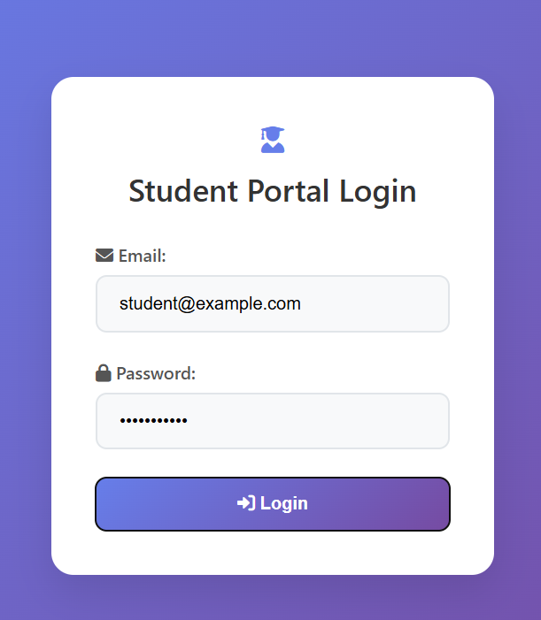

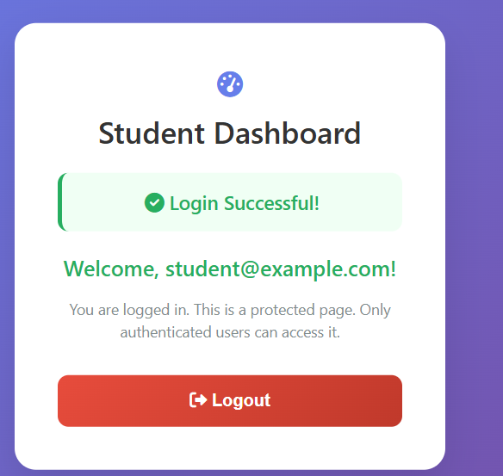

EXPERIMENT:08

CO4: Evaluate interfaces for usability and accessibility..
AIM: Develop a portal for students to upload resumes during placement. Implement file upload form (PDF only). Validate file type and size using PHP. Store files in a designated folder and record metadata in MySQL.

PROCEDURE:
<?php
// single_upload.php - Single-Page Resume Upload with Validation & Details

session_start(); // Start session

// Database configuration (embedded for single page)
$host = 'localhost';
$dbname = 'student_portal';
$username = 'root';
$password = '';

try {
$pdo = new PDO("mysql:host=$host;dbname=$dbname", $username, $password);
$pdo->setAttribute(PDO::ATTR_ERRMODE, PDO::ERRMODE_EXCEPTION);
} catch(PDOException $e) {
die("Connection failed: " . $e->getMessage());
}

// Simple auth check (assume session from login; in full, redirect to login)
if (!isset($_SESSION['user_id'])) {
die('Please login first. (Simulate by setting $_SESSION["user_id"] = 1; $_SESSION["user_email"] = "student@example.com";)');
}

$userId = $_SESSION['user_id'];
$userEmail = $_SESSION['user_email'] ?? 'student@example.com';
$success = '';
$error = '';
$uploadDetails = null;

// Handle POST upload
if ($_SERVER['REQUEST_METHOD'] === 'POST' && isset($_FILES['resume'])) {
$file = $_FILES['resume'];
$uploadDir = 'uploads/';
if (!is_dir($uploadDir)) mkdir($uploadDir, 0755, true);
$maxSize = 5 * 1024 * 1024; // 5MB

$fileSize = $file['size'];
$fileType = $file['type'];
$fileExt = strtolower(pathinfo($file['name'], PATHINFO_EXTENSION));
$isValidType = ($fileExt === 'pdf' && $fileType === 'application/pdf');
$isValidSize = $fileSize <= $maxSize;

if ($file['error'] !== UPLOAD_ERR_OK) {
$error = 'Upload error: ' . $file['error'];
} elseif (!$isValidType) {
$error = 'Invalid file type. Only PDF files allowed. (Detected: ' . $fileType . ')';
} elseif (!$isValidSize) {
$error = 'File too large. Max size: 5MB. (Uploaded: ' . round($fileSize / 1024 / 1024, 2) . 'MB)';
} else {
$filename = uniqid() . '_' . preg_replace('/[^a-zA-Z0-9.-]/', '', basename($file['name']));
$uploadPath = $uploadDir . $filename;

if (move_uploaded_file($file['tmp_name'], $uploadPath)) {
$stmt = $pdo->prepare("INSERT INTO resumes (user_id, email, filename, original_name) VALUES (?, ?, ?, ?)");
if ($stmt->execute([$userId, $userEmail, $filename, $file['name']])) {
$success = 'Resume uploaded successfully!';
$uploadDetails = [
'original_name' => $file['name'],
'size_mb' => round($fileSize / 1024 / 1024, 2),
'size_kb' => round($fileSize / 1024, 2),
'saved_as' => $filename,
'upload_date' => date('Y-m-d H:i:s')
];
} else {
unlink($uploadPath);
$error = 'DB save failed.';
}
} else {
$error = 'Failed to save file.';
}
}
}
?>
<!DOCTYPE html>
<html lang="en">
<head>
<meta charset="UTF-8">
<meta name="viewport" content="width=device-width, initial-scale=1.0">
<title>Student Portal - Resume Upload</title>
<link href="https://cdnjs.cloudflare.com/ajax/libs/font-awesome/6.0.0/css/all.min.css" rel="stylesheet">
<style>
* { margin: 0; padding: 0; box-sizing: border-box; }
body { font-family: 'Segoe UI', Tahoma, Geneva, Verdana, sans-serif; background: linear-gradient(135deg, #667eea 0%, #764ba2 100%); min-height: 100vh; display: flex; align-items: center; justify-content: center; padding: 20px; }
.container { background: white; border-radius: 20px; box-shadow: 0 15px 35px rgba(0, 0, 0, 0.1); padding: 40px; width: 100%; max-width: 500px; text-align: center; transition: transform 0.3s ease; }
.container:hover { transform: translateY(-5px); }
h2 { color: #333; margin-bottom: 20px; font-size: 28px; font-weight: 600; }
.form-group { margin-bottom: 25px; text-align: left; }
label { display: block; color: #555; margin-bottom: 8px; font-weight: 500; }
input[type="file"] { width: 100%; padding: 10px; border: 2px dashed #e1e5e9; border-radius: 10px; background: #f8f9fa; transition: border-color 0.3s; }
input[type="file"]:hover { border-color: #667eea; }
.file-preview { background: #f8f9fa; border: 1px solid #e1e5e9; border-radius: 8px; padding: 10px; margin-top: 10px; text-align: left; font-size: 14px; display: none; }
.file-preview.valid { border-color: #27ae60; background: #f0fff4; }
.file-preview.invalid { border-color: #e74c3c; background: #fdf2f2; }
.size-info { font-size: 12px; color: #666; margin-top: 5px; }
button { width: 100%; padding: 15px; background: linear-gradient(135deg, #667eea 0%, #764ba2 100%); color: white; border: none; border-radius: 10px; font-size: 16px; font-weight: 600; cursor: pointer; transition: transform 0.2s ease, box-shadow 0.2s ease; margin-top: 10px; }
button:hover:not(:disabled) { transform: translateY(-2px); box-shadow: 0 5px 15px rgba(102, 126, 234, 0.4); }
button:disabled { background: #ccc; cursor: not-allowed; transform: none; }
.error { color: #e74c3c; background: #fdf2f2; padding: 12px; border-radius: 8px; margin-bottom: 20px; border-left: 4px solid #e74c3c; font-size: 14px; }
.success { color: #27ae60; background: #f0fff4; padding: 12px; border-radius: 8px; margin-bottom: 20px; border-left: 4px solid #27ae60; font-size: 14px; animation: fadeIn 0.5s ease-in; }
.upload-details { background: #f0fff4; border: 1px solid #27ae60; border-radius: 10px; padding: 15px; margin-top: 20px; text-align: left; }
.upload-details h3 { color: #27ae60; margin-bottom: 10px; text-align: center; }
.detail-item { display: flex; justify-content: space-between; margin-bottom: 5px; font-size: 14px; }
@keyframes fadeIn { from { opacity: 0; transform: translateY(-10px); } to { opacity: 1; transform: translateY(0); } }
.welcome { color: #27ae60; font-size: 18px; margin-bottom: 15px; }
.back-link { color: #667eea; text-decoration: none; margin-top: 20px; display: inline-block; }
.icon { font-size: 24px; color: #667eea; margin-bottom: 10px; }
@media (max-width: 480px) { .container { padding: 30px 20px; margin: 10px; } }
</style>
</head>
<body>
<div class="container">
<div class="icon"><i class="fas fa-file-upload"></i></div>
<h2>Upload Resume</h2>
<p class="welcome">Hello, <?php echo htmlspecialchars($userEmail); ?>!</p>
<?php if ($success): ?>
<div class="success"><?php echo htmlspecialchars($success); ?></div>
<?php if ($uploadDetails): ?>
<div class="upload-details">
<h3><i class="fas fa-info-circle"></i> Upload Summary</h3>
<div class="detail-item"><span>Original Name:</span><span><?php echo htmlspecialchars($uploadDetails['original_name']); ?></span></div>
<div class="detail-item"><span>Saved As:</span><span><?php echo htmlspecialchars($uploadDetails['saved_as']); ?></span></div>
<div class="detail-item"><span>File Size:</span><span><?php echo $uploadDetails['size_mb']; ?> MB (<?php echo $uploadDetails['size_kb']; ?> KB)</span></div>
<div class="detail-item"><span>Upload Date:</span><span><?php echo $uploadDetails['upload_date']; ?></span></div>
<div class="detail-item"><span>Validation:</span><span><i class="fas fa-check-circle" style="color: #27ae60;"></i> Type: PDF | Size: Valid</span></div>
</div>
<?php endif; ?>
<?php endif; ?>
<?php if ($error): ?>
<div class="error"><?php echo htmlspecialchars($error); ?></div>
<?php endif; ?>
<form id="uploadForm" method="POST" enctype="multipart/form-data">
<div class="form-group">
<label for="resume"><i class="fas fa-file-pdf"></i> Select PDF Resume (Max 5MB):</label>
<input type="file" id="resume" name="resume" accept=".pdf" required>
<div id="filePreview" class="file-preview"></div>
<div id="sizeInfo" class="size-info"></div>
</div>
<button type="submit" id="uploadBtn"><i class="fas fa-cloud-upload-alt"></i> Upload Resume</button>
</form>
<a href="dashboard.php" class="back-link"><i class="fas fa-arrow-left"></i> Back to Dashboard</a>
</div>

<script>
// Client-Side File Preview & Validation
const fileInput = document.getElementById('resume');
const preview = document.getElementById('filePreview');
const sizeInfo = document.getElementById('sizeInfo');
const uploadBtn = document.getElementById('uploadBtn');

fileInput.addEventListener('change', function() {
const file = this.files[0];
preview.style.display = 'none';
sizeInfo.textContent = '';

if (file) {
const fileExt = file.name.split('.').pop().toLowerCase();
const isValidType = file.type === 'application/pdf' && fileExt === 'pdf';
const maxSize = 5 * 1024 * 1024;
const isValidSize = file.size <= maxSize;
const sizeMB = (file.size / 1024 / 1024).toFixed(2);
const sizeKB = (file.size / 1024).toFixed(2);

preview.innerHTML = `
<strong>${file.name}</strong><br>
Type: ${file.type} ${!isValidType ? '<span style="color: red;">(Invalid - Must be PDF)</span>' : '<i class="fas fa-check" style="color: green;"></i>'}<br>
Size: ${sizeMB} MB / ${sizeKB} KB ${!isValidSize ? '<span style="color: red;">(Too large - Max 5MB)</span>' : '<i class="fas fa-check" style="color: green;"></i>'}
`;
preview.className = 'file-preview ' + (isValidType && isValidSize ? 'valid' : 'invalid');
preview.style.display = 'block';

sizeInfo.textContent = isValidType && isValidSize ? 'File is valid for upload!' : 'Please select a valid PDF under 5MB.';
sizeInfo.style.color = isValidType && isValidSize ? '#27ae60' : '#e74c3c';

uploadBtn.disabled = !(isValidType && isValidSize);
}
});

// Form Submit Validation (client-side only, server handles full)
document.getElementById('uploadForm').addEventListener('submit', function(e) {
const file = fileInput.files[0];
let isValid = true;

if (!file) {
alert('Please select a file.');
isValid = false;
} else if (file.type !== 'application/pdf') {
alert('Only PDF files allowed.');
isValid = false;
} else if (file.size > 5 * 1024 * 1024) {
alert('File too large (max 5MB).');
isValid = false;
}

if (!isValid) {
e.preventDefault();
}
});
</script>
</body>
</html>

OUTPUT:

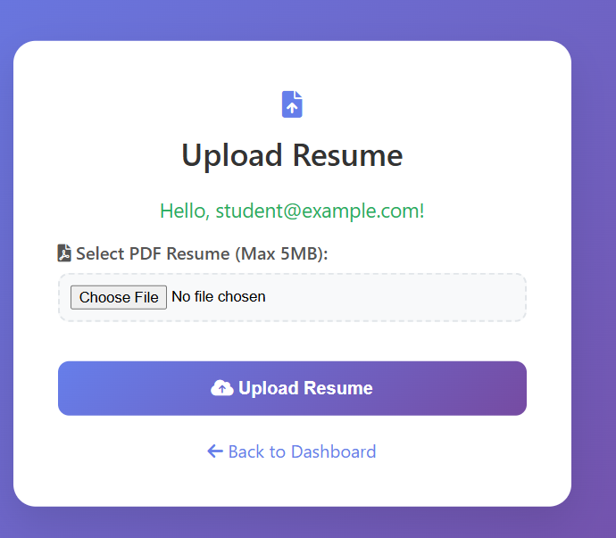

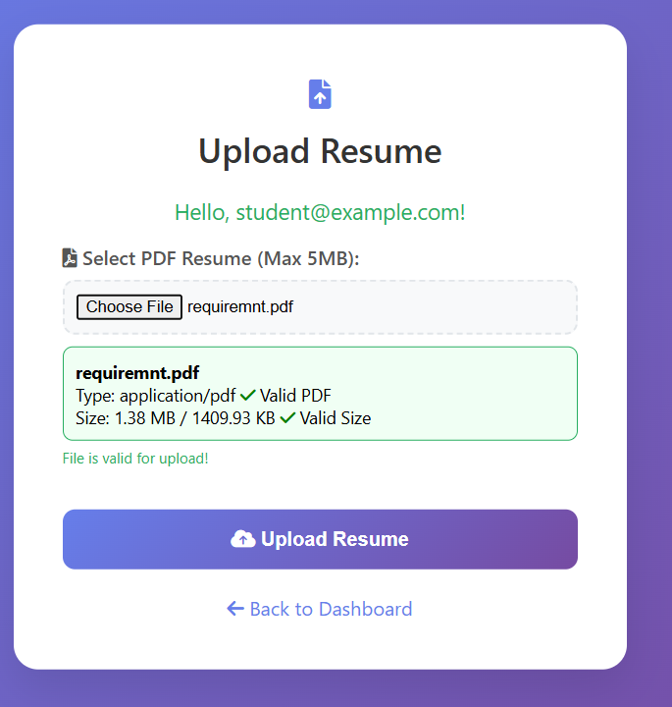

EXPERIMENT:09

CO5: Demonstrate UI design competence via a project portfolio.
AIM: A health startup requires a UI design for an online clinic booking system. Develop complete wireframes and interactive prototypes. Conduct usability testing using WAVE or axe tools. Document test reports and user feedback analysis.

PROCEDURE:
<?php
// booking.php - PHP Version of MediBook Clinic Booking System

// Database configuration (embedded for single page)
$host = 'localhost';
$dbname = 'medibook'; // Create this DB
$username = 'root';
$password = '';

try {
$pdo = new PDO("mysql:host=$host;dbname=$dbname", $username, $password);
$pdo->setAttribute(PDO::ATTR_ERRMODE, PDO::ERRMODE_EXCEPTION);
} catch(PDOException $e) {
die("Connection failed: " . $e->getMessage() . "<br>Run SQL below to setup DB.");
}

// Sample DB Setup (Run once in phpMyAdmin)
$setupSQL = "
CREATE DATABASE IF NOT EXISTS medibook;
USE medibook;
CREATE TABLE IF NOT EXISTS clinics (
id INT AUTO_INCREMENT PRIMARY KEY,
name VARCHAR(100),
specialty VARCHAR(50),
location VARCHAR(50)
);
CREATE TABLE IF NOT EXISTS bookings (
id INT AUTO_INCREMENT PRIMARY KEY,
patient_name VARCHAR(100),
phone VARCHAR(20),
email VARCHAR(100),
slot VARCHAR(50),
doctor VARCHAR(100),
created_at TIMESTAMP DEFAULT CURRENT_TIMESTAMP
);
INSERT IGNORE INTO clinics (name, specialty, location) VALUES
('HeartCare Center', 'cardiology', 'Downtown'),
('SkinClinic', 'dermatology', 'Uptown'),
('General Health', 'general', 'Suburbs');
";

// Handle Form Submission (Booking)
$message = '';
if ($_SERVER['REQUEST_METHOD'] === 'POST' && isset($_POST['book'])) {
$patientName = trim($_POST['patient_name']);
$phone = trim($_POST['phone']);
$email = trim($_POST['email']);
$slot = trim($_POST['slot']);
$doctor = trim($_POST['doctor'] ?? 'Dr. Jane Smith');

if (!empty($patientName) && !empty($phone) && !empty($email) && !empty($slot)) {
$stmt = $pdo->prepare("INSERT INTO bookings (patient_name, phone, email, slot, doctor) VALUES (?, ?, ?, ?, ?)");
if ($stmt->execute([$patientName, $phone, $email, $slot, $doctor])) {
$message = 'Booking confirmed! ID: ' . $pdo->lastInsertId();
} else {
$message = 'Error saving booking.';
}
} else {
$message = 'Please fill all fields.';
}
}

// Fetch Clinics
$clinicsStmt = $pdo->query("SELECT * FROM clinics");
$clinics = $clinicsStmt->fetchAll(PDO::FETCH_ASSOC);

// Handle Filter (Simple GET params for demo)
$locationFilter = $_GET['location'] ?? '';
$specialtyFilter = $_GET['specialty'] ?? '';
$filteredClinics = array_filter($clinics, function($clinic) use ($locationFilter, $specialtyFilter) {
return (empty($locationFilter) || stripos($clinic['location'], $locationFilter) !== false) &&
(empty($specialtyFilter) || $clinic['specialty'] === $specialtyFilter);
});
?>
<!DOCTYPE html>
<html lang="en">
<head>
<meta charset="UTF-8">
<meta name="viewport" content="width=device-width, initial-scale=1.0">
<title>MediBook - Online Clinic Booking</title>
<link href="https://cdnjs.cloudflare.com/ajax/libs/font-awesome/6.0.0/css/all.min.css" rel="stylesheet">
<style>
* { margin: 0; padding: 0; box-sizing: border-box; }
body { font-family: 'Segoe UI', Tahoma, Geneva, Verdana, sans-serif; background: linear-gradient(135deg, #e3f2fd 0%, #bbdefb 100%); min-height: 100vh; color: #333; }
.header { background: linear-gradient(135deg, #1976d2 0%, #42a5f5 100%); color: white; padding: 1rem 2rem; display: flex; justify-content: space-between; align-items: center; box-shadow: 0 2px 10px rgba(0,0,0,0.1); }
.logo { font-size: 1.5rem; font-weight: bold; }
.search-bar { flex: 1; max-width: 400px; margin: 0 2rem; }
.search-bar input { width: 100%; padding: 0.75rem; border: none; border-radius: 25px; font-size: 1rem; }
.nav { display: flex; gap: 1rem; }
.nav a { color: white; text-decoration: none; padding: 0.5rem 1rem; border-radius: 20px; transition: background 0.3s; }
.nav a:hover { background: rgba(255,255,255,0.2); }
.main { max-width: 1200px; margin: 2rem auto; padding: 0 1rem; }
.section { background: white; border-radius: 15px; padding: 2rem; margin-bottom: 2rem; box-shadow: 0 4px 20px rgba(0,0,0,0.08); }
h1, h2 { color: #1976d2; margin-bottom: 1rem; }
.clinic-grid { display: grid; grid-template-columns: repeat(auto-fit, minmax(300px, 1fr)); gap: 1.5rem; }
.clinic-card { border: 1px solid #e0e0e0; border-radius: 10px; padding: 1.5rem; transition: transform 0.3s, box-shadow 0.3s; }
.clinic-card:hover { transform: translateY(-5px); box-shadow: 0 8px 25px rgba(0,0,0,0.1); }
.clinic-card h3 { color: #1976d2; margin-bottom: 0.5rem; }
.filter { display: flex; gap: 1rem; margin-bottom: 1rem; flex-wrap: wrap; }
.filter select, .filter input { padding: 0.5rem; border: 1px solid #ddd; border-radius: 5px; }
.doctor-profile { display: flex; gap: 2rem; align-items: center; }
.doctor-img { width: 150px; height: 150px; border-radius: 50%; background: #f5f5f5; display: flex; align-items: center; justify-content: center; font-size: 4rem; color: #ccc; }
.slots { display: flex; flex-wrap: wrap; gap: 0.5rem; margin-top: 1rem; }
.slot { padding: 0.5rem 1rem; background: #f0f0f0; border-radius: 20px; cursor: pointer; transition: background 0.3s; }
.slot.selected { background: #1976d2; color: white; }
.booking-form { display: grid; grid-template-columns: 1fr 1fr; gap: 1rem; }
.form-group { display: flex; flex-direction: column; }
.form-group label { margin-bottom: 0.5rem; font-weight: 500; }
.form-group input, .form-group select { padding: 0.75rem; border: 1px solid #ddd; border-radius: 5px; }
.btn { background: linear-gradient(135deg, #1976d2 0%, #42a5f5 100%); color: white; border: none; padding: 1rem 2rem; border-radius: 25px; cursor: pointer; font-size: 1rem; transition: transform 0.3s; margin: 1rem 0; }
.btn:hover { transform: translateY(-2px); }
.confirmation { text-align: center; background: #e8f5e8; padding: 2rem; border-radius: 10px; }
.message { padding: 1rem; border-radius: 5px; margin: 1rem 0; }
.message.success { background: #d4edda; color: #155724; border: 1px solid #c3e6cb; }
.message.error { background: #f8d7da; color: #721c24; border: 1px solid #f5c6cb; }
.hidden { display: none; }
@media (max-width: 768px) { .doctor-profile { flex-direction: column; text-align: center; } .booking-form { grid-template-columns: 1fr; } }
</style>
</head>
<body>
<!-- Header -->
<header class="header">
<div class="logo">MediBook</div>
<div class="search-bar">
<form method="GET">
<input type="text" name="search" placeholder="Search clinics or specialties..." value="<?php echo htmlspecialchars($_GET['search'] ?? ''); ?>">
</form>
</div>
<nav class="nav">
<a href="#home">Home</a>
<a href="#book">Book</a>
<a href="#profile">Profile</a>
</nav>
</header>

<main class="main">
<!-- Home/Search Clinics Section -->
<section id="home" class="section">
<h1>Find Clinics Near You</h1>
<form method="GET" class="filter">
<input type="text" name="location" placeholder="Location" value="<?php echo htmlspecialchars($locationFilter); ?>">
<select name="specialty">
<option value="">All Specialties</option>
<option value="cardiology" <?php echo $specialtyFilter === 'cardiology' ? 'selected' : ''; ?>>Cardiology</option>
<option value="dermatology" <?php echo $specialtyFilter === 'dermatology' ? 'selected' : ''; ?>>Dermatology</option>
<option value="general" <?php echo $specialtyFilter === 'general' ? 'selected' : ''; ?>>General</option>
</select>
<button type="submit" class="btn">Search</button>
</form>
<div class="clinic-grid">
<?php foreach ($filteredClinics as $clinic): ?>
<div class="clinic-card">
<h3><?php echo htmlspecialchars($clinic['name']); ?></h3>
<p>Specialty: <?php echo htmlspecialchars($clinic['specialty']); ?></p>
<p>Location: <?php echo htmlspecialchars($clinic['location']); ?></p>
<form method="POST">
<input type="hidden" name="doctor" value="Dr. Jane Smith - <?php echo htmlspecialchars($clinic['specialty']); ?>">
<button type="submit" name="select_clinic" value="<?php echo $clinic['id']; ?>" class="btn">Book Now</button>
</form>
</div>
<?php endforeach; ?>
</div>
</section>

<!-- Doctor Profile & Slots (Hidden initially, shown via JS/PHP) -->
<?php if (isset($_POST['select_clinic'])): ?>
<section id="book" class="section">
<h2>Dr. Jane Smith - <?php echo htmlspecialchars($clinics[$_POST['select_clinic'] - 1]['specialty'] ?? 'General'); ?>ist</h2>
<div class="doctor-profile">
<div class="doctor-img"><i class="fas fa-user-md"></i></div>
<div>
<p>Experience: 15 years | Rating: 4.8/5</p>
<p>Clinic: <?php echo htmlspecialchars($clinics[$_POST['select_clinic'] - 1]['name'] ?? 'HeartCare Center'); ?></p>
</div>
</div>
<h3>Available Slots</h3>
<div class="slots" id="slots">
<?php
$slots = ['10:00 AM', '11:00 AM', '2:00 PM', '3:00 PM', '4:00 PM'];
foreach ($slots as $slot): ?>
<div class="slot" onclick="selectSlot('<?php echo $slot; ?>')"><?php echo $slot; ?></div>
<?php endforeach; ?>
</div>
<form method="POST" id="bookingForm" class="booking-form">
<input type="hidden" name="doctor" value="Dr. Jane Smith">
<div class="form-group">
<label>Patient Name</label>
<input type="text" name="patient_name" required>
</div>
<div class="form-group">
<label>Phone</label>
<input type="tel" name="phone" required>
</div>
<div class="form-group">
<label>Email</label>
<input type="email" name="email" required>
</div>
<div class="form-group">
<label>Slot</label>
<select name="slot" id="selectedSlot" required>
<option value="">Select Slot</option>
<?php foreach ($slots as $slot): ?>
<option value="<?php echo $slot; ?>"><?php echo $slot; ?></option>
<?php endforeach; ?>
</select>
</div>
<button type="submit" name="book" class="btn">Confirm Booking</button>
</form>
</section>
<?php endif; ?>

<!-- Confirmation -->
<?php if ($message): ?>
<section id="confirmation" class="section">
<div class="confirmation">
<i class="fas fa-check-circle" style="font-size: 4rem; color: #4caf50;"></i>
<h2>Booking Confirmed!</h2>
<p>Your appointment is scheduled for <strong><?php echo htmlspecialchars($_POST['slot'] ?? 'Selected Slot'); ?></strong>.</p>
<p><?php echo $message; ?></p>
<a href="<?php echo $_SERVER['PHP_SELF']; ?>" class="btn">Book Another</a>
</div>
</section>
<?php endif; ?>
</main>

<script>
// Client-side interactions (same as HTML version)
function selectSlot(slot) {
document.querySelectorAll('.slot').forEach(s => s.classList.remove('selected'));
event.target.classList.add('selected');
document.getElementById('selectedSlot').value = slot;
}

// Form validation
document.getElementById('bookingForm')?.addEventListener('submit', function(e) {
if (!document.getElementById('selectedSlot').value) {
alert('Please select a slot.');
e.preventDefault();
}
});
</script>
</body>
</html>
OUTPUT:

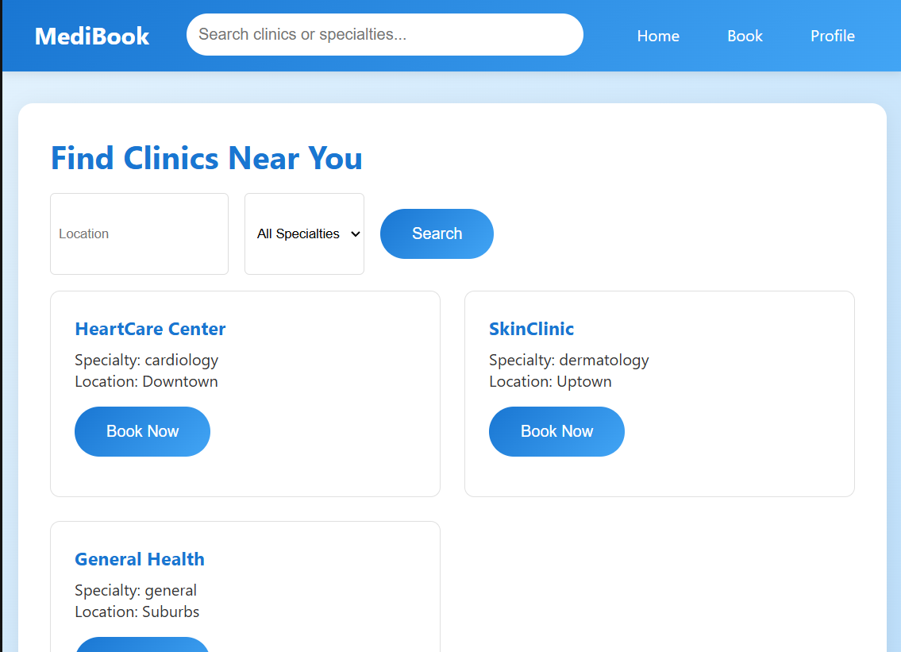

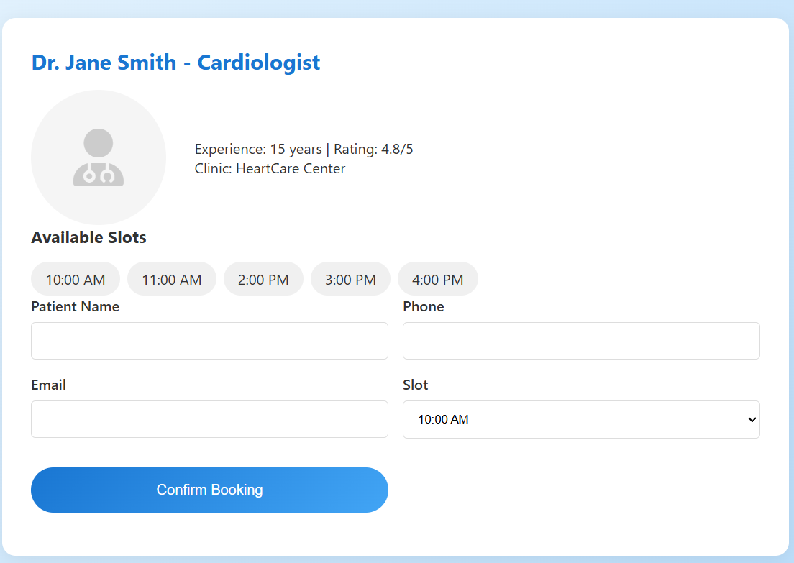

EXPERIMENT:10

CO5: Demonstrate UI design competence via a project portfolio.
AIM: Evaluate the accessibility of your college website as a usability expert. Analyze key pages using automated tools (axe, WAVE). Identify accessibility violations and suggest improvements. Submit an audit report with screenshots and proposed fixes.

PROCEDURE:
<!DOCTYPE html>
<html lang="en">
<head>
<meta charset="UTF-8">
<meta name="viewport" content="width=device-width, initial-scale=1.0">
<title>Sample College - Page Not Found</title>
<link href="https://cdnjs.cloudflare.com/ajax/libs/font-awesome/6.0.0/css/all.min.css" rel="stylesheet">
<style>
* { margin: 0; padding: 0; box-sizing: border-box; }
body { font-family: 'Segoe UI', Tahoma, Geneva, Verdana, sans-serif; line-height: 1.6; color: #333; background: #f4f4f4; }
.header { background: #2c3e50; color: white; padding: 1rem 0; position: fixed; width: 100%; top: 0; z-index: 1000; }
.nav { max-width: 1200px; margin: 0 auto; display: flex; justify-content: space-between; align-items: center; padding: 0 2rem; }
.logo { font-size: 1.5rem; font-weight: bold; }
.nav ul { display: flex; list-style: none; gap: 2rem; }
.nav a { color: white; text-decoration: none; transition: color 0.3s; }
.nav a:hover { color: #3498db; }
.main { margin-top: 80px; max-width: 1200px; margin-left: auto; margin-right: auto; padding: 2rem; text-align: center; }
.error-section { background: white; margin-bottom: 2rem; padding: 4rem 2rem; border-radius: 8px; box-shadow: 0 2px 10px rgba(0,0,0,0.1); }
h1 { color: #e74c3c; margin-bottom: 1rem; font-size: 4rem; }
h2 { color: #2c3e50; margin-bottom: 1rem; }
.error-img { width: 300px; height: 200px; background: #f0f0f0; border: 2px dashed #bdc3c7; border-radius: 8px; margin: 2rem auto; display: flex; align-items: center; justify-content: center; font-size: 1.2rem; color: #7f8c8d; }
.error-img::before { content: "Image Not Available"; font-weight: bold; } /* Simulated broken image */
.btn { background: #3498db; color: white; padding: 1rem 2rem; border: none; border-radius: 4px; cursor: pointer; transition: background 0.3s; text-decoration: none; display: inline-block; margin: 1rem; }
.btn:hover { background: #2980b9; }
footer { background: #2c3e50; color: white; text-align: center; padding: 1rem; margin-top: 2rem; }
.sr-only { position: absolute; width: 1px; height: 1px; padding: 0; margin: -1px; overflow: hidden; clip: rect(0,0,0,0); border: 0; }
@media (max-width: 768px) { .nav ul { flex-direction: column; gap: 1rem; } h1 { font-size: 3rem; } }
</style>
</head>
<body>
<a href="#main" class="sr-only">Skip to main content</a>

<header class="header">
<nav class="nav">
<div class="logo">Sample College</div>
<ul>
<li><a href="college_website.html#home">Home</a></li>
<li><a href="college_website.html#about">About</a></li>
<li><a href="college_website.html#admissions">Admissions</a></li>
<li><a href="college_website.html#contact">Contact</a></li>
</ul>
</nav>
</header>

<main id="main">
<section class="error-section">
<h1><i class="fas fa-exclamation-triangle"></i> 404</h1>
<h2>Oops! Page Not Found</h2>
<p>The page you're looking for doesn't exist or has been moved. Sorry for the inconvenience.</p>
<div class="error-img">
<!-- Simulated broken/missing image: No src, so browser shows broken icon -->
<img src="nonexistent-image.jpg" alt="Error illustration (not available)" style="width: 100%; height: 100%; object-fit: cover;">
</div>
<p>This is a demo of a missing image – in real audits, check for alt text and graceful degradation.</p>
<a href="college_website.html#home" class="btn">Go to Home</a>
<a href="college_website.html#admissions" class="btn">Admissions</a>
</section>
</main>

<footer>
<p>&copy; 2025 Sample College. All rights reserved.</p>
</footer>
</body>
</html>

OUTPUT:
