DATABASE ERD & RELATIONAL DESIGN
Pharmacy Management System
Entity Relationship Diagram | Relational Schema | v1.0 | March 2026
Database | PostgreSQL 15+ / MySQL 8.0+
Total Tables | 7 tables
Normalization | Third Normal Form (3NF) / BCNF
All Relationships | 7 FK relationships — all One-to-Many (1:N)

1. Entity Relationship Diagram (ERD)
The diagram below shows all 7 entities, their attributes, and One-to-Many relationships using Crow's Foot notation. Gold rows = Primary Key (PK), Blue rows = Foreign Key (FK). Relationship lines use || (one) and >< (many) crow's foot symbols.

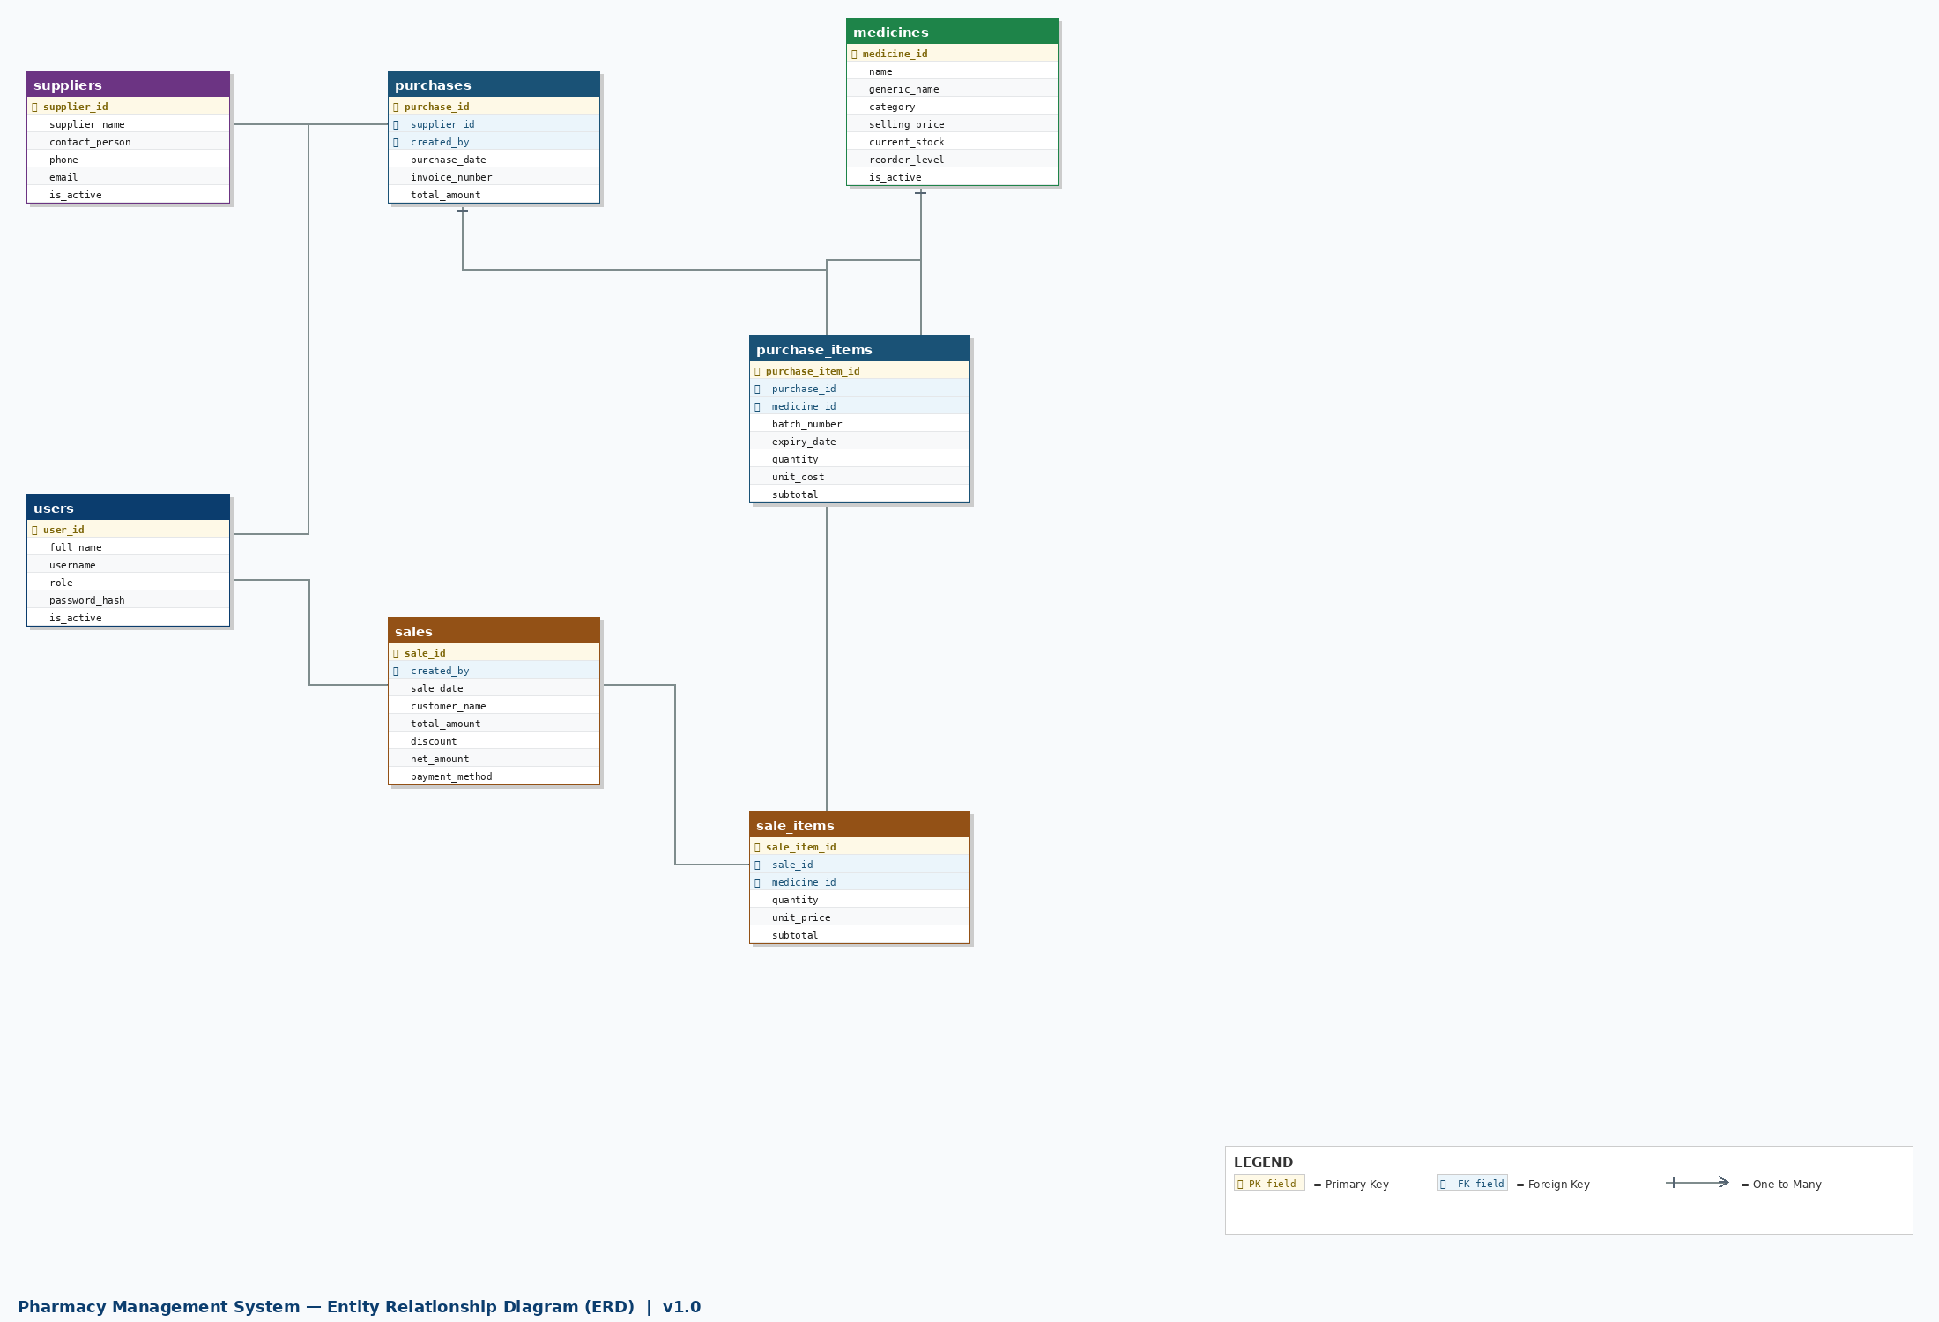

Figure 1 — Pharmacy Management System ERD (Crow's Foot Notation, 7 Tables)

2. Relationship Summary
All 7 relationships are One-to-Many (1:N). The table below captures the parent, child, foreign key column, and the referential integrity action on delete.

Parent Table |  |  | Child Table | Foreign Key | On Delete Action
suppliers | 1 | → N | purchases | supplier_id | RESTRICT (preserve history)
users | 1 | → N | purchases | created_by | SET NULL
purchases | 1 | → N | purchase_items | purchase_id | CASCADE (delete lines)
medicines | 1 | → N | purchase_items | medicine_id | RESTRICT (preserve history)
users | 1 | → N | sales | created_by | SET NULL
sales | 1 | → N | sale_items | sale_id | CASCADE (delete lines)
medicines | 1 | → N | sale_items | medicine_id | RESTRICT (preserve history)

3. Full Relational Schema
Complete column definitions for all 7 tables. Primary Keys highlighted in gold, Foreign Keys in blue.

Table: users
Column | Data Type | Key | Notes
user_id | SERIAL | PK | Auto-increment surrogate PK
full_name | VARCHAR(150) |  | NOT NULL
username | VARCHAR(80) | UQ | NOT NULL — unique login identifier
email | VARCHAR(150) |  | NULL allowed
password_hash | VARCHAR(255) |  | NOT NULL — bcrypt hash, min factor 12
role | VARCHAR(50) |  | NOT NULL — admin / pharmacist / viewer
is_active | BOOLEAN |  | DEFAULT TRUE — soft-disable accounts
last_login | TIMESTAMP |  | NULL — updated on each login
created_at | TIMESTAMP |  | DEFAULT NOW()
updated_at | TIMESTAMP |  | DEFAULT NOW()

Table: medicines
Column | Data Type | Key | Notes
medicine_id | SERIAL | PK | Auto-increment surrogate PK
name | VARCHAR(200) |  | NOT NULL — indexed for search
generic_name | VARCHAR(200) |  | NULL allowed
category | VARCHAR(100) |  | NULL — e.g. Antibiotic, Analgesic
unit | VARCHAR(50) |  | NOT NULL — tablet / syrup / injection
manufacturer | VARCHAR(150) |  | NULL allowed
selling_price | NUMERIC(10,2) |  | NOT NULL CHECK >= 0
reorder_level | INTEGER |  | NOT NULL DEFAULT 10 — triggers low-stock alert
current_stock | INTEGER |  | NOT NULL DEFAULT 0 CHECK >= 0 — INDEXED
is_active | BOOLEAN |  | DEFAULT TRUE — soft delete
created_at | TIMESTAMP |  | DEFAULT NOW()
updated_at | TIMESTAMP |  | DEFAULT NOW()

Table: suppliers
Column | Data Type | Key | Notes
supplier_id | SERIAL | PK | Auto-increment surrogate PK
supplier_name | VARCHAR(200) |  | NOT NULL — indexed
contact_person | VARCHAR(150) |  | NULL allowed
phone | VARCHAR(30) |  | NULL allowed
email | VARCHAR(150) |  | NULL allowed
address | TEXT |  | NULL allowed
city | VARCHAR(100) |  | NULL allowed
is_active | BOOLEAN |  | DEFAULT TRUE — soft delete
created_at | TIMESTAMP |  | DEFAULT NOW()
updated_at | TIMESTAMP |  | DEFAULT NOW()

Table: purchases
Column | Data Type | Key | Notes
purchase_id | SERIAL | PK | Auto-increment surrogate PK
supplier_id | INTEGER | FK | FK → suppliers.supplier_id — NOT NULL, RESTRICT
created_by | INTEGER | FK | FK → users.user_id — NULL allowed, SET NULL
purchase_date | DATE |  | NOT NULL DEFAULT CURRENT_DATE — INDEXED
invoice_number | VARCHAR(100) |  | NULL — supplier invoice reference
total_amount | NUMERIC(12,2) |  | NOT NULL DEFAULT 0.00 CHECK >= 0
notes | TEXT |  | NULL allowed
created_at | TIMESTAMP |  | DEFAULT NOW()

Table: purchase_items
Column | Data Type | Key | Notes
purchase_item_id | SERIAL | PK | Auto-increment surrogate PK
purchase_id | INTEGER | FK | FK → purchases.purchase_id — CASCADE
medicine_id | INTEGER | FK | FK → medicines.medicine_id — RESTRICT
batch_number | VARCHAR(100) |  | NOT NULL — supplier batch/lot number
expiry_date | DATE |  | NOT NULL — INDEXED for expiry alert queries
quantity | INTEGER |  | NOT NULL CHECK > 0
unit_cost | NUMERIC(10,2) |  | NOT NULL CHECK >= 0
subtotal | NUMERIC(12,2) |  | NOT NULL — quantity × unit_cost
created_at | TIMESTAMP |  | DEFAULT NOW()

Table: sales
Column | Data Type | Key | Notes
sale_id | SERIAL | PK | Auto-increment surrogate PK
created_by | INTEGER | FK | FK → users.user_id — SET NULL on user delete
sale_date | DATE |  | NOT NULL DEFAULT CURRENT_DATE — INDEXED
customer_name | VARCHAR(150) |  | NULL — optional customer name
customer_phone | VARCHAR(30) |  | NULL — optional customer phone
total_amount | NUMERIC(12,2) |  | NOT NULL DEFAULT 0.00
discount | NUMERIC(10,2) |  | NOT NULL DEFAULT 0.00 CHECK >= 0
net_amount | NUMERIC(12,2) |  | NOT NULL — total_amount minus discount
payment_method | VARCHAR(50) |  | NOT NULL DEFAULT 'cash'
notes | TEXT |  | NULL allowed
created_at | TIMESTAMP |  | DEFAULT NOW()

Table: sale_items
Column | Data Type | Key | Notes
sale_item_id | SERIAL | PK | Auto-increment surrogate PK
sale_id | INTEGER | FK | FK → sales.sale_id — CASCADE
medicine_id | INTEGER | FK | FK → medicines.medicine_id — RESTRICT
quantity | INTEGER |  | NOT NULL CHECK > 0
unit_price | NUMERIC(10,2) |  | NOT NULL — captured at time of sale
subtotal | NUMERIC(12,2) |  | NOT NULL — quantity × unit_price
created_at | TIMESTAMP |  | DEFAULT NOW()

4. Referential Integrity & Business Rules

4.1 Delete Behaviour
- CASCADE: Deleting a purchase also deletes all its purchase_items. Deleting a sale also deletes all its sale_items.
- RESTRICT: Cannot delete a supplier with existing purchases or a medicine with any recorded purchase/sale lines — historical data is protected.
- SET NULL: Deleting a user preserves all their sale and purchase records, with created_by set to NULL.

4.2 Check Constraints
- medicines.current_stock >= 0 — stock cannot be negative.
- medicines.selling_price >= 0 — prices cannot be negative.
- purchase_items.quantity > 0 and sale_items.quantity > 0 — line items must have at least 1 unit.
- purchase_items.expiry_date >= parent purchase date — no already-expired stock on arrival.
- sales.discount >= 0 AND <= sales.total_amount — discount cannot exceed total.

4.3 Transaction-Enforced Rules
- On purchase save: medicines.current_stock += sum of all purchase_item quantities (atomic).
- On sale confirm: Pre-check stock >= requested qty AND expiry valid. Then medicines.current_stock -= sum of sale_item quantities (atomic).
- Any failure triggers a full ROLLBACK — no partial records are ever persisted.

5. Normalization Compliance

Form | Requirement | Status in PMS Schema
1NF | Atomic values; no repeating groups | All line items separated into dedicated tables (purchase_items, sale_items)
2NF | No partial dependency on composite PK | All PKs are single-column surrogates — no composite PKs
3NF | No transitive dependency | All non-key columns depend only on the PK of their table
BCNF | Every determinant is a candidate key | No hidden functional dependencies — schema is fully BCNF compliant

— End of ERD & Relational Design Document —

