Market Growth Queries
Return on Ad Spending (ROAS):
Select
month_name,
marketing_spend,
monthly_revenue,
Round(monthly_revenue / marketing_spend,2) as ROAS
from Market_Growth
order by ROAS desc
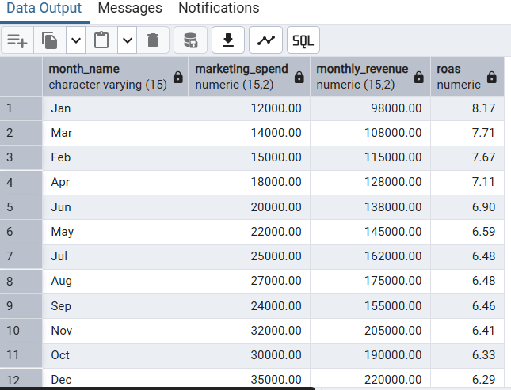
Revenue Prediction and Range
select
month_name,
(marketing_spend* 5.2571 + 33212) as predicted_revenue,
(marketing_spend* 5.2571 + 33212) - (1.645*2748) as Lower_bound,
(marketing_spend* 5.2571 + 33212) + (1.645*2748) as Upper_bound
From Market_Growth
