**Thyroid Disease Classification**

A Multiclass Classification Approach

**Wireframe Documentation**

1. **Home Page:** The user will land on this home page. KPI Score Cards includes: F1-weighted, RoC_AUC_OVR_weighted, Balanced Accuracy score and log loss. These score cards display live scores for the implemented model.

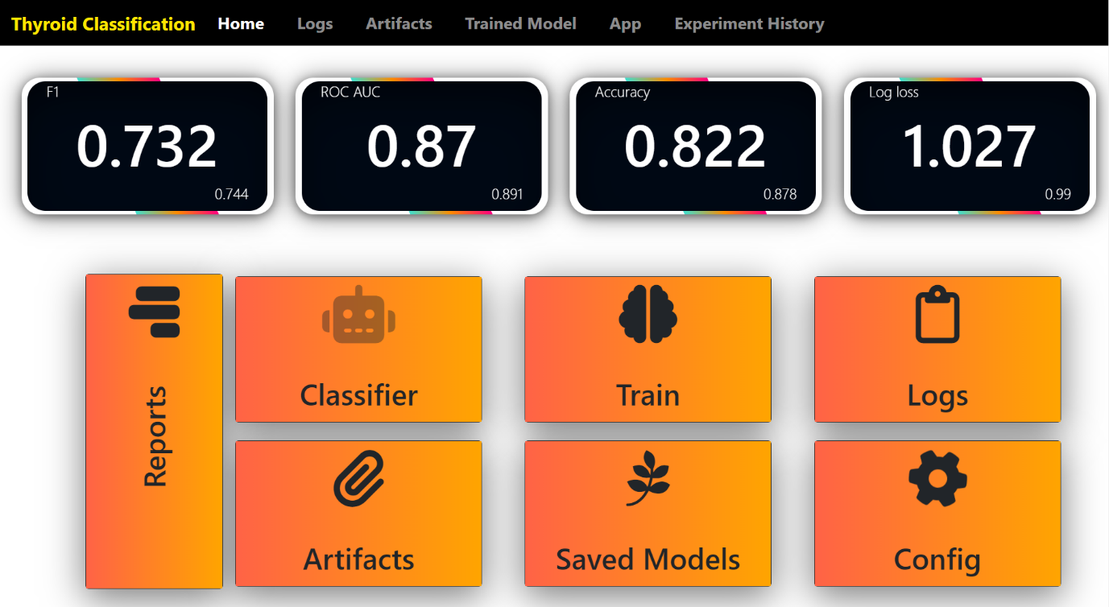

Train

Test Log loss

Train

Test Balanced Accuracy

Test ROC-AUC-Ovr- Weighted

Train

Train F1

Test F1 Weighted



1. **Prediction Interface:**

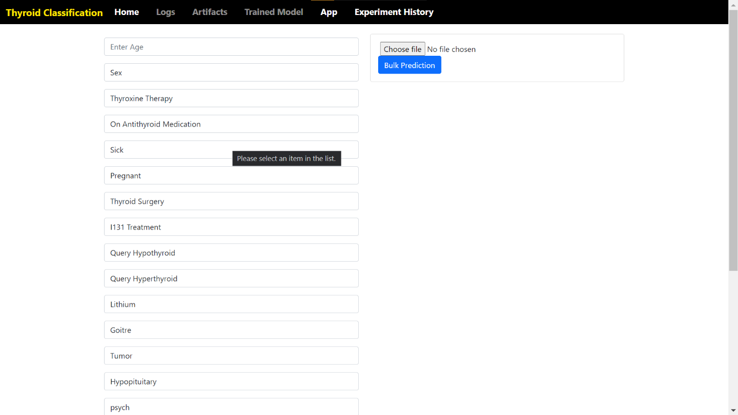

User Input Record

PREDICTION