Logistics Delivery Performance Analysis
and Late-Delivery Prediction
Week 3 Task: Advanced Data Analysis and Visualization
Actual DataCo Supply Chain Dataset

1. Dataset and EDA Objective
The Week 3 analysis uses the actual uploaded DataCoSupplyChainDataset.csv. The file contains 180,519 records and 53 original columns before the three derived analytical fields were added. The EDA focuses on delivery performance, shipping behavior, sales contribution, market differences, distributions, and relationships among selected numeric variables.
The analysis follows the internship requirement to calculate central tendencies, examine distributions and correlations, create multiple visualizations, and interpret the results for logistics decision-making.

2. Descriptive Statistics
Variable | Mean | Std. Dev. | Median
Sales | 203.77 | 132.27 | 199.92
Order Item Total | 183.11 | 120.04 | 163.99
Order Item Quantity | 2.13 | 1.45 | 1.00
Days for shipping (real) | 3.50 | 1.62 | 3.00
Days for shipment (scheduled) | 2.93 | 1.37 | 4.00
Benefit per order | 21.97 | 104.43 | 31.52
delay_days | 0.57 | 1.49 | 1.00

3. Delivery Performance
The observed late-delivery risk rate is 54.83%. Average actual shipping duration is 3.50 days compared with 2.93 scheduled days. The mean difference between actual and scheduled shipping duration is 0.57 days.
These metrics provide the baseline for evaluating logistics performance. A positive average delay indicates that actual shipping duration is, on average, above the scheduled duration.

4. Visualization: Shipping Mode
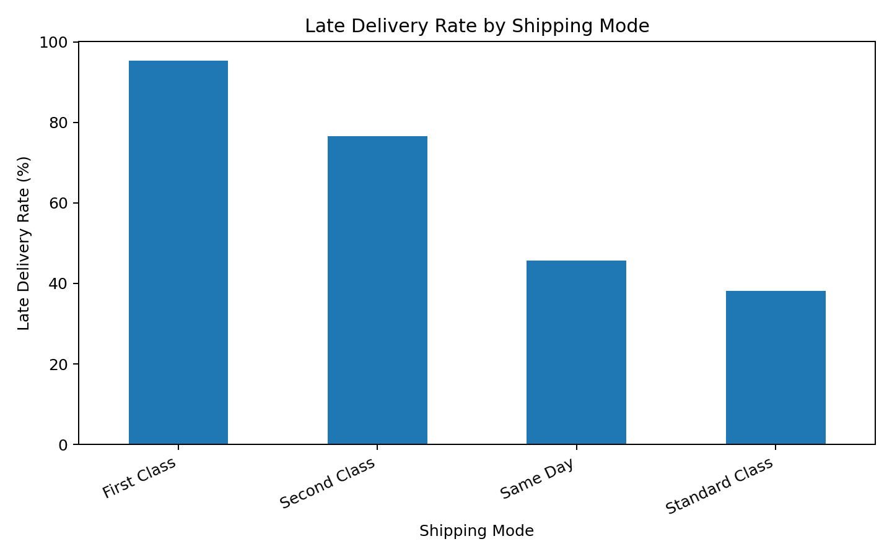
Interpretation: Late-delivery rates differ across shipping modes. This comparison is useful because shipping mode is an operational decision variable. Management can use the result to investigate whether service-level design, fulfillment priority, or mode-specific capacity is associated with higher delay risk.

5. Visualization: Shipping-Time Distribution
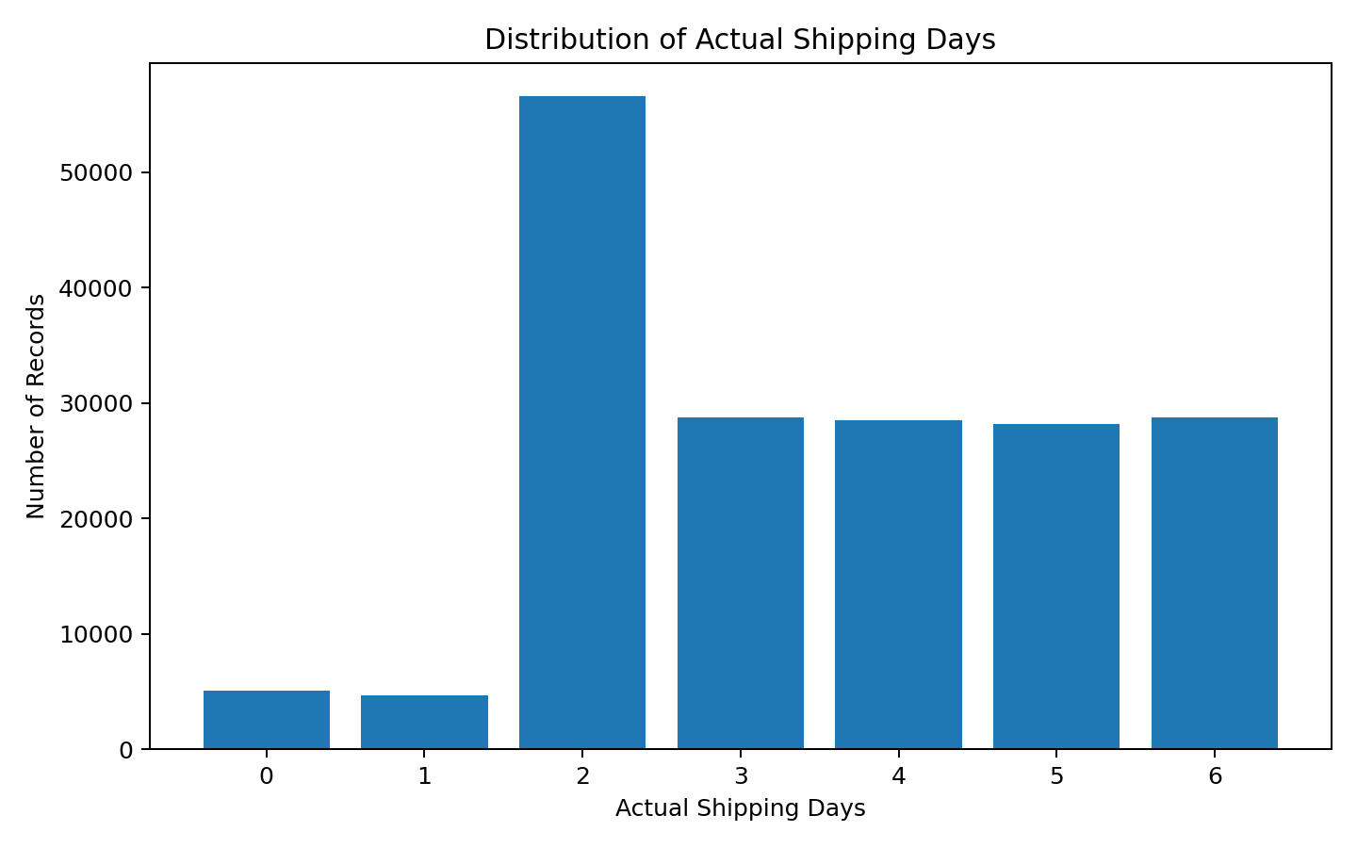
Interpretation: Actual shipping time is concentrated in a small number of day values rather than being continuously spread across a wide range. This makes the variable easy to segment operationally and supports comparisons between scheduled and actual service times.

6. Visualization: Market Comparison
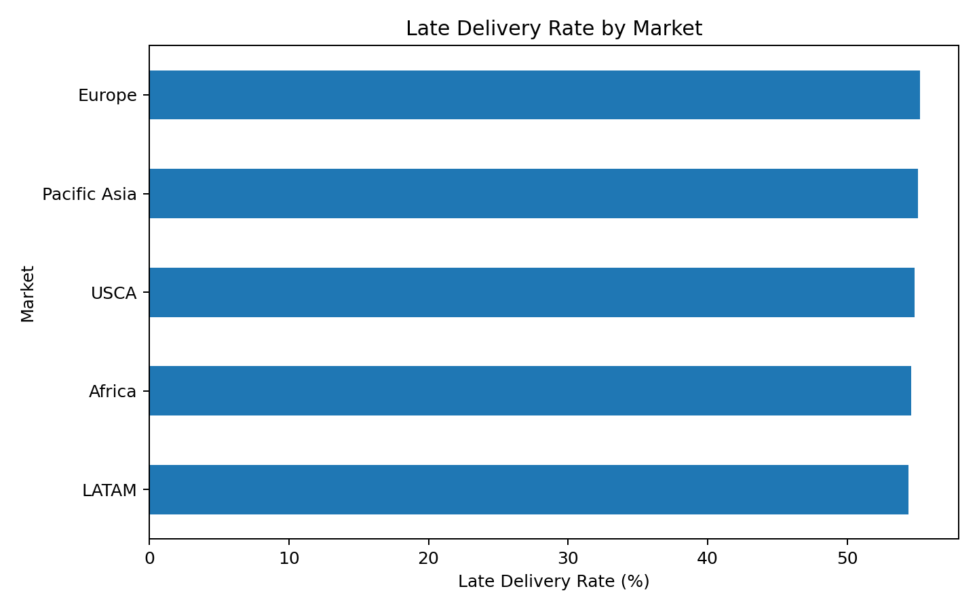
Interpretation: Delivery performance is not uniform across markets. The variation suggests that geography, network configuration, demand patterns, fulfillment capacity, or carrier practices may contribute to differences. Market-level monitoring can therefore help prioritize operational investigation.

7. Visualization: Product Category Sales
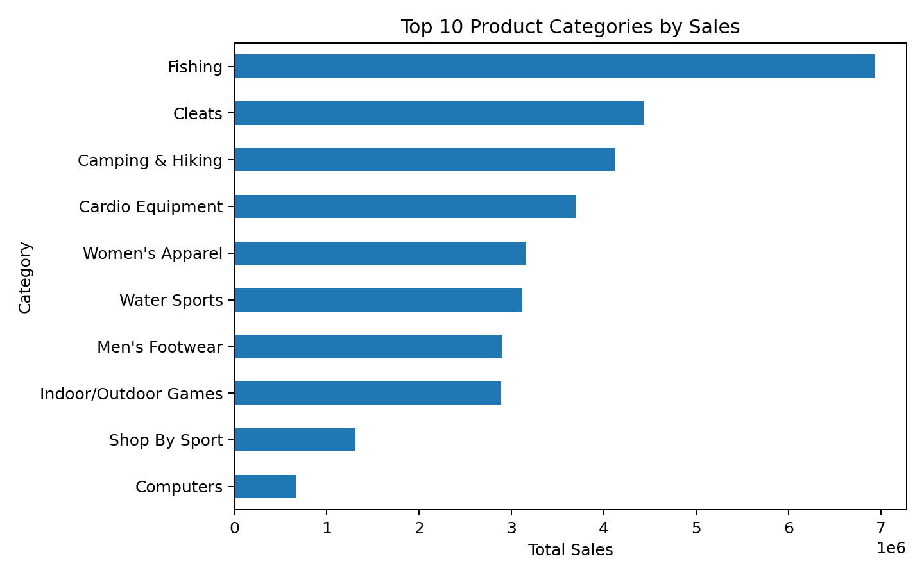
Interpretation: Sales contribution is concentrated among leading product categories. This helps management identify where commercial volume is concentrated and where fulfillment performance may have the largest customer and revenue impact.

8. Correlation Analysis
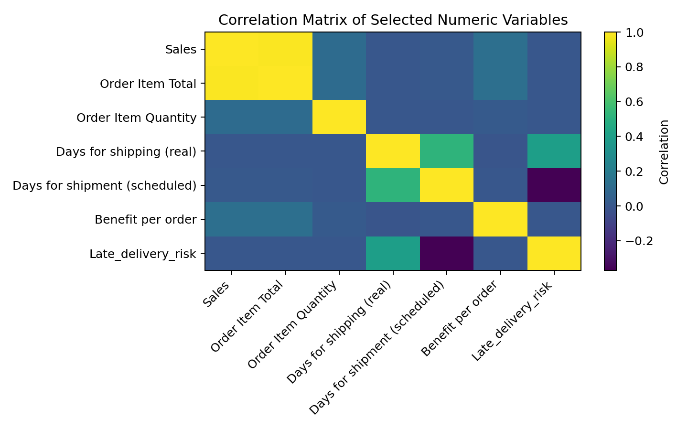
Interpretation: Correlation measures linear association and should not be interpreted as causation. The matrix is useful for screening relationships among sales, order value, quantity, shipping duration, scheduled duration, benefit per order, and the late-delivery indicator. Variables showing strong association should be investigated further with group comparisons and, later, controlled predictive modeling.

9. Key Analytical Insights
- Overall late-delivery risk is 54.83%, establishing a clear baseline for service-performance monitoring.
- Actual shipping duration averages 3.50 days versus 2.93 scheduled days.
- The mean actual-minus-scheduled difference is 0.57 days, making schedule adherence an important operational metric.
- Late-delivery rates vary by shipping mode and market, indicating that aggregated KPIs can hide operational differences between segments.
- Sales are concentrated across a smaller group of leading product categories, so fulfillment issues in high-volume categories may have greater business impact.
- Correlation analysis provides screening evidence but does not establish causality; further modeling and controlled comparisons are required.

10. Python Code Used
import pandas as pd
import matplotlib.pyplot as plt
df = pd.read_csv(
"data/raw/DataCoSupplyChainDataset.csv",
encoding="latin1"
)
df["order_date"] = pd.to_datetime(
df["order date (DateOrders)"], errors="coerce"
)
df["delay_days"] = (
df["Days for shipping (real)"]
- df["Days for shipment (scheduled)"]
)
df["is_late"] = df["Late_delivery_risk"].astype(int)
# Descriptive statistics
print(df.describe())
# Late-delivery rate by shipping mode
late_by_mode = (
df.groupby("Shipping Mode")["is_late"]
.mean()
.mul(100)
.sort_values(ascending=False)
)
late_by_mode.plot(kind="bar")
plt.ylabel("Late Delivery Rate (%)")
plt.title("Late Delivery Rate by Shipping Mode")
plt.tight_layout()
plt.show()
# Correlations
print(df[
["Sales", "Order Item Total",
"Order Item Quantity",
"Days for shipping (real)",
"Days for shipment (scheduled)",
"Benefit per order",
"Late_delivery_risk"]
].corr())

11. Conclusion
The Week 3 EDA demonstrates how the DataCo logistics dataset can be transformed into operational insights through descriptive statistics, segmentation, visualization, and correlation analysis. Delivery risk varies across operational segments, while shipping duration and schedule adherence provide direct measures of fulfillment performance. The findings provide a foundation for Week 4 predictive modeling, where leakage-controlled features can be used to estimate late-delivery risk and translate model findings into optimization recommendations.

12. Submission Description
This report presents the exploratory data analysis and visualization stage of the logistics delivery-performance project using the actual DataCo SMART SUPPLY CHAIN dataset. The analysis examines delivery performance, shipping duration, market differences, product-category sales, and relationships among selected numerical variables. Descriptive statistics were calculated to understand central tendency and variation, while derived features were created to compare actual shipping duration with scheduled duration and identify late-delivery observations. Multiple visualizations were produced, including late-delivery rate by shipping mode, the distribution of actual shipping days, late-delivery rate by market, top product categories by sales, and a correlation matrix. Each visualization is accompanied by a logistics-focused interpretation explaining how the result can support operational monitoring and decision-making. The analysis also highlights an important analytical limitation: correlation indicates association rather than causation, so apparent relationships must be validated with further analysis and predictive modeling. The results establish a baseline for the next project stage, where a leakage-controlled predictive model will be developed to estimate late-delivery risk and support optimization recommendations.

