Logistics Delivery Performance Analysis
and Late-Delivery Prediction
Week 4 Task: Predictive Modeling and Optimization
Actual DataCo Supply Chain Dataset

1. Prediction Problem
The final project stage treats Late_delivery_risk as a binary classification target. The objective is to estimate whether an order is at risk of late delivery using information intended to be available before the delivery outcome is known. This supports proactive exception management and prioritization.

2. Leakage-Controlled Feature Design
Actual shipping duration and delivery-status fields were excluded because they describe realized outcomes and would leak information into a pre-delivery prediction. Direct personal identifiers and unnecessary high-cardinality fields were also excluded. The model uses scheduled shipping duration, shipping mode, customer segment, market/region, order-item, product, sales, discount, department/category, and other candidate pre-outcome attributes.

3. Modeling Method
An 80/20 stratified train-test split was used with random_state=42. Numerical features were median-imputed and standardized. Categorical features were imputed with their most frequent value and one-hot encoded with rare categories grouped through min_frequency=20. A Logistic Regression classifier with class_weight='balanced' was selected as an efficient and interpretable baseline.

4. Actual Test Results
Metric | Test Result
Accuracy | 0.6968
Precision | 0.8501
Recall | 0.5428
F1 | 0.6625
ROC-AUC | 0.7426
Training and preprocessing completed in approximately 6.7 seconds. All reported metrics above were calculated on the held-out test set.

5. Confusion Matrix
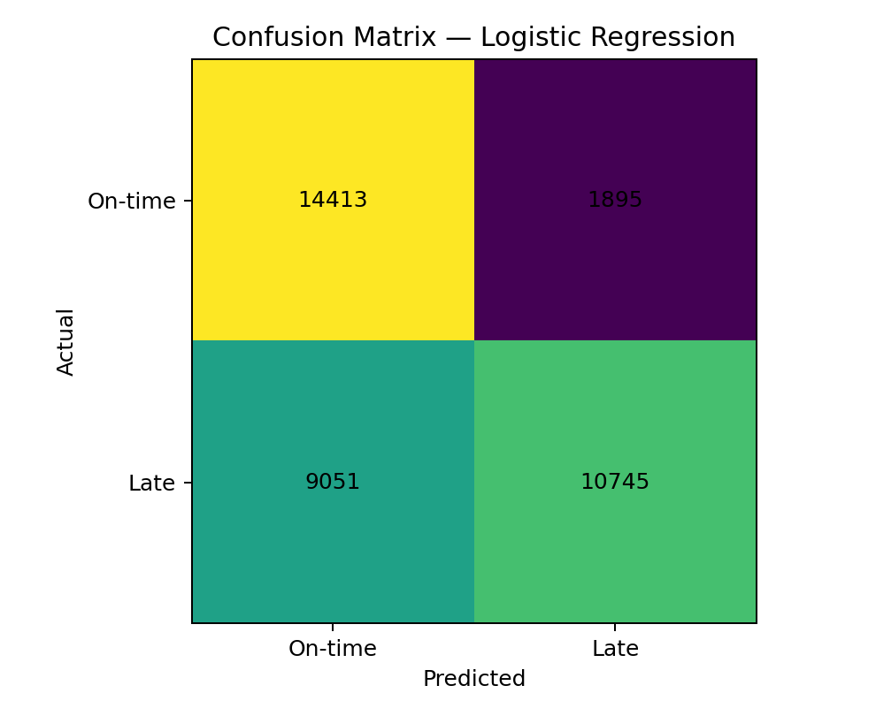
The confusion matrix shows correct and incorrect classifications for the two classes. Recall is important operationally because failing to identify a genuinely late-risk order may remove an opportunity for preventive intervention.

6. Model Interpretation
Logistic Regression coefficients indicate the direction and relative strength of association after preprocessing. Positive coefficients increase the model's estimated log-odds of the positive class, while negative coefficients decrease it. These are model associations, not causal effects.
Strong positive coefficient signals:
- Shipping Mode_First Class: 1.9758
- Shipping Mode_Second Class: 0.4021
- Customer State_AR: 0.3791
- Customer State_ND: 0.3091
- Customer State_SC: 0.2195
- Customer State_NM: 0.2088
- Type_PAYMENT: 0.1740
- Type_DEBIT: 0.1487
Strong negative coefficient signals:
- Shipping Mode_Same Day: -1.5181
- Shipping Mode_Standard Class: -0.7316
- Customer State_MT: -0.5371
- Customer State_infrequent_sklearn: -0.5038
- Days for shipment (scheduled): -0.3805
- Customer State_AL: -0.3149
- Type_TRANSFER: -0.3126
- Order Region_Canada: -0.3074

7. Optimization Strategies
- Risk-based exception queue: prioritize orders with high predicted late-delivery probability for operational review.
- Capacity allocation: use risk scores to focus limited fulfillment and transportation resources on high-risk shipments.
- Shipping-mode review: investigate whether particular service modes consistently show higher risk and whether process or capacity changes can improve reliability.
- Market/region intervention: use segment-level risk patterns to identify locations requiring carrier, inventory, or fulfillment review.
- Threshold optimization: select an intervention threshold according to the business cost of false positives versus missed late deliveries.
- Continuous monitoring: track recall, precision, late-delivery rate, and intervention outcomes after deployment.

8. Python Code
from sklearn.model_selection import train_test_split
from sklearn.compose import ColumnTransformer
from sklearn.pipeline import Pipeline
from sklearn.preprocessing import OneHotEncoder, StandardScaler
from sklearn.impute import SimpleImputer
from sklearn.linear_model import LogisticRegression
from sklearn.metrics import classification_report, roc_auc_score
X = df[feature_cols]
y = df["Late_delivery_risk"].astype(int)
X_train, X_test, y_train, y_test = train_test_split(
X, y, test_size=0.20, random_state=42, stratify=y
)
preprocessor = ColumnTransformer([
("num", Pipeline([
("imputer", SimpleImputer(strategy="median")),
("scale", StandardScaler())
]), numeric_features),
("cat", Pipeline([
("imputer", SimpleImputer(strategy="most_frequent")),
("onehot", OneHotEncoder(handle_unknown="ignore",
min_frequency=20))
]), categorical_features)
])
model = Pipeline([
("pre", preprocessor),
("classifier", LogisticRegression(
max_iter=500, solver="liblinear",
class_weight="balanced"
))
])
model.fit(X_train, y_train)
pred = model.predict(X_test)
prob = model.predict_proba(X_test)[:, 1]
print(classification_report(y_test, pred))
print("ROC-AUC:", roc_auc_score(y_test, prob))

9. Validation and Limitations
The held-out test set provides an unbiased final check relative to the training split, but a production system should use time-aware validation because logistics data are temporal. The current model is a baseline rather than a production deployment. Threshold tuning, temporal cross-validation, calibration, stronger nonlinear models, and post-deployment monitoring should be evaluated in future iterations.

10. Conclusion
The actual DataCo dataset was used to train and evaluate a leakage-controlled late-delivery classifier. The Logistic Regression baseline achieved an F1 score of 0.6625 and ROC-AUC of 0.7426 on the held-out test set. The resulting framework can support proactive logistics exception management, while future improvements should focus on time-aware validation, threshold optimization, richer feature engineering, and business-impact measurement.

11. Submission Description
This report presents the predictive modeling and optimization stage of the logistics delivery-performance project using the actual DataCo supply-chain dataset. The prediction task was defined as binary classification of late-delivery risk. To make the experiment operationally meaningful, direct delivery-outcome information such as actual shipping duration and delivery status was excluded from the predictive feature set, preventing future information from being used to predict the past. An 80/20 stratified train-test split was applied, and preprocessing was implemented inside a reproducible machine-learning pipeline. Numerical features were median-imputed and standardized, while categorical variables were imputed and one-hot encoded. A class-balanced Logistic Regression model was selected as an efficient and interpretable baseline. The model was evaluated on the held-out test data using accuracy, precision, recall, F1 score, and ROC-AUC. A confusion matrix was also generated to show the classification outcomes. The report explains how model signals can be interpreted and translates the predictive output into practical logistics strategies, including risk-based exception queues, capacity allocation, shipping-mode review, regional intervention, threshold optimization, and continuous monitoring. The results provide a complete connection between the data preparation and exploratory analysis performed in earlier weeks and a practical predictive decision-support framework for logistics operations.

