**Mini Project Report on**



**Cartoonify Image with Machine Learning**



**Submitted in partial fulfillment of the requirement for the award of the degree of**

**BACHELOR OF TECHNOLOGY**

**IN**

**COMPUTER SCIENCE & ENGINEERING**

**Submitted by:**

**Mohd Junaid Ali**

**University Roll No. 2016854**

***Under the Mentorship of***

**Mr. Vikas Tripathi**

**Associate Professor**



**Department of Computer Science and Engineering**

**Graphic Era (Deemed to be University)**

**Dehradun, Uttarakhand**

**January 2023**



I hereby certify that the work which is being presented in the project report entitled **“Cartoonify Image with Machine Learning”** in partial fulfillment of the requirements for the award of the Degree of Bachelor of Technology in Computer Science and Engineeringof the Graphic Era (Deemed to be University), Dehradun shall be carried out by the under the mentorship of **Mr. Vikas Tripathi, Associate Professor**, Department of Computer Science and Engineering, Graphic Era (Deemed to be University), Dehradun.

Name:Mohd Junaid ALi

University Roll no: 2016854

**Table of Contents**

|  |  |  |
| --- | --- | --- |
| **Chapter No.** | **Description** | **Page No.** |
| Chapter 1 | Introduction | 4-5 |
| Chapter 2 | Literature Survey | 6-8 |
| Chapter 3 | Methodology | 9-11 |
| Chapter 4 | Result and Discussion | 12 |
| Chapter 5 | Conclusion and Future Work | 13 |
|  | References | 14 |

**Chapter 1**

**Introduction**

The process of converting high-quality images from real life into practical cartoon scenes is called Cartoonifying. Cartoonifying is a classic art in itself, but developments in machine learning cover almost all areas. Earlier models that proposed the same approach used black-box models, the first model achieves great accuracy but reduces the quality of the stylization and causes a few bad cases. Just as any cartoon workflow considers different features, these variations have a relevant effect on black box models. To overcome the disadvantages of the previous model, more emphasis was placed on human painting behavior and cartoon images of various styles, and the white box model was developed.

The model decomposes the images into three different cartoon representations, which further advises the optimization of the network to generate the cartoon images.

* **Surface Representation:** Helps to extract smooth surfaces of an image that contains a weighted low-frequency component where color composition and surface texture are preserved along with edges, textures and details.
* **Structure Representation:** It helps to derive global structural information and sparse color blocks, once done, we implement adaptive coloring algorithms such as the Felzenswalb algorithm to develop a structural representation that can help us generate sparse visual effects for the celluloid style cartoon process.
* **Textured Display:** Helps us preserve painted details and edges. The 3D image is converted to a single-channel intensity map, which helps preserve pixel intensity with a trade-off for color and brightness, following the approach of a hand-drawn artist who first draws a line sketch with outlines and then applies colors to it.

**Chapter 2**

**Literature Survey**

Library Cartoons: Liter oons: A Literature Review of Libr view of a library-themed car

Cartoons, Caricatures, Caricatures, and y-themed comics Julia B. Chambers is an MLIS student at San Jose State University's School of Library and Information Science.

Understand contrasting views of past events, antiquarian books, political theory

researchers and sociologists have examined political and publishing children's shows with themes from decisions to financial access to human rights. However, he has a rare examination was devoted to children's programs with a library theme. The creator of this document is peer-explored writing relating to matters of library children's exhibitions, including verifiable foundations, examination ongoing topics and disputes about advancing children's programs with the theme of libraries, exaggerations, and jokes. The creator finds a huge hole in the writing of this topic and assumes this data practitioners would benefit from an extensive examination of the content of children's library-themed shows

improve understanding of the nature of libraries on significant occasions, research

public view of the libraries and after some time distinguish the patterns.

Researchers examined and analyzed the impact and estimation of publishing children's programs in the in the United States since the early twentieth century, not long after children's shows turned around into a standard feature in East Coast papers. In a 1933 article American Craft and scholar Elizabeth Luther Cary argued that American hyperbole gave

understanding into history, revealing perspectives or optional mentalities that document a

the history books neglected to record in each case. Twenty years later, Stephen Becker

(1959), a comic creator in America, agreed that early instances of exaggeration served

to compensate for editorial shortcomings, in some cases it is the solitary satisfactory source

editorial too indecent or touching to appear in composed publications. Richard Felton

Children's programs in Outcault's Yellow Kid, distributed in 1896 in the New York World, are one model: “[Yellow Kid] brought something new and disturbing to American households: ghetto and ghetto kids and the usual wildness, slang and arrogance

emergency' (Becker, 1959, p. 13).

Current publications of children's programs are still being added as an adequate arrangement

dissemination of contested perspectives (Kuipers, 2011), often with the aim of influencing

public assessment. In an investigation of political children's programs with an official political decision Edwards and Ware (2005) analyzed the influence of children's program publications on open rating and assumed that the negative personification of voters contributes to public indifference towards the discretionary cycle. A comparative determination of the intensity of comic craft for a general impact assessment were taken into account in Josh Greenberg's (2002) investigation, whose research recommended that children's programs help individuals interpret life opportunities. Conversely, various researchers have examined children's political programs as a reflection

general assessment instead of thought provocateur. Anyway, the writing here represents

opposite ends. Edward Holley and Norman Stevens (1969), for example, argue that the child is shows are an accurate representation of public opinion, while others emphasize the evidence that shows it children's shows don't really reflect the big picture or fill in as appropriate images of the notables opportunities (Gilmartin & Brunn, 1998; Meyer, Seidler, Curry, & Aveni, 1980). Concentrated as artistic expressions (Robb, 2009), Zeitgeist ephemera (Holley and Stevens, 1969), fundamental resources (Thomas, 2004), and even problem solvers (Edwards and Product, 2005; see further Marin-Arrese, 2008; Neuberger and Kremar, 2008), the article children's shows were the subject research in the assortment of specialist trains. However, the survey was not enough dedicated to the theme of children's programs or cartoons containing library themes. Indeed, the creator

this written survey revealed only one investigation directed by Alireza Isfandyari- Moghaddam and Vahideh Kashi-Nahanji (2010), devoted to the fabric exploration of themes in the small selection of children's shows from the library and this review forgot to describe its determination cycle or further on the other hand, the strategy used to explore the content. However, children's shows with a library theme exist in wealth and return to the late 19th century. Children's programs in the library do not only offer a wide range criticism of administrators, however, library funding and data digitization also provide exceptional

an understanding of the historical background of US libraries, for example, is indispensable

reading material used in introductory librarianship classes, Library and Data Basics

Science by Richard E. Rubin (2010) presents a laudable view of Andrew

Carnegie pledges $56 million to develop thousands of libraries across

America (p. 60). While Rubin notes that several people have examined Carnegie's gifts as a

type of social control, there is no warning of public shock at the rate of taxation they have implemented.

There is no mention of any of them holding the view that the development of these libraries was simpleabout Carnegie's personality as opposed to about the public giant. However, various articles for children for example, he shows two models below them, mocking Carnegie's generosity, disparaging his self image and issue a critique of the rate of taxation finally brought to the public by his foundation libraries to urban communities across the country. Despite the library's rich history children's shows, many exam questions about children's shows containing library items he was never inclined to write. For example, the library that was probably the most accurate children's shows in this nation? What were the normal topics? Have items changed all the time in the long run – especially as the internet has turned into a vast investigative device? Most significantly, does the investigation of children's programs matter in the library?

This survey of academic writing on the topic of children's libraries distinguishes past regions

studies, presents some current patterns and claims to be a far-reaching exploration of content

Children's programs with a library theme would contribute to the field of librarianship much like researchers do different orders have used publication children's shows to improve their understanding of remarkable opportunities, examine public discrimination and recognize patterns.

**Chapter 3**

**Methodology**

Step 1: Import the required modules

We will import the following modules:

* CV2: Imported to use OpenCV for image processing
* easygui: Imported to open the file. It allows us to select any file from our system.
* Numpy: Images are stored and processed as numbers. These are taken as arrays. We use NumPy to solve field.
* Imageio: Used to read the file that is selected by the filebox using the path.
* Matplotlib: This library is used for visualization and plotting. So it is imported to create an image graph.
* OS: To interact with the operating system. Here to read the path and save images for this path.

Step 2: Ask for file or open image file

In this step, we will asked for a image to process so that a window will open and then we have to choose the image which we wanted to cartoonifying.

Step 3:

Start by transforming the image:

To convert an image into a cartoon, several transformations are performed. First, the image is converted to a grayscale image. Yes, similar to the old pictures. Then the grayscale image is smoothed and we try to extract the edges in picture. Finally, we create a colored image and mask it with edges. This will create a beautiful cartoon image with edges and lightened color of the original image.



Step 4: Transform the image to grayscale



Step 5: Smooth the grayscale image and simply apply the blur effect.



Step 6: Load image edges

Here we will try to get the edges and highlight them.

Step 7: Preparing the mask image



Step 8: Create a cartoon effect

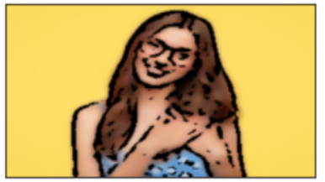

Step 9: Rendering all transitions together

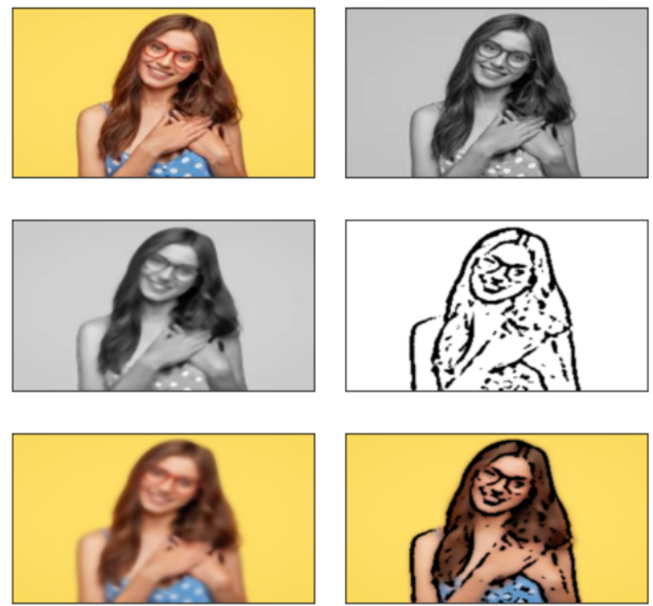

**Chapter 4**

**Result and Discussion**

Basically, we got our image cartoonified by using our code and got our output image in form of cartoon.We can also see the various stages that combinely makes up the cartoonified images which are gray,smoothgray,edges and blurred images.

**INPUT:-**  
  
**OUTPUT:-**

**Chapter 5**

**Conclusion and Future Work**

This report presents an efficient method for extracted cartoon objects. Test results show that the developed method could well extract meaningful objects in different characters and backgrounds. The extracted cartoon objects expect to be effectively used in cartoon image retrieval because they can well represent the colour characteristics of cartoon objects. Here we came to know about the methods and various techniques to get our data into cartoon images.

Overall, we basically learned to:

* How to create an application to convert an image into its cartoon form.
* How to use Tkinter to provide a GUI.
* How to use easygui.
* Working on the application.

**Future work would be:**

Currently the system is facing issues with face cartoonization. This can be improved by providing more facials data with different perspective to the model. The resolution of the output also need to be increased.

**References**

* Yi Yang, Yueting Zhuang, Dacheng Tao, Dong Xu, Jun Yu, and Jiebo Luo;
* "Recognizing Cartoon Image Gestures for Retrieval and Interactive Cartoon Clip
* Synthesis", IEEE Transactions On Circuits And Systems For Video Technology, Vol. 20,
* No. 12, Pp. 1745-1756, December 2010
* Zhang Liang,Yueting Zhuang , Yi Yang and Jun Xiao; "Retrieval-Based Cartoon Gesture
* Recognition and Applications Via Semi-Supervised Heterogeneous Classifiers Learning
* ", Pattern Recognition, 2013
* Sungyoung Kim, Soyoun Park, and Minhwan Kim; "Central Object Extraction for
* Object-Based Image Retrieval", E. M. Bakker et al. (Eds.): CIVR 2003, LNCS 2728, Pp.
* 39-49, 2003.
* Yi Yang, Yueting Zhuang, Dong Xu, Yunhe Pan, Dacheng Tao and Steve Maybank; "
* Retrieval Based Interactive Cartoon Synthesis via Unsupervised Bi-Distance Metric
* Learning", MM’09, Beijing, China, Pp. 311-320, 2009.
* Savitha Sivan and Thusnavis Bella Mary; "An Optimized Feature Extraction Technique
* for Content Based Image Retrieval", International Journal of Image Processing and
* Vision Sciences (IJIPVS), Pp. 35-40, 2013
* Saikrishna, Yesubabu, Anandarao, Sudha Rani; "A Novel Image Retrieval Method Using
* Segmentation and Color Moments", Advanced Computing: An International Journal
* (ACIJ), Vol.3, No.1, Pp. 75-80, 2012.
* Miki Haseyama and Atsushi Matsumura; "A Trainable Retrieval System For Cartoon
* Character Images", in Proc. ICME, Pp. 393–396, Jul. 2003
* Miki Haseyama and Atsushi Matsumura; "A Cartoon Character Retrieval System
* Including Trainable Scheme", in Proc. ICIP, Pp. 37–40, Sep. 2003.
* Ahmed Talib, Massudi Mahmuddin, Husniza Husni and Loay E. George; "A Weighted
* Dominant Color Descriptor for Content-Based Image Retrieval", J. Vis. Commun. Image
* R., (Elsevier), Pp. 345-360, 2013.
* Ackerman. (2004, December 9). Why bother going to the adult bookstore. . . . The
* Oregonian.
* Comic art in America: A social history of the funnies, the political cartoons, magazine
* humor, sporting cartoons, and animated cartoons. New York: Simon and Schuster.
* Bergson, S. (2002). Librarians in comics: Sources: Comic strips.
* Best editorial cartoons of the year. Gretna, Louisiana: Pelican Publishing. Cary, E. L.
* (1933). American caricature past and present. Parnassus, 5(7), pp. 1-3.
* Reconsidering the decline of the editorial cartoon. PSOnline, (April), 245-247.
* doi:10.1017/S1049096507070370