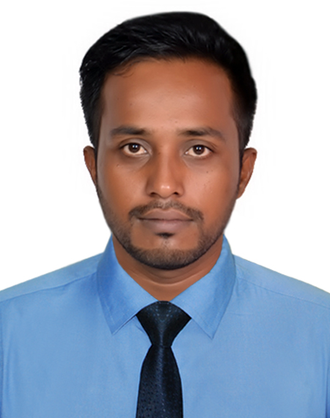
Curriculum Vitae
of

MD. NUR-E-ALAM
H#49/B(3rd Floor), Sugandha R/A, R# 2/KHA,
Panchlaish, Chattogram.
Cell: +8801708179999
email: limonmcsons@gmail.com

Career Objective

I would like to face challenges using knowledge, perception and innovation to pursue long-term successful career in dynamic & professional environment of any leading organization through my attitude, hard work, dedication & determination.

What Makes Me Different

I deserve effective and analytical presentation and communication skill. I am self-motivated, able to adapt any organizational environment, diligent and ready to give my best effort to achieve the targets. I am a natural team player and I can lead and be led, as the situation require, I am an optimistic by nature and sensible to my concern.

Experience

- I had been servicing as Area Sales Manager (pirelli Tyre) in Bir Group Holdings, from June 2019 to March 2020.

Key responsibilities:
- Responsible for the sales, marketing, and distribution, Sales Collection, Due payment collection of the company's products in assigned territory.
- Meet monthly sales target through the company's rule.
- Visit Automotive markets, factories, Workshop, Garaz, all around Bangladesh Planned area.
- Visit and follow up existing and new prospective customers on regular basis to enhance sales.

- I had been servicing as Territory Manager”(Michelin Tyre) in Rayhan Motors, From February 2017 to May 2019.

Key Responsibilities:
- Territory Business development.
- Dealer Management.
- Sales planning and strategy development.

- I had been servicing as Manager, Key Account in Grameen Phone Ltd, Under Ready Corporate solutions Ltd, From October 2014 to January 2017.

Key Responsibilities:
- Meet the Sales Target.
- Creating Sales planning and Execution.
- Controlling Training and Development of sales manager and executive.
- Monitoring the Sales Team.

- I had been servicing as Sales Manager in Grameen Phone Ltd, Under Enroute International Limited, From August 2013 to September 2014.
Key Responsibilities:
- Meet the team Sales Target.
- Execution of sales planning.

Key Skill

Leadership, Negotiation, Presentation, Self-driven, Quick Decision Making, Public Relation, Persuasion, Team Work, Ability to Work under Pressure, Time Management.

Scholastic Status

Bachelor of Business Administration (B.B.A.)
Subject : Business Studies
Passing Year : 2010
University : National University

Higher Secondary Certificate (H.S.C)
Institute : Haji Mohammad Mohsin College, Chattogram.
Group : Business Studies
Passing Year : 2003
Board : Chattogram

Secondary School Certificate (S.S.C)
Institute : Rahmania High School.
Group : Business Studies
Passing Year : 2001
Board : Chattogram

Computer Skill

- Microsoft Office ( MS Word, MS Excel, MS Power Point).
- Internet Browsing.

Language Proficiency

- Bengali: Both Verbal and writing.
- English: Fluent in both Verbal and writing.

Interests and Hobbies

- Reciting, Reading and introducing new persons.
- Sports

Personal Information

Fathers Name : Md. Haris Ahmed
Mothers Name : Mrs. Amatun Nur Begum
Date of Birth : 30th April 1985
Religion : Islam
Nationality : Bangladeshi (by Birth)
Home District : Chattogram.
Marital Status : Married
Gender : Male
Permanent Address : 49/B(3rd Floor), Sugandha R/A, R# 2/KHA, Panchlaish, Chattogram.

Reference:

Md Sala Uddin  Manager, Key Account  Enroute International Ltd.  Baridhara DOHS, Dhaka  Email: arif@enrote.com.bd  Call: 01619001001 | Moinul Islam  Channel Manager  Commercial Division  Grameen Phone Ltd.  Email: moinul_islam@grameenphone.com  Call: 01711506986

Md. Nur-E Alam

